**AWS Developer**

Local Development:

* Everything runs locally on same machine.
* Files stored on server.
* Database on same server as application.
* Connections done manually.

Aws Development:

* One service = one responsibility
* Files served from S3
* Database as a Service (DynamonDB)
* Connections done with AWS SDK

EC2 (Elastic Cloud Compute): you can think of this as the service that provides servers where your application will be running. EC2 actually forms the basis of many other services as well, such as Relational database Service and Elastic Beanstalk.

To store that session in a cache such as ElasticCache, to avoid wasting application memory. All things will be stored in a database using the relation Database Service (RDS), image will be created and stored in s3

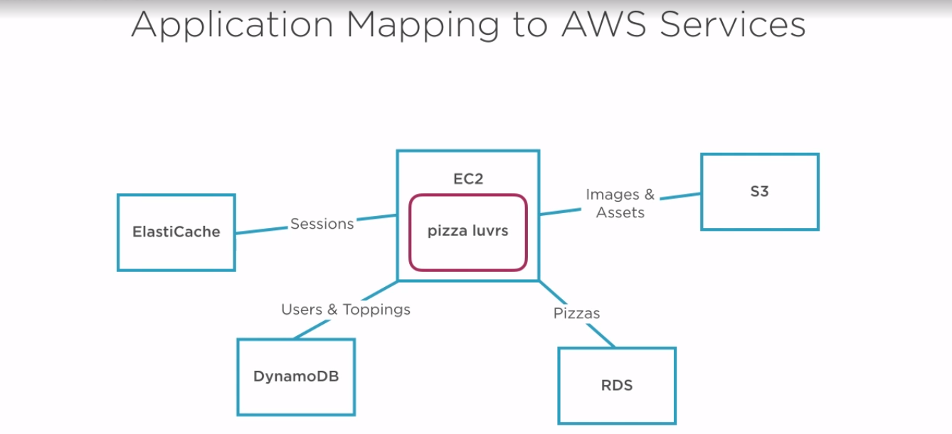

Identity and Access Management Service (IAM)

CLOUD WATCH: you can configure alarms to notify you or trigger automatic actions if services go down, are overloaded, or otherwise act crazy. With IAM service you can easily configure access for users and protect sensitive resources to limit the possibility that things can go awry.

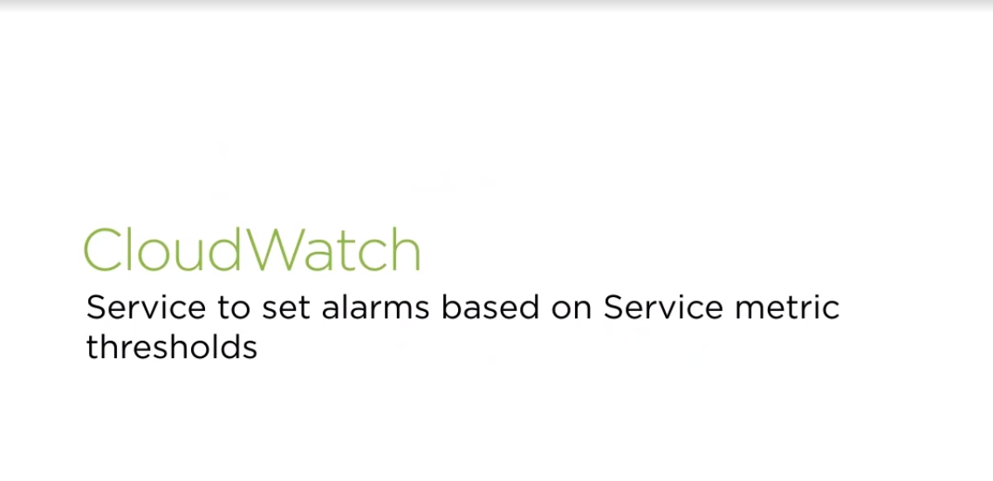

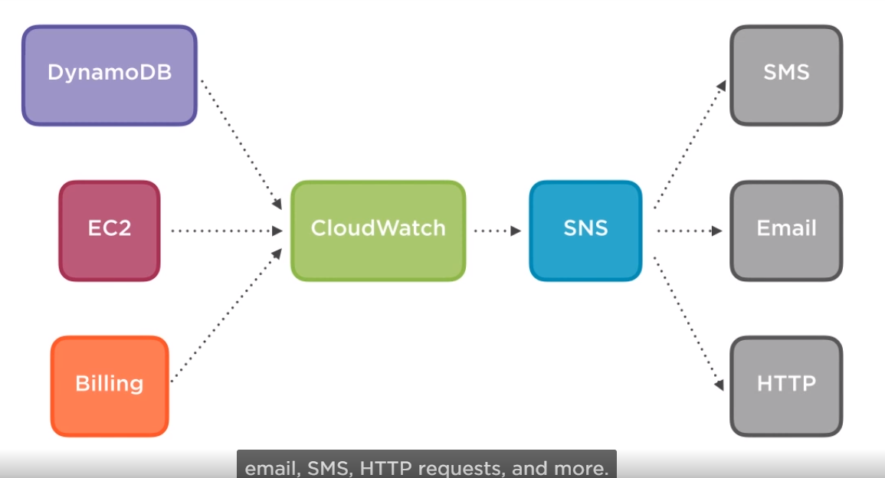

Cloud watch Alarm Actions:

1. Send Notification via SNS
2. Configure an alarm to trigger an action, when a certain threshold is passed. This action-based response is available for EC2 instances and auto Scaling groups.

Simple Notification Service (SNS):

Is an integral companion to cloud watch, allowing you to easily push alerts to a group of notification endpoints. The main structure in SNS is the topic. A topic is used to create the unique Amazon resource Name that can have notifications sent to it. Once you subscribe to a topic with an email or sms number, any notification sent to that SNS topic will then be communicated to your subscribe endpoint.

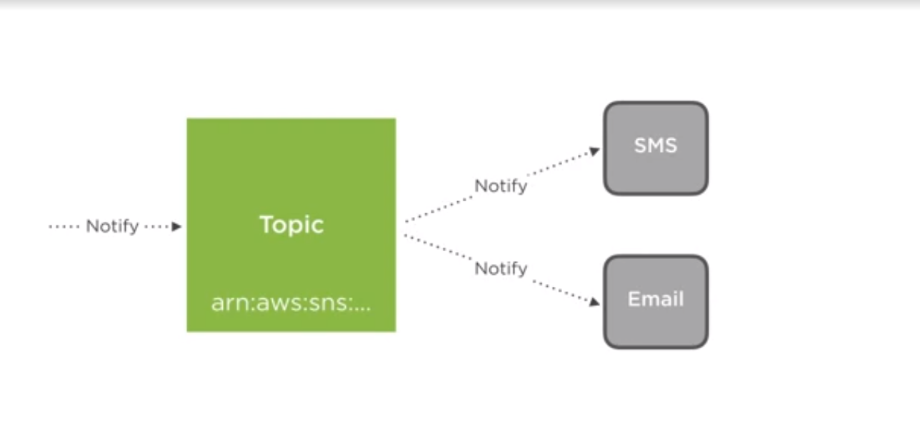

CREATING AN BILLING ALARM

1. First set up your region, before create your topic:

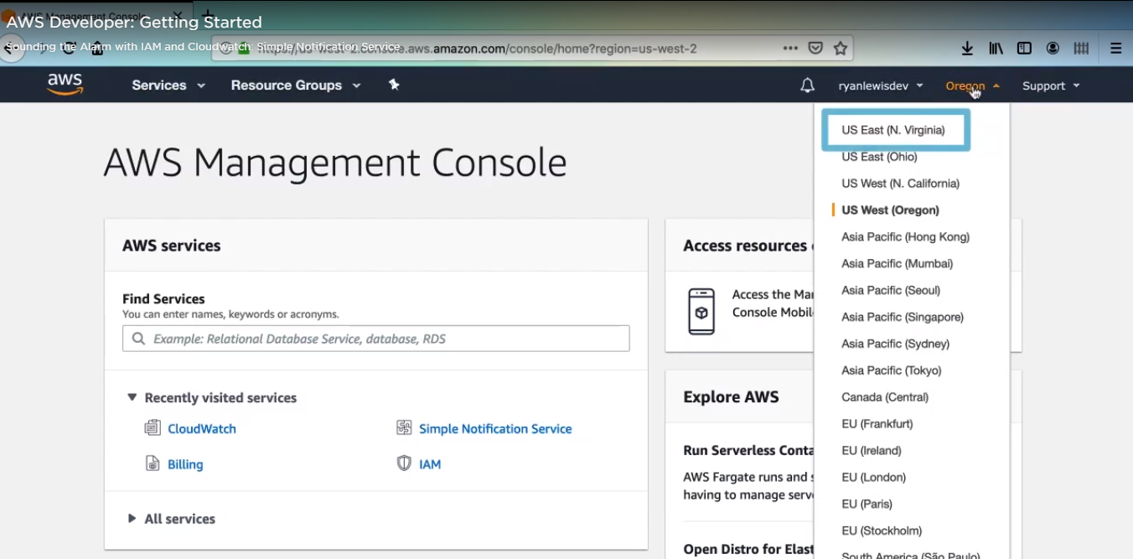

1. Then click on services, type SNS:

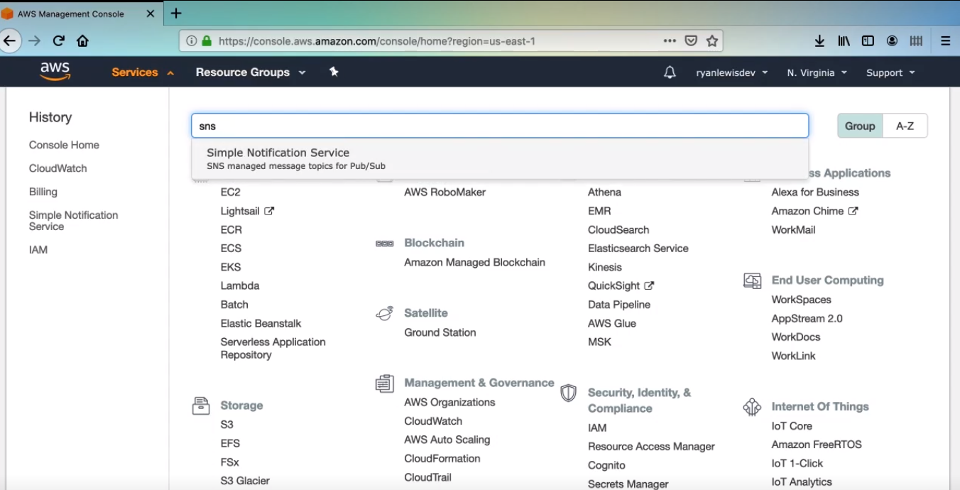

1. For instance, if you are going to send an emails, you can create a name topic admin_email.

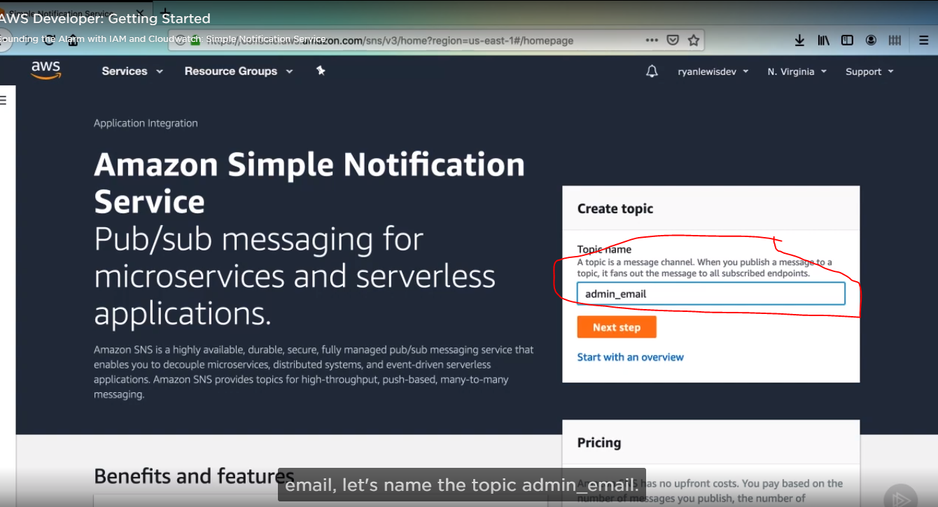

1. Then click next step, you would find different configurations, do not change,

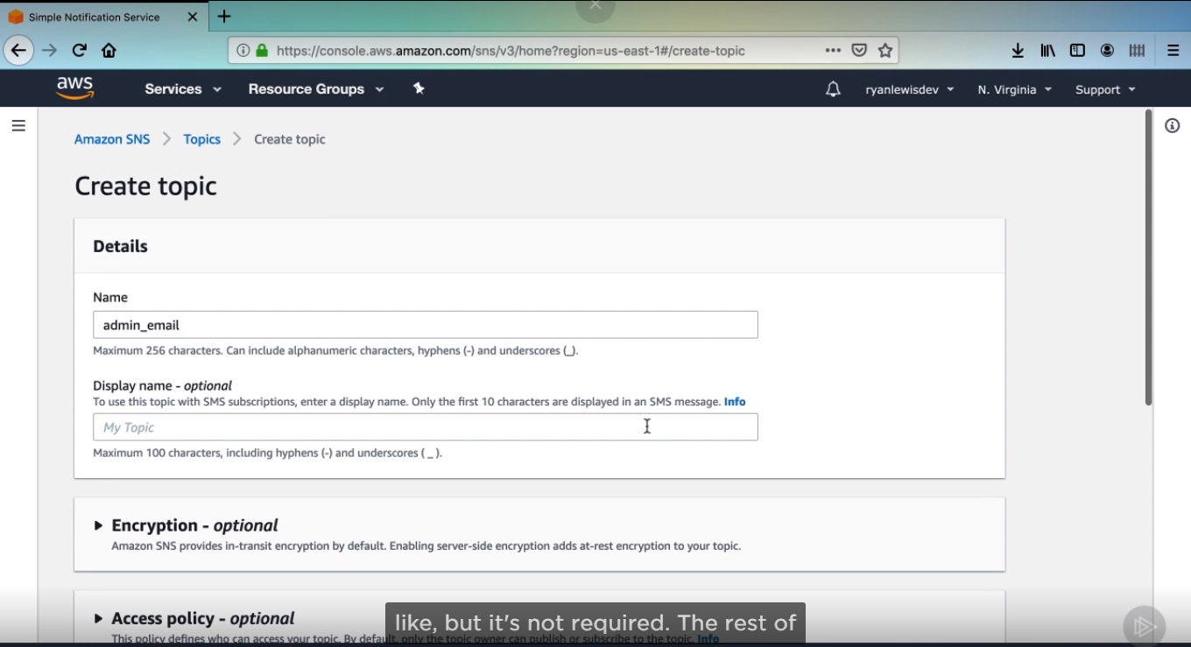

1. Click create Topic.

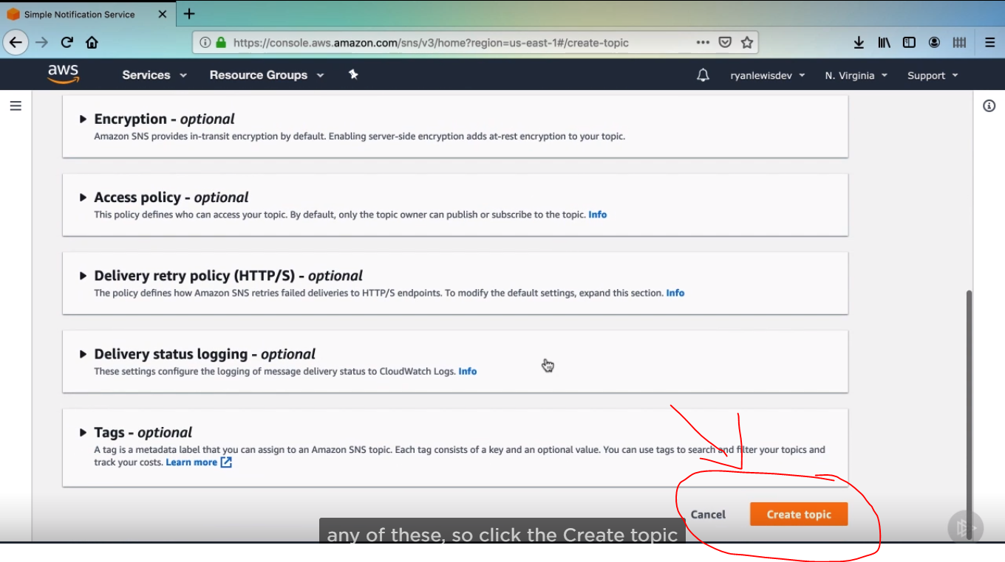

1. Then you will get this screen:

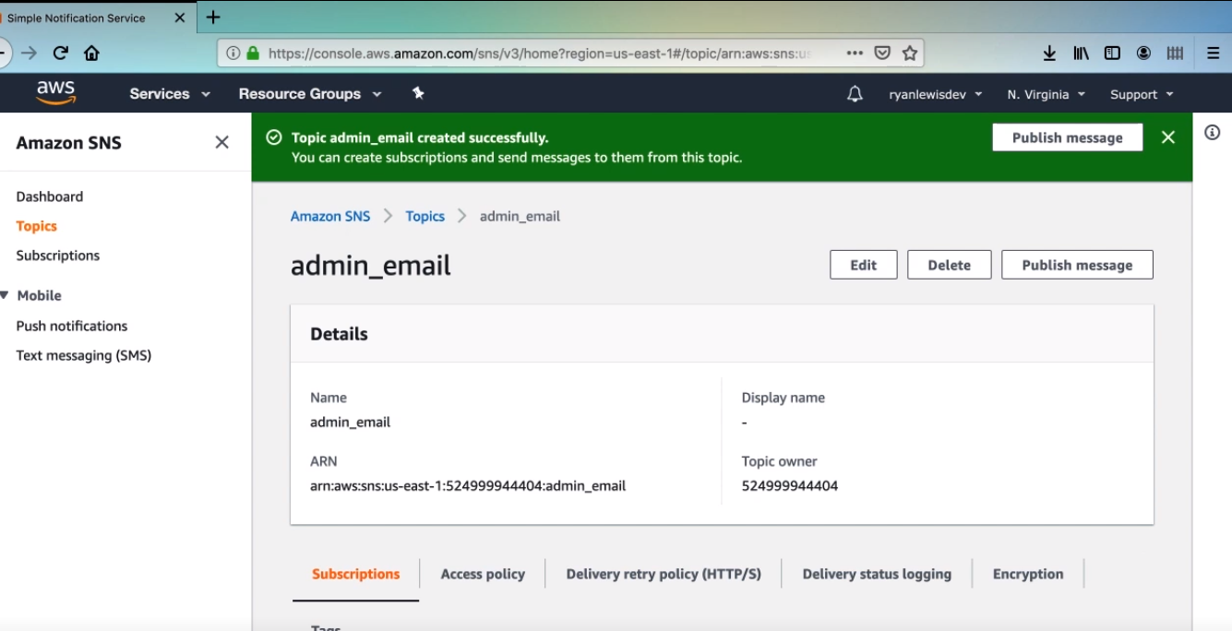

1. Then scroll down and you will find a subscription section, then click, create subscription:

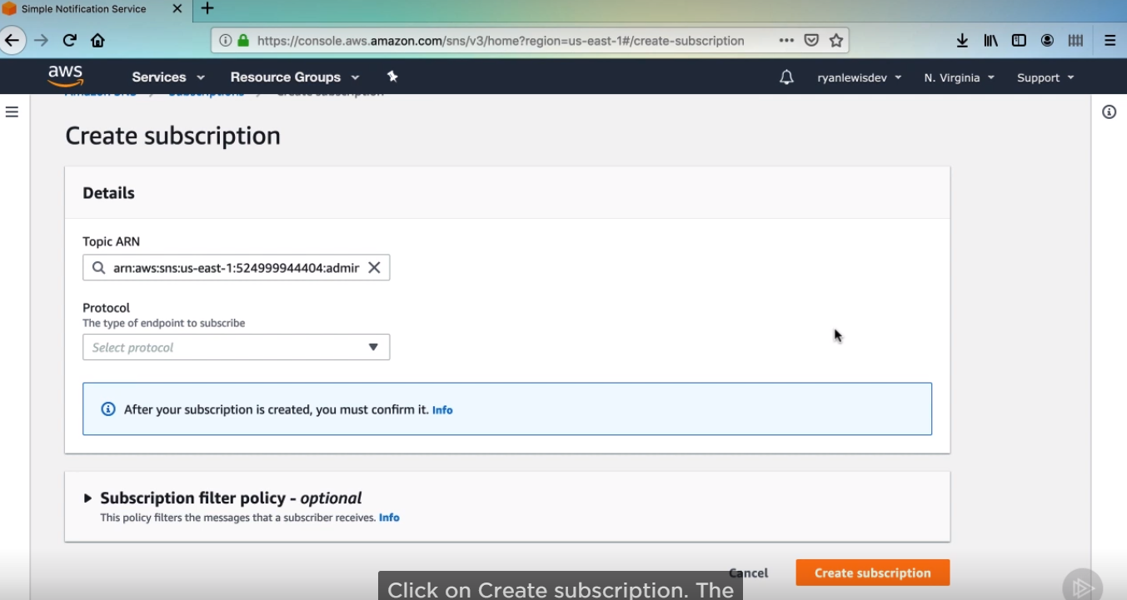

1. Then click on protocol and select email.

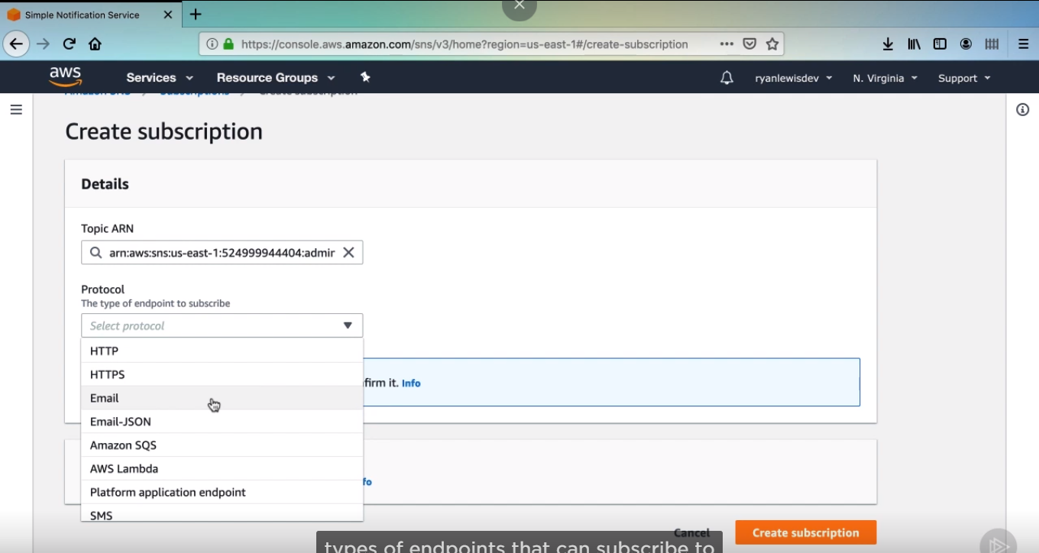

1. Then, write the email which you want to send a notification in input Endpoint. Then click a create subscription.

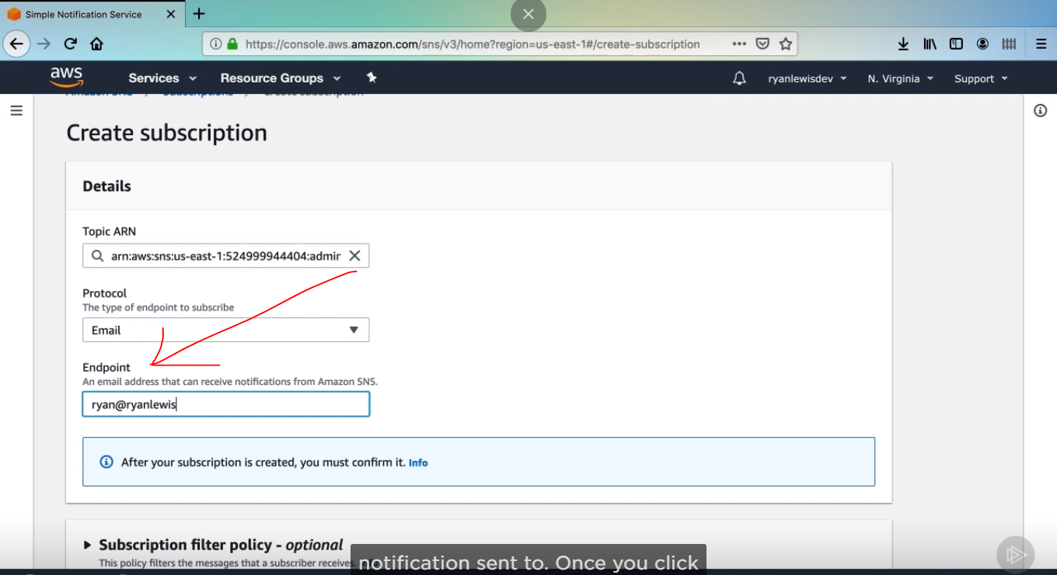

1. Result:

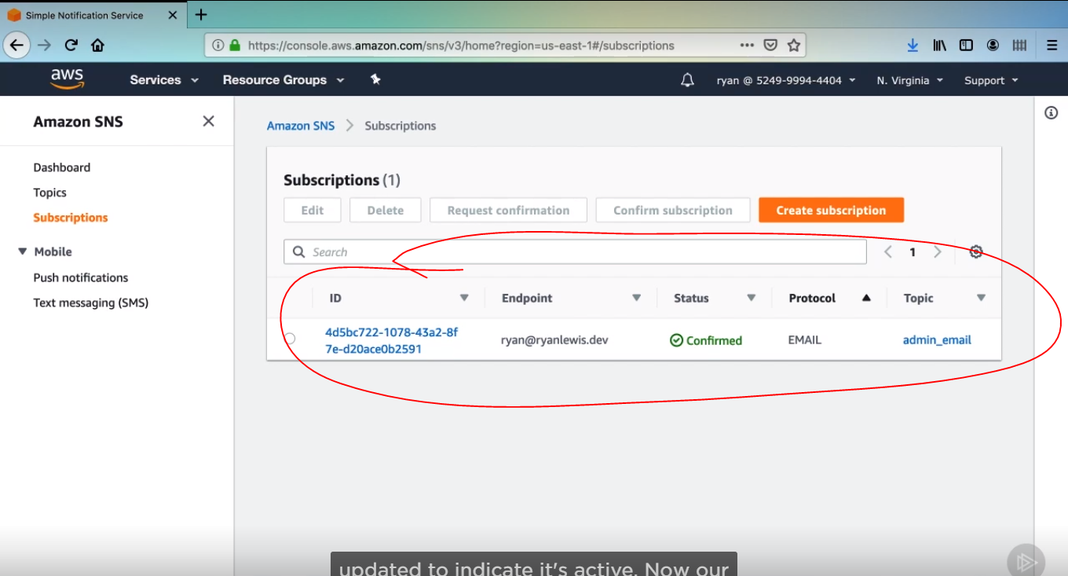

IAMServices that controls who can have access to what in your AWS account, you can give access for all users created on an account.

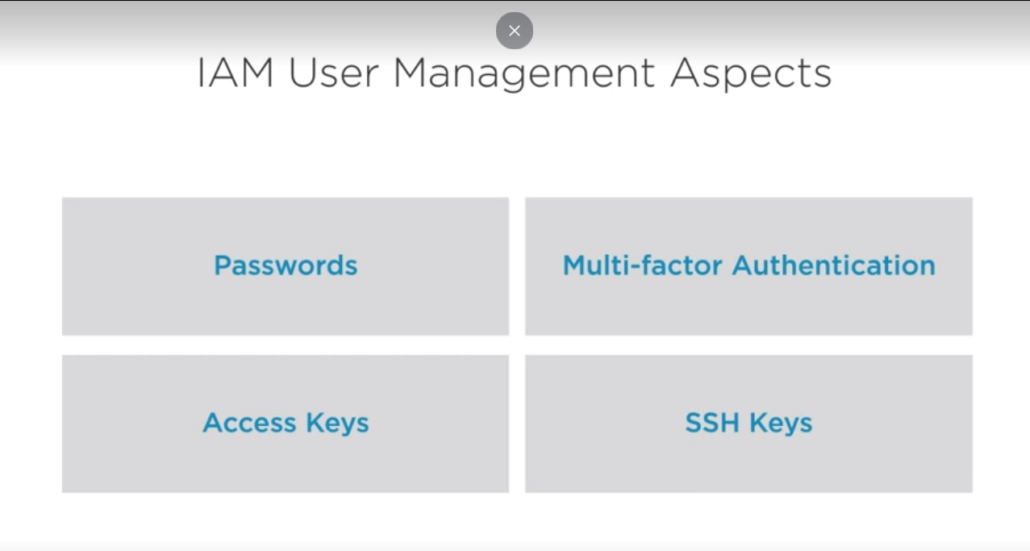

**POLICY**

There are several different methods to control these permissions, but the main structure to work is a policy. A policy is a collection of permissions to access different services in a particular way. Policies can be very specific to the resource level or broad and allow permissions on a type of service. In addition, policies are typically mixed and matched to a particular user or group.

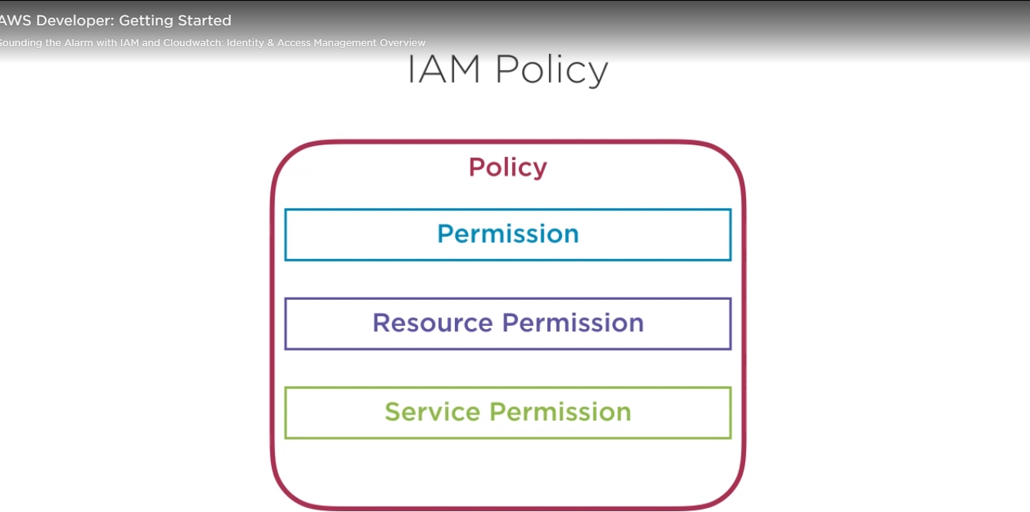

A group for developers might have full access to EC2, so they can spin up instances as needed , or group for testers might have read only access to a DynamoDB table, but full access to a particular S3 bucket.

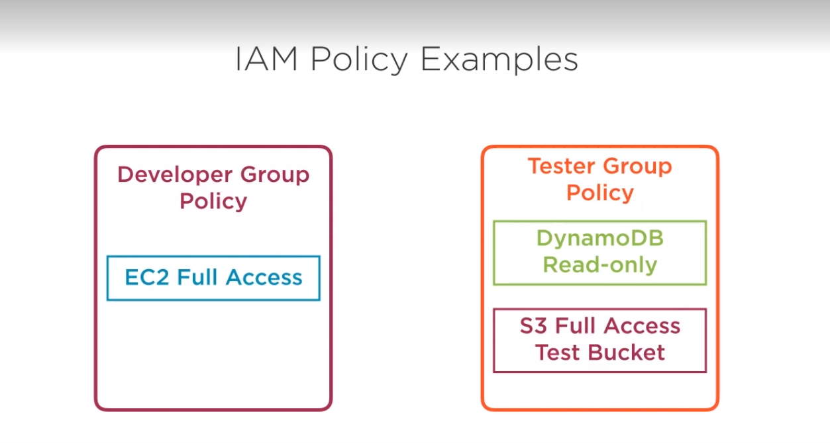

1. Write IAM and find services:

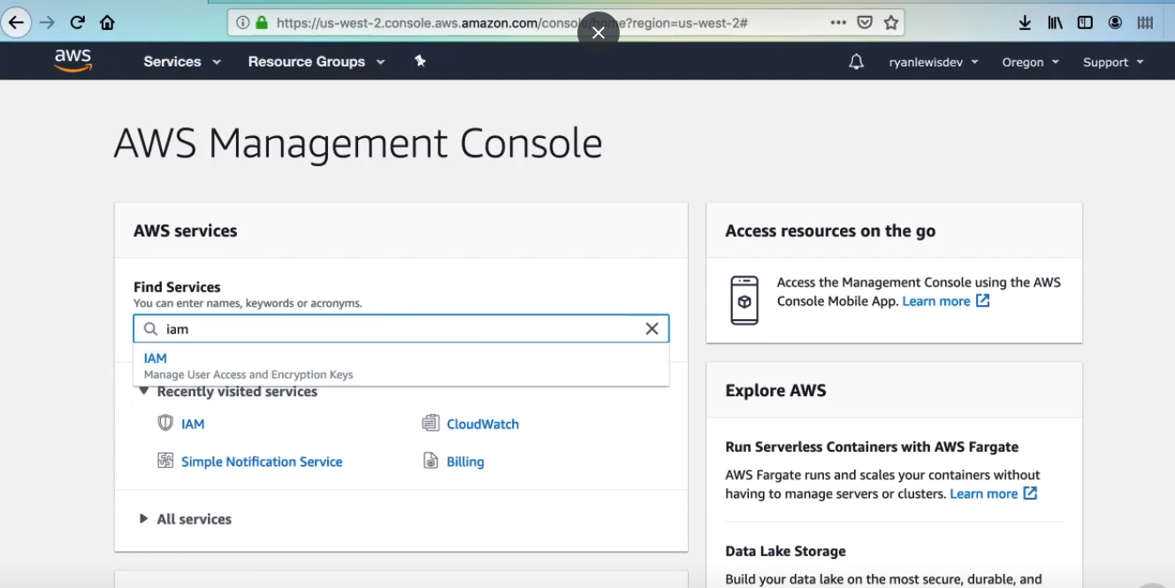

1. This dashboard gives you a snapshot of your current IAM Setup, such as number of users, groups, etc. In addition, it has some security checks based on Amazon

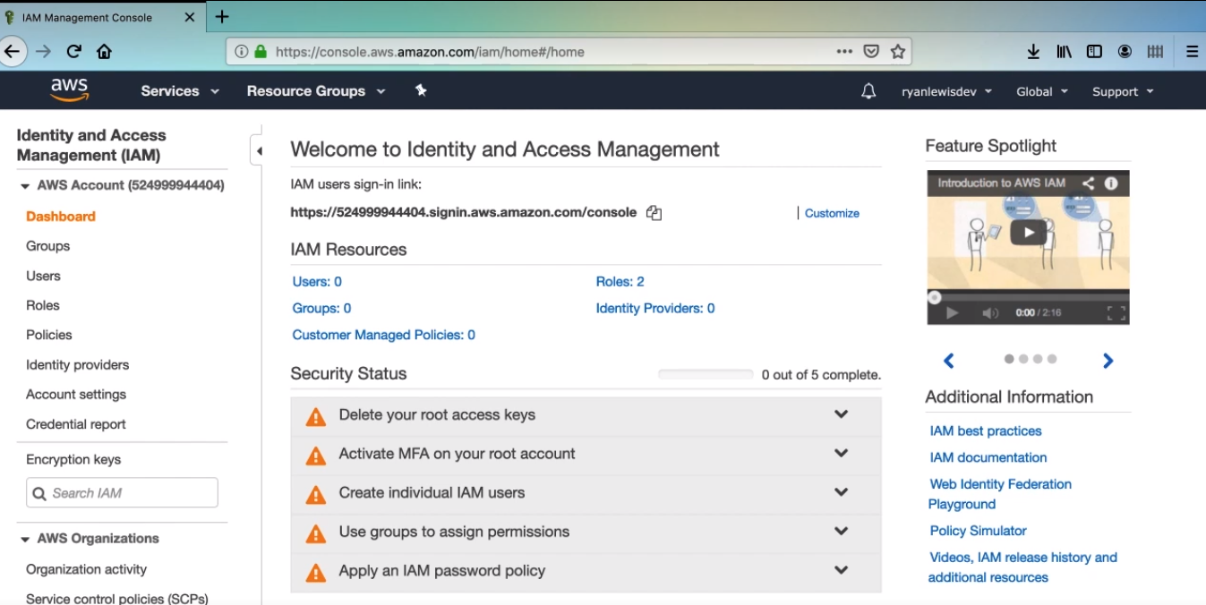

MFA with AWS



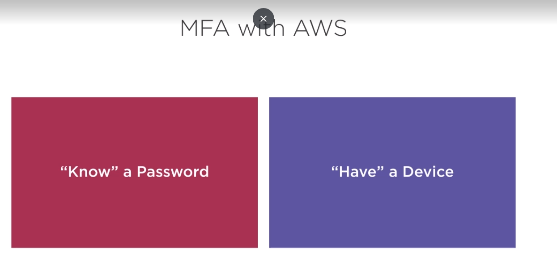

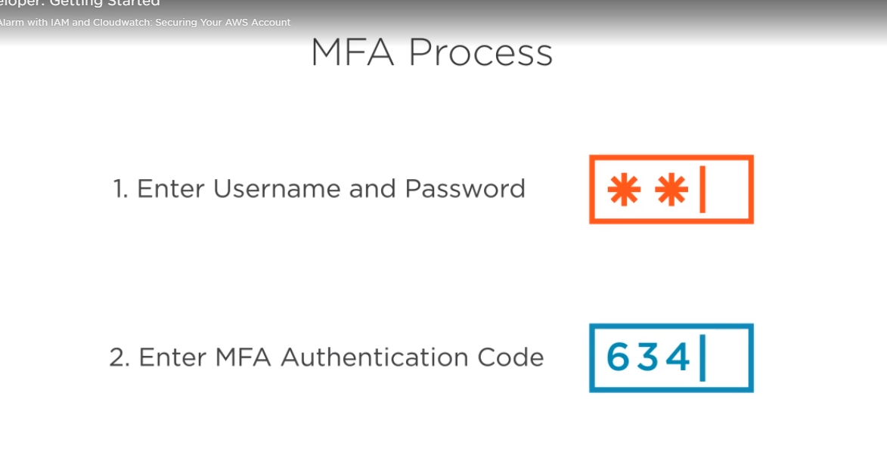

MFA can use both

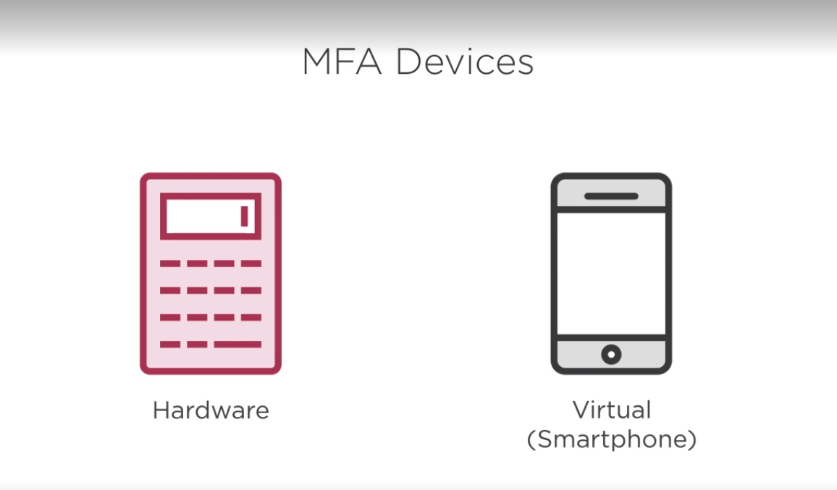

Set up MFA

1. Right hand corner and then select my security credentials.

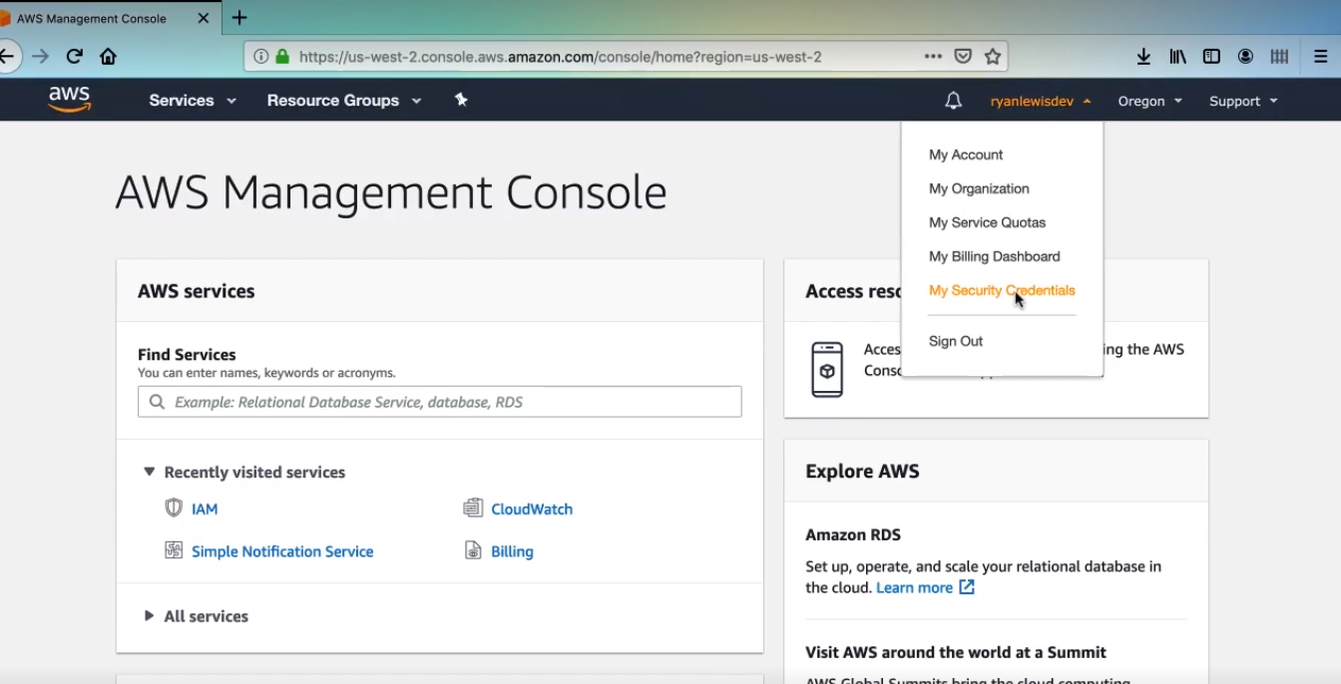

1. Close the pop up warning suggestion for us to use IAM.

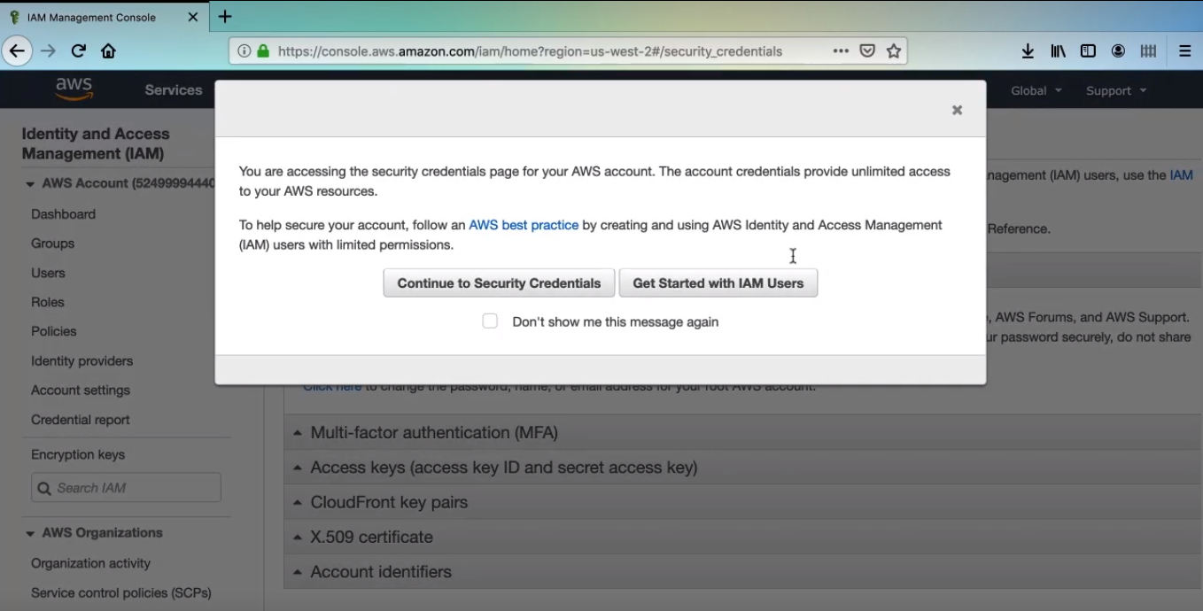

1. Expand multi factor authentication section and click the active MFA button

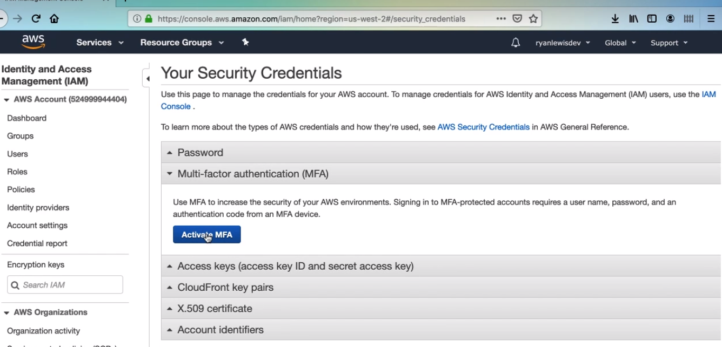

1. Select virtual if you are using a smartphone .

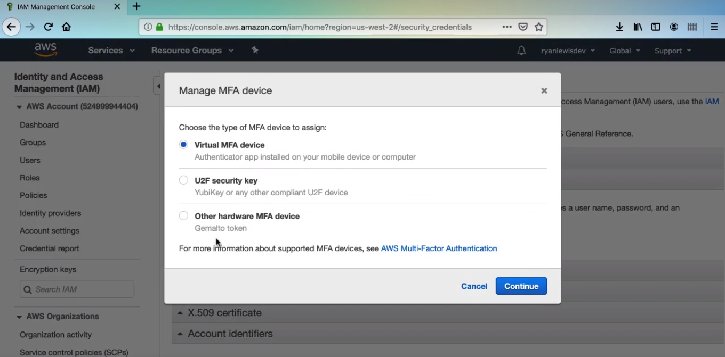

1. Then you will see a large QR, basically, you want to scan the QR code with your MFA app and then enter code

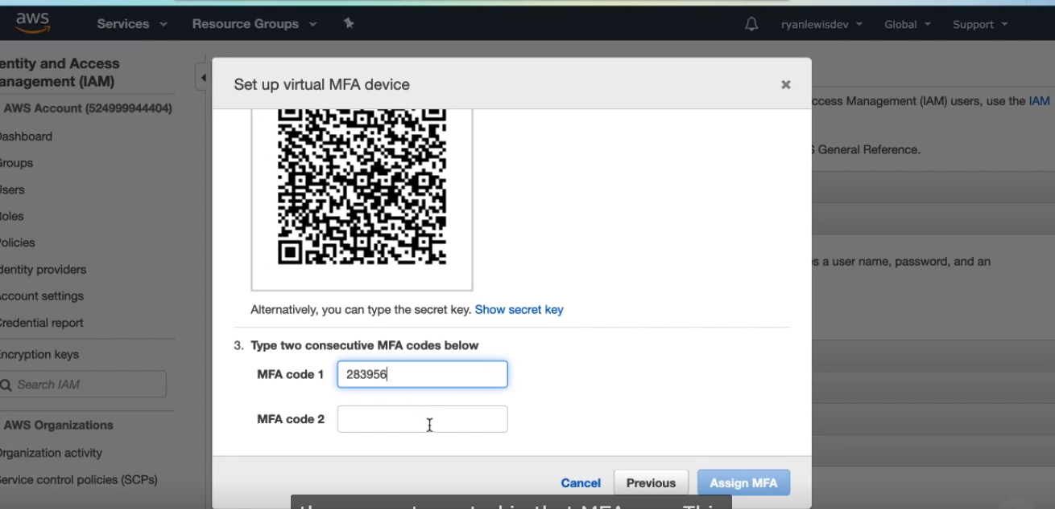

1. Then Sign out and log in, now you are presented a new screen, and this is where you will enter the authentication code from your MFA app. Get the code from your app, make sure the most recent code, some apps automatically refresh the codes, but some require a manual refresh.

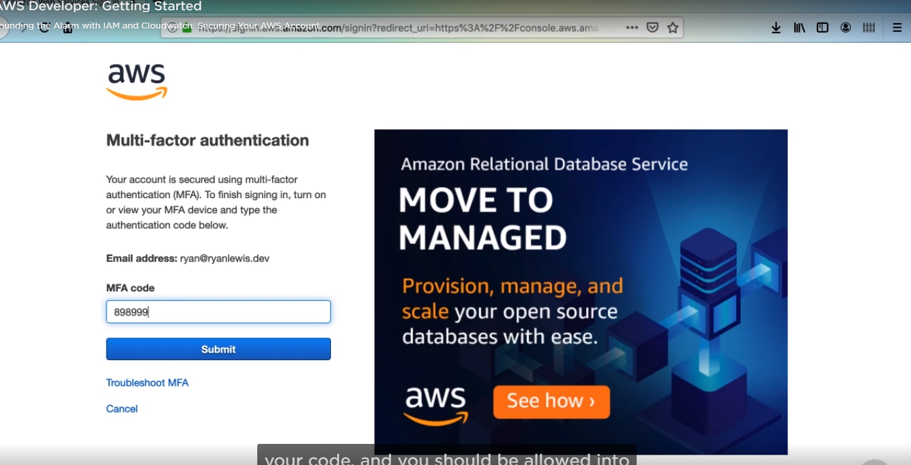

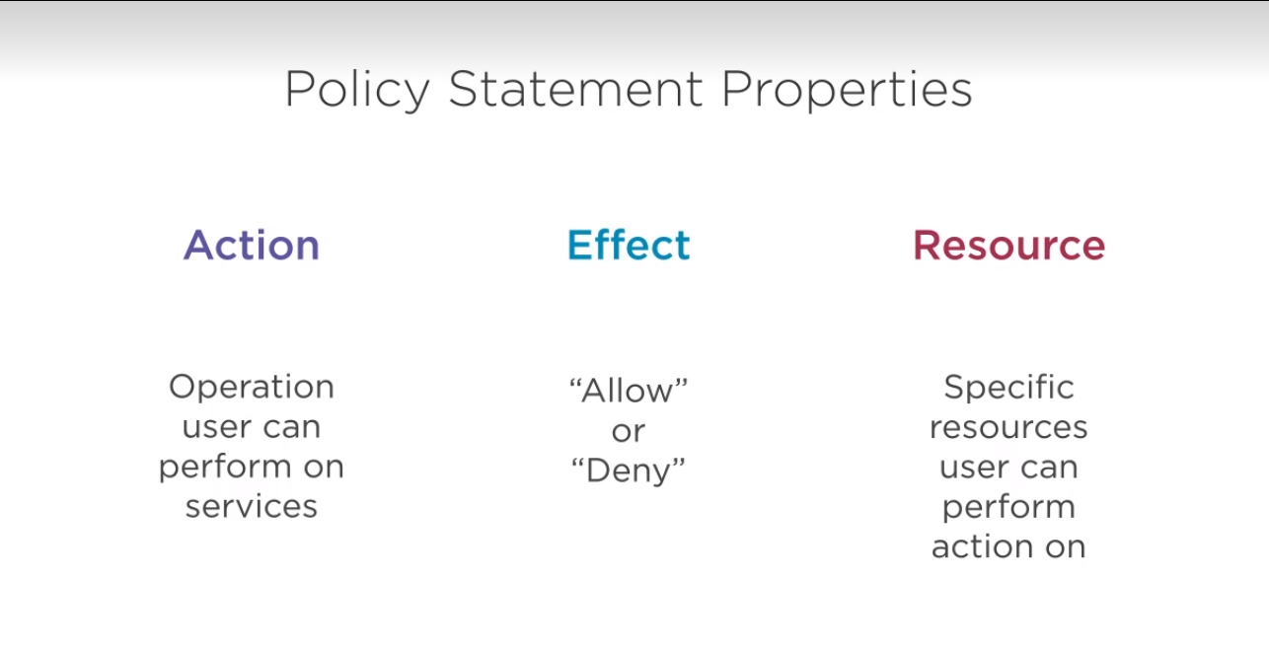

1. Select Policies

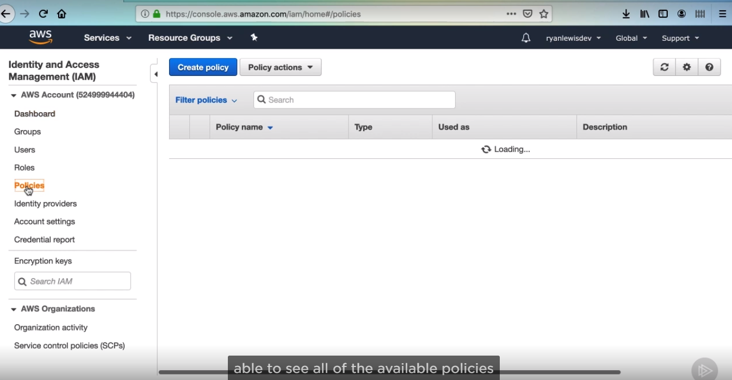

1. Click on AdministratorAccess

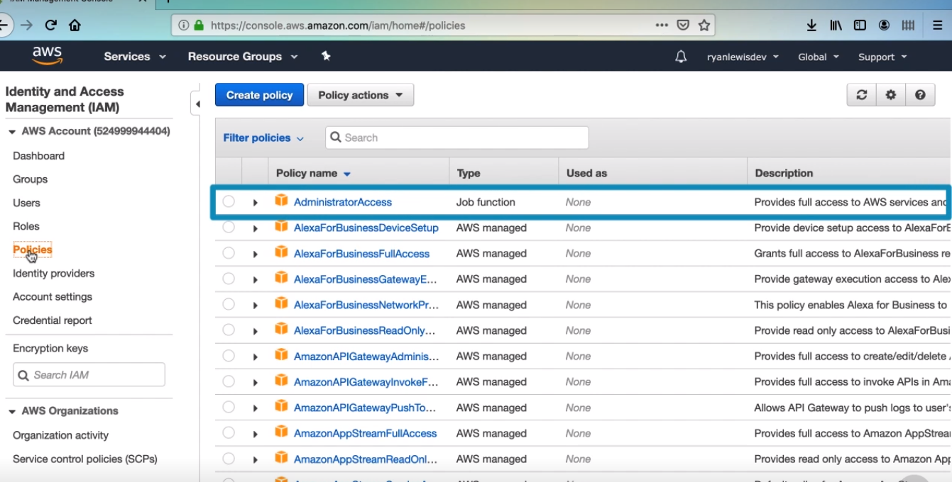

1. the policy document is the important part of this policy. It gives permissions for an attached entity to access something, a policy document is just basic JSON, and the part we care about is the property named Statement that is an array of objects. Administrator access gives access to all services to do anything, so the action and resource fields are both assigned an asterisk.

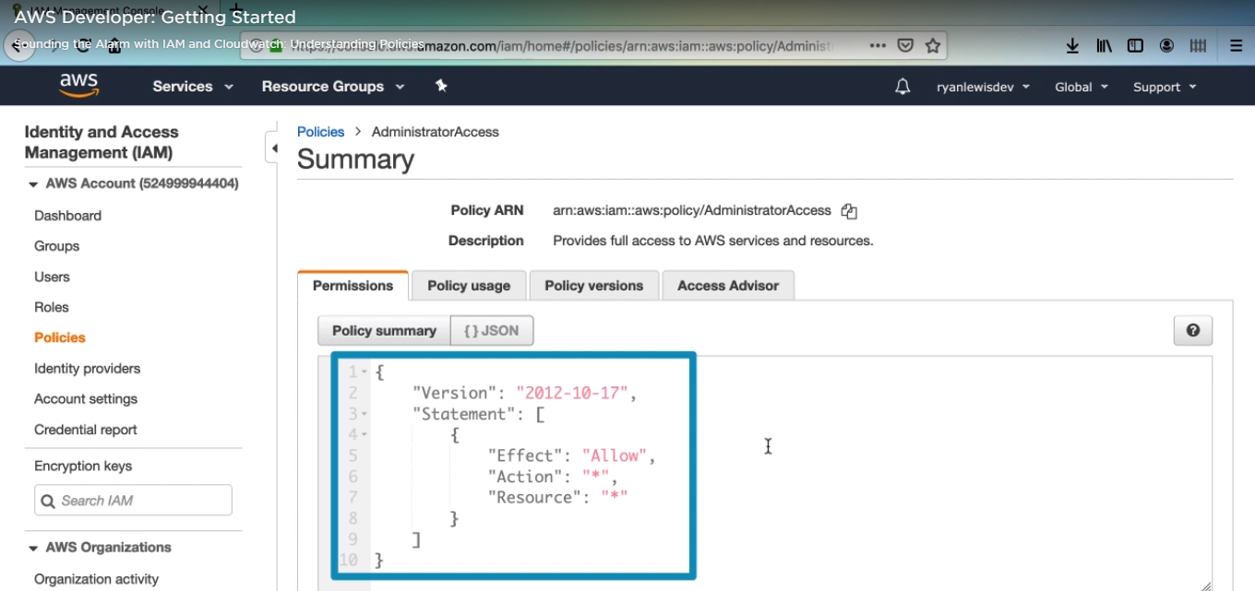

1. for instance, go polices and search ec2.

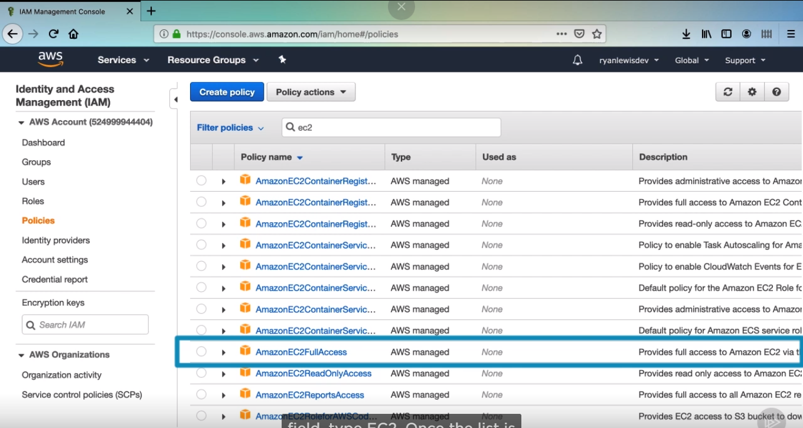

1. then you find about Ec2

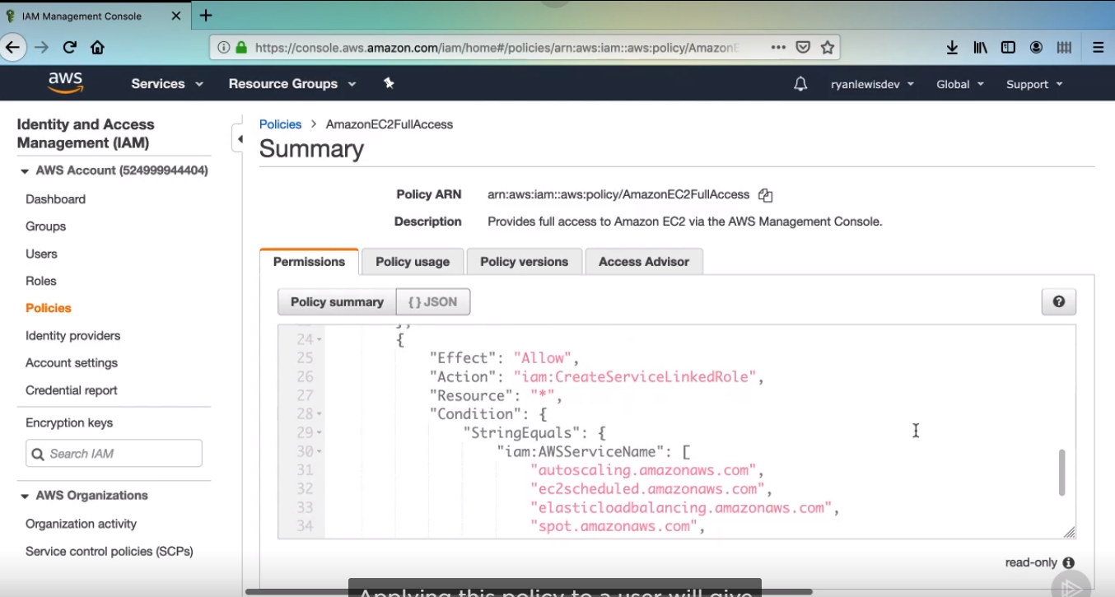

Configure Users and groups

As a best practice, Amazon suggests not using your root account to do things in AWS because you have unlimited permissions to do just about anything. Instead, it is suggested to created a user and login under that account to administer services in AWS, so let’s do that now.

1. First type IAM and hit enter:

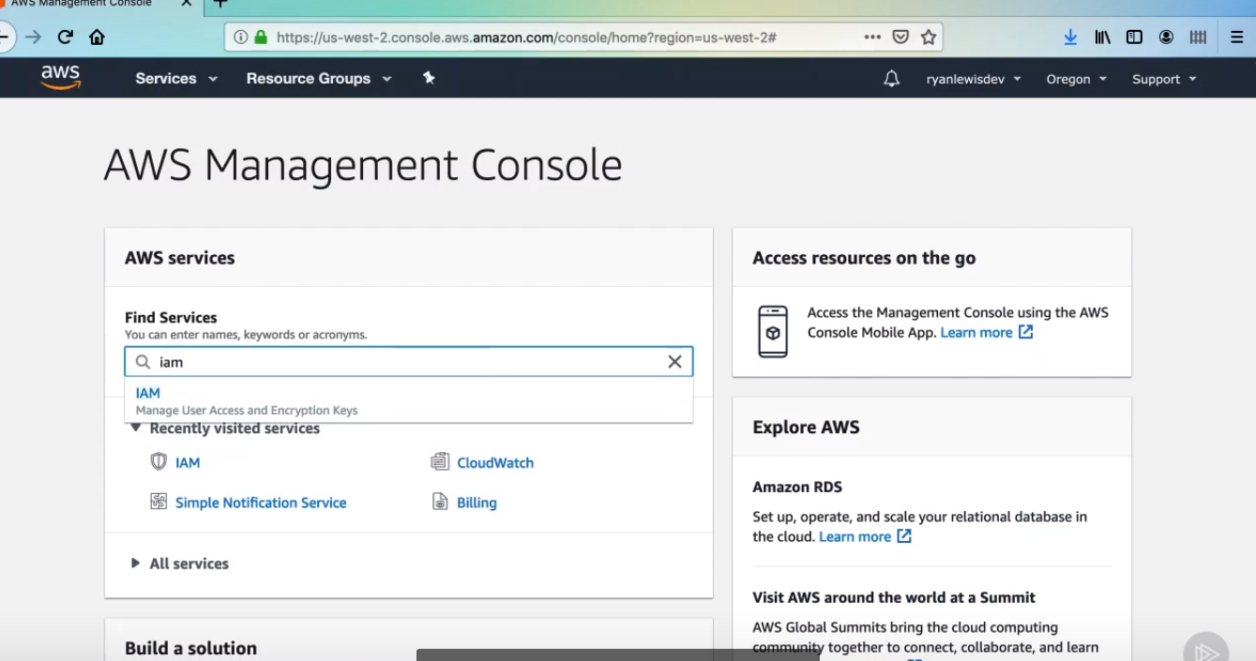

1. Then select User options:

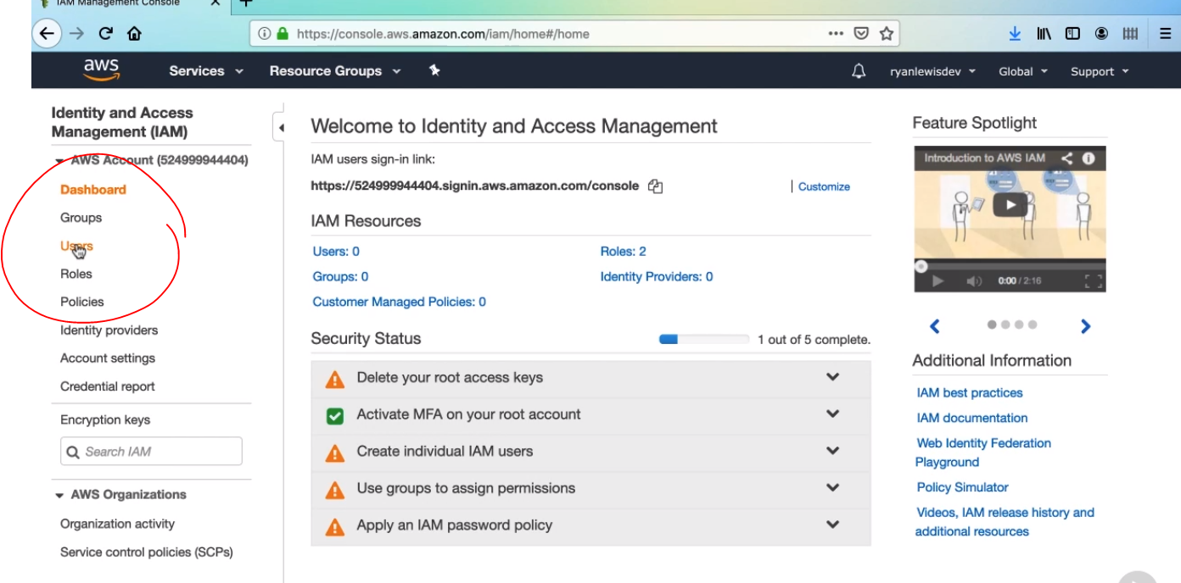

1. Then click add user button

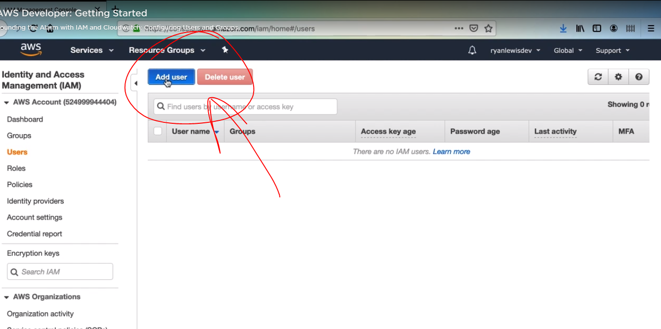

1. Enter your user name, it is probably different from your root login to avoid confusion, if you registered with a key access in you aws cli, you will replace our AWS CLI access key with the one assigned to this user, so click programmatic access and console as well. Then click next.

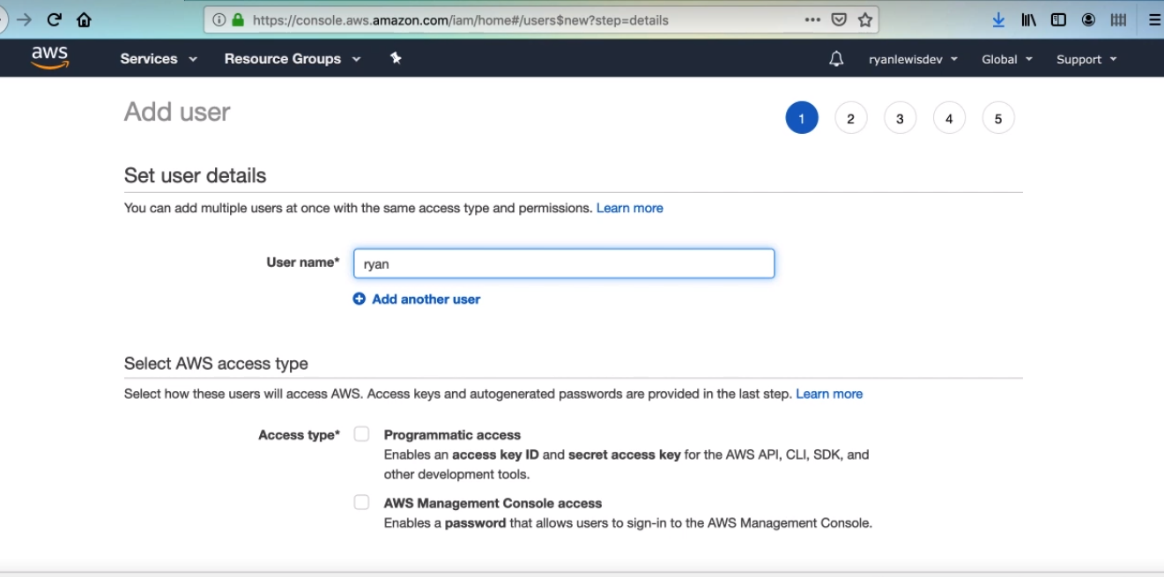

1. Then click both Programmatic access and AWS management Console access

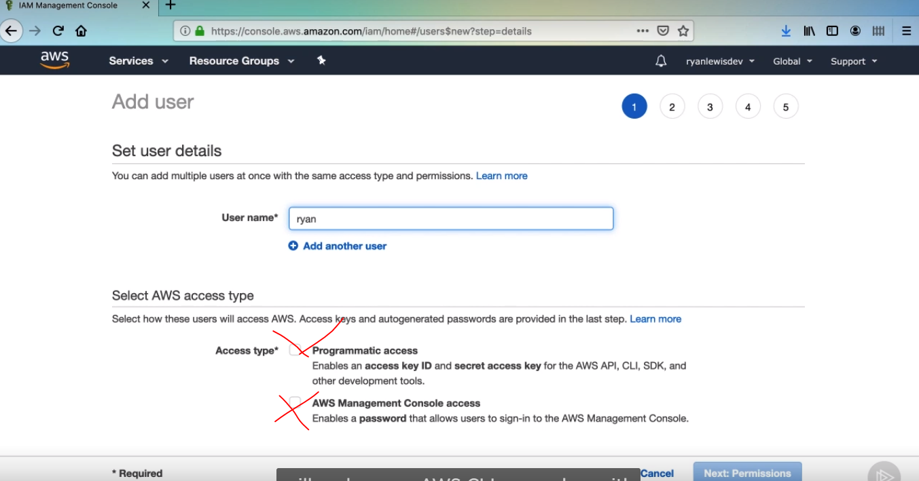

1. Then click next tag and again and finally Create User.

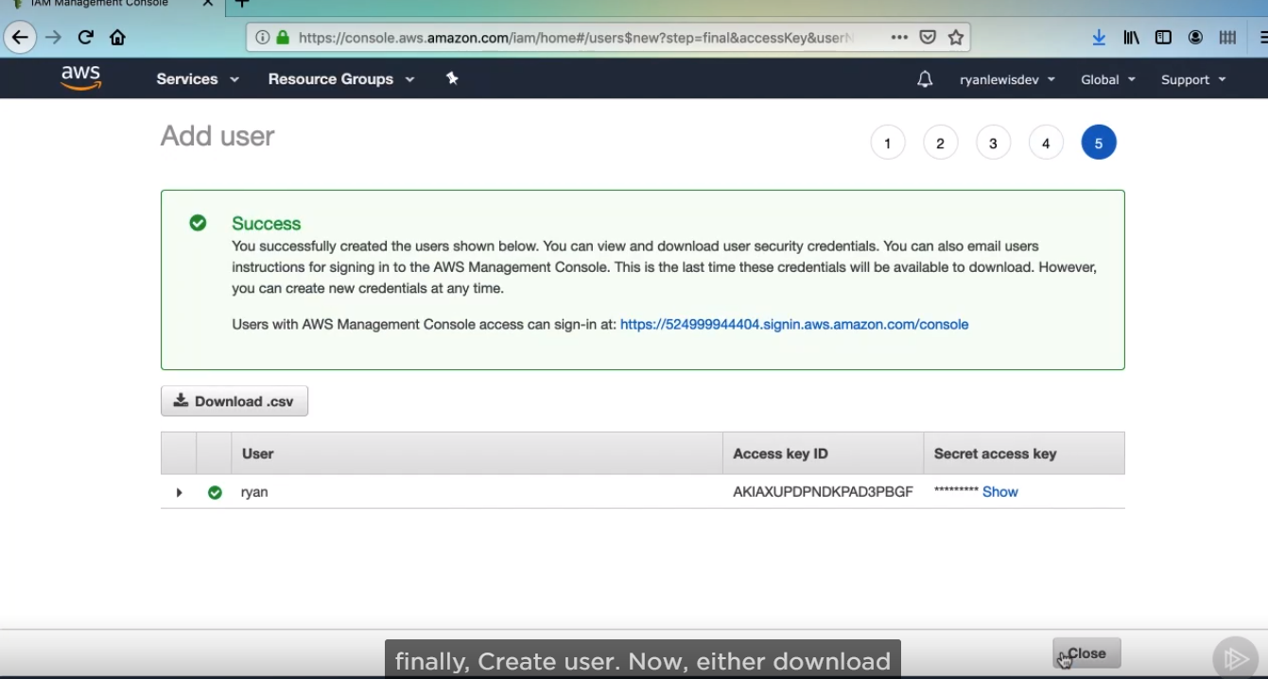

Then setup all credentials to aws cli. So this user we haven’t given this user any permissions yet. Now back in the console.

1. Next step is to set up credentials in aws cli console: write

aws configure on the console then write your access key ID, secret access key, region name and output format.

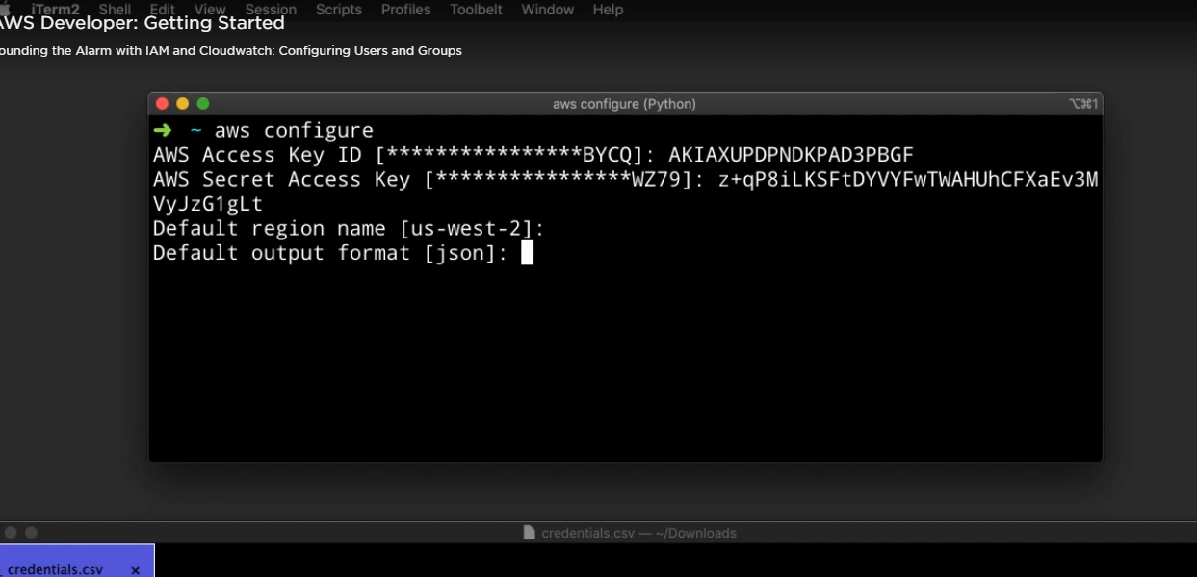

1. If we enter ec2 instance just for checking if we have some permissions.

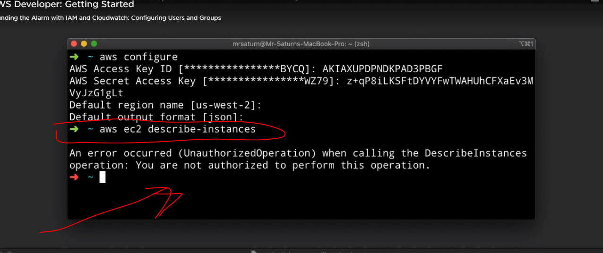

1. Go to click my security credentials

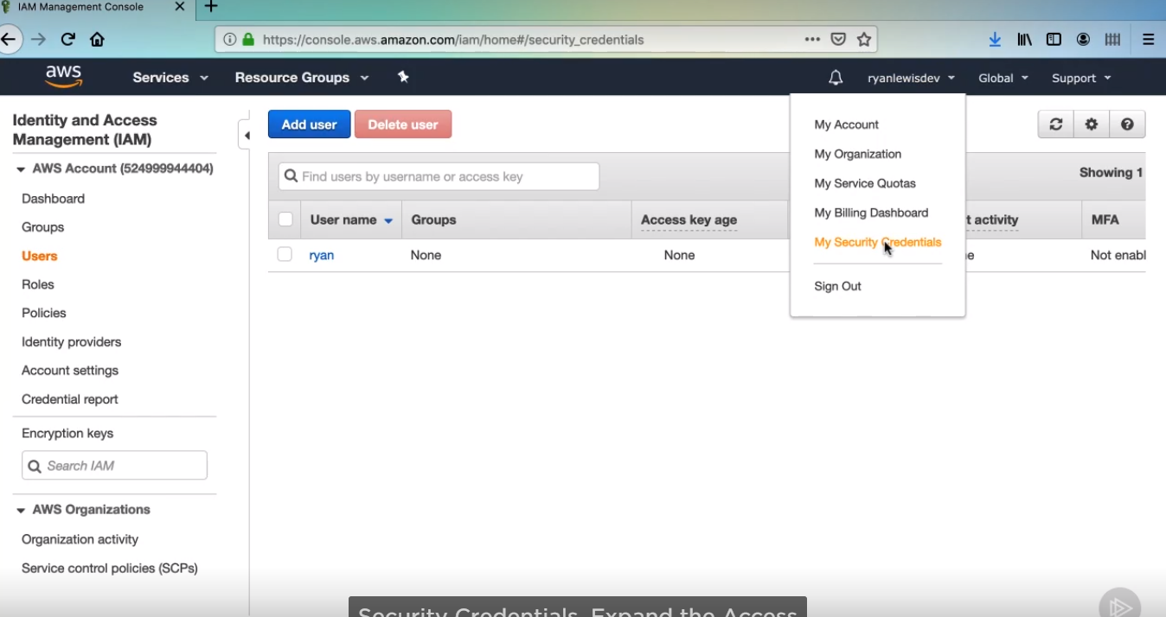

1. Delete any actions

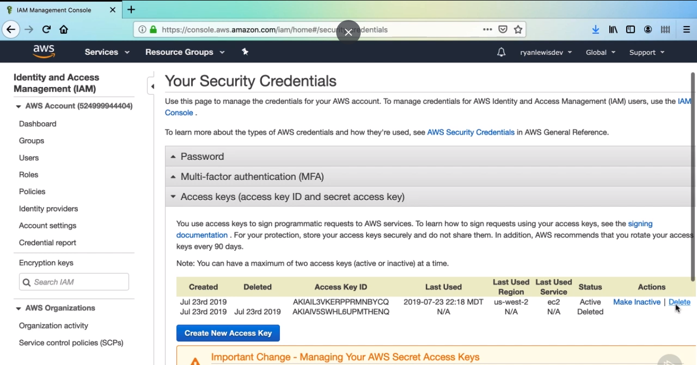

1. Remember, Amazon suggests applying policies to groups, so let’s create an admin group for our user to be added to. Form the IAM

Console select the groups menu option

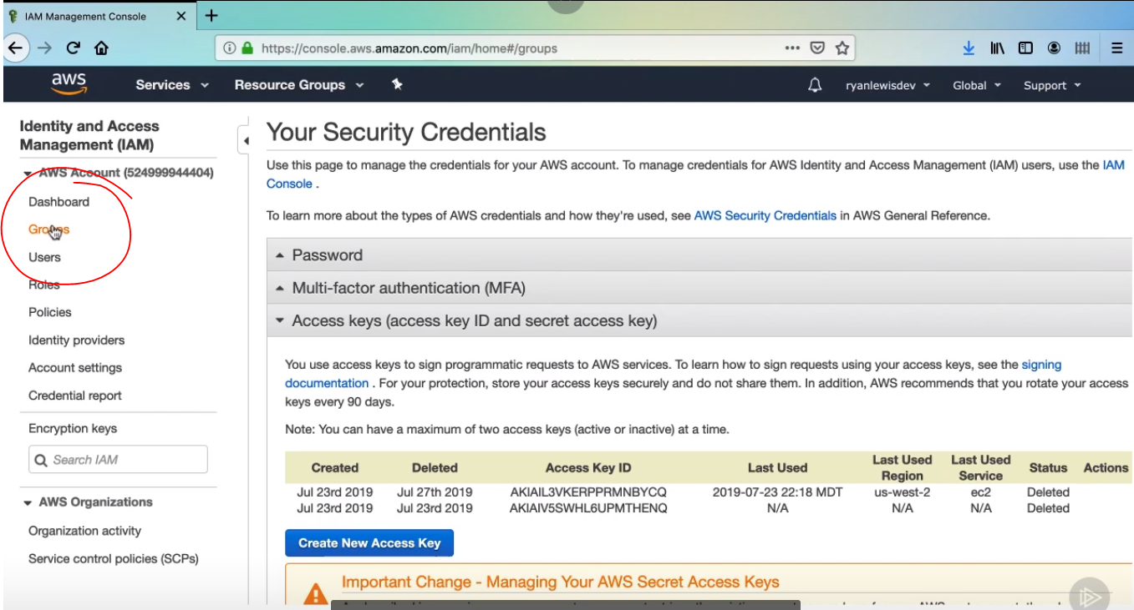

1. Then set a group Name: for instance admin, then next

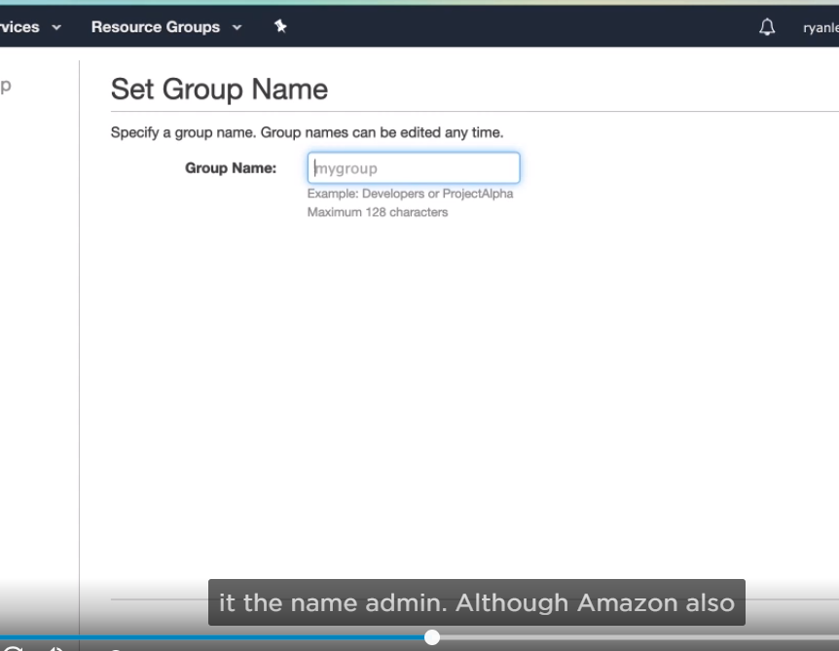

1. Then it will appear a list for apps, then get access for what apps you want. Then click next

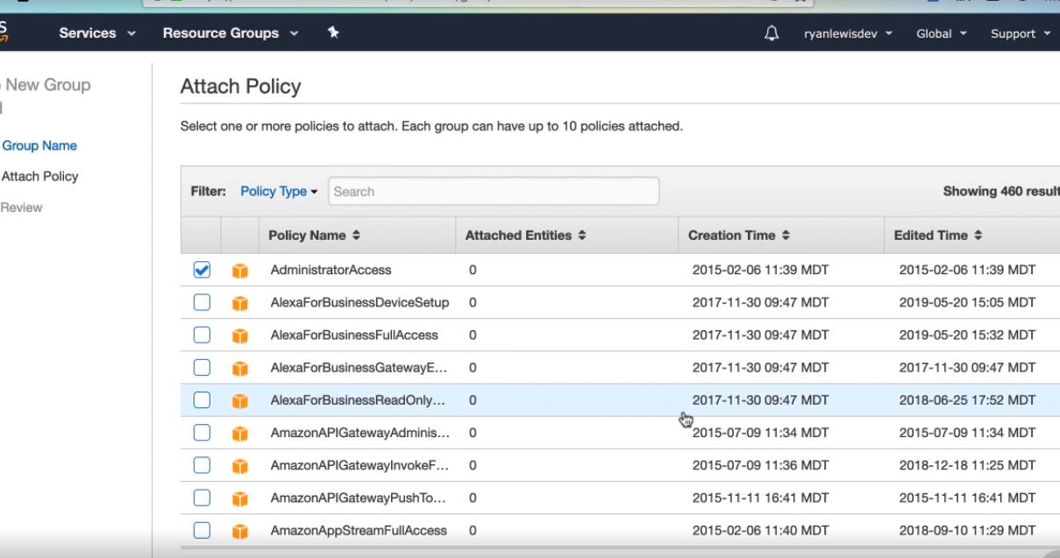

1. Then create group from the review screen and click create.

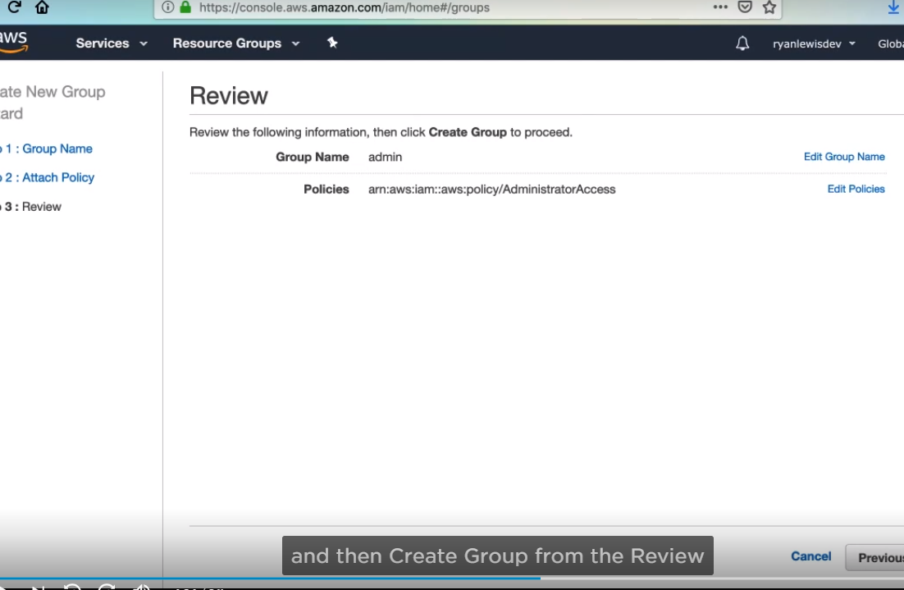

1. Then click the name of the group which you set up.

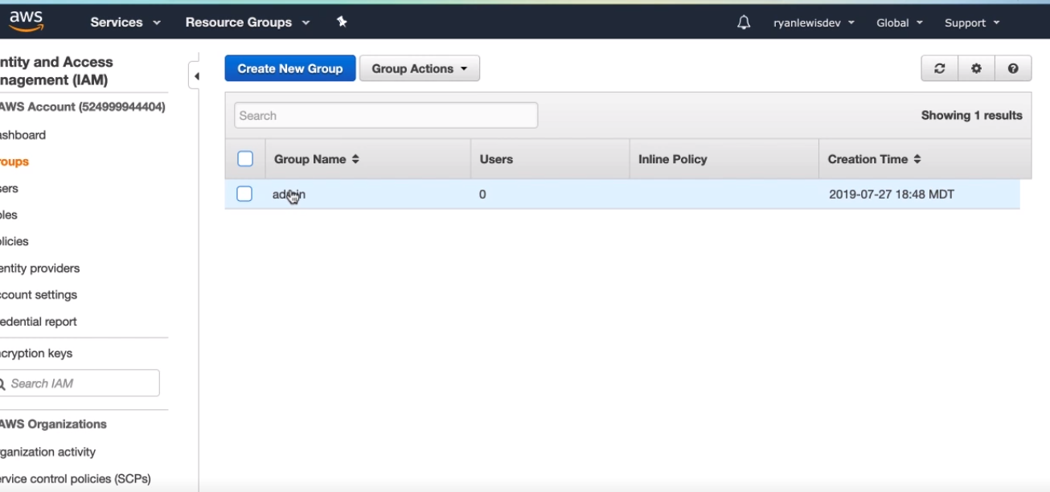

1. Then click add user to group.

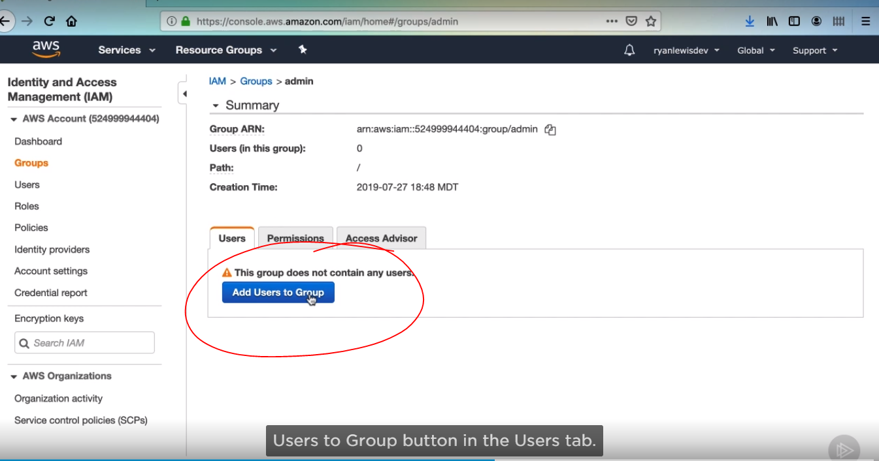

1. We encounter here just one user, then select.

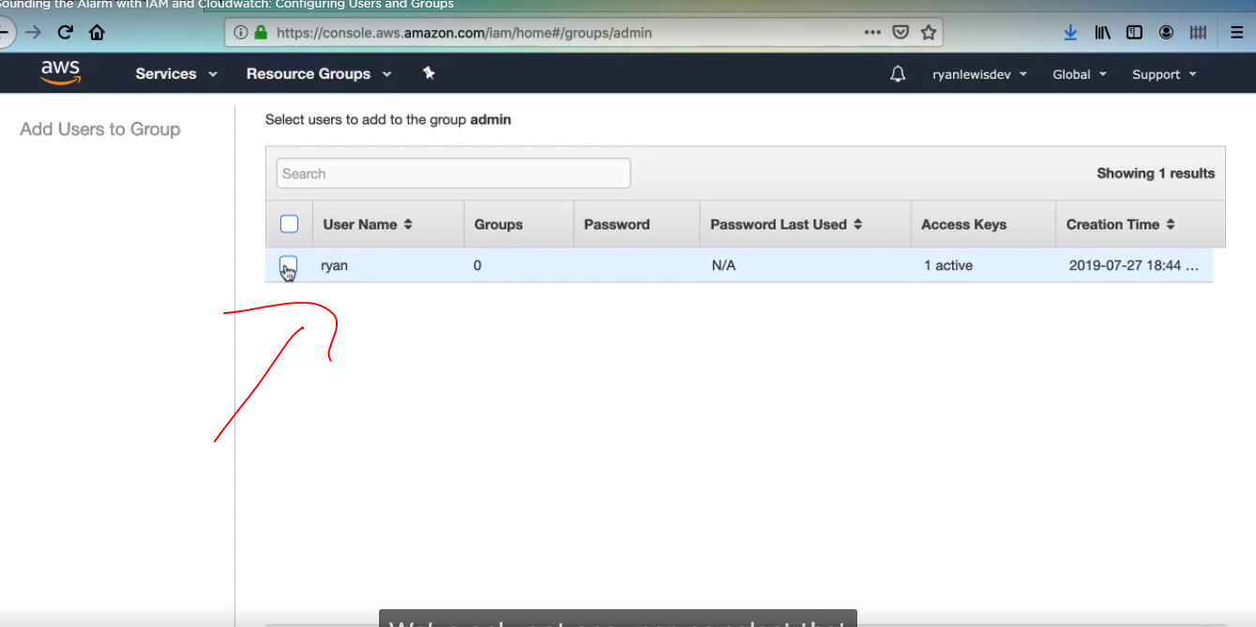

1. Then you will see the group with the users, in this case just we have one user. And your user you just added should be visible. I want us to confirm the permissions we have given the user.

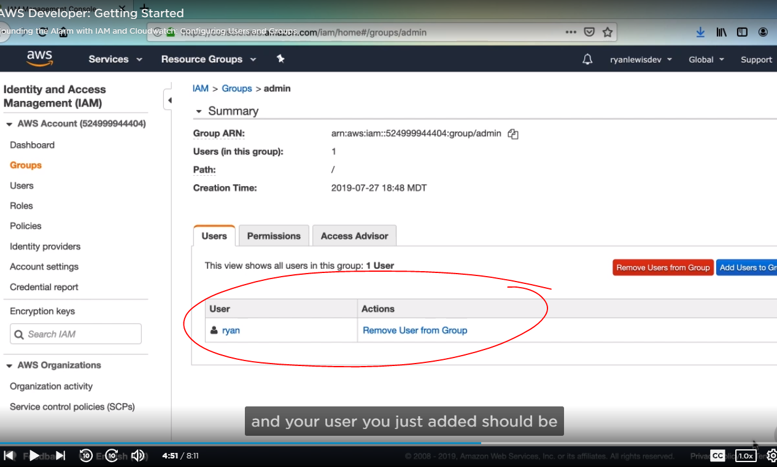

1. so click the user then click to on the permission tab.

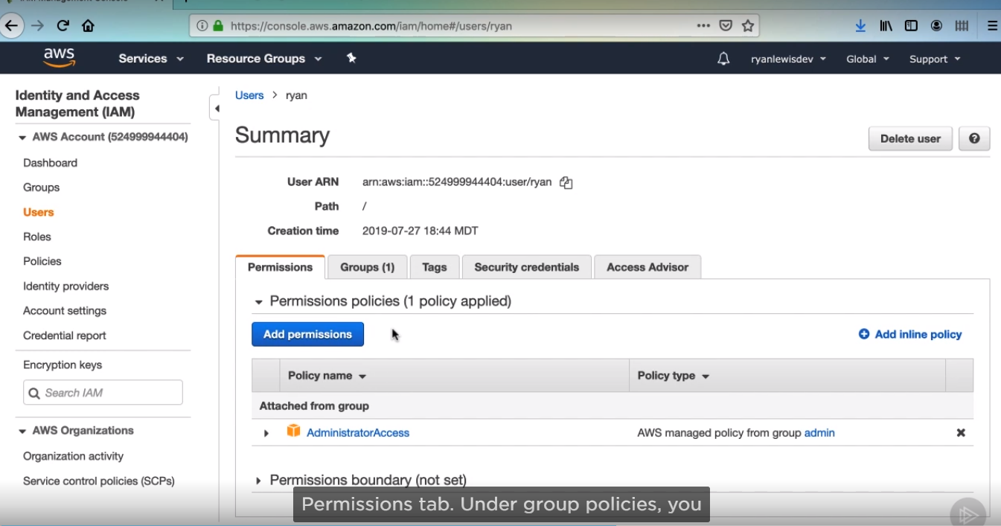

1. First we need to set up a password policy on our AWS account. Select the account settings.

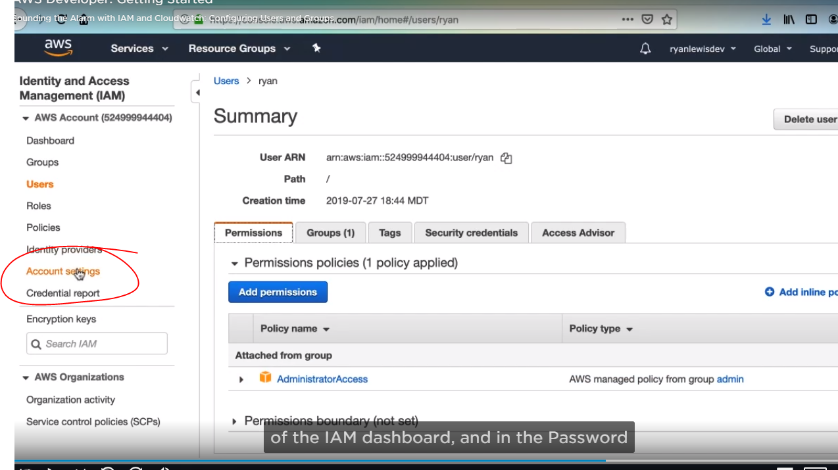

1. Policy section, you’ll see many different options for improvement requirements for users, select all that you want. Then click apply password.

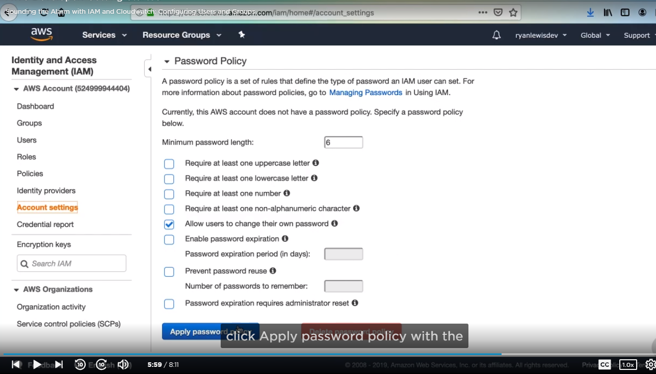

11 Assign a password to our User. First navigate and select that user you created.

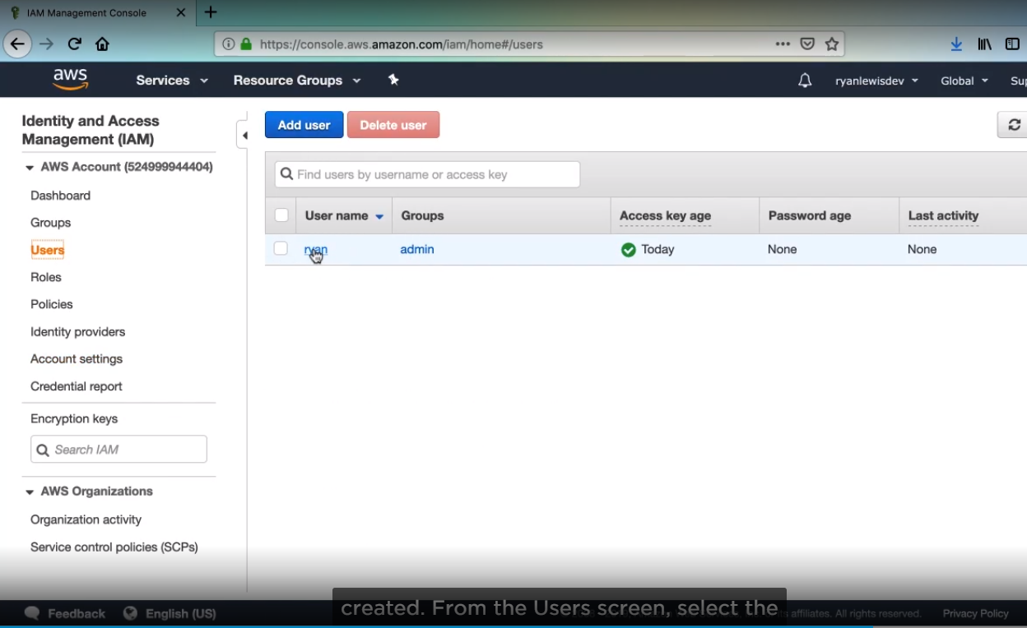

1. Then select Security credentials.

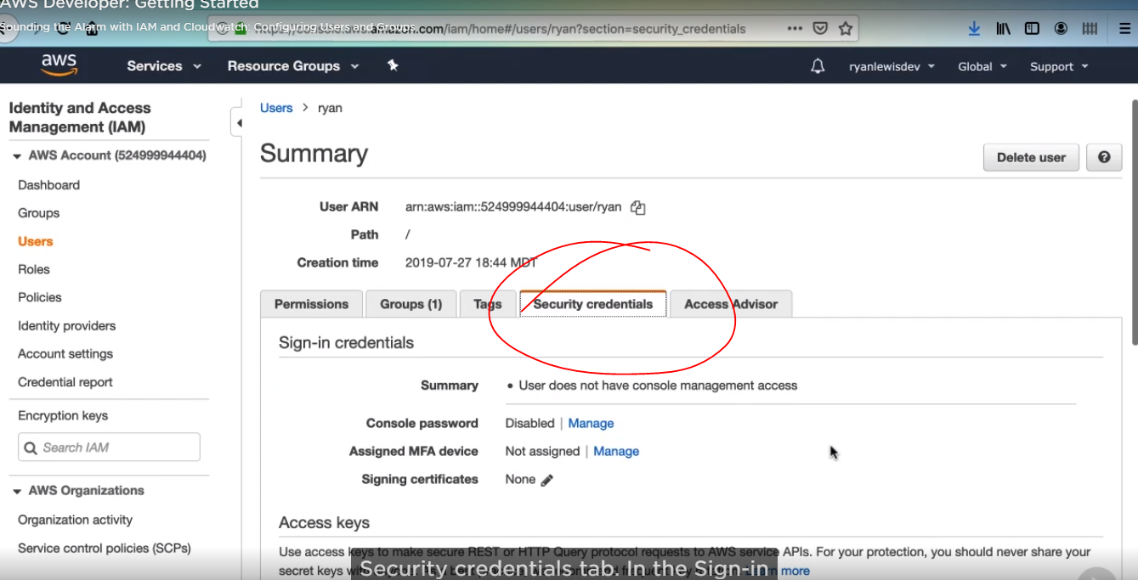

1. Then click console password manage to enable the manage console access, then select custom password.

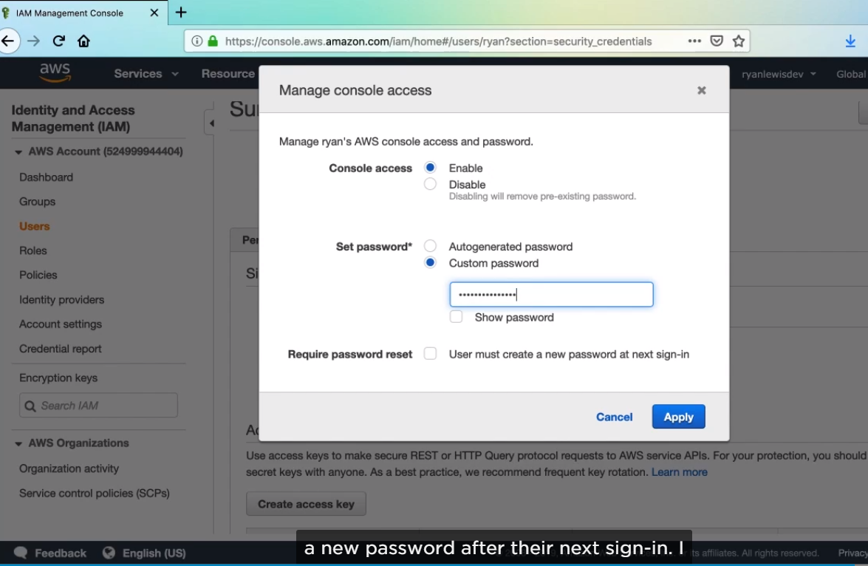

1. Then go to dashboard and copy IAM users sign-in link, first close you account and enter to new account as User created.

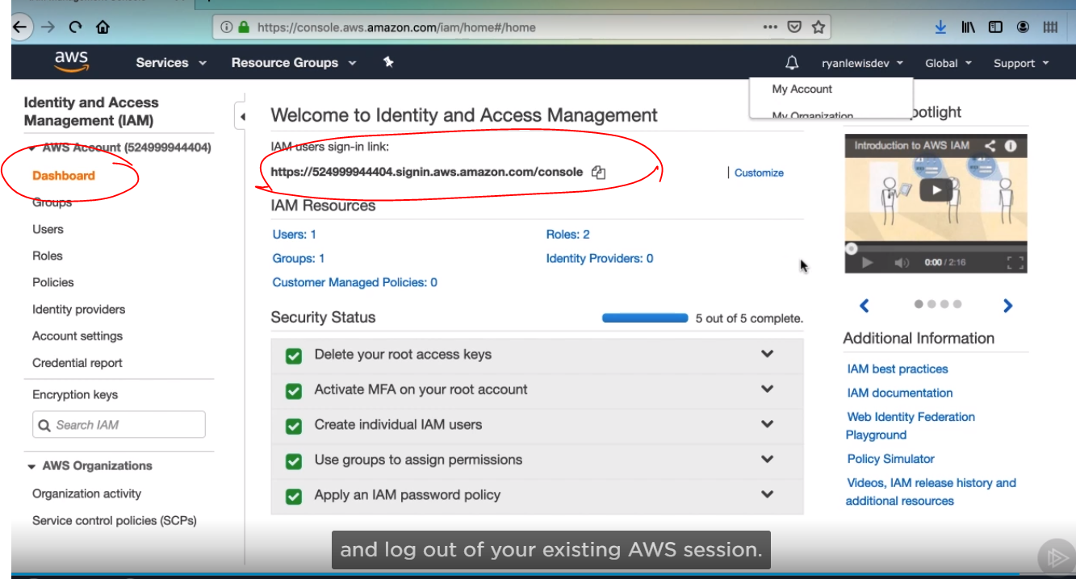

1. It will appear a new window that is totally different for root account, as you can see, it will appear your Id immediately.

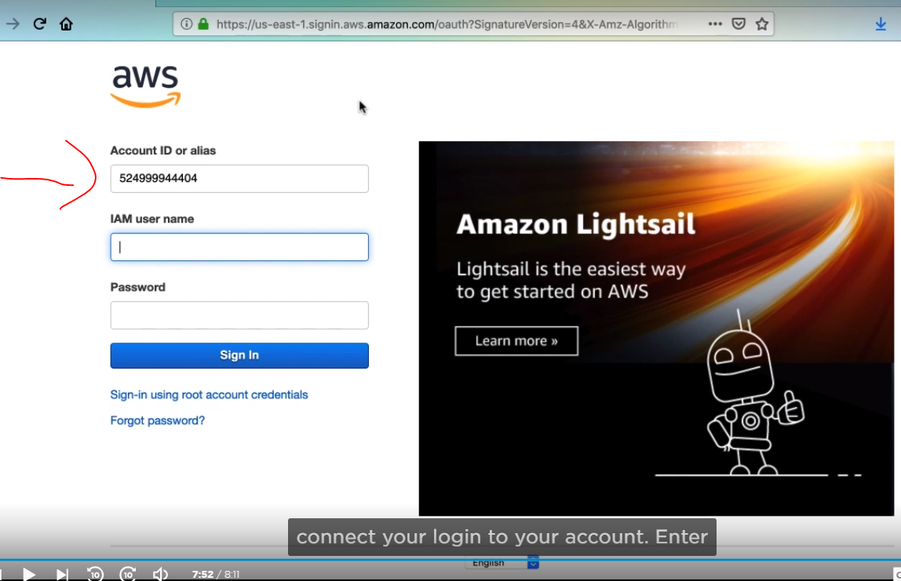

**VIRTUAL PRIVATE CLOUD**

It allows developers to create a virtual network where they can launch resources and have the logically isolated from other VPCs in the outside world.

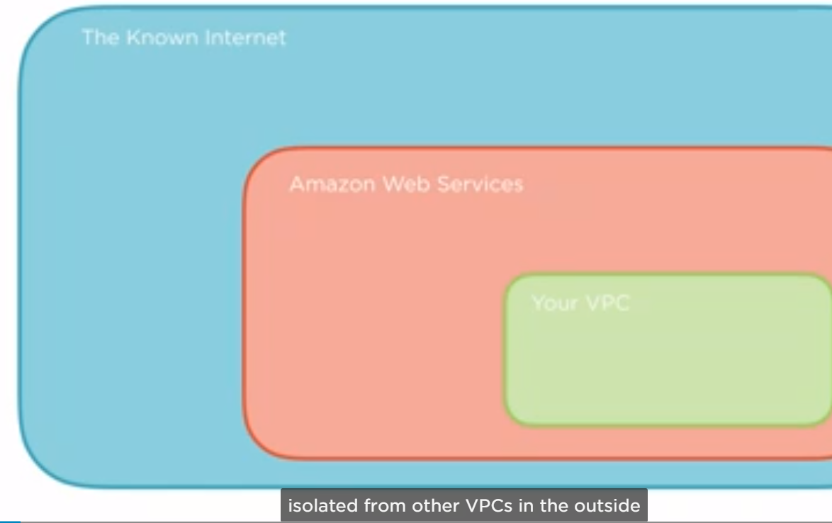

With VPC, your resources have a private IP addresses with which they can communicate with each other. You can control access to all of the resources inside a VPC and route outgoing traffic as you would like

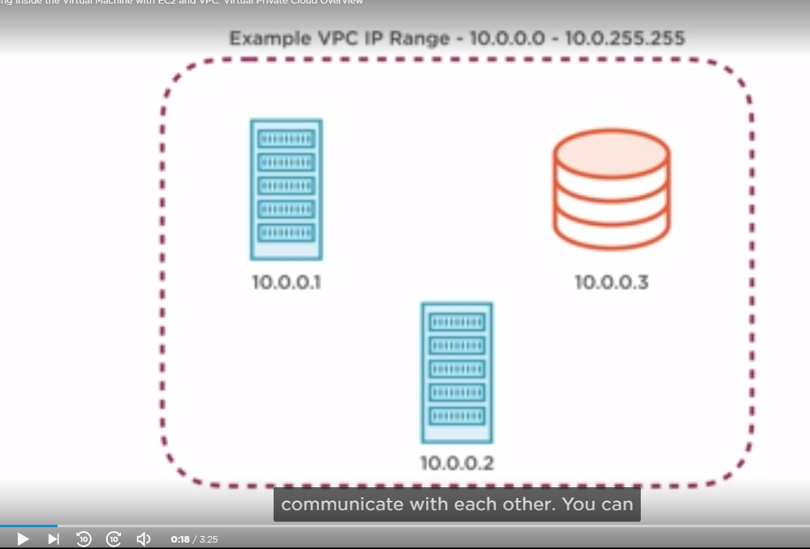

VPC is a free service, although you can only have a maximum of five VPCs on one account, the only charges are if you need a special VPN connection. There are several key structures used in VPCs to configure access. The most important and widely used tool that VPCs introduce are security groups.

Security group defines a collections of IPs that are allowed to connect to your instance and IPs That instance is allowed to connect to.

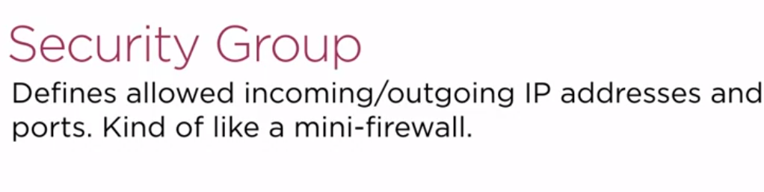

Security groups are attached at the instance level and can be shared among many instances. You can even set security group rules to allow access from other security groups instead of by IP.

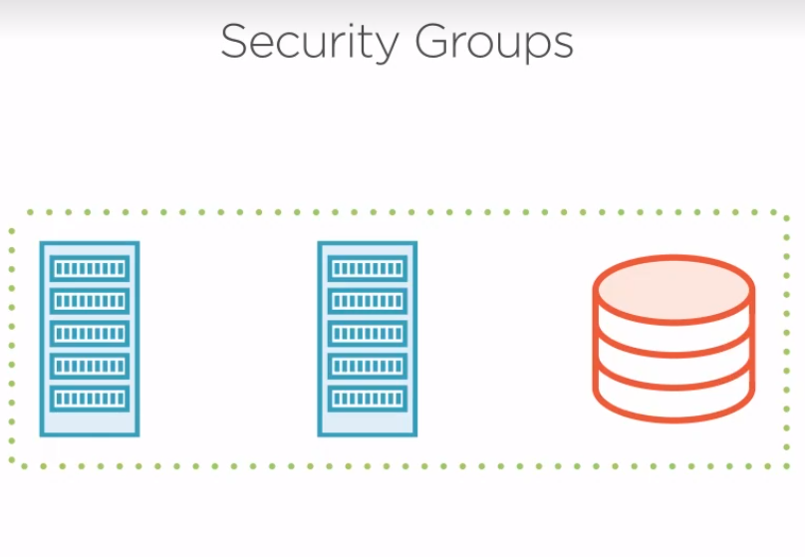

VPCs use routing tables to configure routing destinations for traffic coming out of the VPC. Each VPC has one routing table, which declares attempted destinations IPs and where they should be routed to. For instance, if you want to run all through a proxy, [ What’s a Proxy Server? A proxy server acts as a gateway between you and the internet. It’s an intermediary server separating end users from the websites they browse. Proxy servers provide varying levels of functionality, security, and privacy depending on your use case, needs, or company policy.], you can set a routing table rule to automatically send traffic to that IP.

Another tool for networking control is the network access control list. Each VPC has one access control list, and this acts as an IP filtering table saying which IPs are allowed through the VPC for both incoming and outgoing traffic.

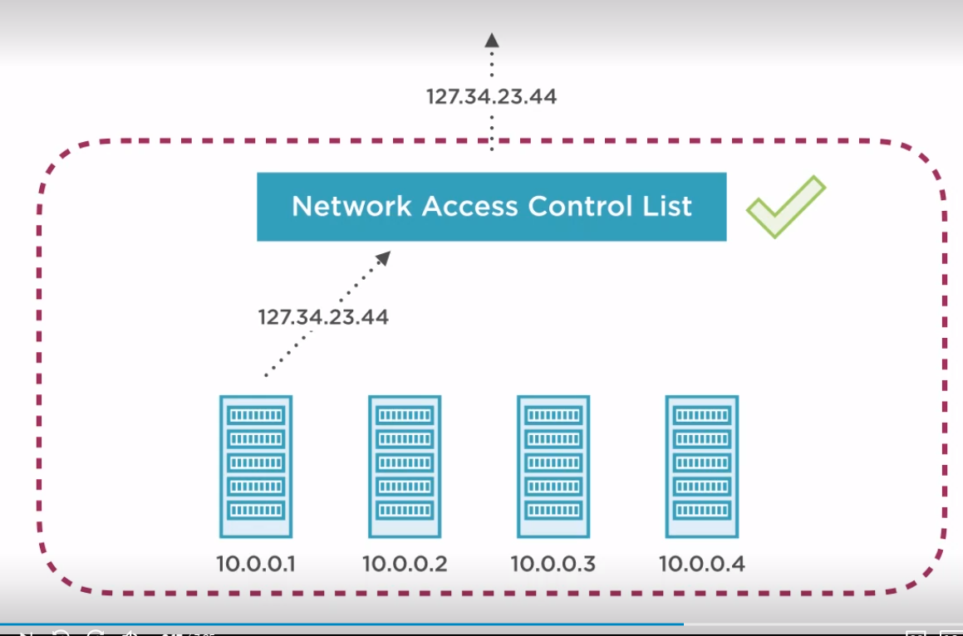

A VPC defines a private, logically isolated area for instances, but a subnet is where things really get interesting. Instances cannot be launched into just a VPC. They must also be launched into a subnet that is inside a VPC. A subnet is an additional isolated area that has its own CIDR block, routing table and access control list. Subnets enable to create different behavior in the same VPC.

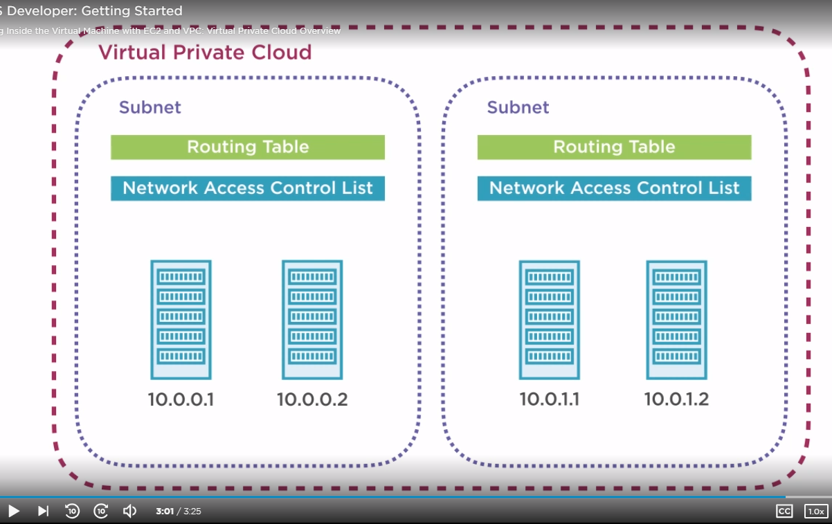

For instance, creating a public subnet that can be accessed and have access to the public internet and a private subnet that is not accessible from the internet and must go through a NAT(Network address translation) gateway to access the outside world. With subnets, you can achieve very secure infrastructure for your instance.

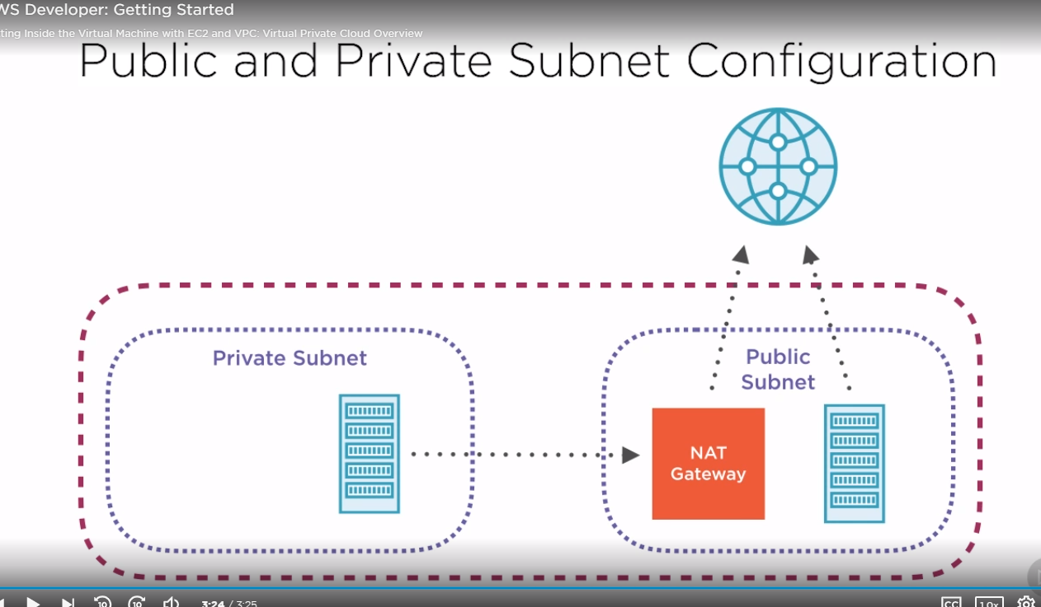

NAT Gateways

You can use a network address translation (NAT) gateway to enable instances in a private subnet to connect to the internet or other AWS services, but prevent the internet from initiating a connection with those instances.

**CREATE VPC AND SUBNETS**

The diagram shows a rough architecture.

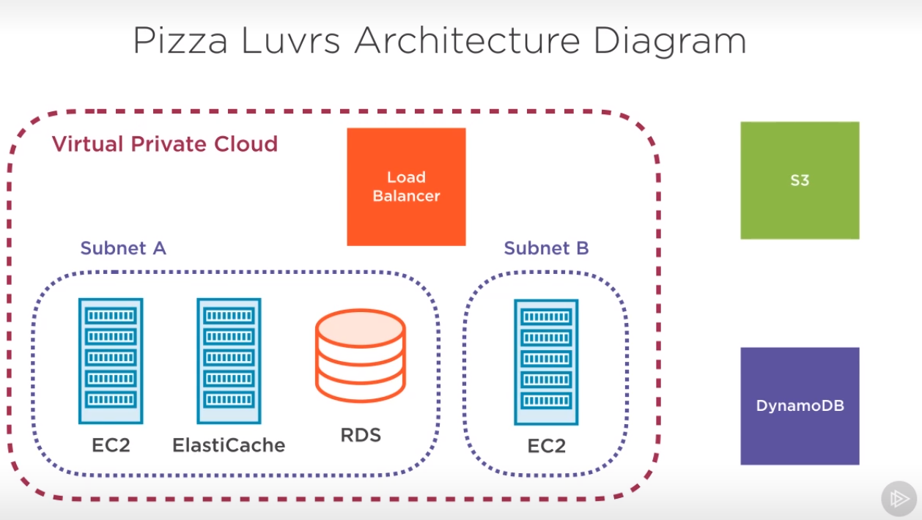

1. Go to the web console, Use the service search bar and type VPC then enter.

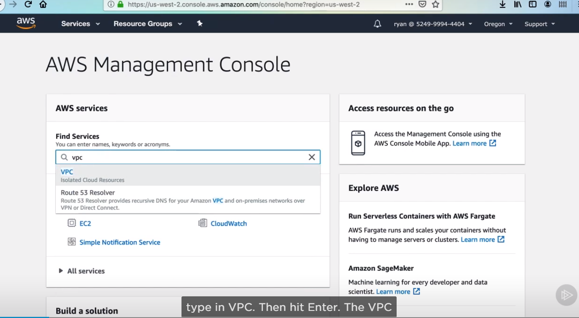

1. The first thing we’ll take a look at is the resources by region section. You may notice something a little odd here. It looks like you have already got a VPCs, some subnets and other resources. This is a default VPC.

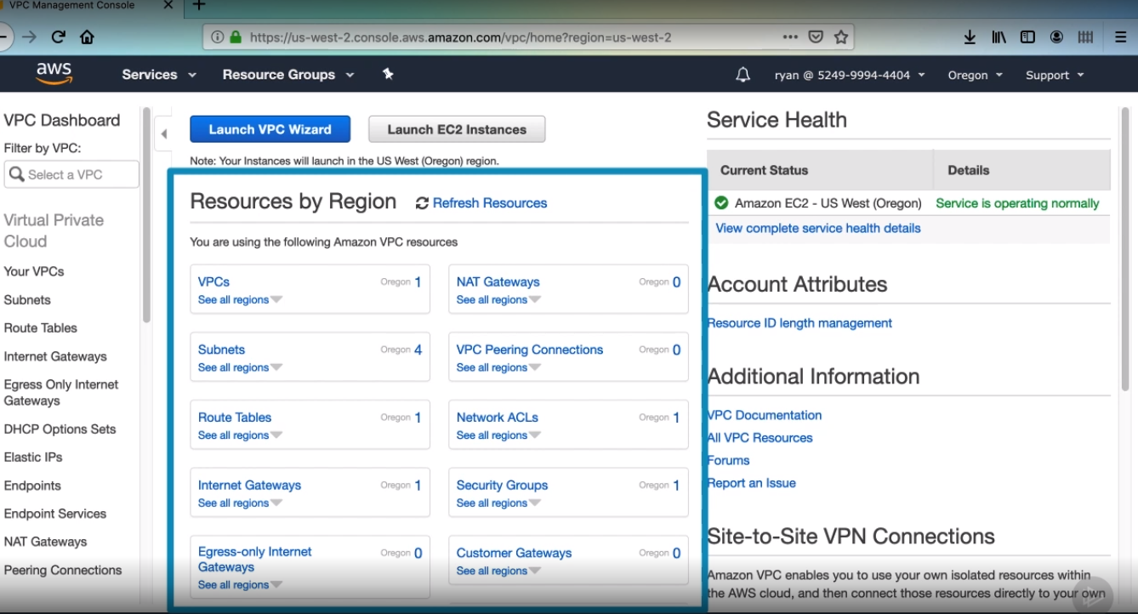

1. Ensure, you are in the correct region you want to be working in. then click to the launch VPC Wizard.

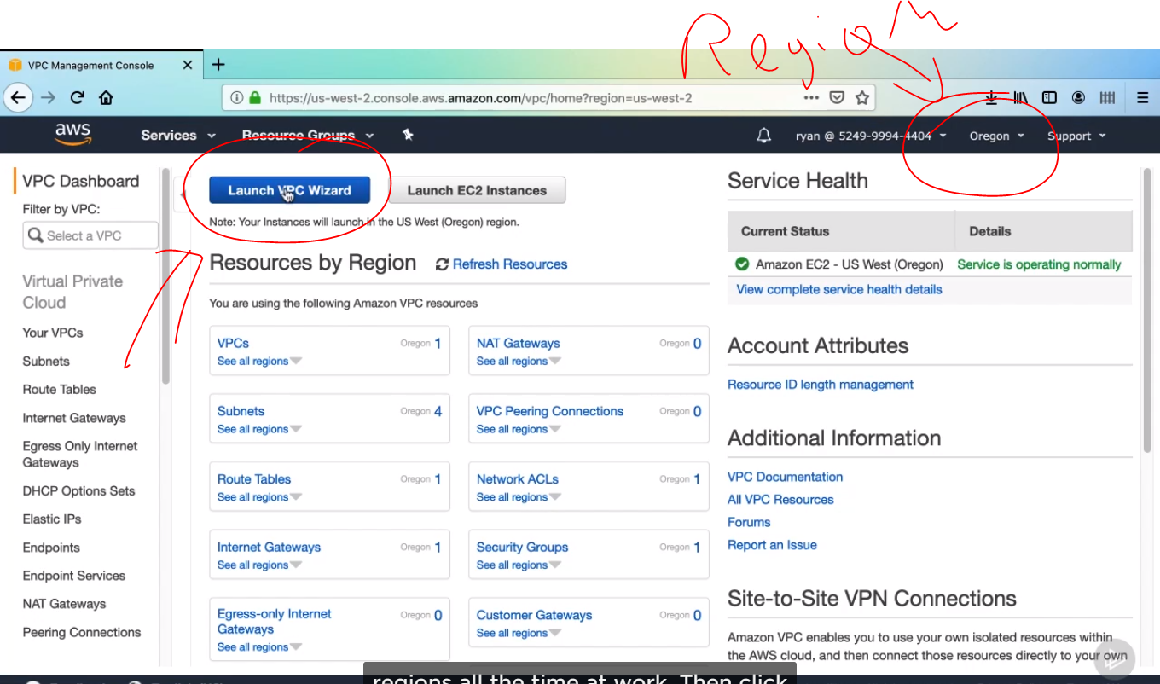

1. The first option is to decide what kind of VPC configuration we want Amazon to start us with. Here is the private public subnet setup. And you can also see options to create a VPC with a VPN connection. We’ll pick the configuration that is preselected and the easiest as select.

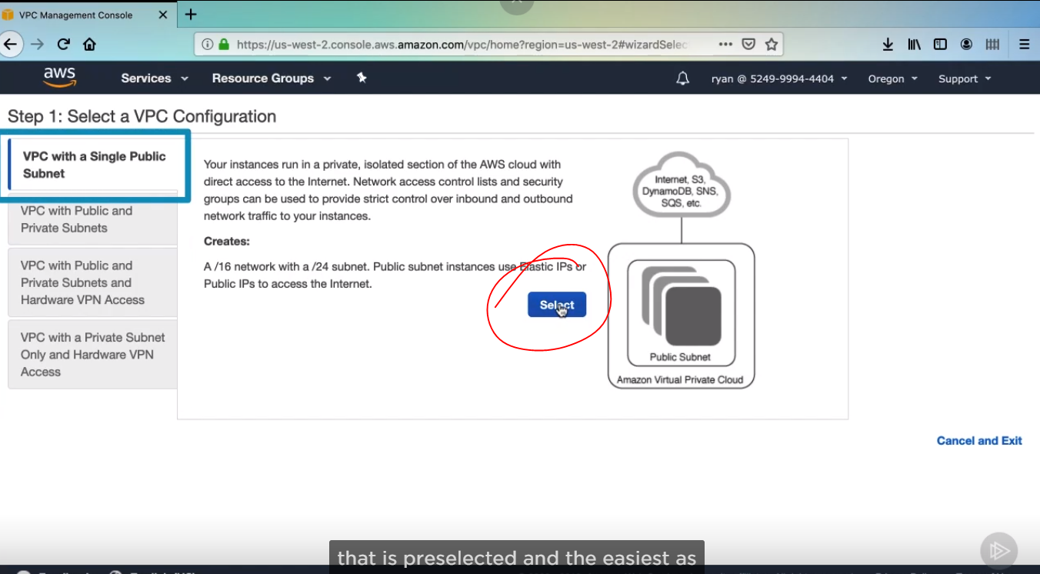

1. Then we have more details the first is the IP CIDR block (Range of Available IP Address) the resources created in this VPC. This is the range of IPs that will be assigned to created resources. For our purposes 10.0.0.0 is fine.

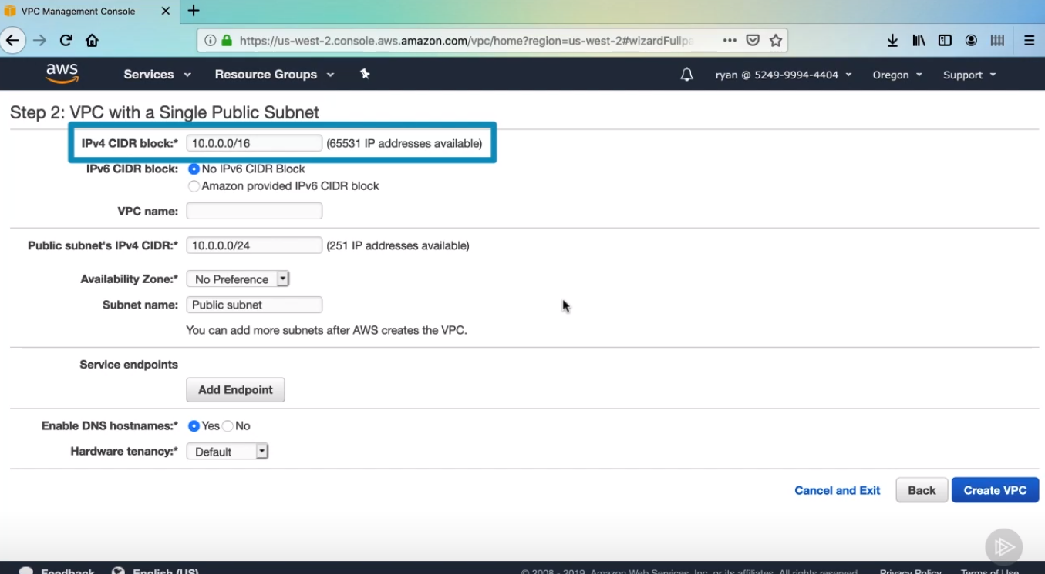

1. Then give a name for our VPC.

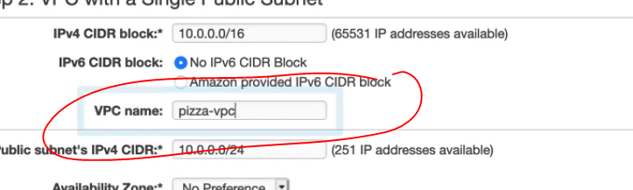

1. Now we’ll configure our public subnet. The CIDR block for the subnet is a subset of the VPC block, which will be 10.0.0.0 /24. This basically means the resources launched in this subnet will have a range 10.0.0.0 to 10.0.0.255 for their IP addresses.

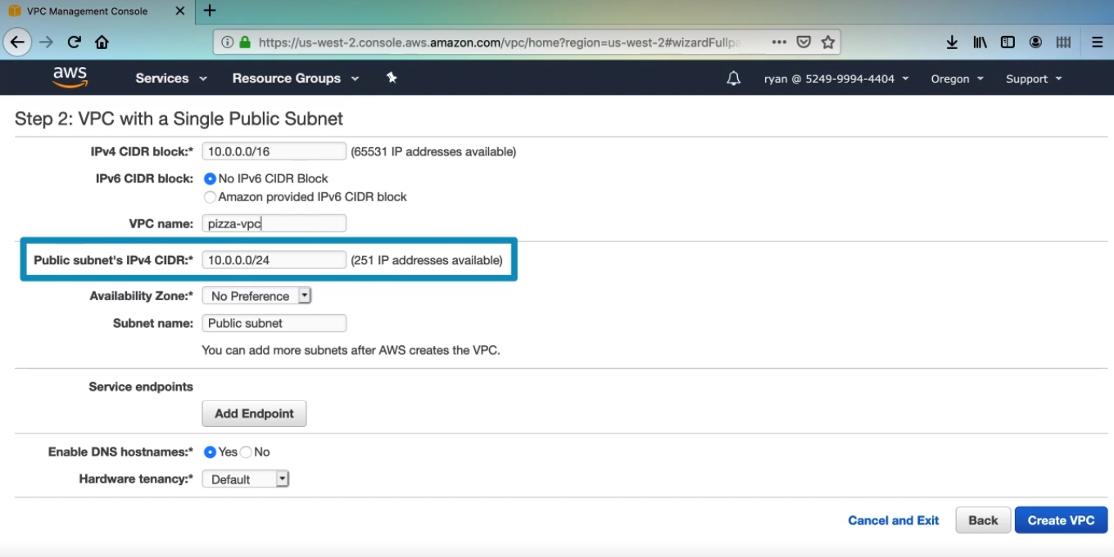

1. For Availity Zone, you may see something different than I do, In the Oregon region, we see four different availability Zones, which are basically data centers that have super – fast connections to each other, but are actually physically separated. This is basically to add redundancy in case of a disaster, just select the first zone that you see. Then you can set a name for this subnet. Then click create VPC.

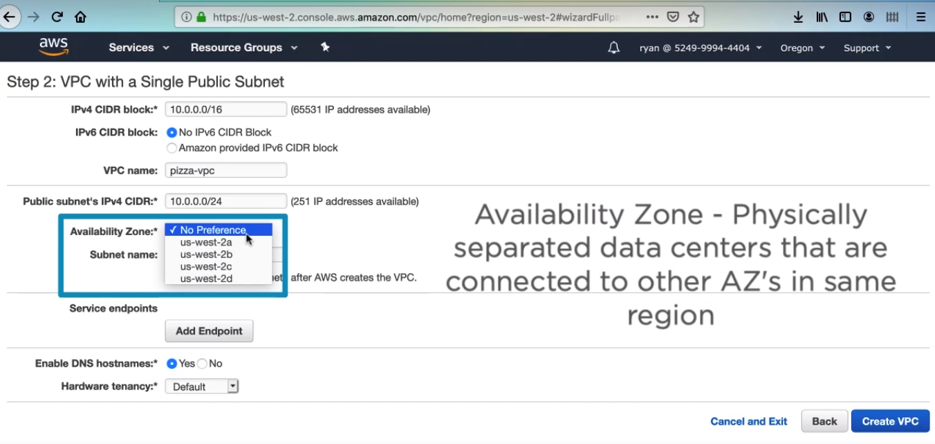

1. Then you have this confirmation that you are ready to launch instances into this VPC. The routing table was created with currently doesn’t have any way for instances to connect to the internet

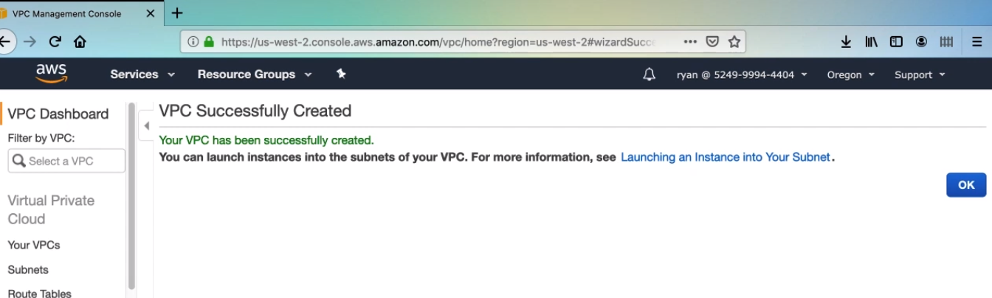

1. So we do need to add an entry to the routing table to allow all traffic to go through an internet gateway into the public internet. An internet gateway is basically just a connection to internet. There is not really any configuration beyond that so click your VPCs menu option on the left. And then select pizza-vpc.

. 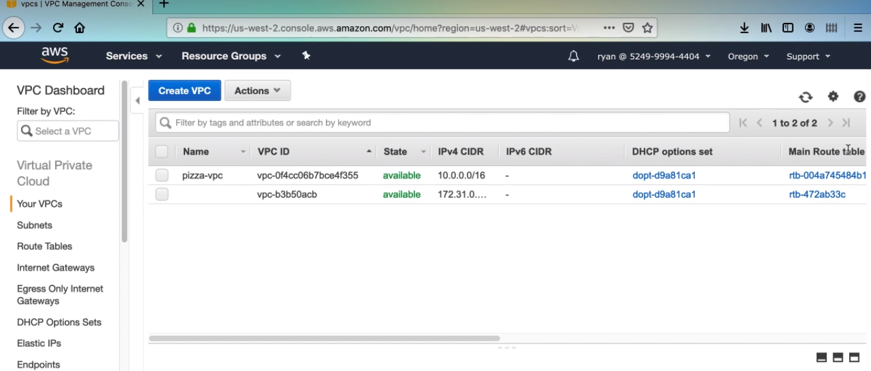

1. In details section, click on the link next route table.

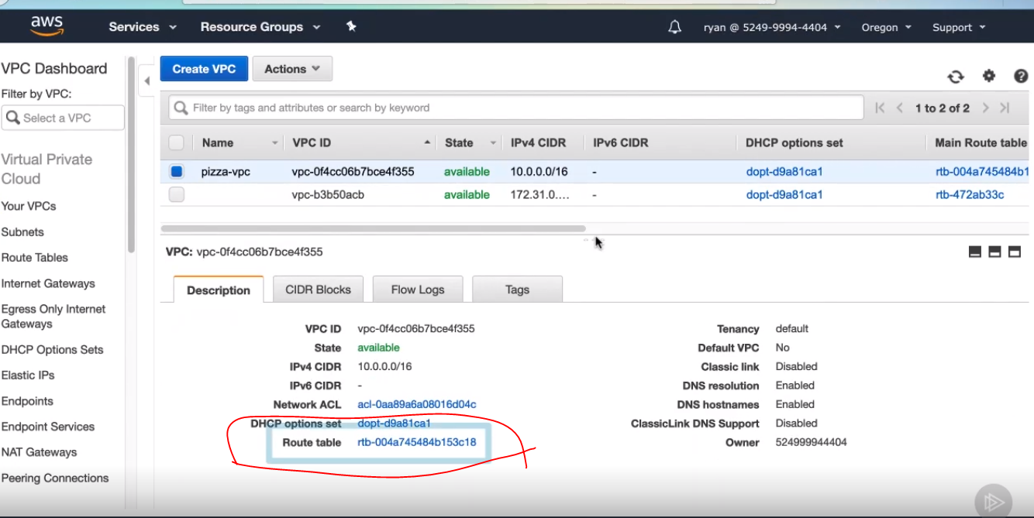

1. Then click routes. There is a single entry that says any IP address referencing our local VPC CIDR block should resolve locally.

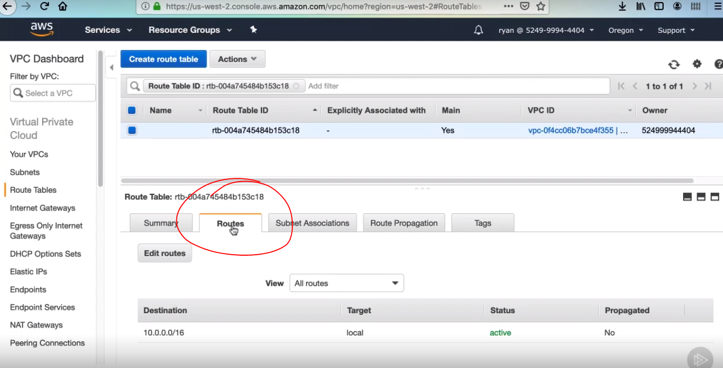

1. Create a new entry. So click Edit routes and then Add route. In the destination field, we’ll put 0.0.0.0/0, which basically means anywhere. Then in the Target column, expand it and select the internet Gateway option. 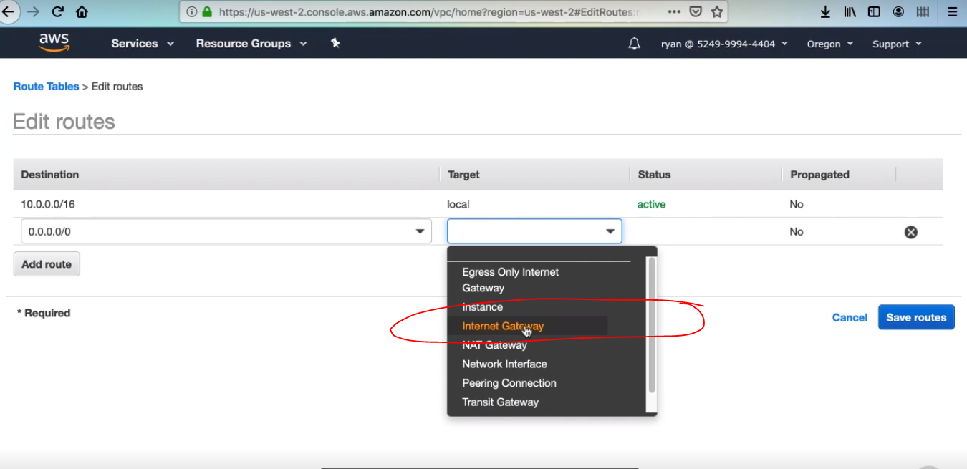
2. You should have one result available to select here with an ID starting with igw.

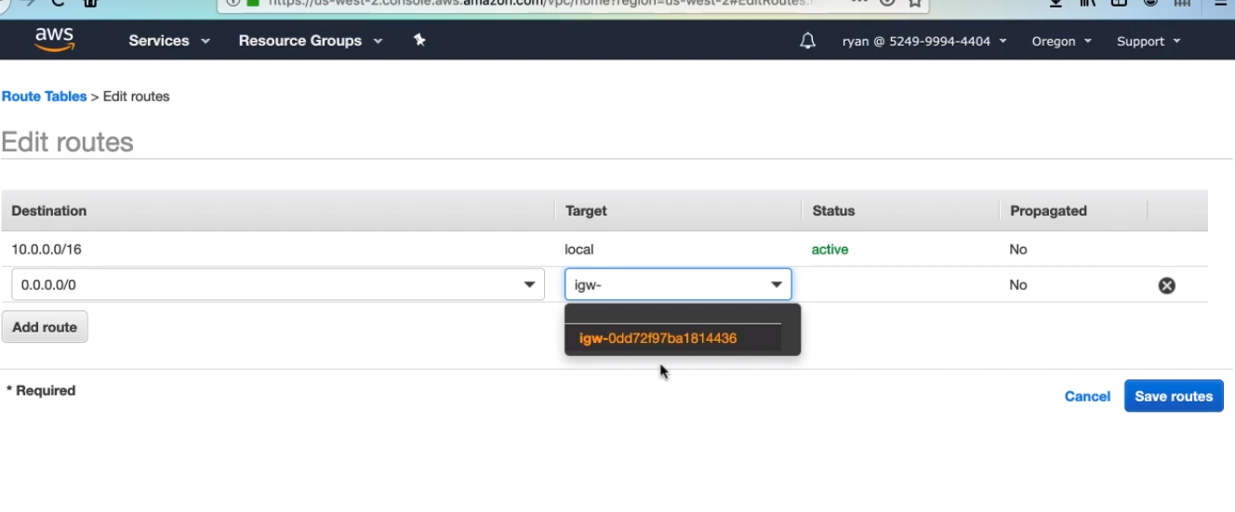

1. Then select that, this is the precreated internet gateway for your VPC. Click on it, and then click Save.

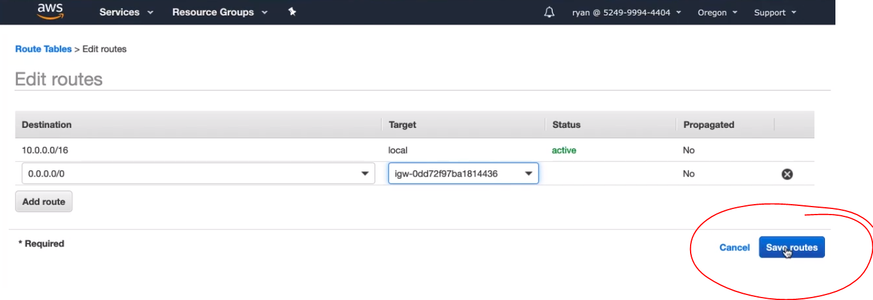

1. Now we’ve configured our VPC to let outgoing traffic reach outside world.

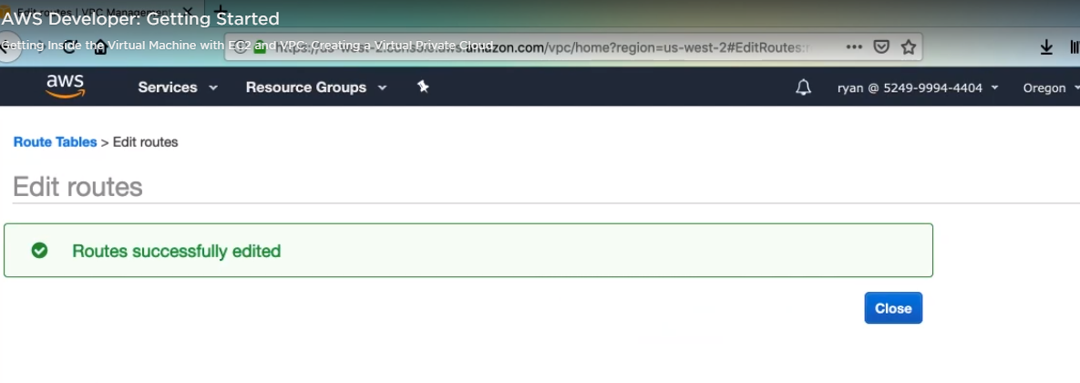

**CREATE PUBLIC SUBNET FOR SCALING**

We will be launching our application using Auto Scaling groups, so I want us to get some experience deploying into multiple Availability Zones. Because a subnet can only exist in a single Availability Zone. We will need to create more subnets to deploy into different Availability Zones. Let’s add one more public subnet to cover another availability Zone in our region.

* Click on subnets then click create subnet

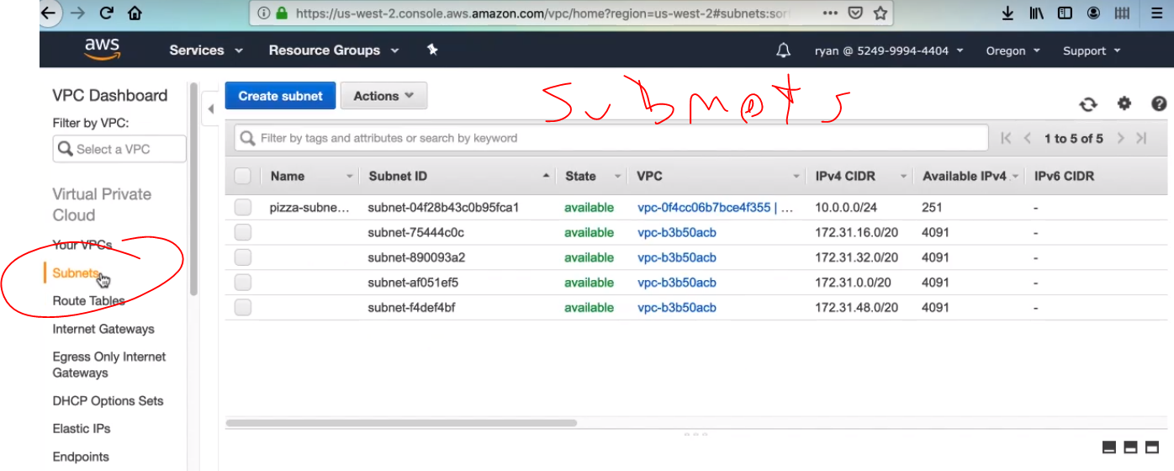

* Then enter a name almost equal with the first name, but we have to add with b, for instance pizza-subnet-b, into the name tag field. Ensure that our pizza VPC is selected in the VPC dropdown.

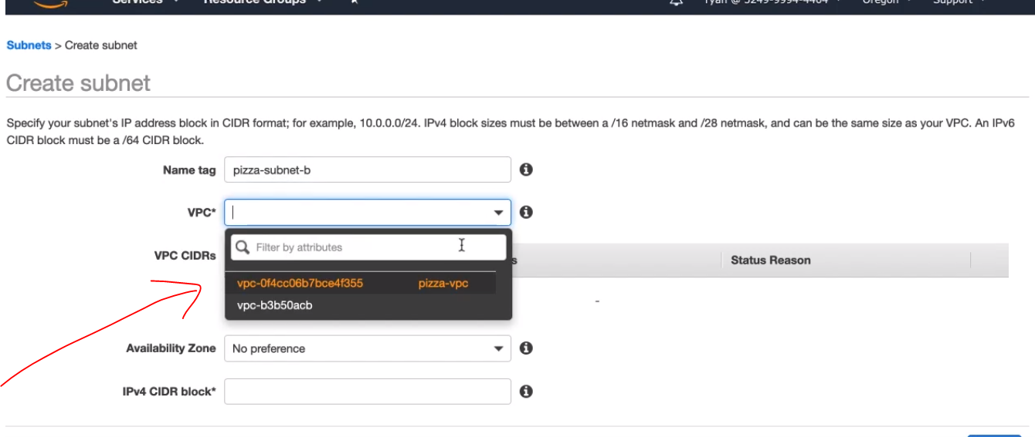

* Select a different Availability Zone than the other subnet.

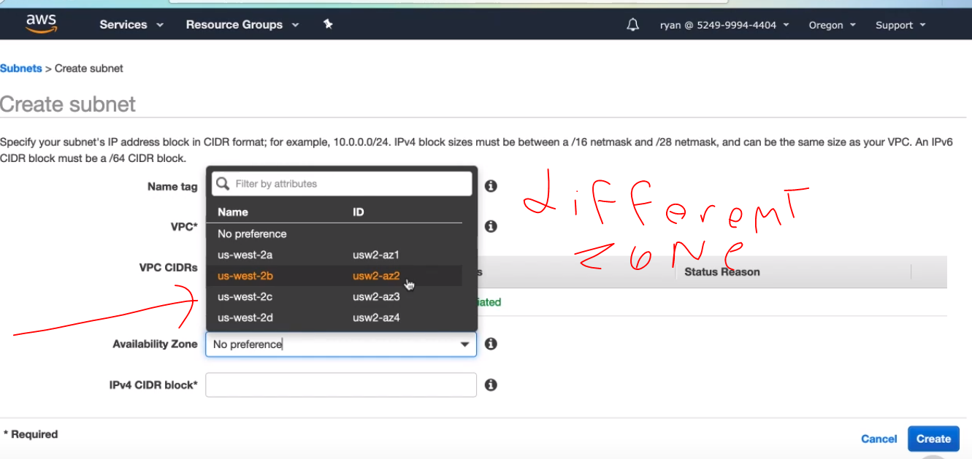

* Now the CIDR block is kind of important since we do not want IPs conflicting between subnets. Here enter 10.0.1.0/24 this will give us another 255 IP addresses that are different from those in the other subnet. Then click create.

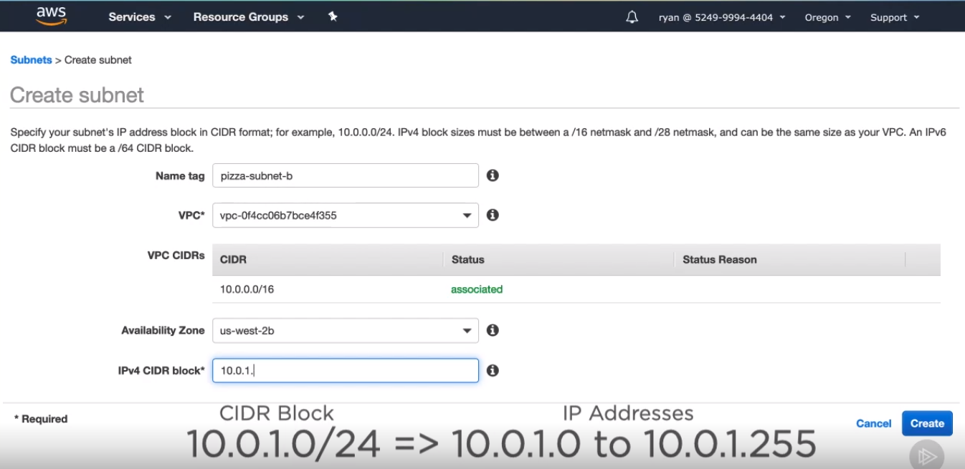

* **Then you see it.**

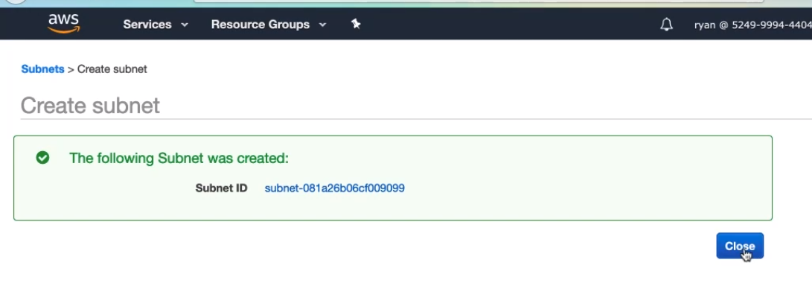

**ELASTIC CLOUD COMPUTE OVERVIEW**

**EC2 instance** is just a virtual machine provisioned with a certain amount of CPU cores, gigabytes of memory, storage space, and network performance. Because of this you can install any type of operating system or software on it that. You want.

The operating system and software that is installed on an EC2 instance is also called an Amazon Machine image (AMI).

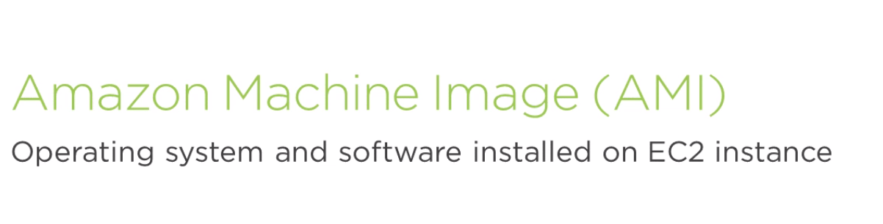

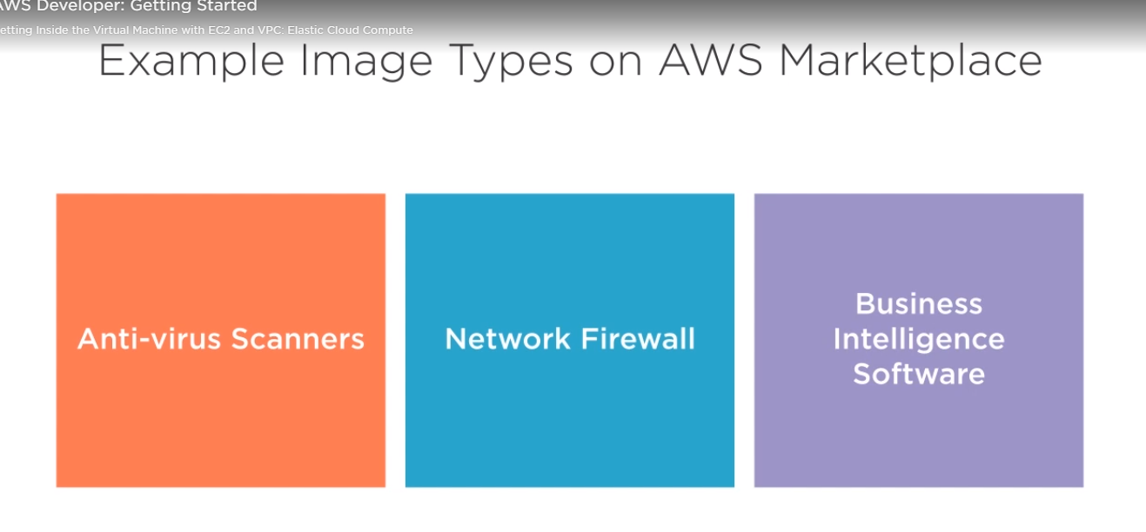

Each instance has a certain group of technical specifications, and Amazon charges you based on what type of instance you are running.

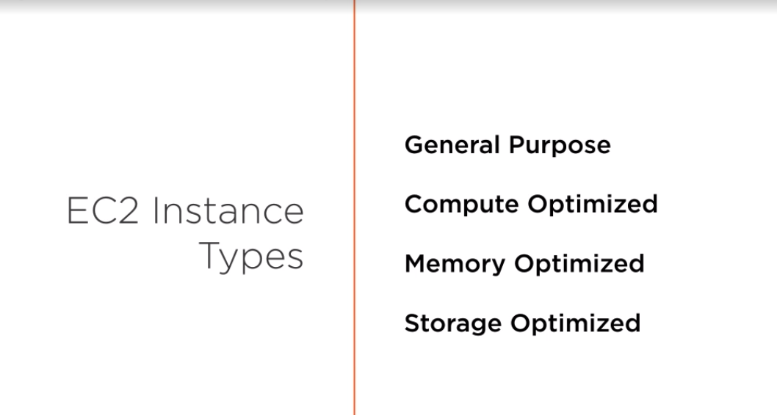

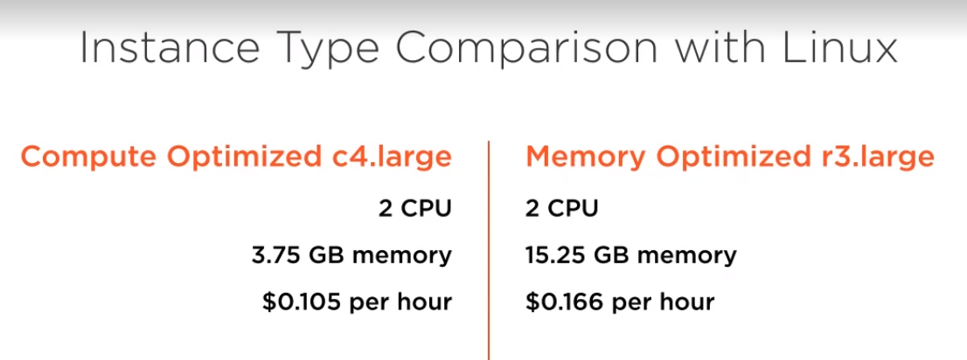

Ec2 instances also require some storage for things like the operating system and any application code you expect to upload. Storage for EC2 instances uses another AWS service called Elastic Block Storage or EBS. EBS allows the storage of your EC2 instance to live independently of the instance itself. This means that if configured correctly, your EBS storage volume can be transferred between different sized EC2 instance or continue to exist even after an instance has been terminated

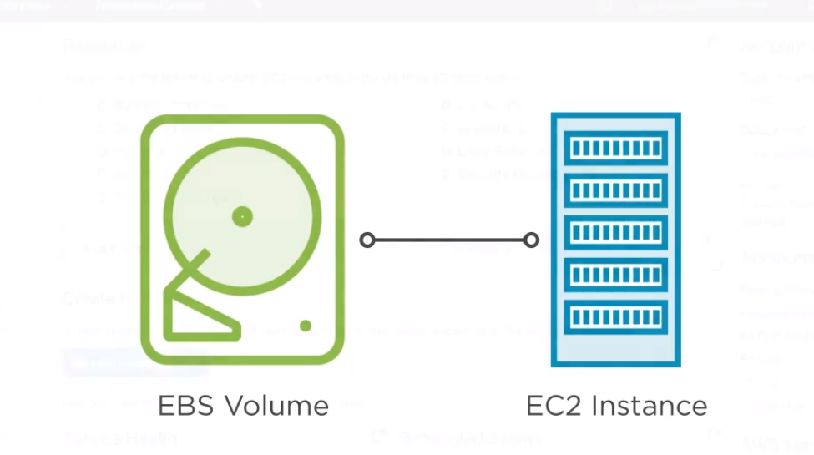

**EC2 DASHBOARD**

* This section gives you a snapshot of your resources that you have created.

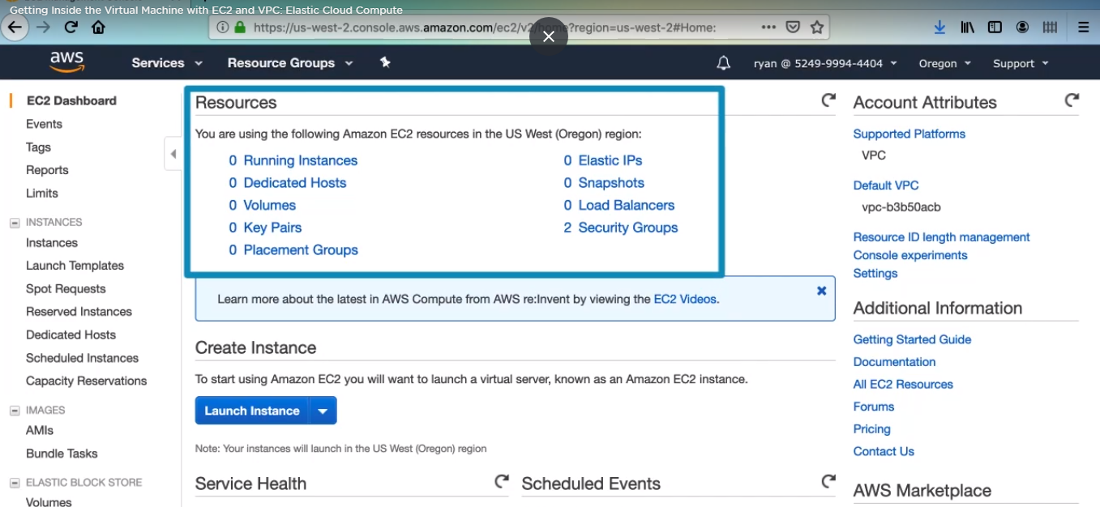

* That mark is your EC2 instances that you have

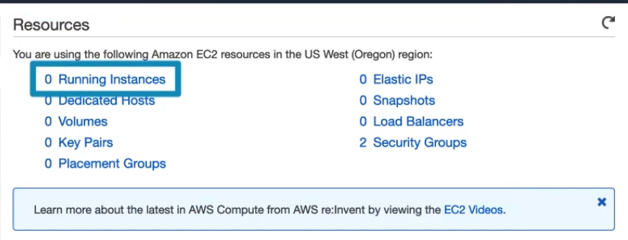

* that mark is your volumes which are Elastic Block Storage volumes.

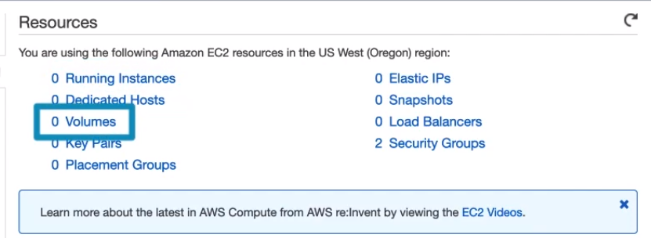

* the blue Launch Instance button is the quickest route to launching a new EC2 instance.

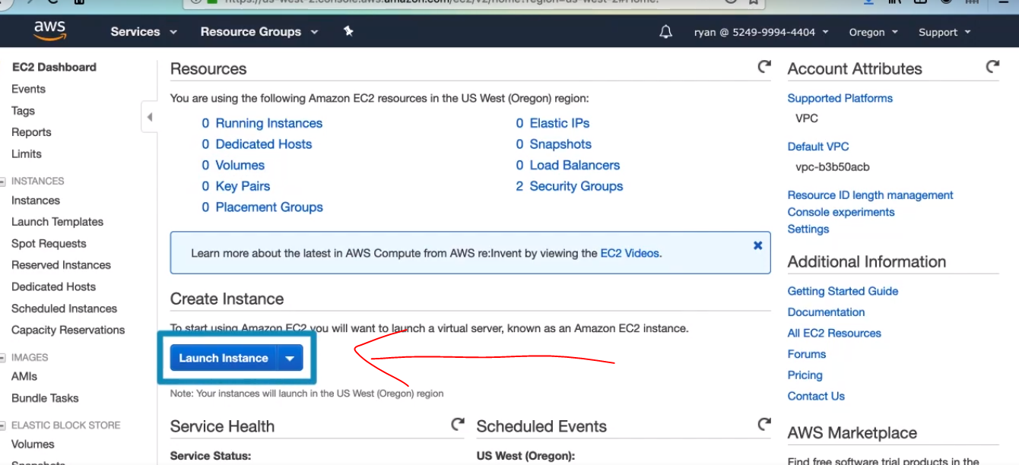

* On the left side is the menu of Ec2 features, and there are even more That you can see here, so you’ll need to scroll down.

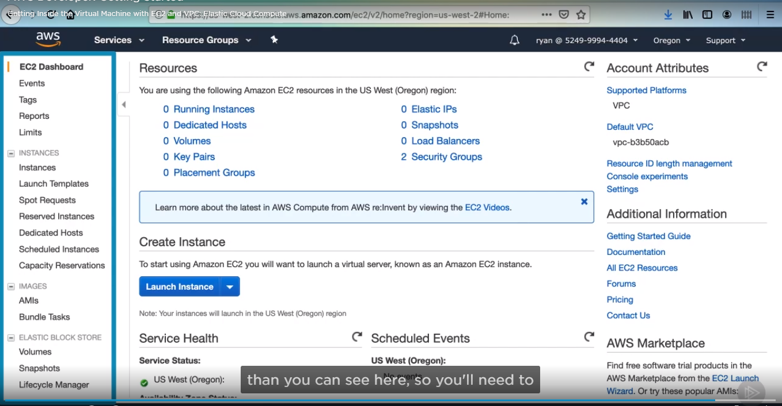

* But you can at least see the instance section.

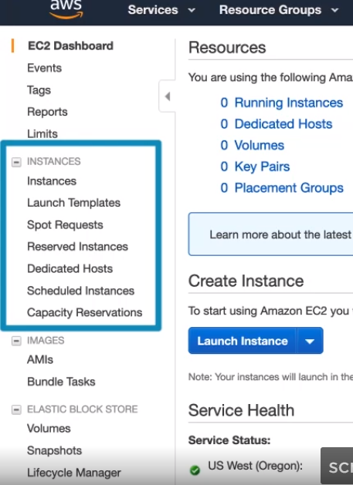

* AMIs for your custom Amazon machine images

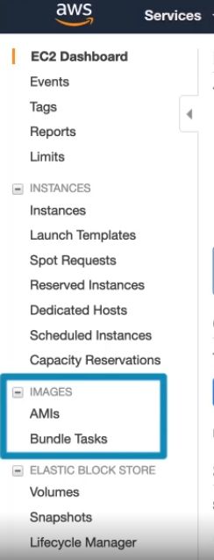

* And security group option

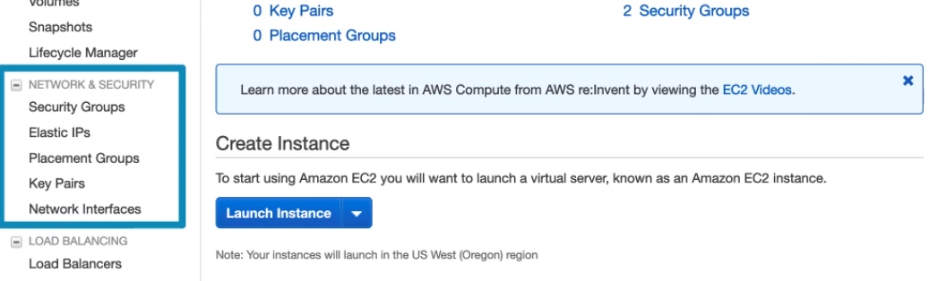

Set up as favorite, this will give it a permanent place in the top menu bar.

Click on the thumbtack Icon.

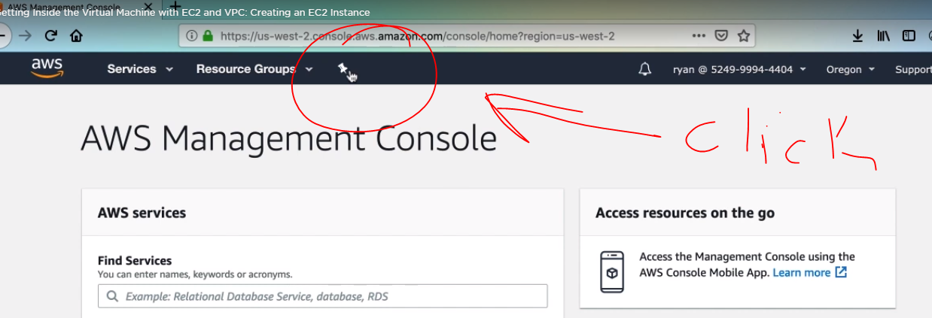

* You will be presented with a list of services.

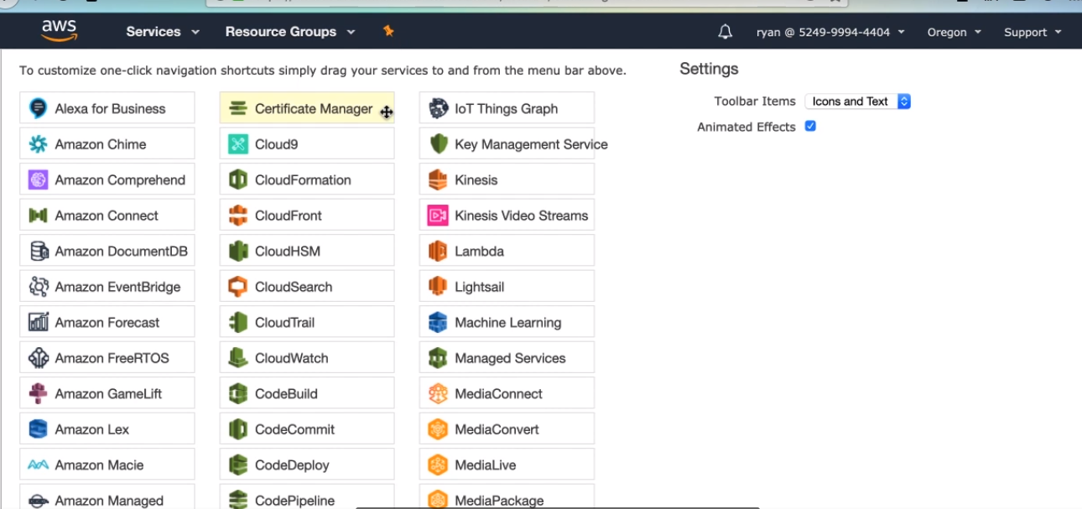

* Find one , and then click and drag it up to the top.

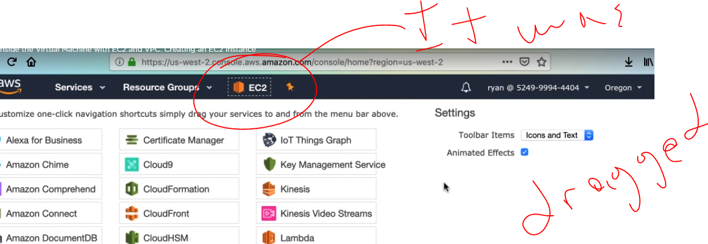

**Create an EC2 instance**

1. Click Launch wizard instance

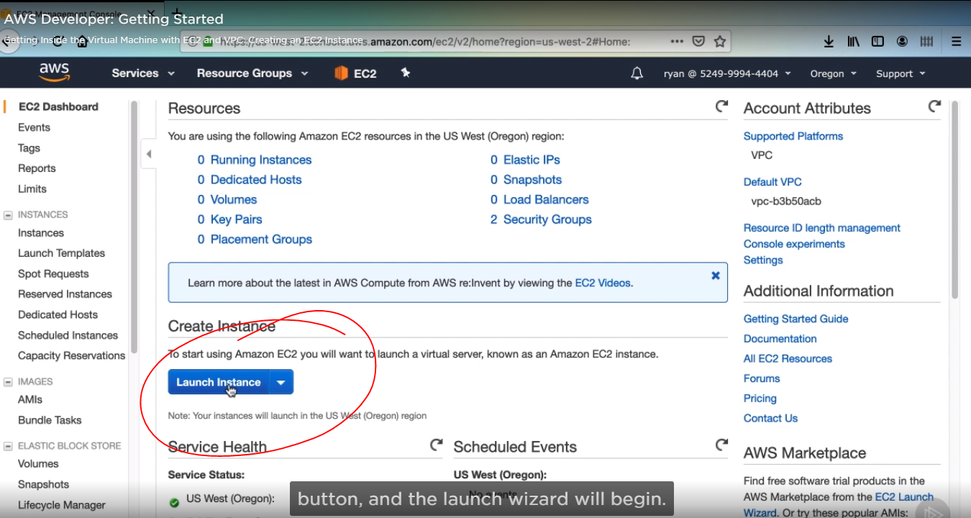

1. We need to choose an image for this instance. On the left, you can see different sections for images.

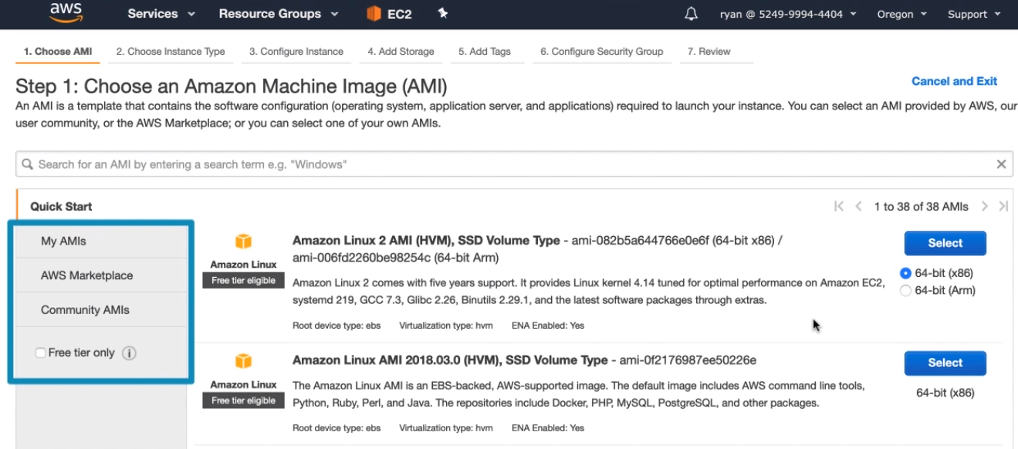

1. . For instance, the AWS marketplace. We will select this Amazon Linux 2 image from the quick Start section. Then click select:

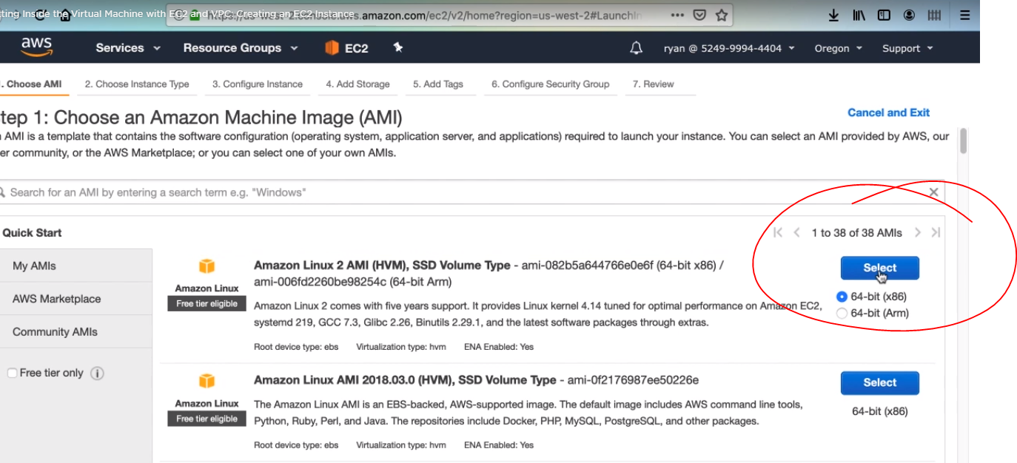

1. Now we need to choose the instance type for our image. Since we are sticking to the free tier in this course, we have to pick the free tier, so we have the only one option, and that is the t2.micro instance with 1 CPU, 1 GB of Ram and low to moderate network performance. Then click next.

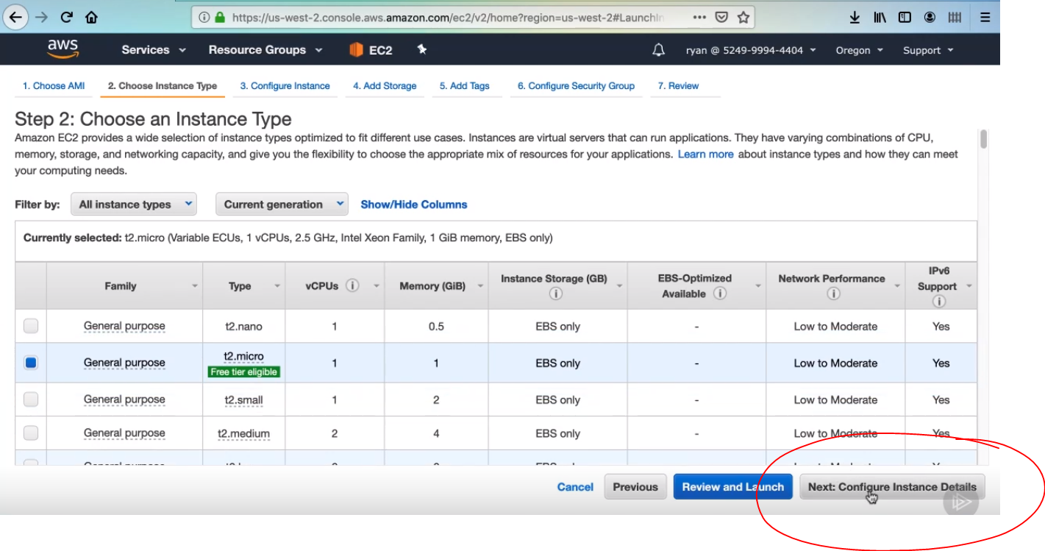

1. We will just go with one instance for the time being, as we’ll be setting up our Auto Scaling groups later.

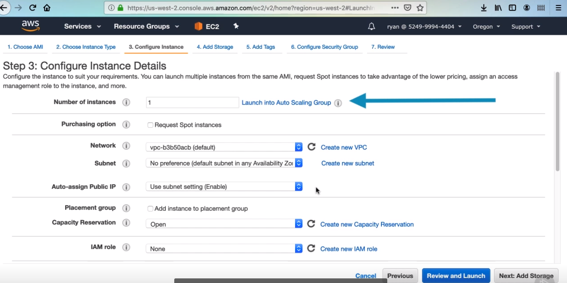

1. For Network, select pizza-vpc.

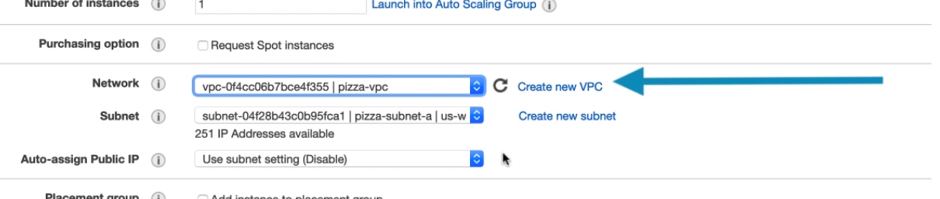

1. Pick either one of your subnets, whichever doesn’t matter.

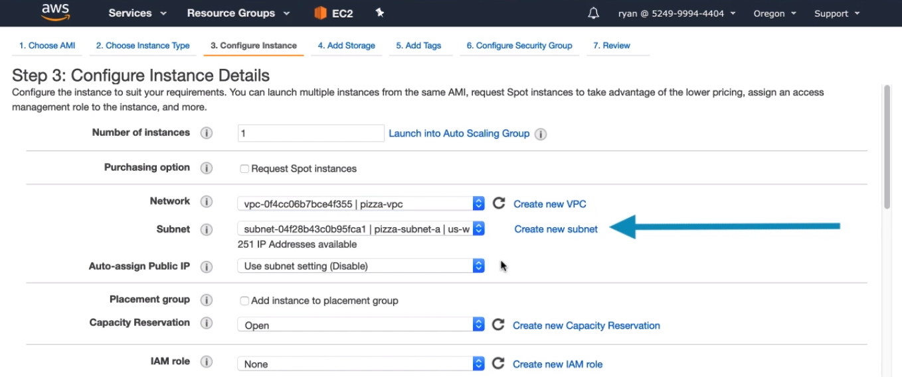

1. We don’t need a public IP, we’ll assign one later, so just use disable for auto – assign Public IP. We will avoid setting an IAM role for this instance for now. Then click next.

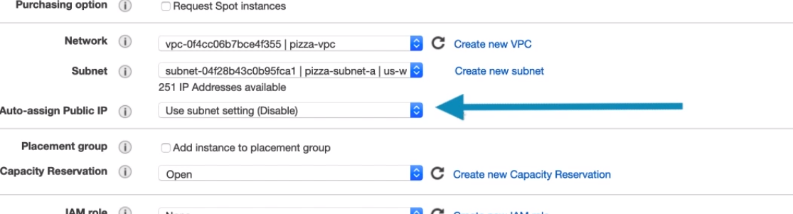

1. The wizard automatically configures the instance with an 8 Gb Elastic Block storage volume. Then next click.

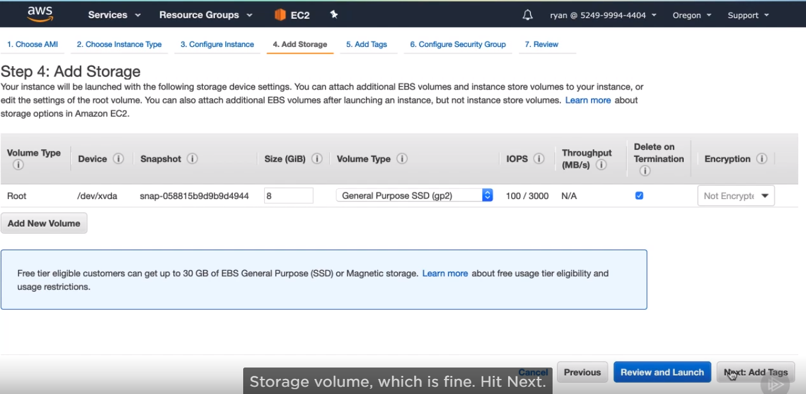

1. Then we can add a name tag to this instance to better differentiate it in the instance. Then, click next

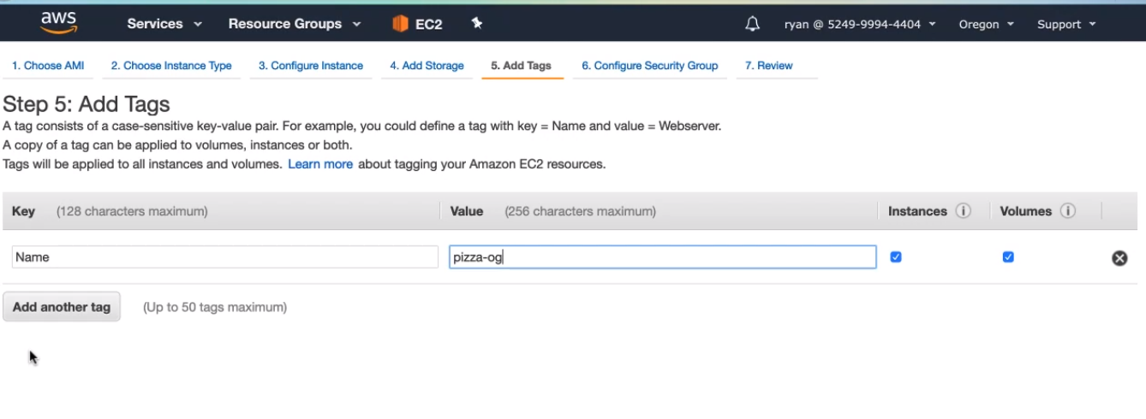

1. Here we will define the main security group for our instance, then we are creating the name of security group, we will name pizza-ec2-sg, and we will give a description as well, security group for pizza luvr EC2 instances . there is one rule exposing the instance to SSH sessions for anywhere, you can leave this for now. Once an application goes into production, you would want to either completely close off SSH access or restrict it to a single IP such as your own.

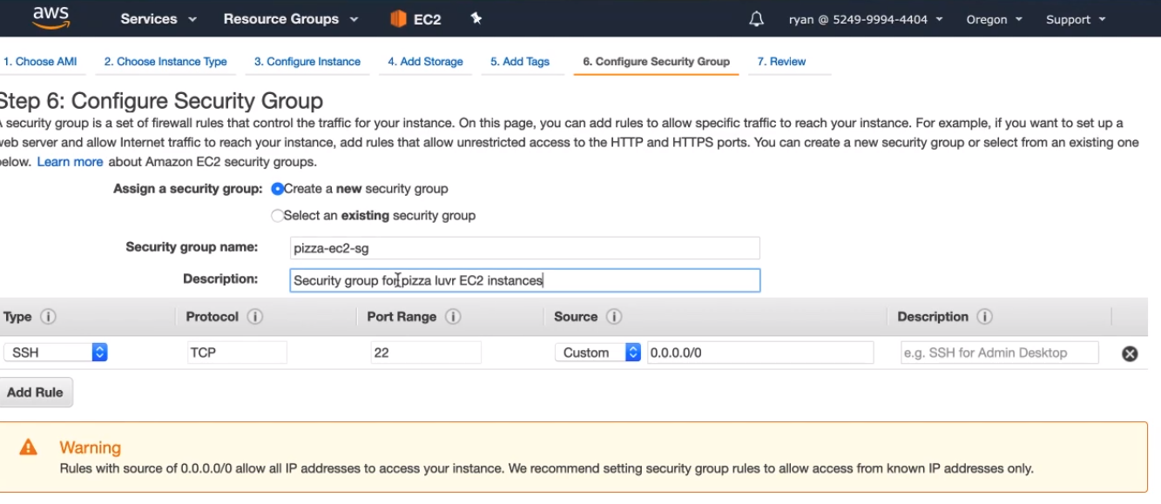

1. Let’s add another rule to our security group, click Add Rule. We want to open the port that our application will be running on, which is 3000, so leave the drop down as custom TCP rule. In the Port Range, enter 3000, and in the source, select Anywhere. Then next review and launch.

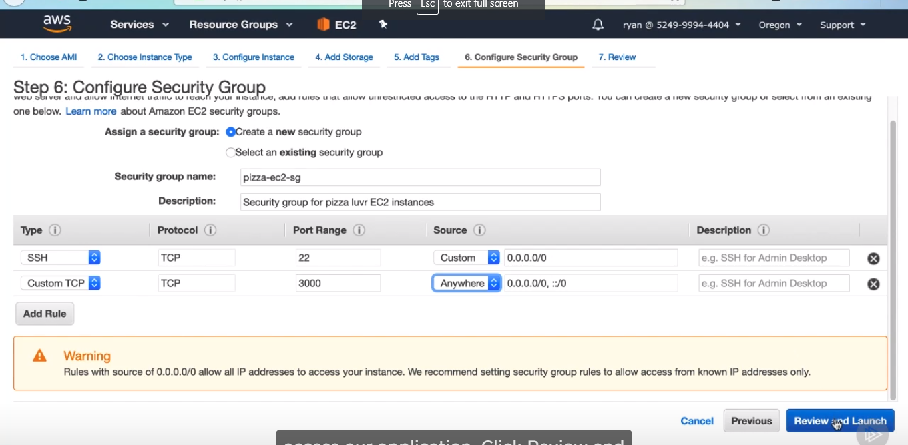

1. Then you need to create a key pair, and name this key pair. Next download the key pair it will be a .pem file, then click launch instances.

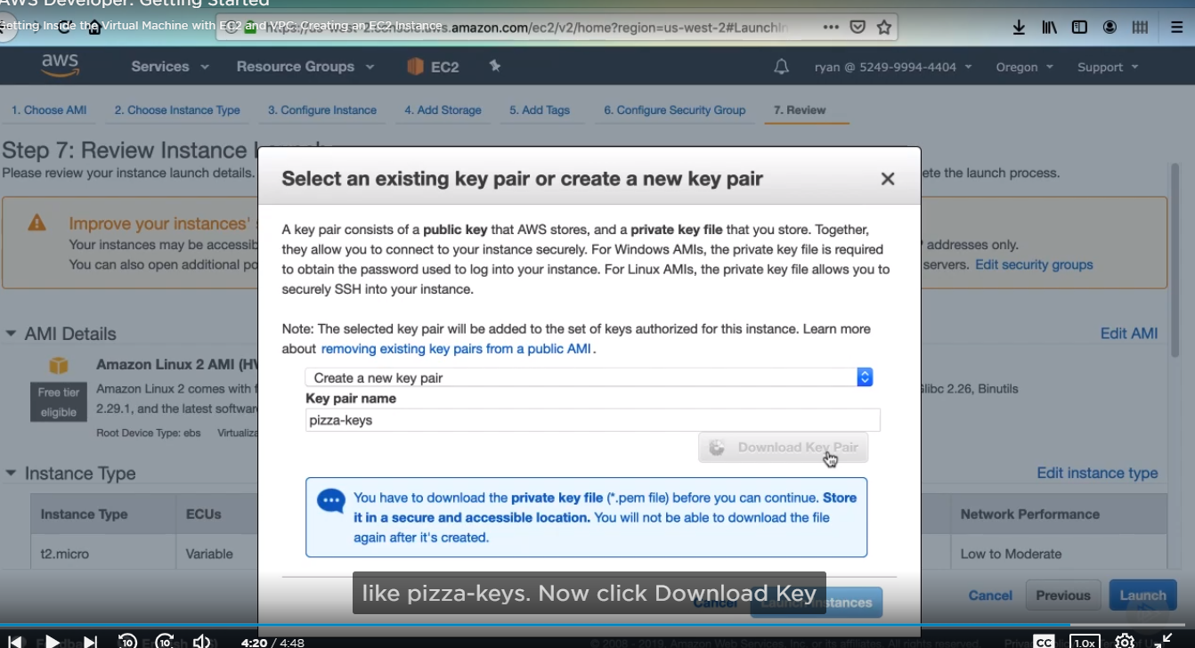

AN INSTANCE:

* You can see that there is actually no public ip for this instance, we can see.

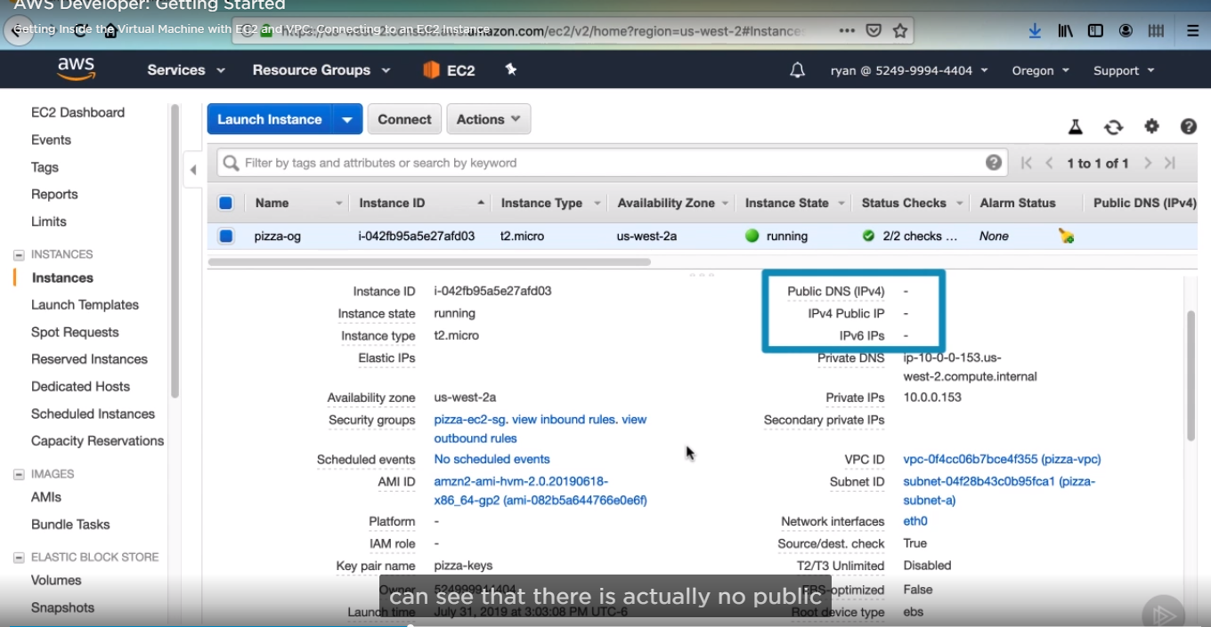

* There is a private ip and it is in the range of address that we configured for our vpc and subnet.

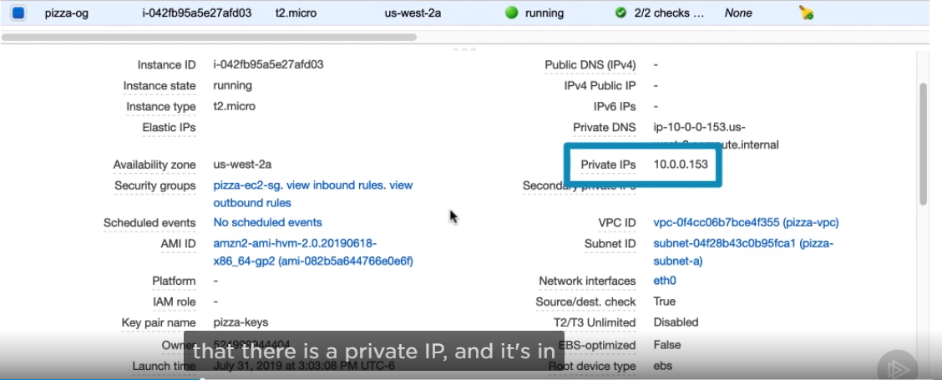

* You can see the availability zone where this instance has been created.

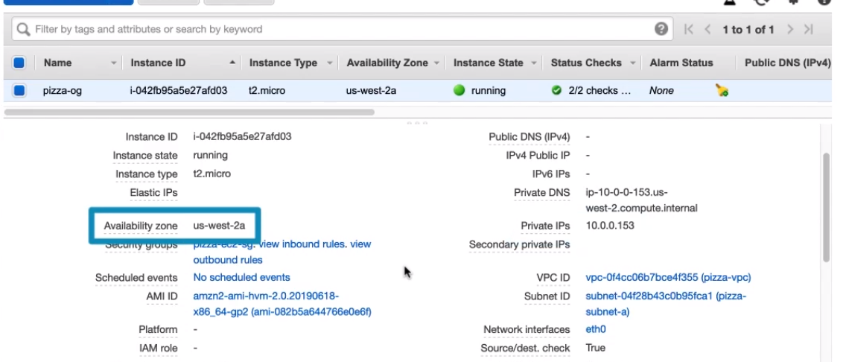

* The last is the key pair. This is important because we’ll be using the same key pair to connect via SSH.

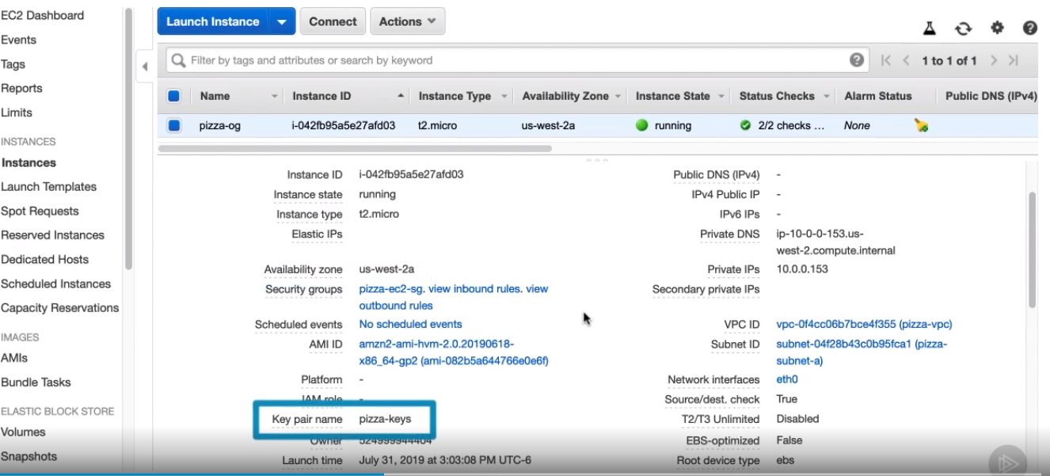

CREATE AND ASSIGN A PUBLIC IP ADDRESS

Our EC2 instance currently has no public IP address, which means that even though we configured security groups to allow SSH sessions from anywhere, there is no way to connect because there is no public endpoint outside the VPC, An [**endpoint**](https://www.paloaltonetworks.com/products/secure-the-endpoint/traps) is a remote computing device that communicates back and forth with a network to which is it connected. Examples of endpoints include:

* Desktops
* Laptops
* Smartphones
* Tablets
* Servers
* Workstations

To assign this instance a public IP address, we will first create an Elastic IP.

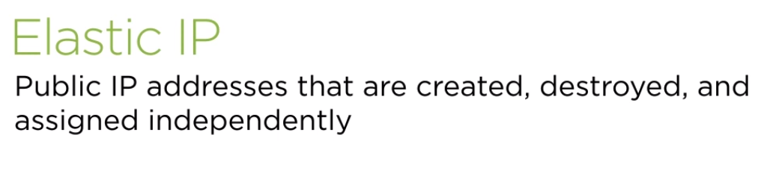

1. ElasticIPs are basically public IP addresses that can be associated with instances. If the underlying instance is terminated, the Elastic IP will still exist and can be associated with a different instance. This is very useful when you are building services or configuring DNS off of IP address that you need to stay consistent. We will create an elastic IP and associate it our current EC2 instance. In the left menu select Elastic IP.

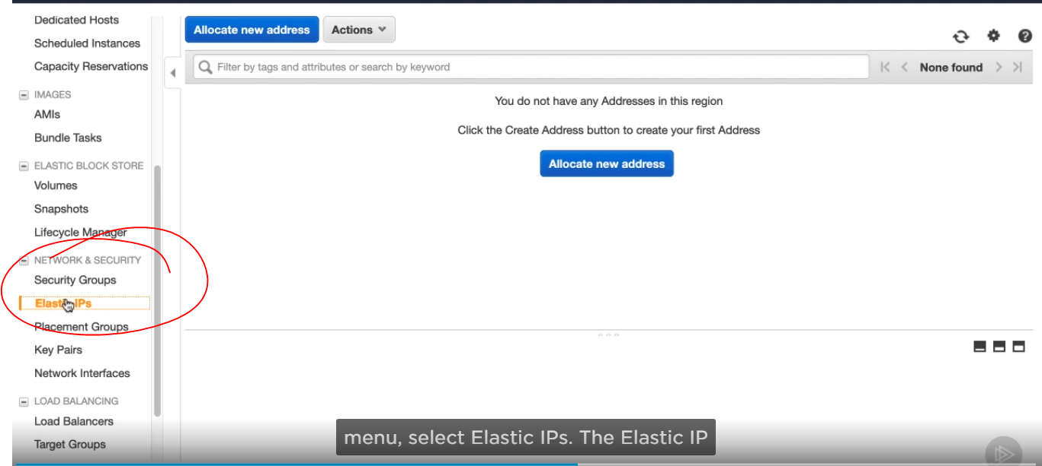

1. Then click to allocate new address, then just pick up Amazon pool, then click Allocate.

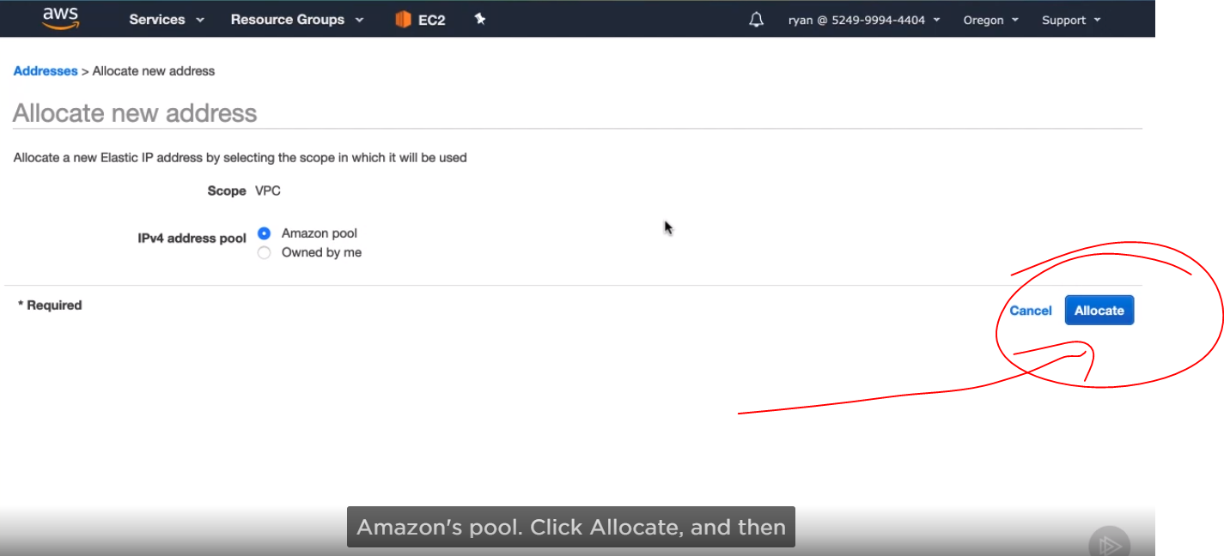

1. Then click close.

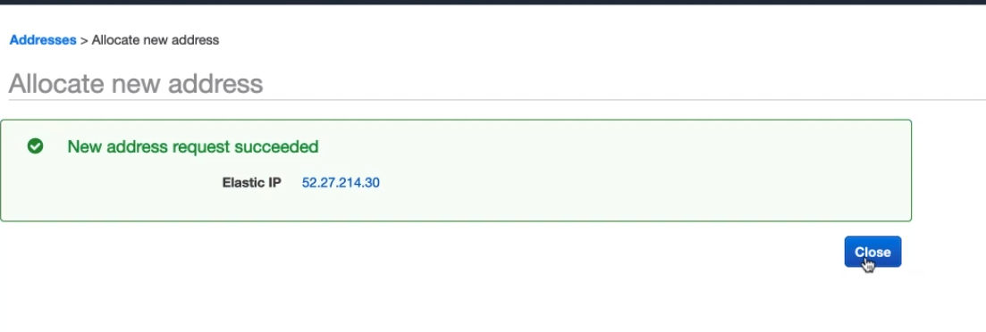

1. Then click actions and select Associate address.

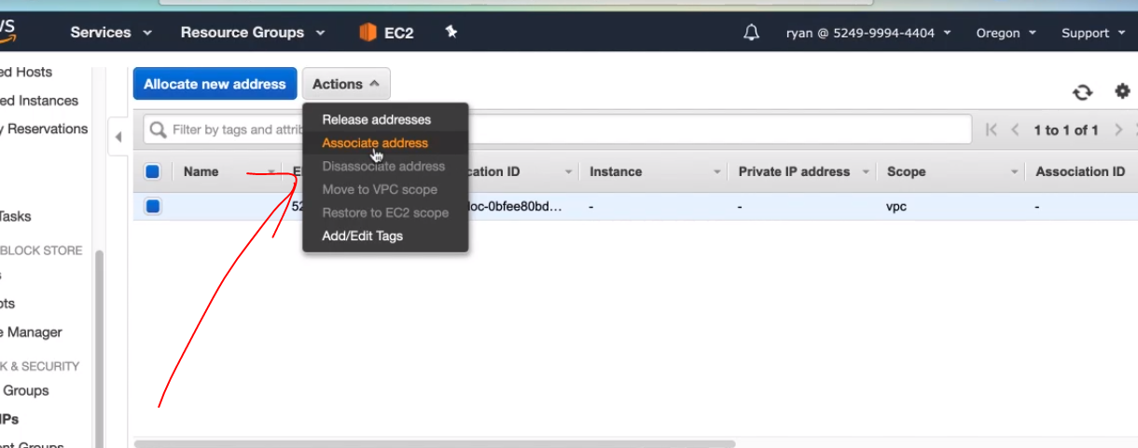

1. We will be associating this elastic ip to our pizza-og.

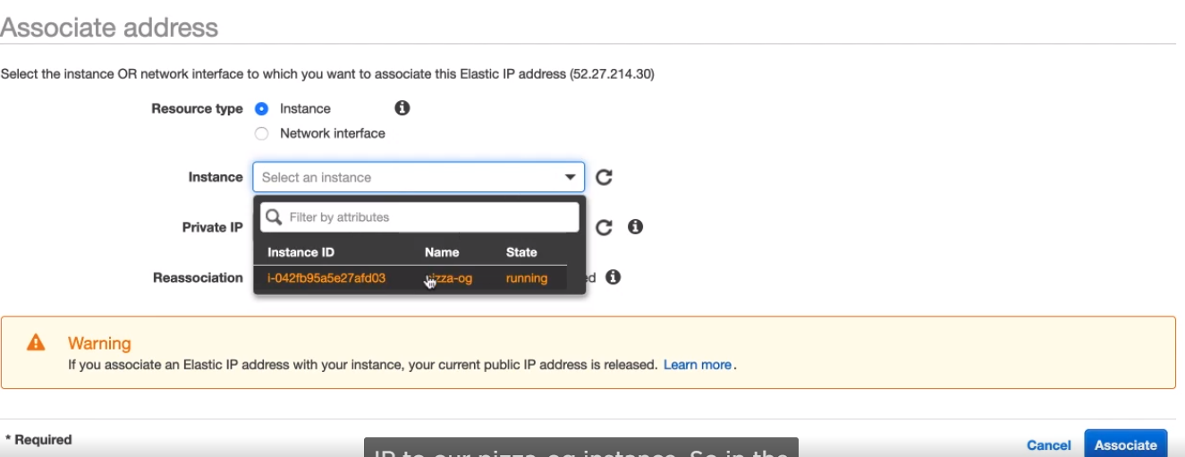

So in the instance drop down select pizza-og. In the next field, we need to select a private Ip to connect to, click drop-down, then click Associate and then close.

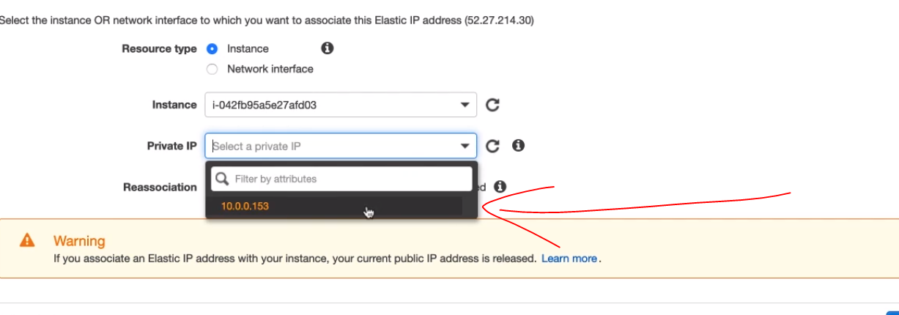

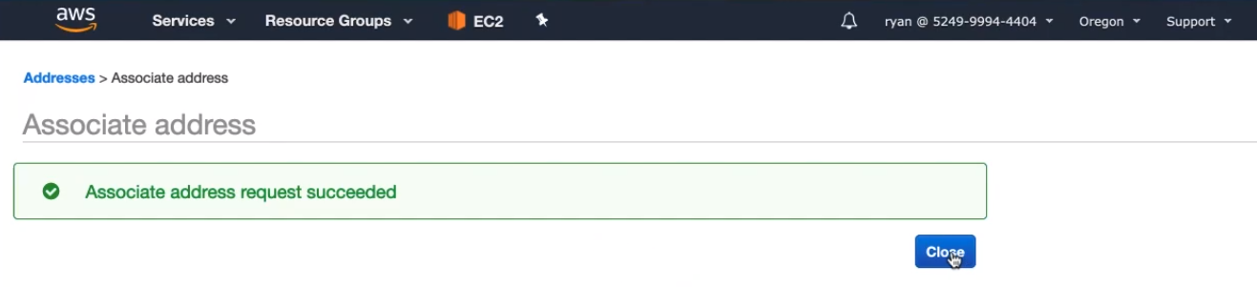

If you enter again to instance now you can see ip public.

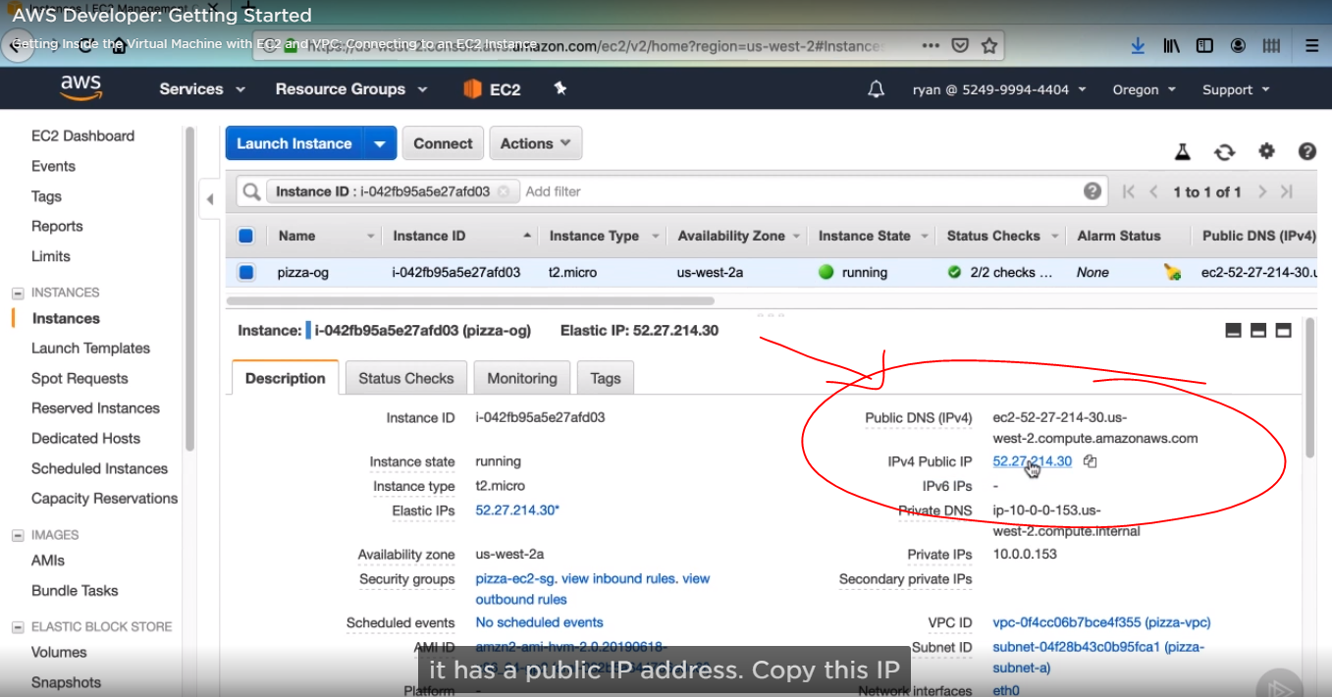

Connect to the EC2 instance via SSH

First, we need to copy public Ip from the instance. Now we have an endpoint, windows users won’t likely have SSH installed natively, so you need to use an application like PuTTY to connect.

This is only for mac and linux users.

1. Open a command line. We first need to modify our key pair file that we downloaded so SSH will let us use it. Enter the next command,

This will change the permissions of that file, so it is only readable by us

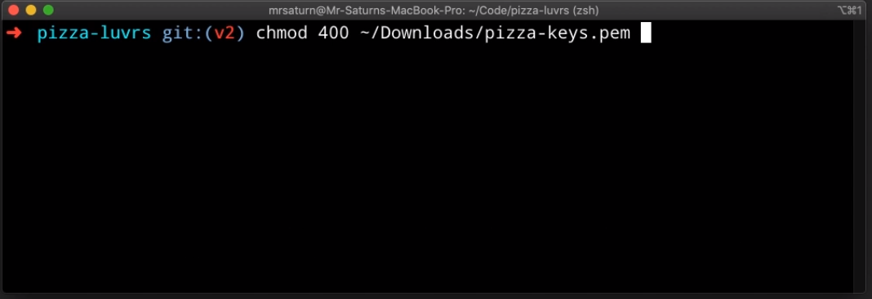

1. Now we can enter the SSH command to connect to our instance. Enter ssh -i path to your PEM file, then ec2-user at the Elastic IP of your instance. Every EC2 instance sets up ec2-user as default user name to log into, which is why we are using that to log into instance.

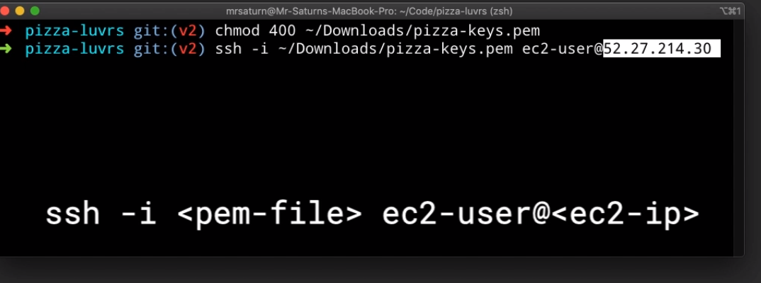

1. Once you execute this command, there should be a message about the authenticity of the host, and type yes here

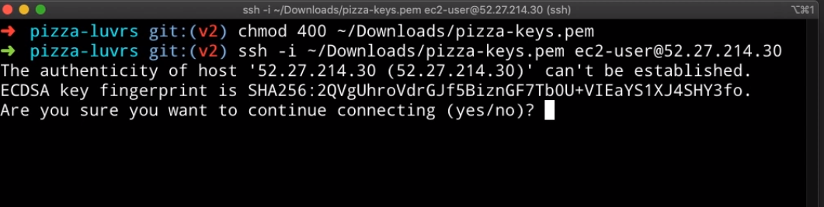

1. Then you should be presented with a new prompt after an ASCII art Ec2 logo. Now we have successfully connected to our instance.

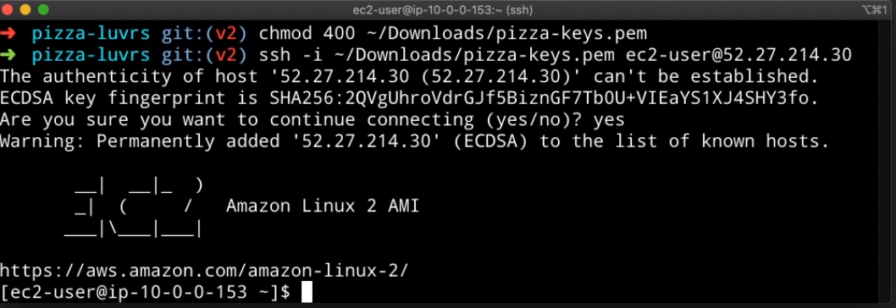

Finally, we can proceed to deploy our application

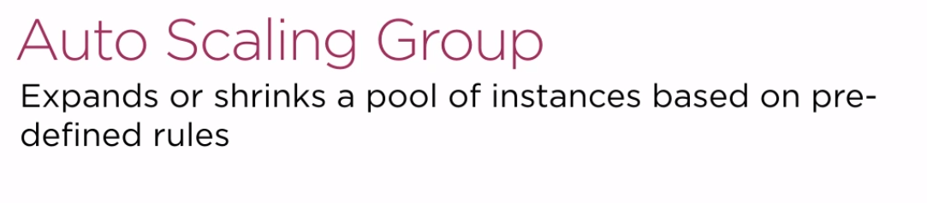

An auto scaling group uses a launch configuration which has an image in it and scaling rules to expand or shrink a pool of instances automatically. As long as you set your thresholds correctly, you can let the Auto scaling group worry about creating and managing the instance of your application.

With an Auto scaling group adding or removing instances. There is one thing to do, How do you tell your users where to find your application instances? If the IPs keep changing, there is no way to create accurate DNS entries. There is where a load balancer comes into the picture

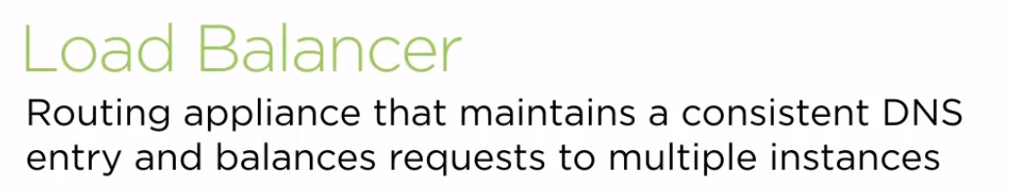

A load balancer is essentially a router instance that provides a stable endpoint to reliably send your users and set DNS entries to. The load balancer will keep track of which IPs are available and send users to them efficiently. The load balancer connects to an Auto Scaling group, so they both work together to efficiently create groups of instances and route users to them.

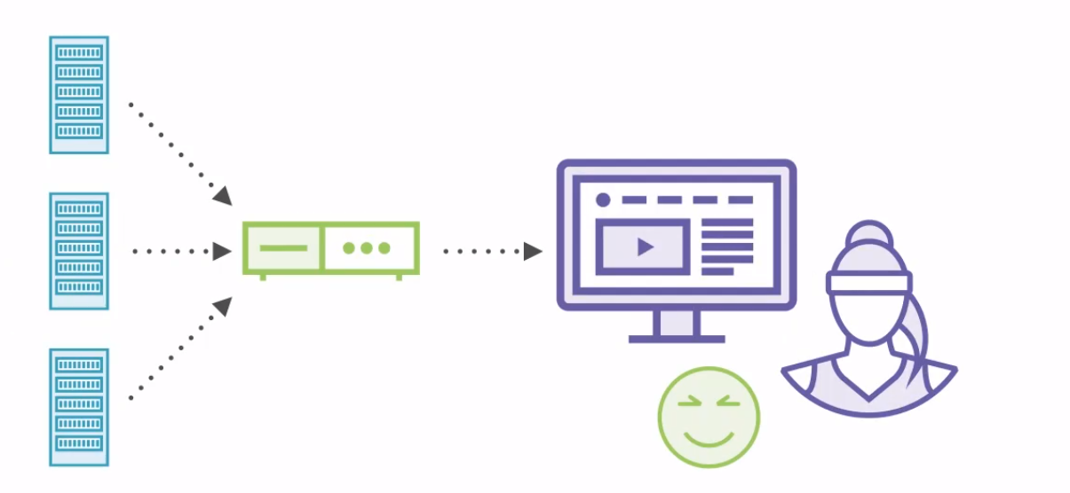

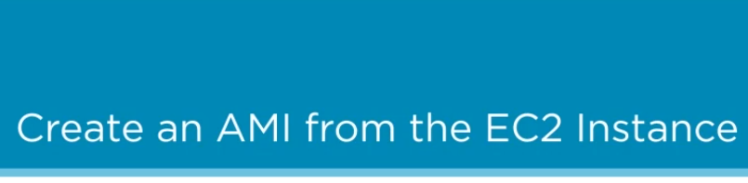

* First, click instance:

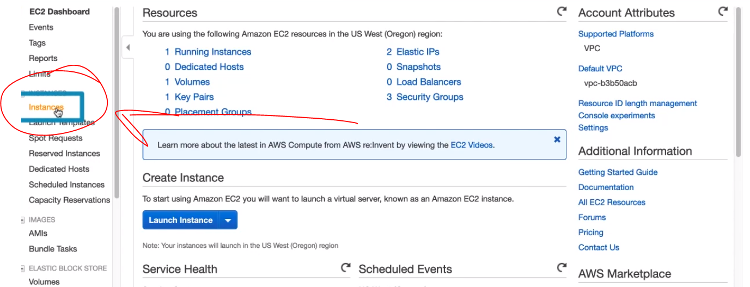

* Then select your instance and click Action:

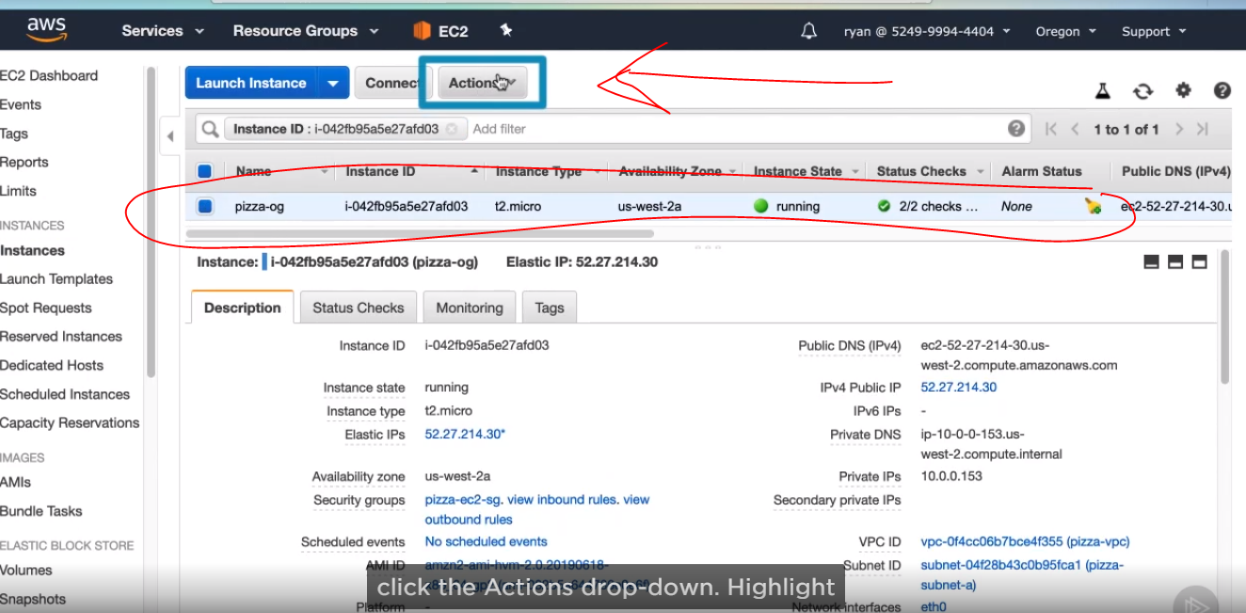

* Then go to Image and then click create Image:

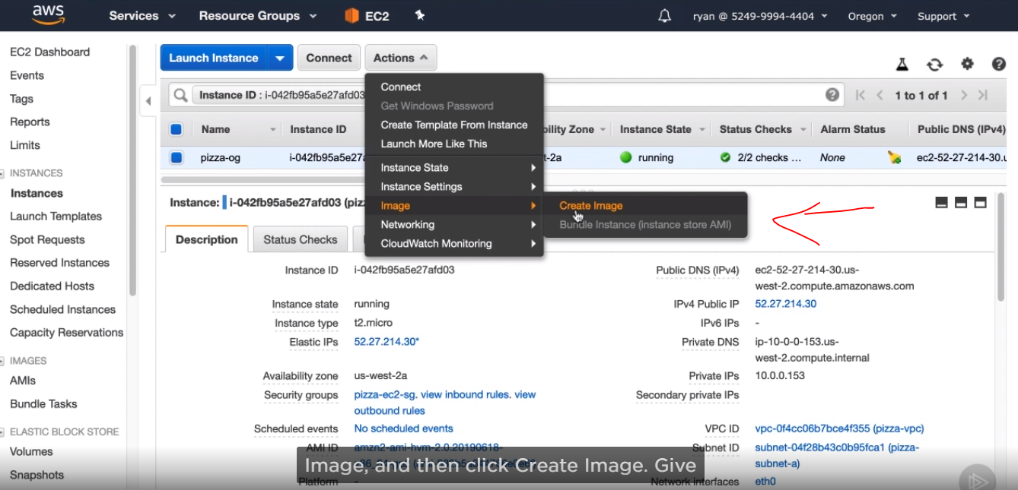

* Then, write the image name like pizza-image. The instance volumes just define the size of volume needed for this image, and we can leave it set to 8 GB. Go ahead and click to create.

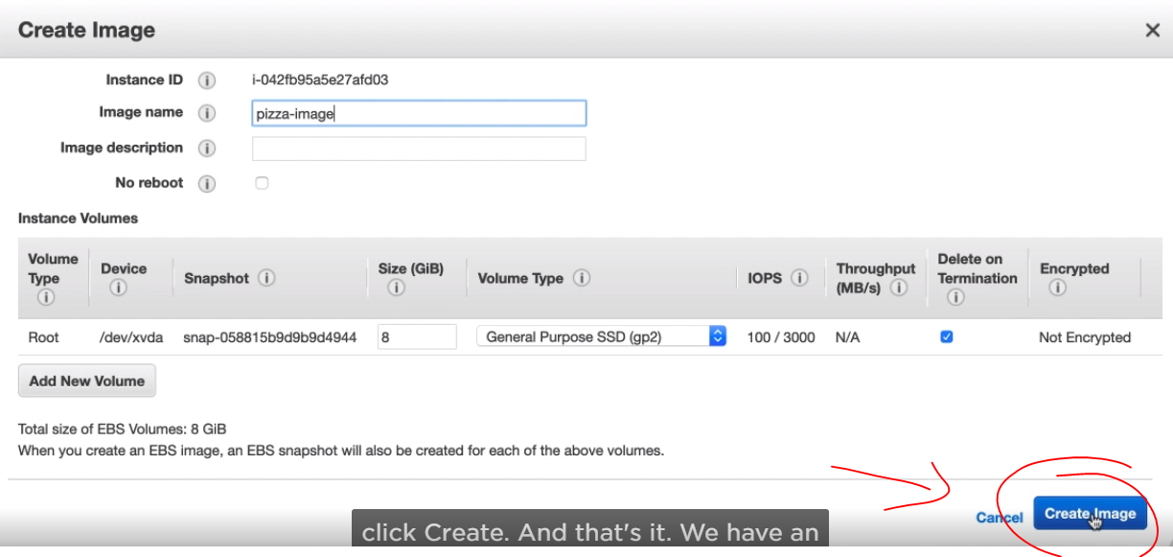

* If we click the launch instance.

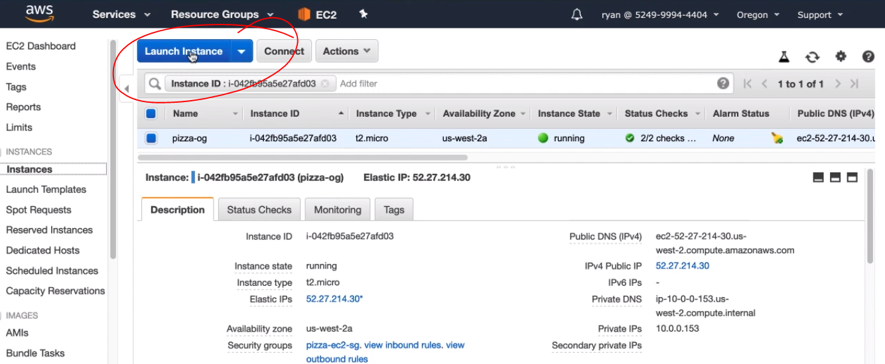

* And then select my AMIs, you will see that we can now choose to launch with our custom AMI, which means it will come with Amazon, Linux, Node, All the node dependencies, and our demo application ready to execute.

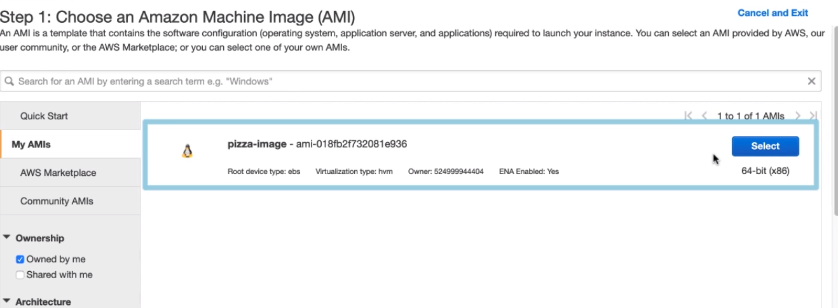

you can also view the AMI in the AMI’s menu section. You can see that it is still creating the AMI, so pizza-image is in a pending state

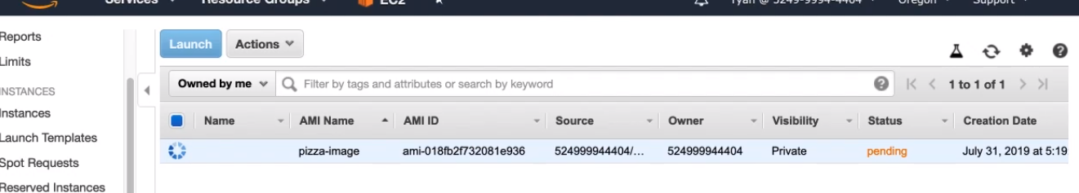

we want to use this AMI to replicate instances of our demo application.

CREATING A LOAD BALANCER

* From the EC2 dashboard, click on Load Balancers,

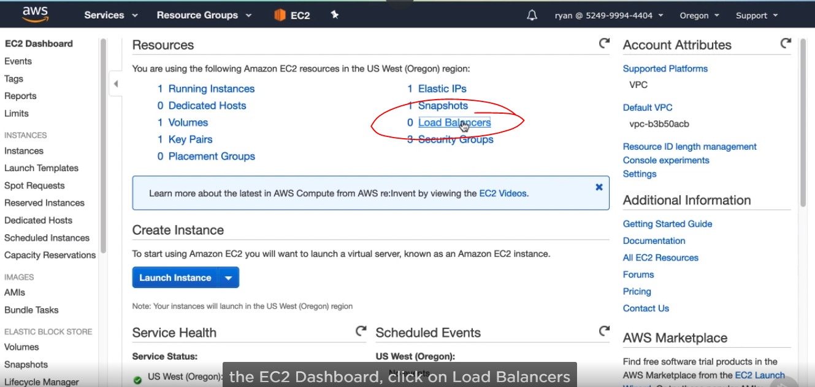

* Then create a load balancer.

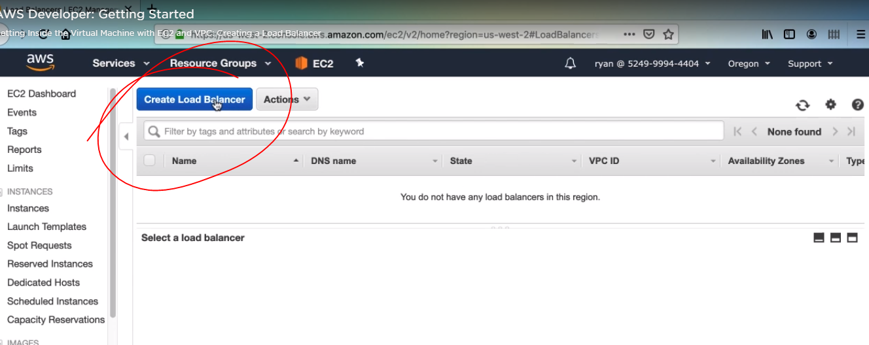

* First, we need to select the load balancer type. Application load balancers are for web applications that use HTTP and HTTPS, just like our pizza lovers application. There’s also network load balancers, which focus on lower-level protocols like TCP and UDP, and there is a classic load balancers, which are an older type of load balancer that AWS used to support, but that aren’t particularly relevant anymore. Click Application Load Balancer.

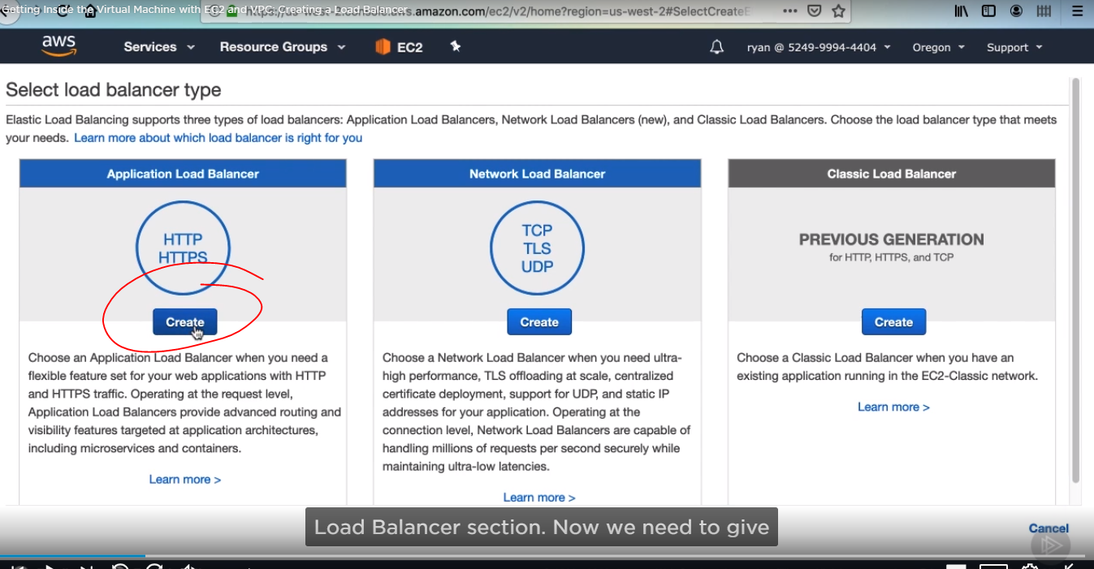

* Now we need to give the load balancer a name, which will of course be pizza-loader, then do not change the scheme and Ip address type.

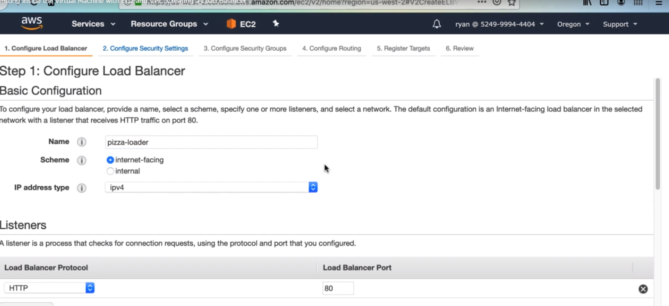

* The listener configuration section is basically saying which ports you want the load balancer listening on. Usually you’ll have to entries one for HTTP on port 80 and one for HTTPS on port 443. We do not have an SSL certificate for HTTPS, so just Use port 80

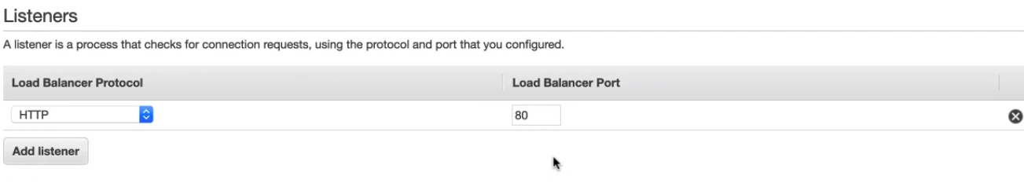

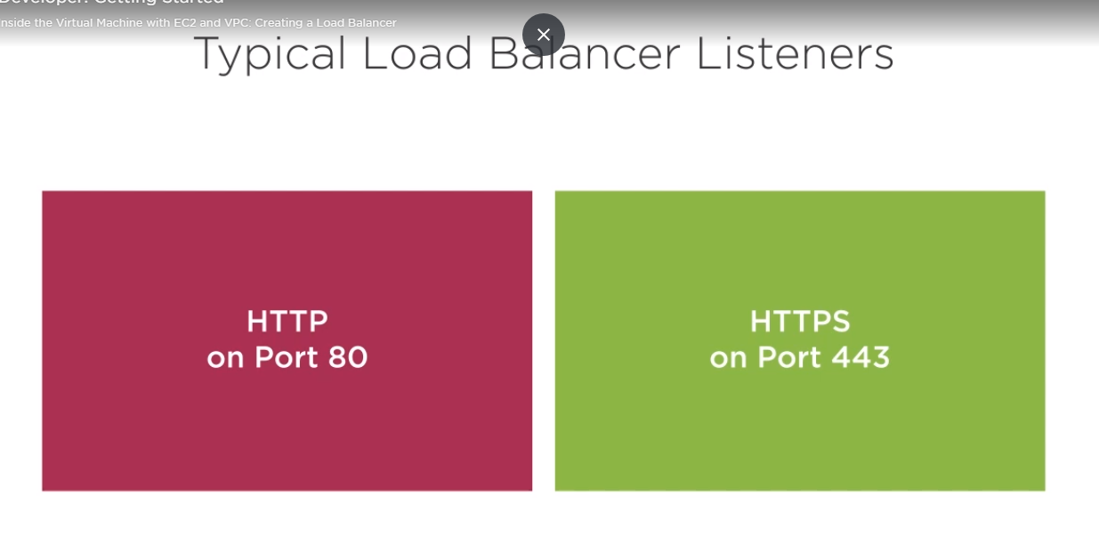

## What is HTTP?[#](https://www.keycdn.com/blog/difference-between-http-and-https#what-is-http)

HTTP stands for **Hypertext Transfer Protocol**. When you enter http:// in your address bar in front of the domain, it tells the browser to connect over HTTP. HTTP uses TCP (Transmission Control Protocol), generally over port 80, to send and receive data packets over the web. To put it simply it is a protocol that’s used by a client and server which allows you to communicate with other websites. The client sends a request message to an HTTP server (after the TCP handshake) which hosts a website, the server then replies with the response message. The response message contains completion status information, such as “HTTP/1.1 200 OK”.

## What is HTTPS?[#](https://www.keycdn.com/blog/difference-between-http-and-https#what-is-https)

HTTPS stands for **Hypertext Transfer Protocol Secure** (also referred to as HTTP over TLS or HTTP over SSL). When you enter https:// in your address bar in front of the domain, it tells the browser to connect over HTTPS. Generally sites running over HTTPS will have a redirect in place so even if you type in http:// it will redirect to deliver over a secured connection. HTTPS also uses TCP (Transmission Control Protocol) to send and receive data packets, but it does so over port 443, within a connection encrypted by Transport Layer Security (TLS)

* Next select our pizza-vpc, indicating we want to create the load balancer inside of our pizza-vpc, Here we need to select two availability Zones to enable our load, select both of them, now, click next.

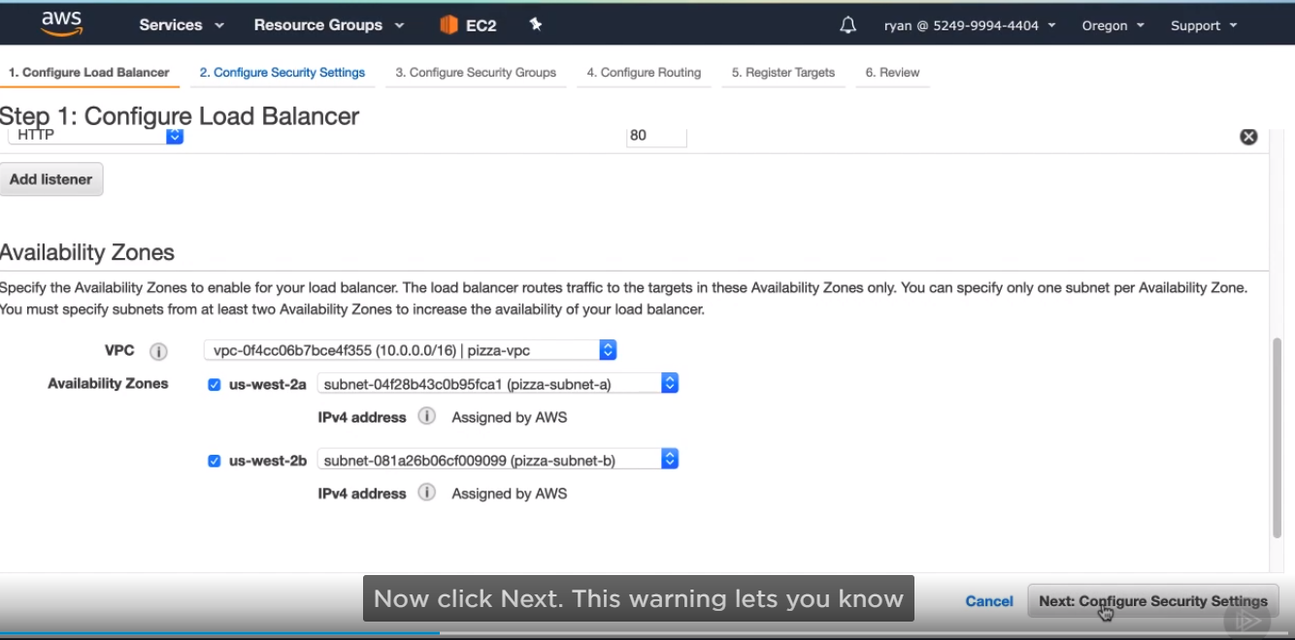

* this warning lets you know that you are not using a secure listener like HTTPS, that’s fine for us for this demo. Go ahead and hit next.

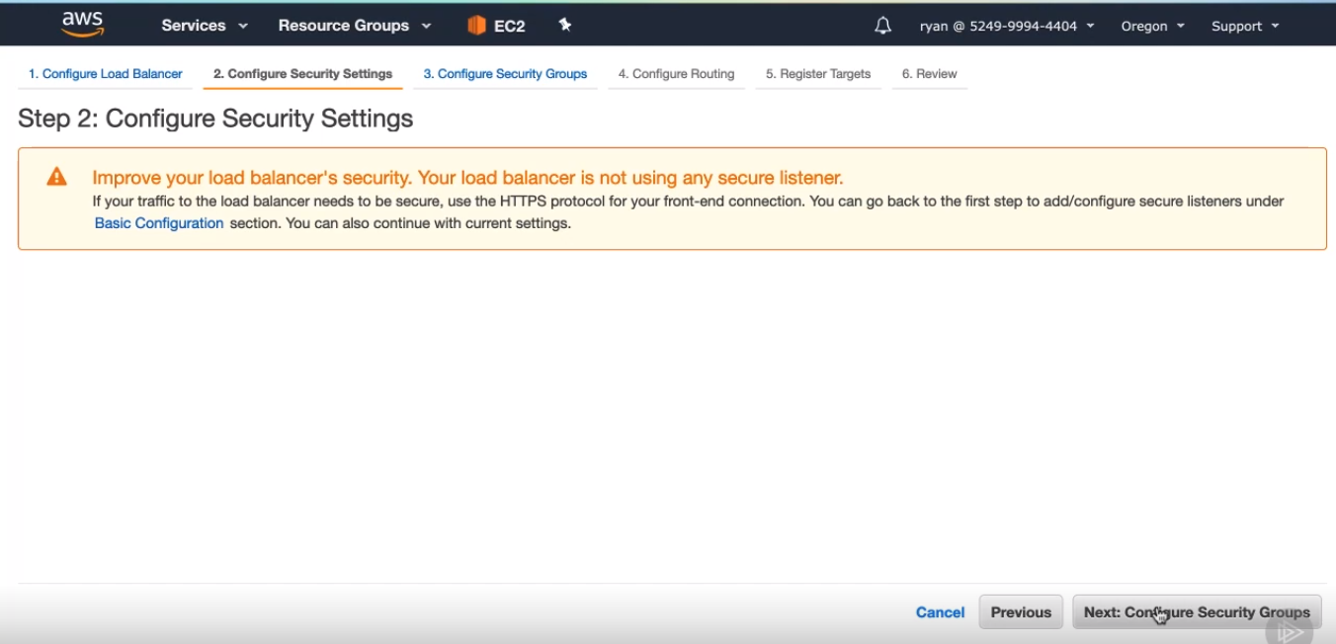

* next screen, select create a new security group.

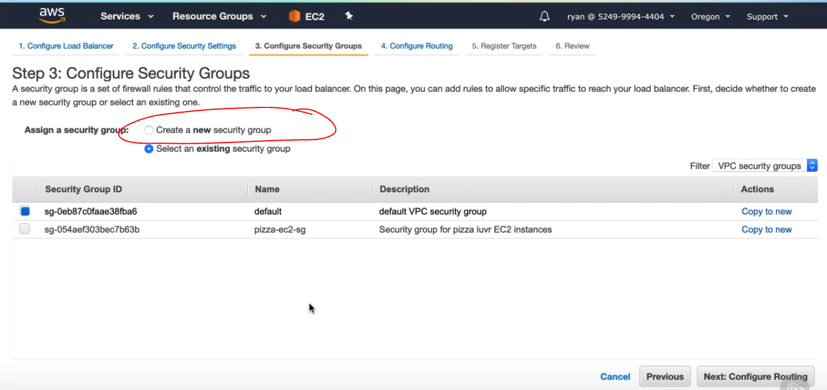

* then name a security group, click next:

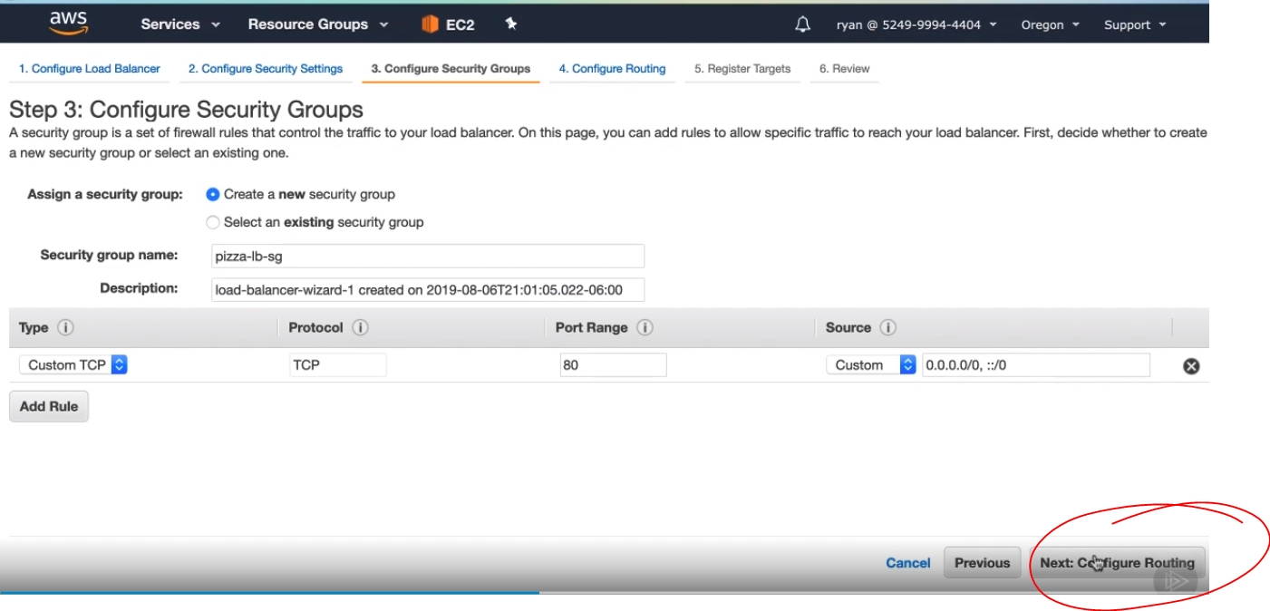

* in this screen, we will configure how the load balancer will send requests to our application instances. It does this by defining a target group and routing to any instances in that target group. We will start by naming the target group pizza-tg, the target type is an EC2 instance, so leave the instance radio button selected. Our protocol is HTTP, so leave that option selected, But our application is listening on port 3000, not port 80, so change the port in this field to 3000. Load balancers know which instances to send requests to by checking their status with a health check. These fields let you configure what protocol to use and the path to hit. Sometimes applications will have a dedicated check path, but for our app, we can just use the root index page which be leaving this slash in the path field. Now we can click Next

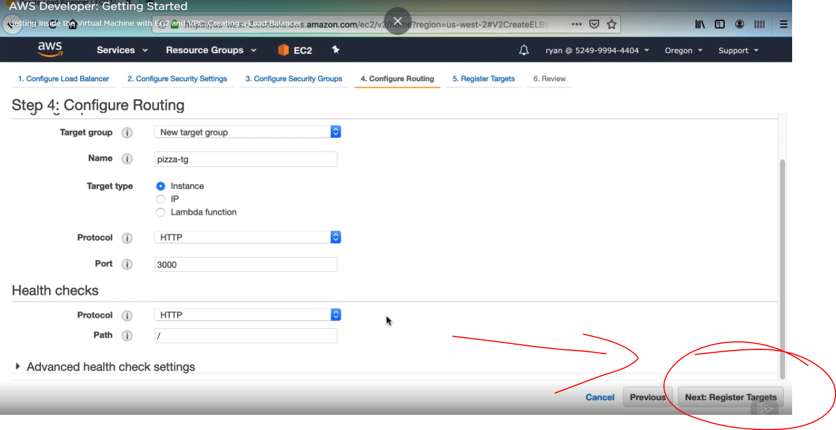

* this page will let us register instances with the target group, you can see it shows that there are currently no registered targets. If you scroll down, you should see a short list of instances, including your pizza-og instance. Select that instance, and then click Add to registered, Now our load balancer will send requests to our pizza-og. Click Next to review .

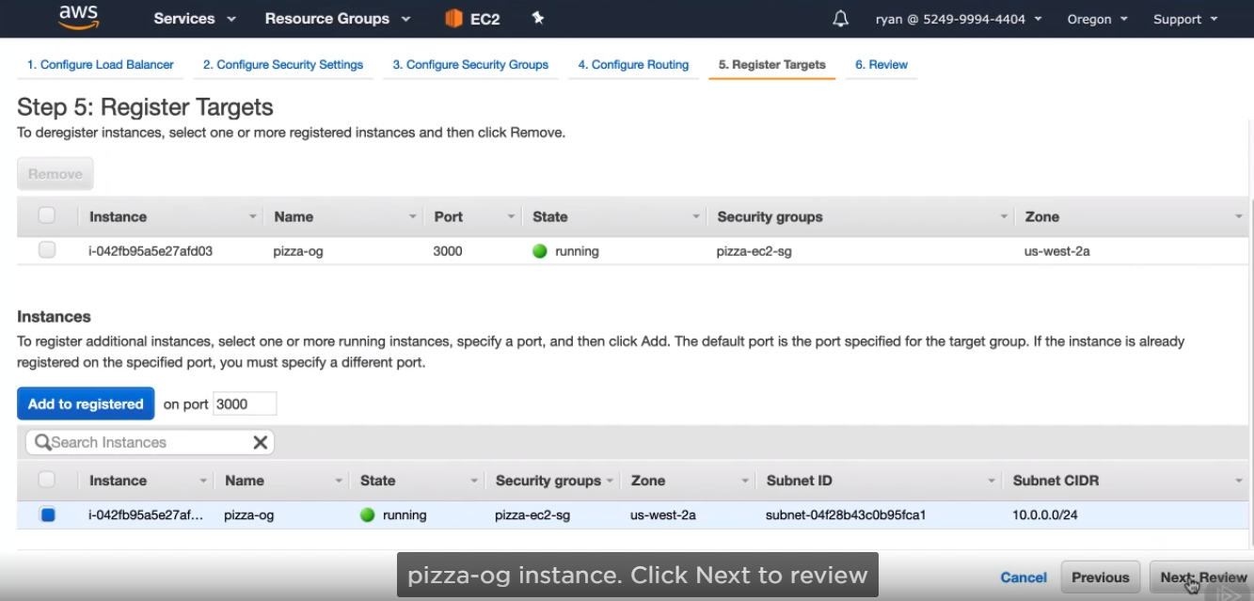

* then, click create.

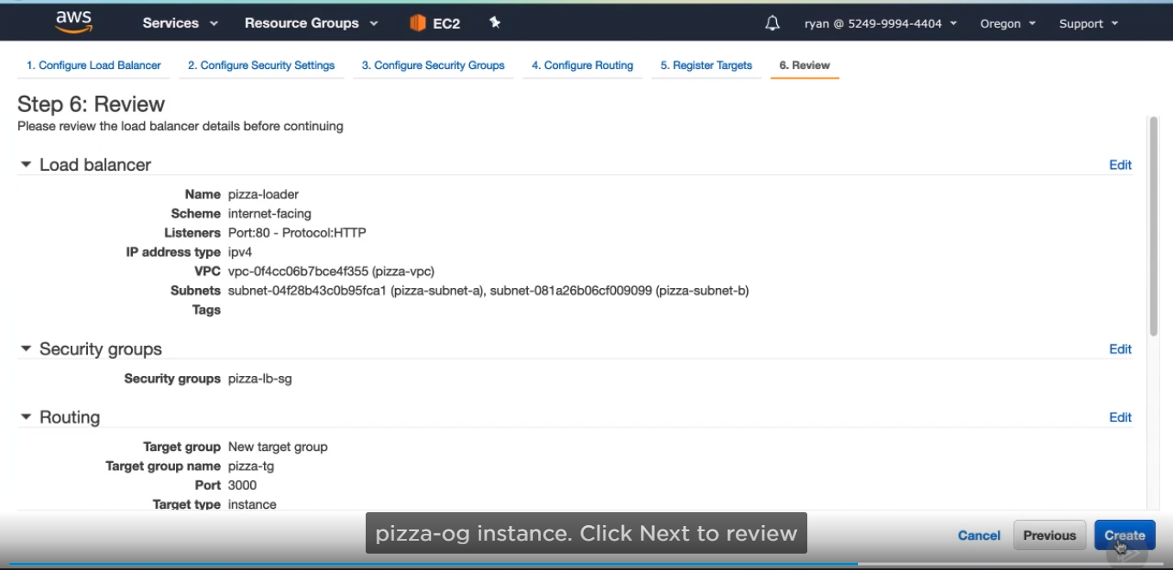

* last step for load balancer. We need to ensure that if a user logs into our app in one EC2 instance that they continue to connect to that same instance with subsequent requests. If we didn’t do this, there is a possibility that they would hit an instance where they don’t have a session. To avoid this situation entirely, let’s enable stickiness on the load balancer. The load balancer will use a cookie to keep track of which user should be sent to which instances.

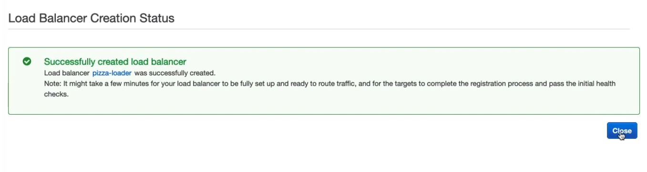

* Session stickiness is configured in the target group, so click there.

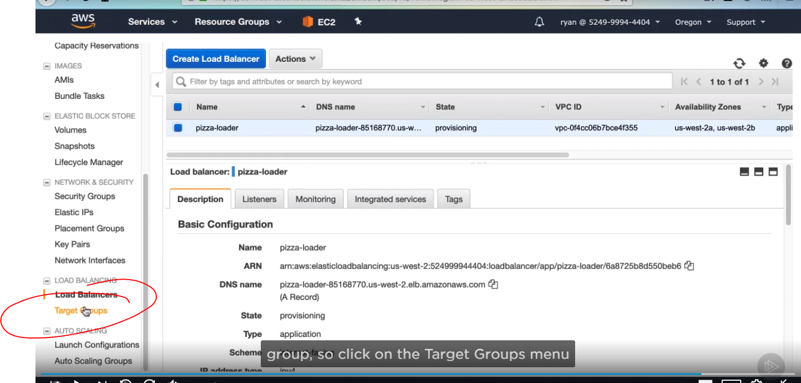

* Select the pizza-tg.

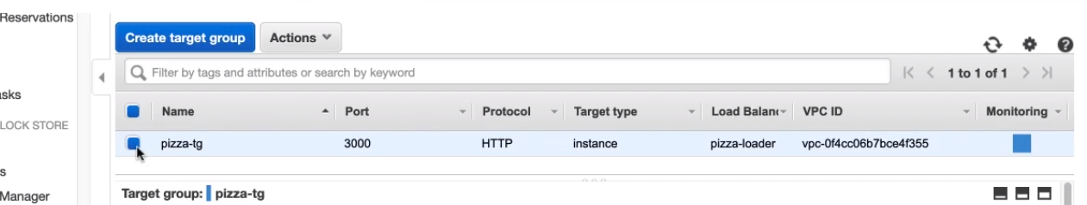

* And description tab at the bottom, there is an attributes section. Click edit attributes.

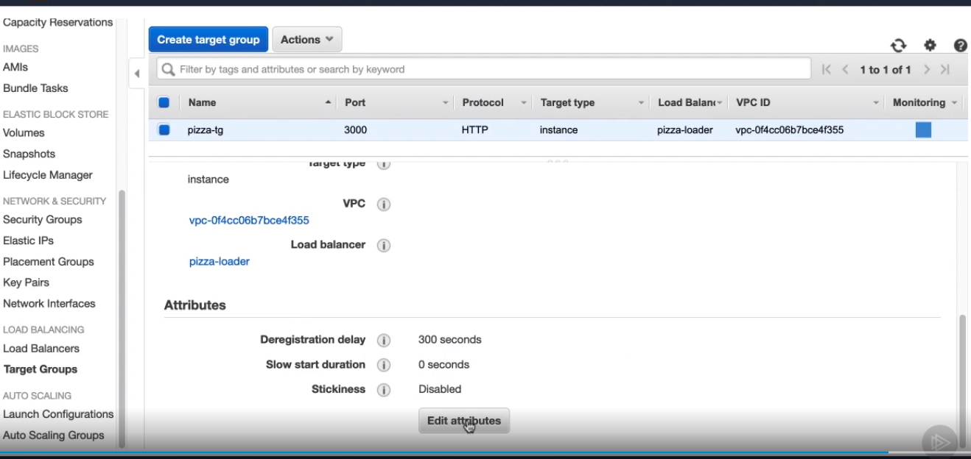

* Then select enable checkbox to stickiness. We need to specify how long to keep that cookie alive. We currently have our sessions in Pizza Lovers lasting as single day, so let’s match that here and enter the number 1 and then select days from drop-down. Now click save.

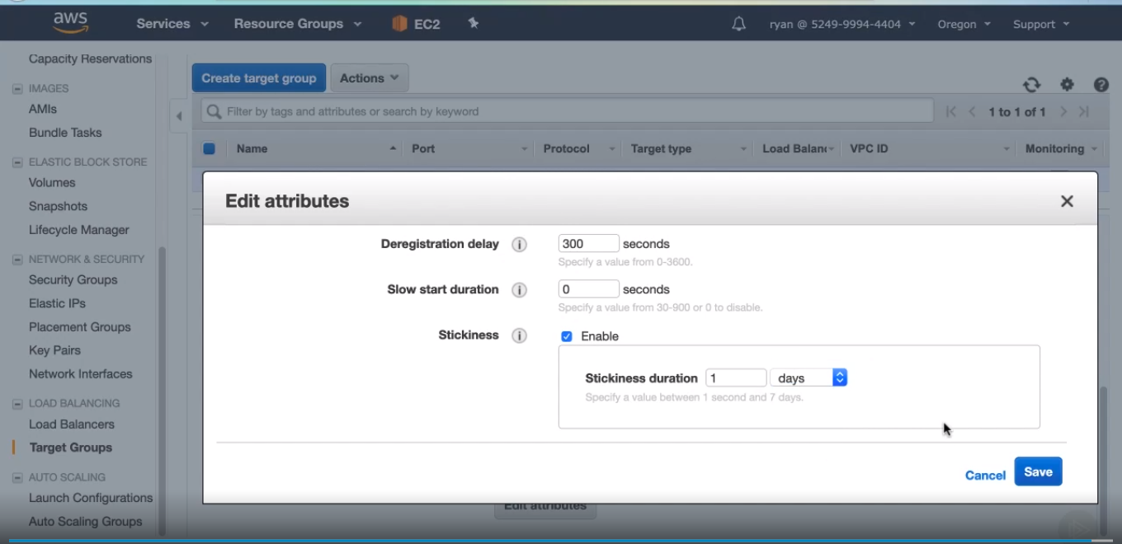

* Then you got it:

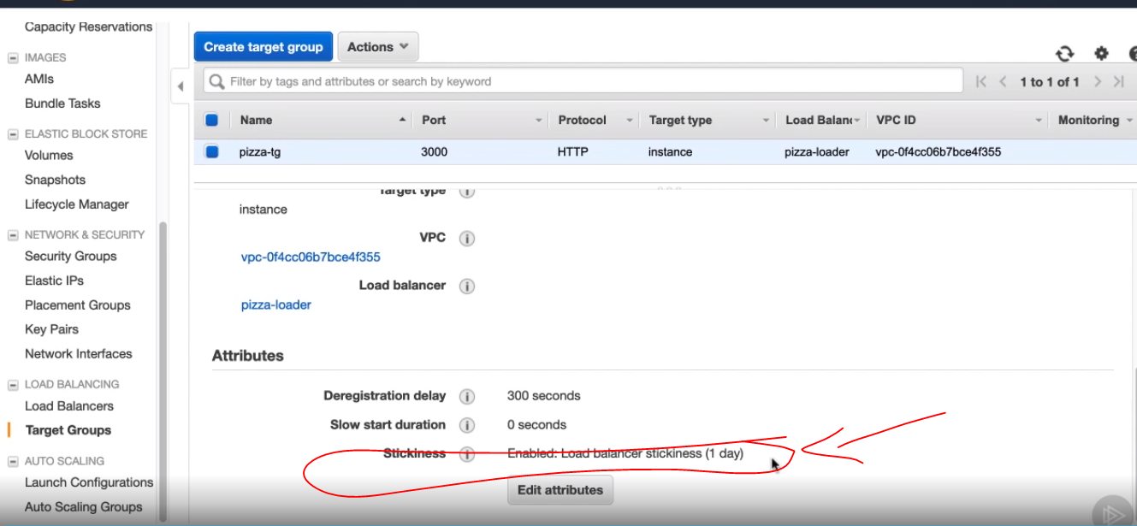

CREATE AN AUTO SCALING GROUP.

That can attach to it and supply it with instances to send traffic EC2 console.

* Scroll down to see Auto Scaling Groups

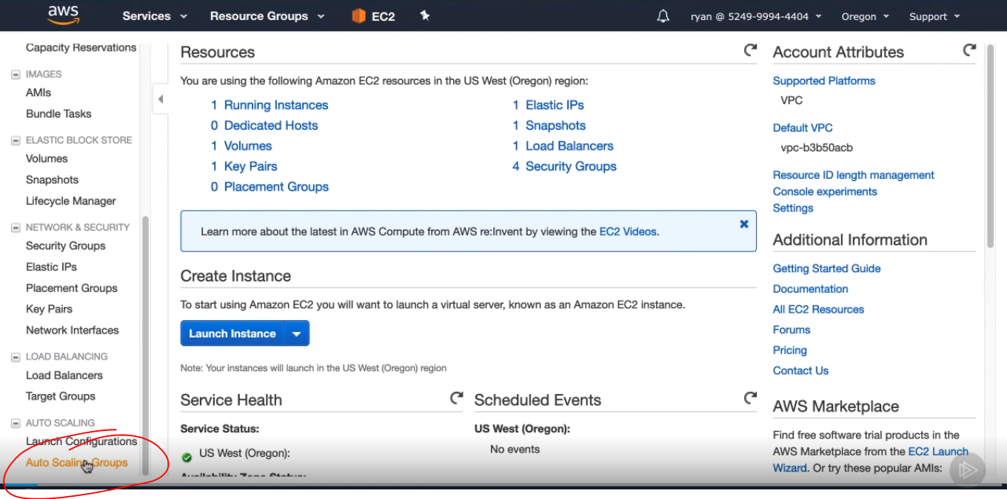

* Click create Auto Scaling group.

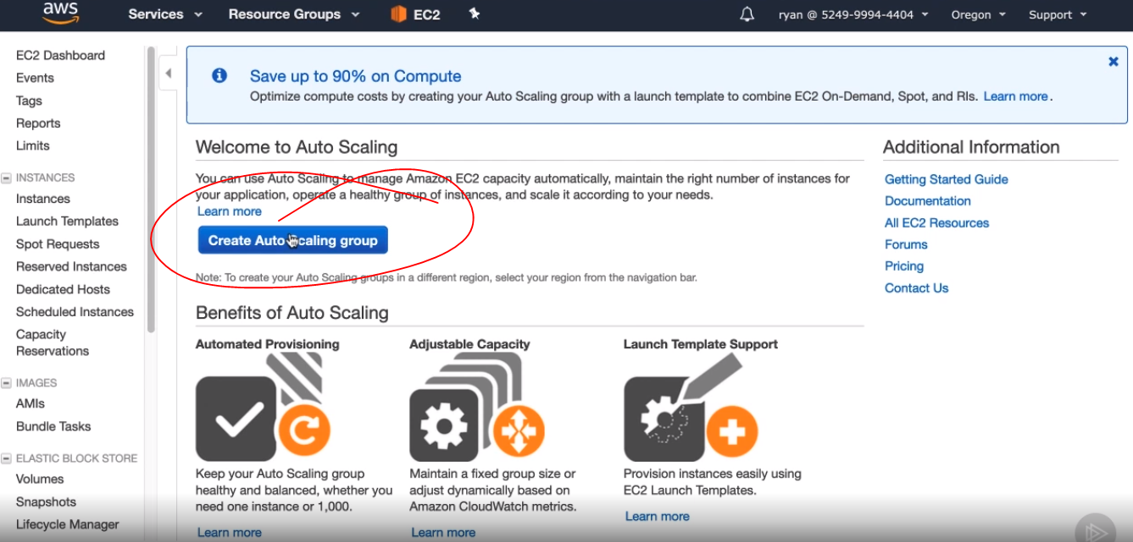

* Then click get started.

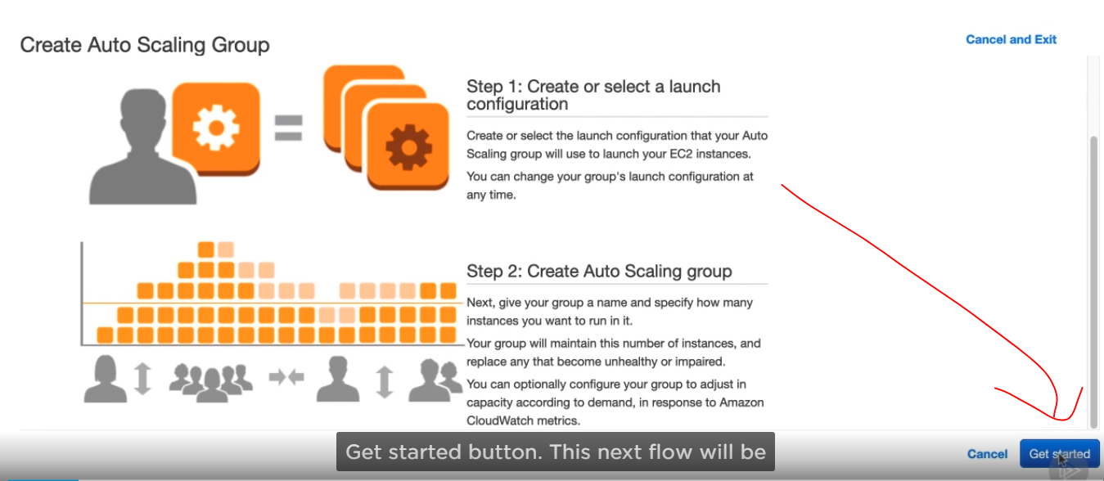

* We want to use the AMI we created, so selected My AMIs, and select pizza image

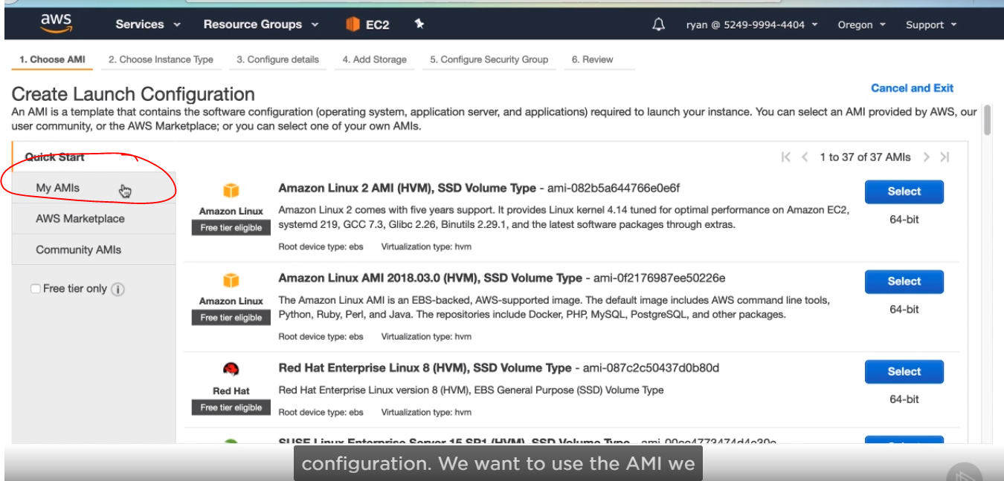

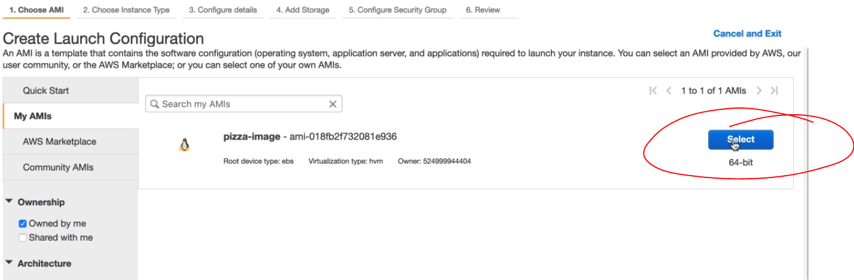

* Next, we’ll go with another t2.micro sized instance type for the instances that will be created. Click Next: configure details

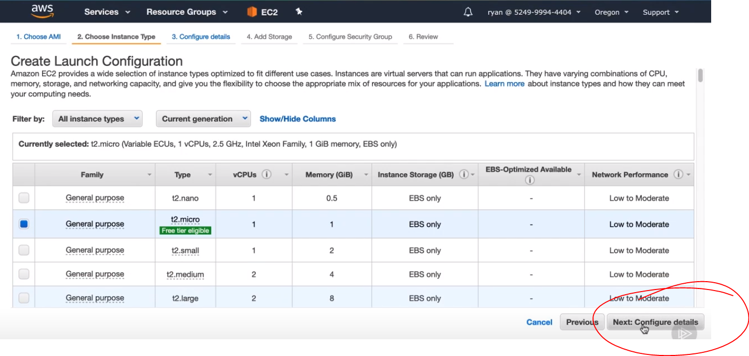

* Next, we’ll name this launch configuration pizza-launcher.

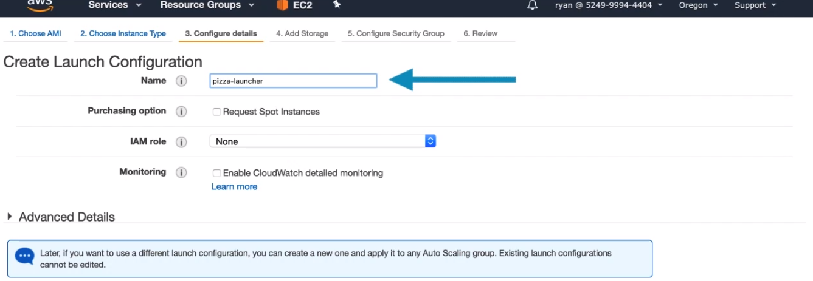

* Now expand the advanced

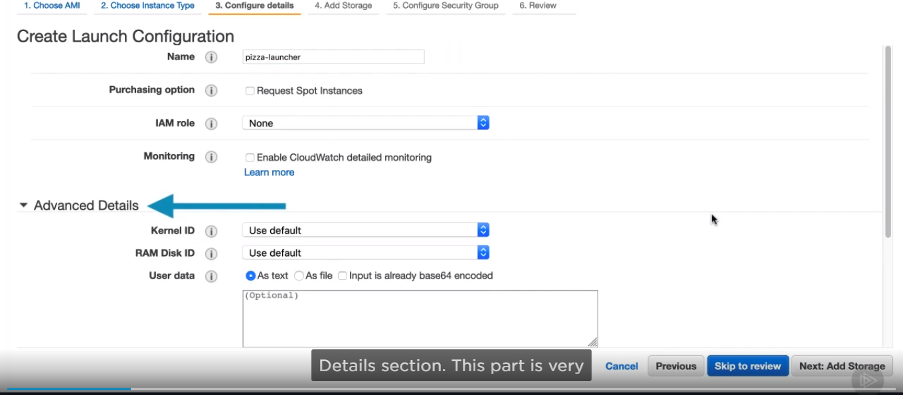

* It is enough for our instance to just be created. We need it to automatically start our Node application. The User data section is where we can run scripts to execute at instant startup. Here we will paste in a shell script that changes directories to our application directory and then executes npm start.

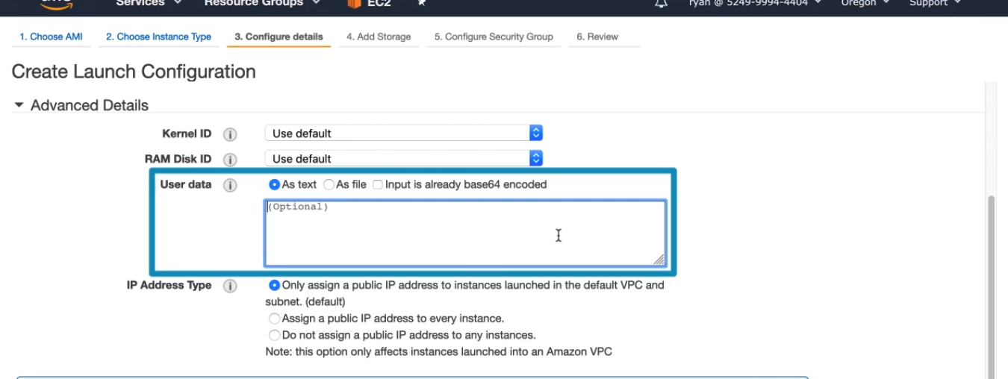

* Here is a script to enter into this user data field. The #! /bin/bash at the top of the script tells the launch configuration to execute the user data as a shell script.

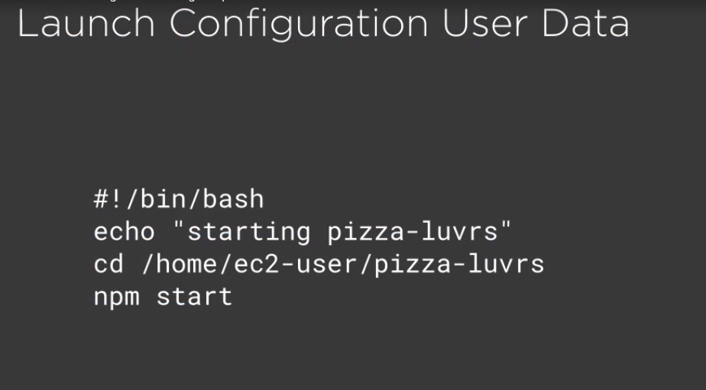

* Now click next,

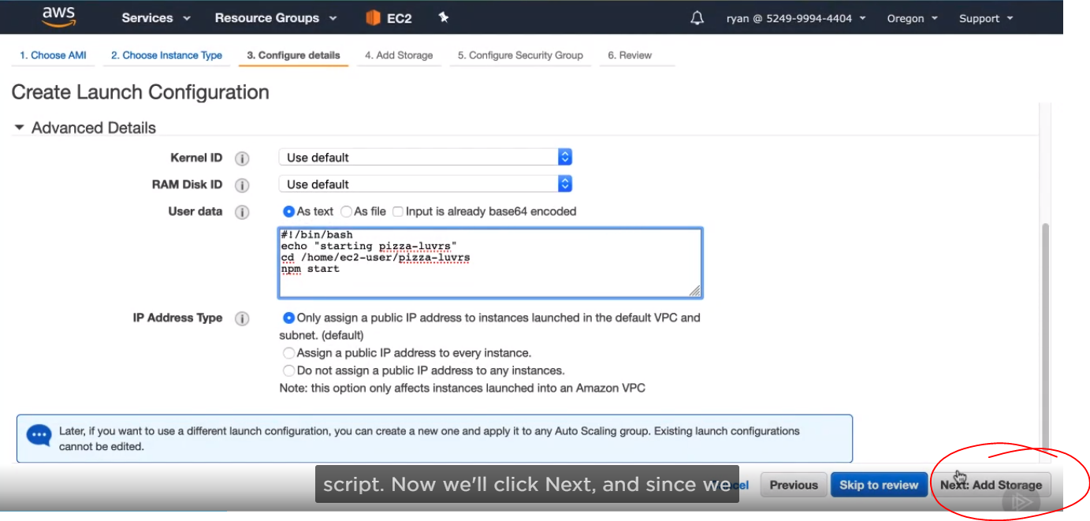

* We don’t need to modify storage volume options, click Next again.

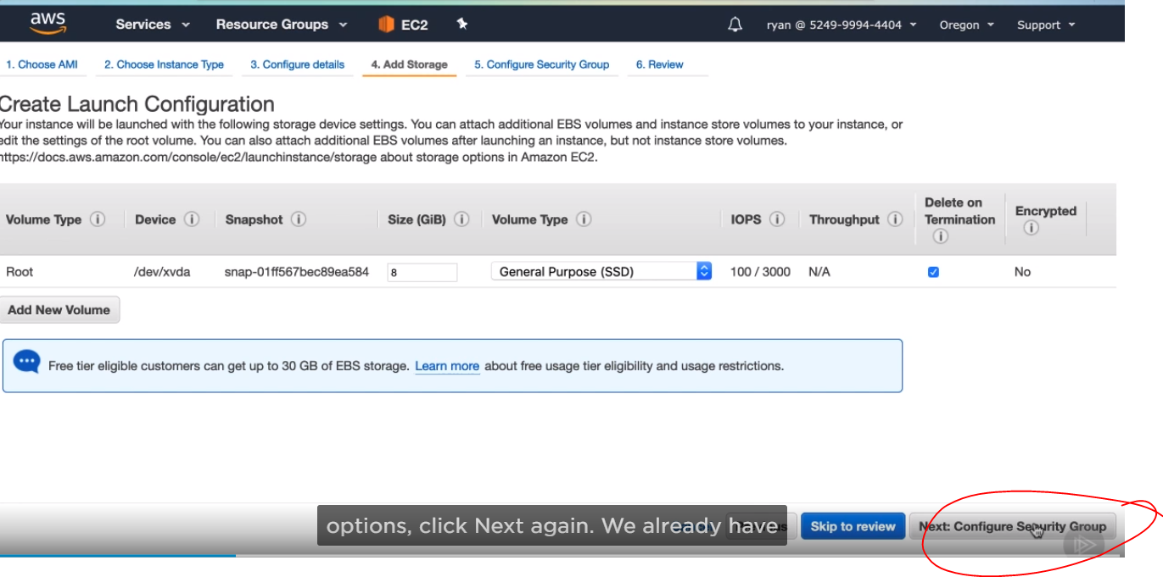

* We already have our pizza EC2 security group with the rules we want for instance access, so select an radio button next to existing security group, and select the pizza-ec2-sg group. Click Review.

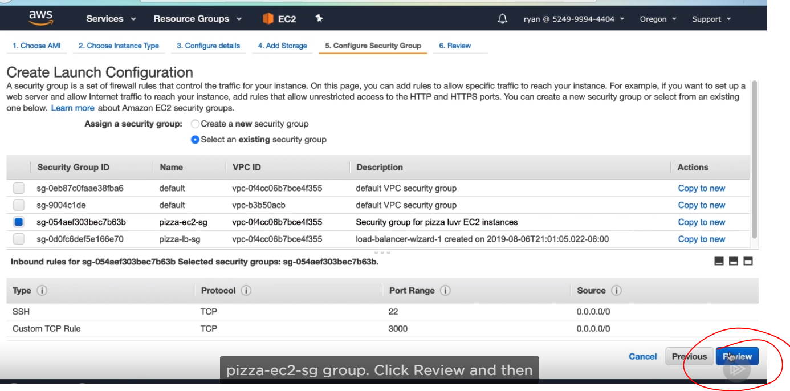

* Create launch configuration. Choose the pizza-keys key par to start each instance with. Check the confirmation box and then create launch configuration.

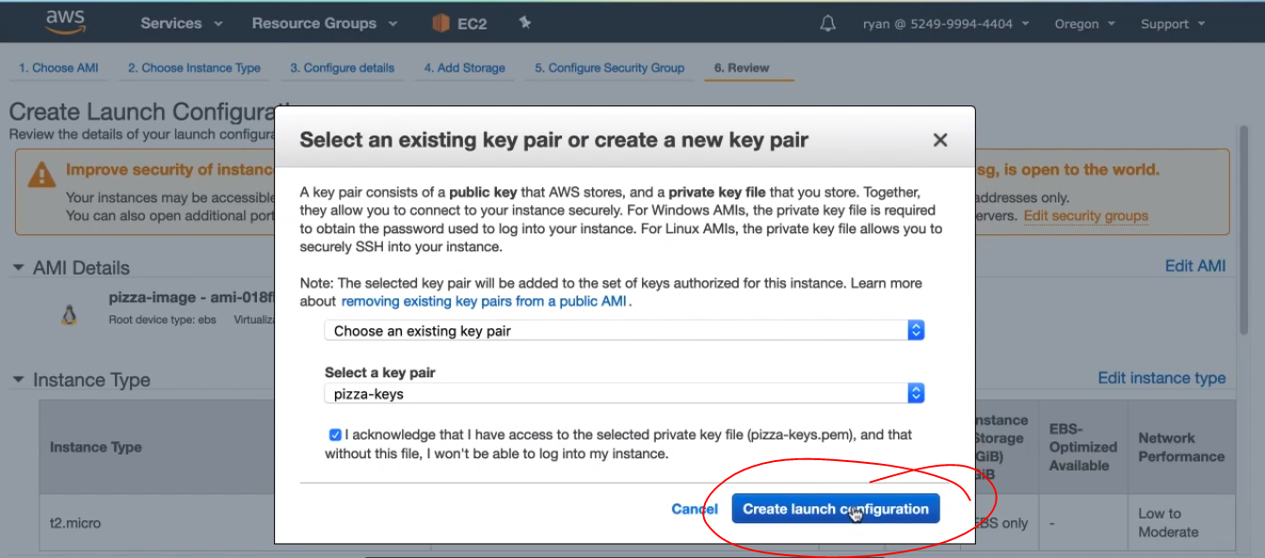

* Now we get to create the Auto Scaling group, let’s name it pizza-scaler, now we have a choice for the initial number of instances. Let’s enter 2 here, for Network, we want to launch into our pizza-vpc, so select that from the drop-down. In the subnet field, we want to add both of our subnets in the VPC so the load balancer will be sending traffic both places. Click in the input field, and select one and the other subnet from the auto-suggest box. The big warning below about public IP address is fine. We don’t actually want our internal instances to have public IP address because we only want them externally available through the load balancer.

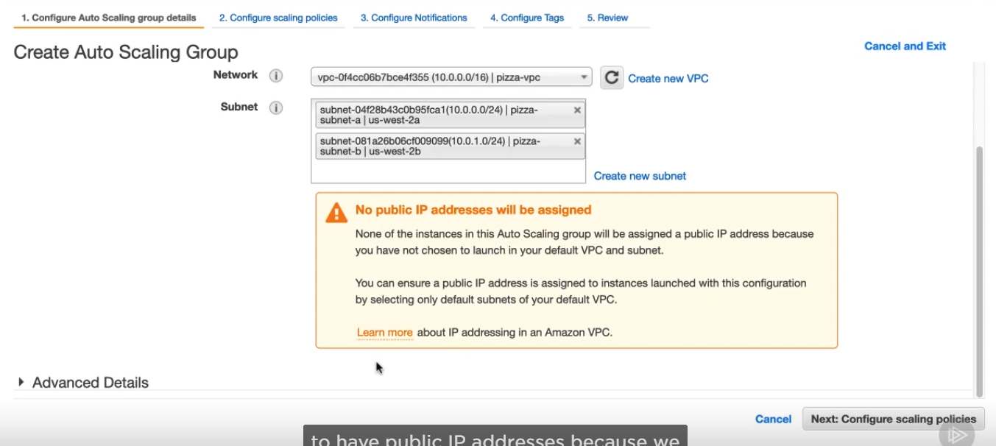

* Expand the advanced Details, section and check the box Receive traffic from elastic load balancers. Here is where we will enter the target group we created, which is connected to our load balancer. So click in the input, and select it from the auto-suggest box. Click Next

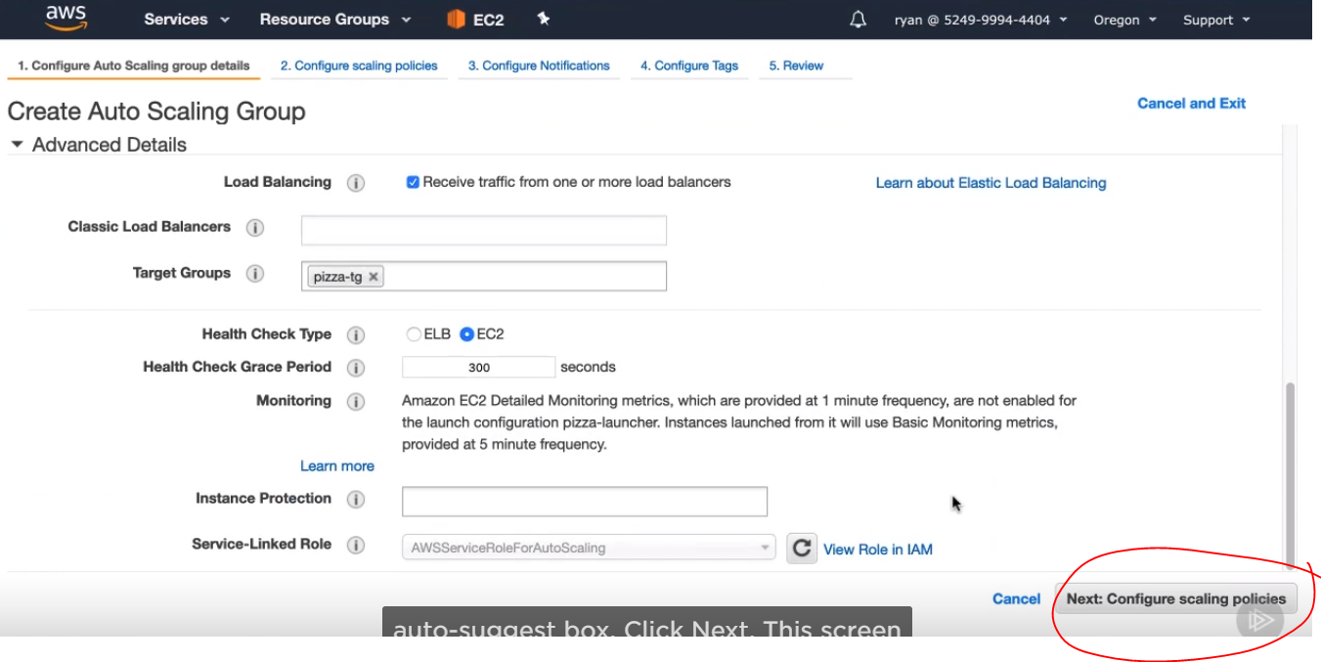

* This screen is where we can configure the scaling rules. We’ll do this after we’ve created the Auto Scaling group, so go ahead and click next again.

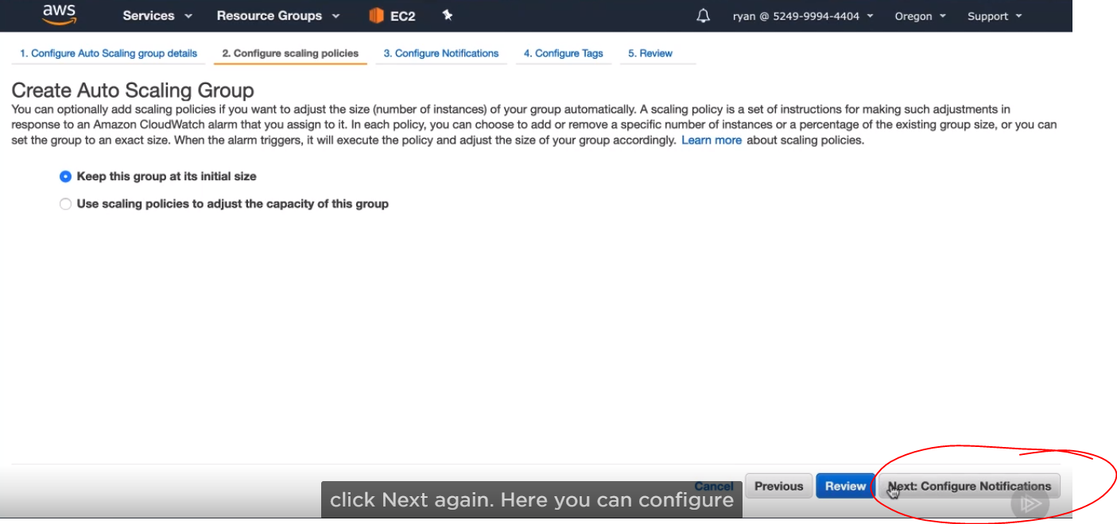

* Here you can configure the auto scaling group to send you notifications anytime it scales up or down or something fails. You can configure if you want, but you will need to create a new SNS topic since the topic we created previously is in the North Virginia region, and you may be working in a different region.

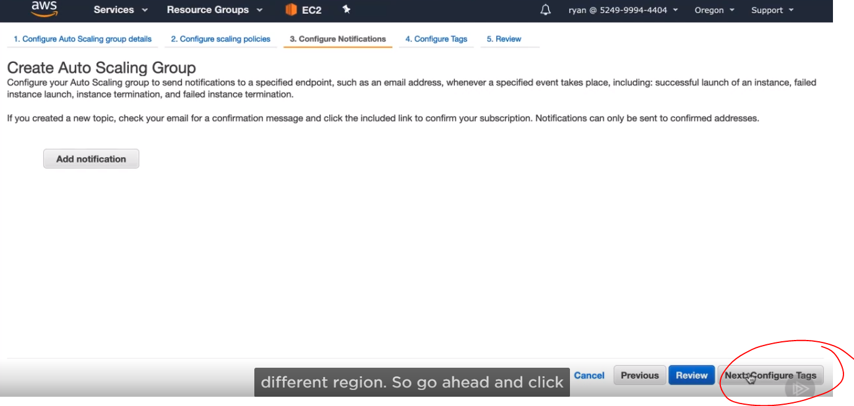

* Then create auto scaling group

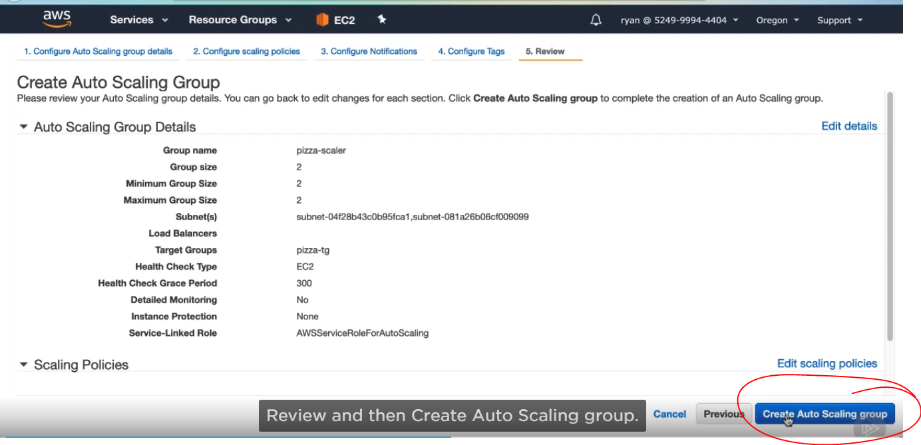

* Now Close.

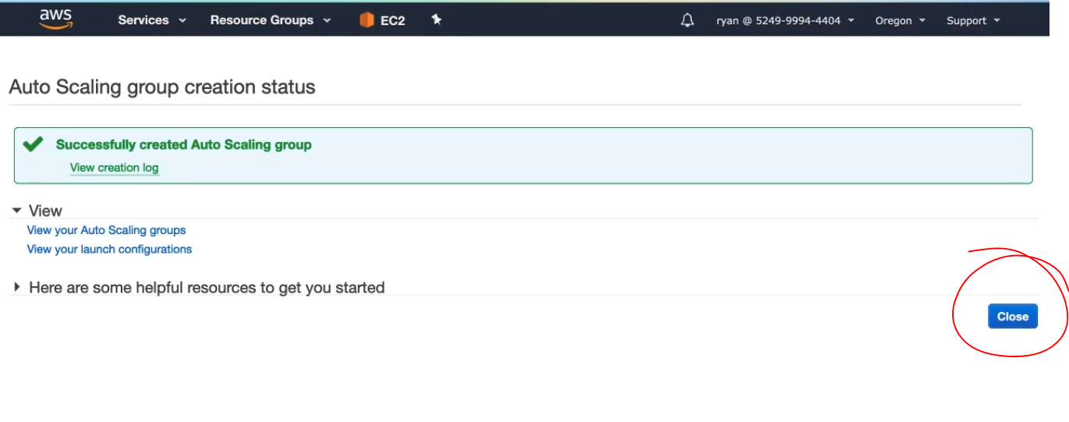

* If you look in the list entry for the auto scaling group. we just created. You’ll see some good information. This section of numbers is where it tells us how many instances are launched and healthy in the Auto scaling group and our min, max, and desired numbers. We should be at 0 instances right now because we just launched the auto Scaling group

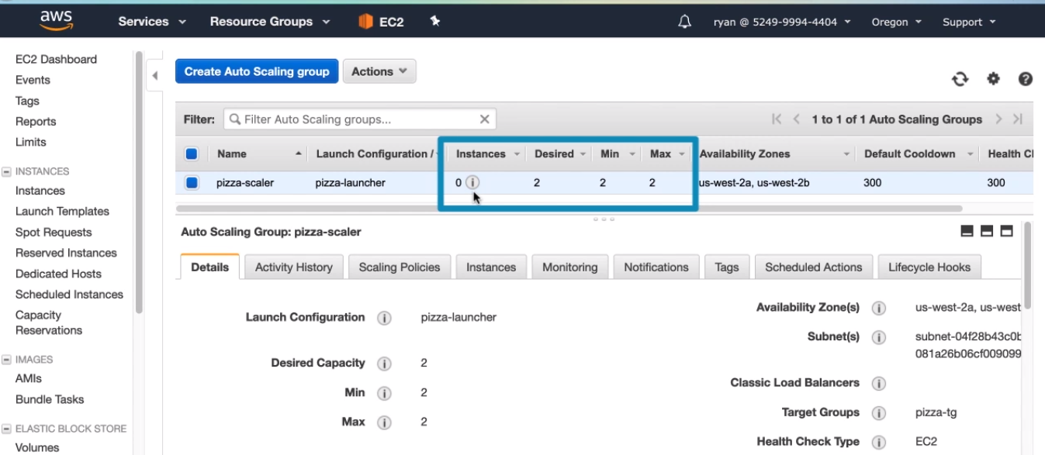

* Skipping ahead in time about 15 minutes, we can click refresh and see that the instances has updated to 2

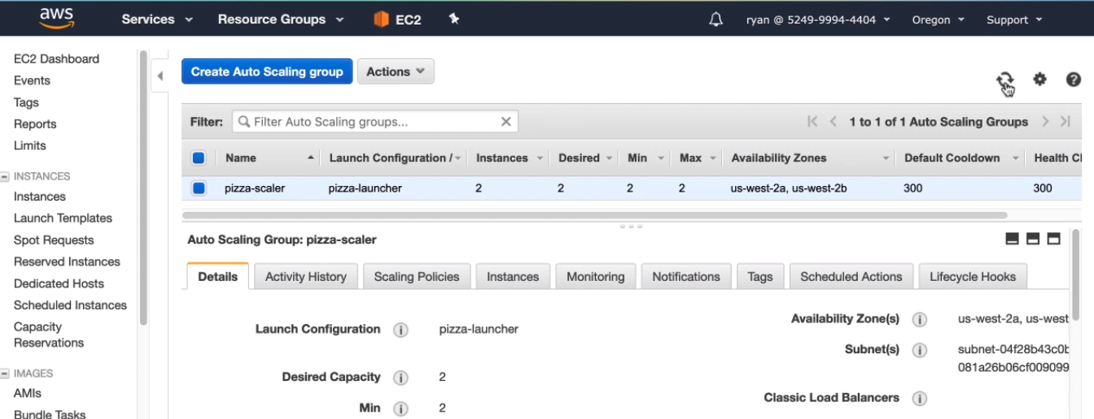

* If we click on the instances tab in the details section, we can see both instances. They are listed as inservices with a health Status of healthy

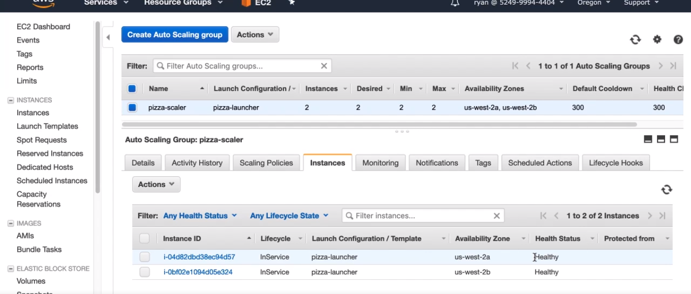

* Click an target groups

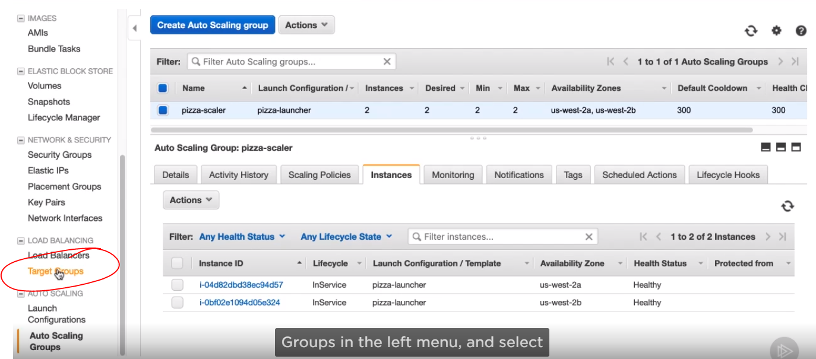

* Select pizza-tg in the list. In the targets tab, you can see it lists those same two instances with status of healthy. This means we have everything configured correctly with our Auto Scaling group feeding the load balancer’s target group with instances.

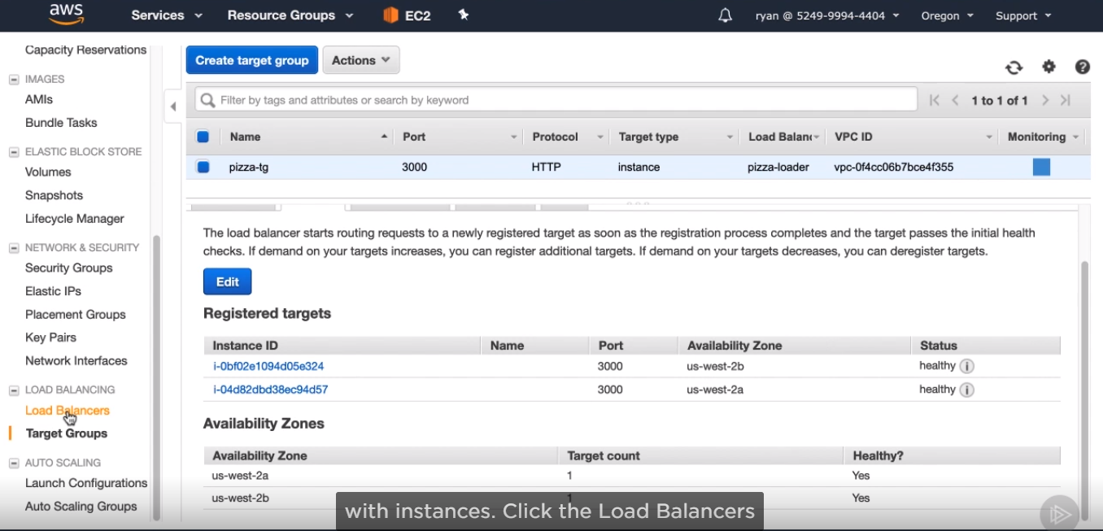

* Click the load balancers menu option, and then select pizza-loader. On the description tab at the top, you should see the DNS name field. This is how you can access a load balancer in your browser. The ideas is that then you would get a normal URL like pizzalovers.com and create a DNS CNAME record to point to this load balancer DNS name.

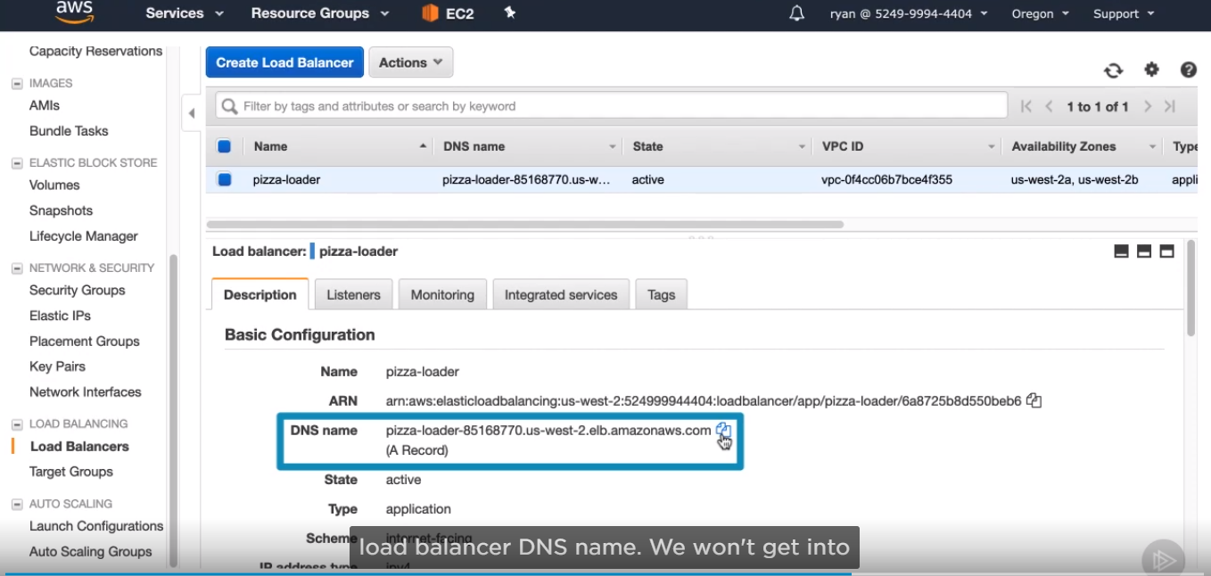

* We can copy DNS record and try it out in our browser copy and paste into new tab.

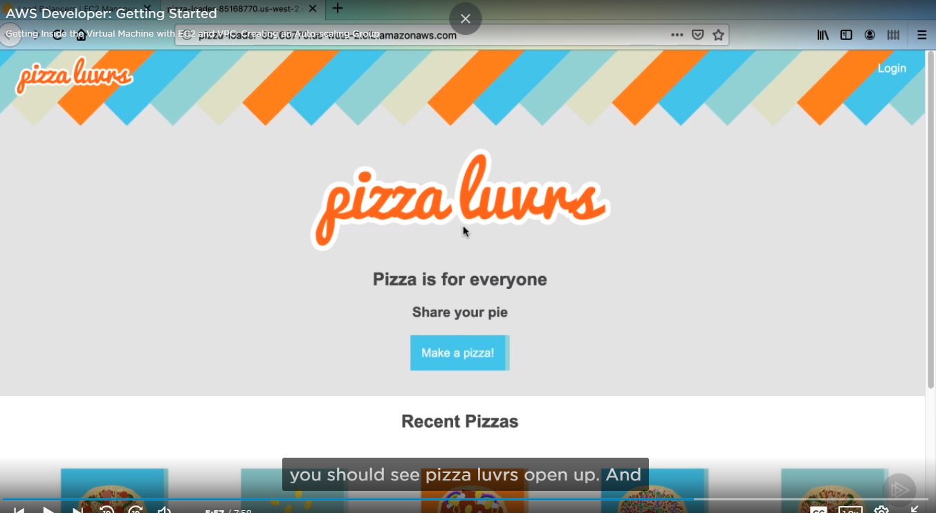

* For more security, click on the security groups option

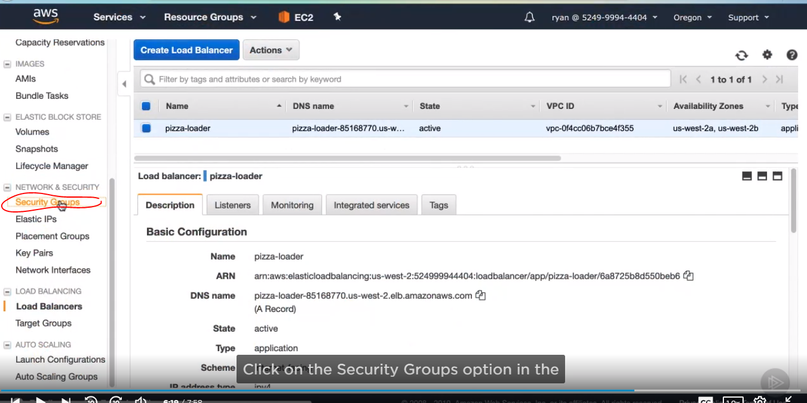

* Then click into pizza-ec2-sg, in the details section, select the Inbound, we have three rules listed here, one for SSH access, one for public access to port 3000 and one port 3000 for all IPv6 addresses. We will still need to SSH into our instance as we modify the application to take advantage of other services, so we’ll leave that SSH rule, but we can change the 3000 rules to only accept connections from our load balancer. Click Edit.

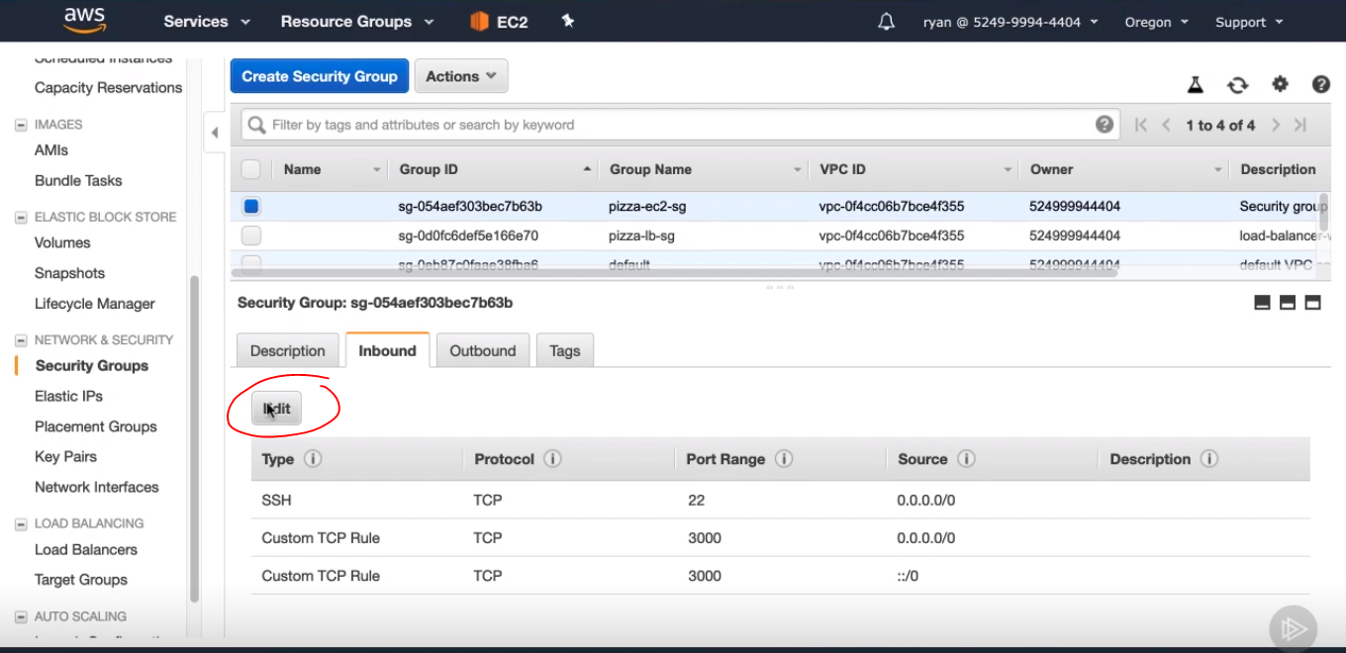

* First go ahead and delete the rule for port 3000 from ::/0. This rule is just for IPv6 addresses,

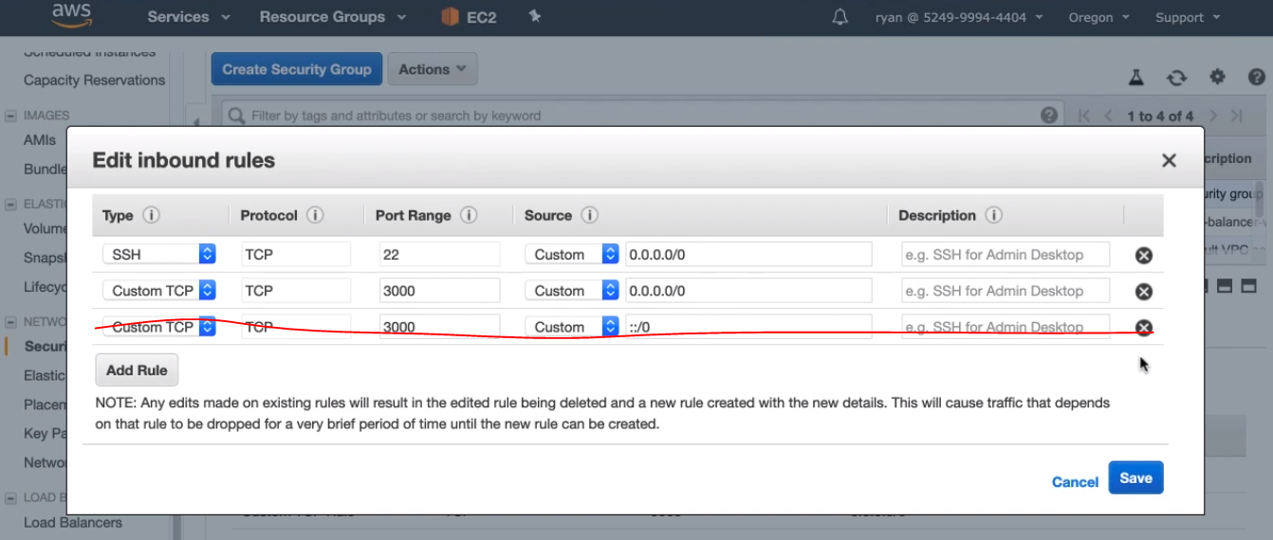

* In the source field for the other port 3000 rule, clear the source input field, and then type the letter s, this is going to bring up the auto-suggest drop-down with security groups to allow access from. Here, we will select our security group for the load balancer. This configurations means that any instance with the load balancer security group will be allowed to connect to our instances on port 3000. This is a way of conveniently giving access without being tied to an ip. Then click save.

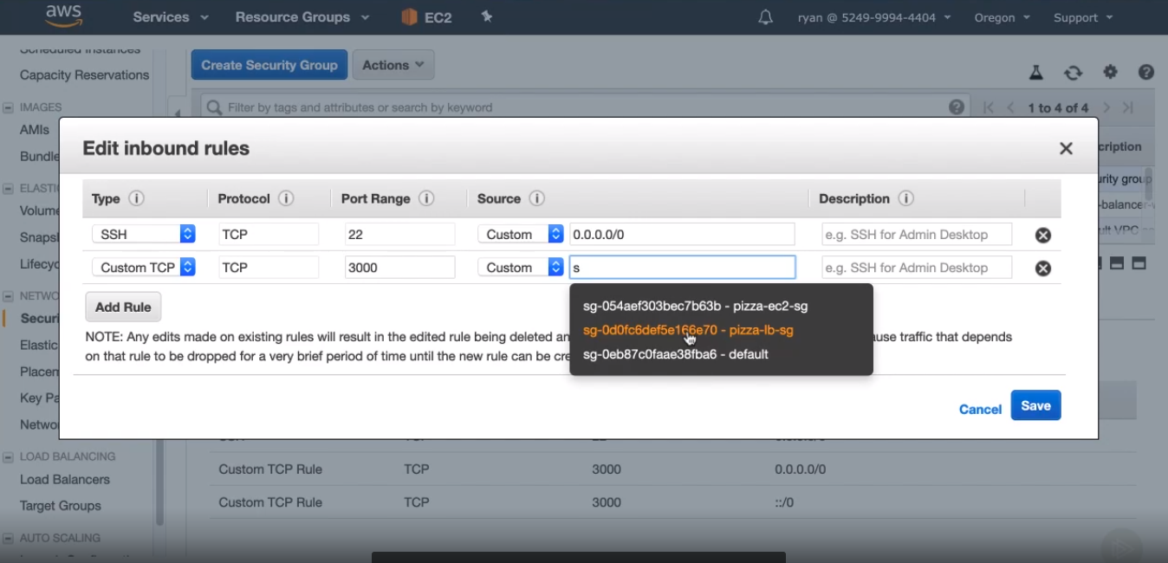

SCALING ACTIONS

* First we need to configurate some scaling rules for our Auto Scaling group.
* Click Auto Scaling groups menu option on the left, and select.

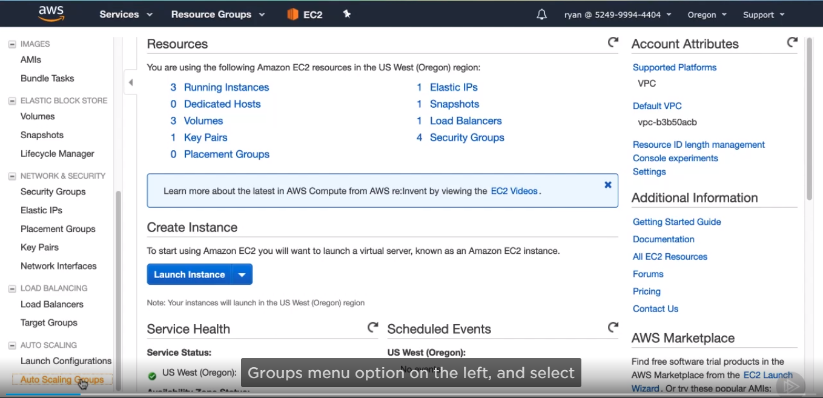

* Select pizza-scaler on the details, click on the scaling Policies tab. This will be empty since we haven’t added any yet, so go ahead and click on Add policy.

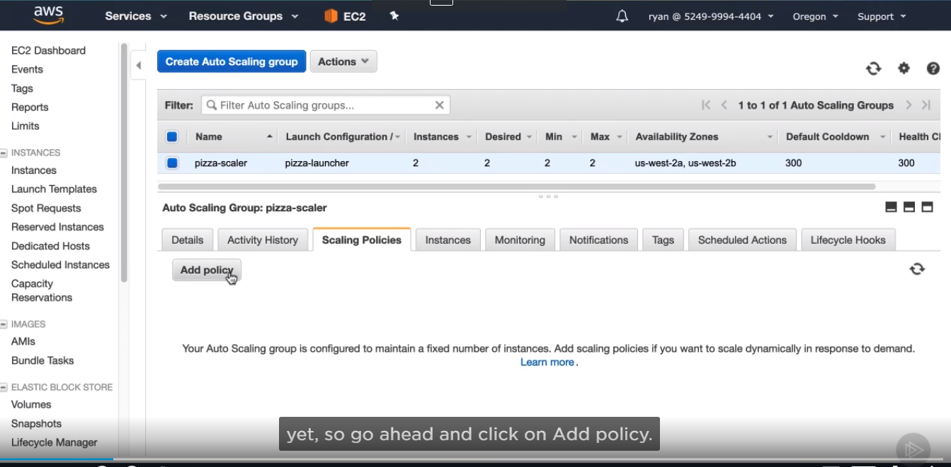

* We will go to a simple policy, name it, next we need to create a cloud alarm.

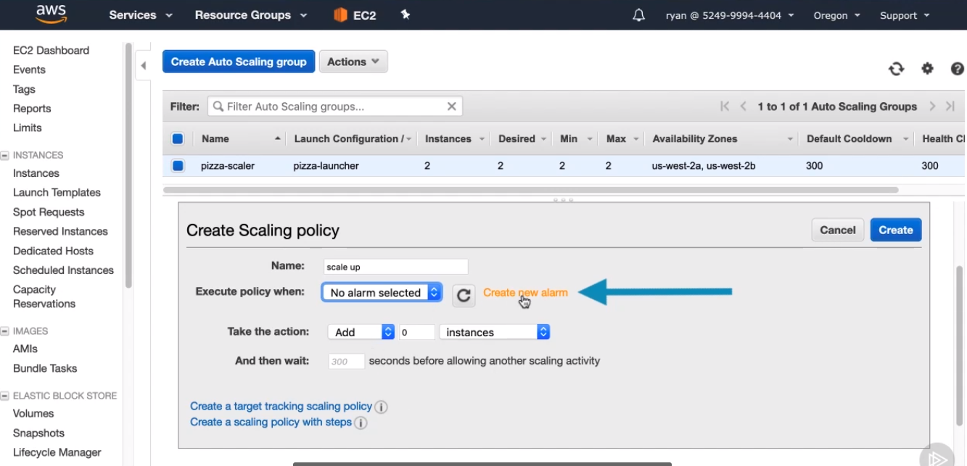

* Uncheck send notifications unless you really want to have an email sent. In production, this is a good idea to do, but we can skip it for this course, now we can set which metric we want to look for at for the instance. My preference is to use Network out as a good judge of how hard the instance is having to work. CPU utilization wouldn’t be bad either, but it is a little easier for us to simulate network out

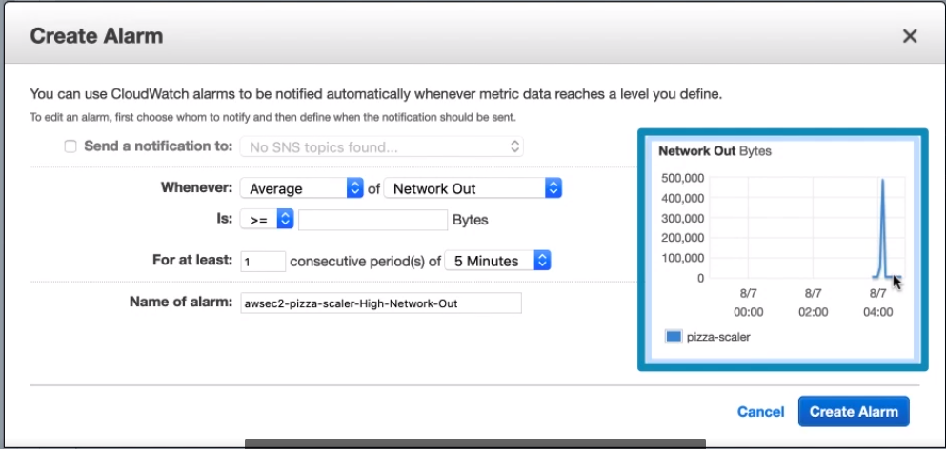

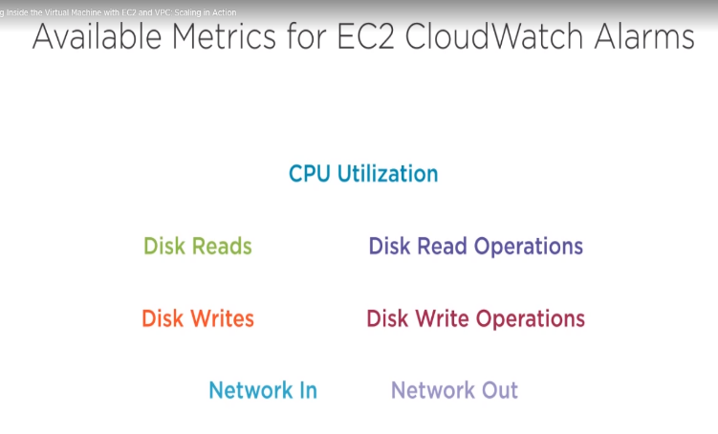

* To the right you’ll see a graphed update and show you the recent average network bytes out from your instances. It will likely be sitting at a kind of average out, maybe around 5000 bytes, which is from the health check sending a request every 30 seconds to the instances. Let’s set this alarm just a little above that baseline. this is definitely not a realistic alarm as you’ll want to set the alarm based on real traffic you are seeing, but this will enable us to easily see scaling in action. I am going to set mine to 10,000 bytes. We leave like this, then create alarm and close.

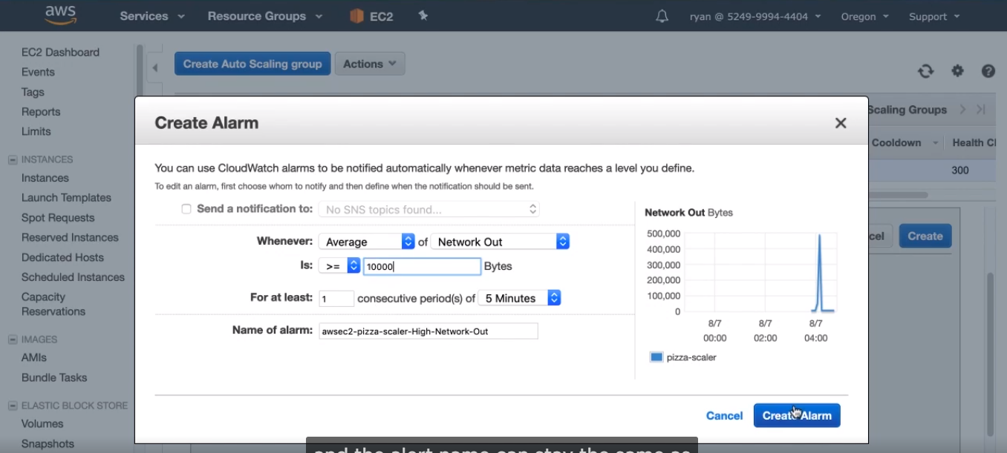

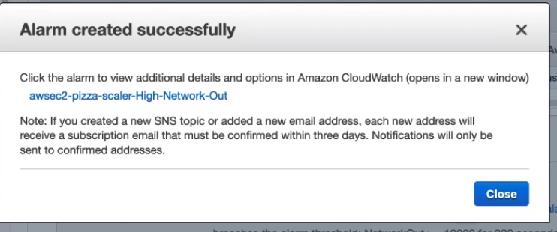

* And the take the action section, this is what the scaling group will do. We want to add one instance, so change the 0 to a 1. And now the policy is complete, so click Create.

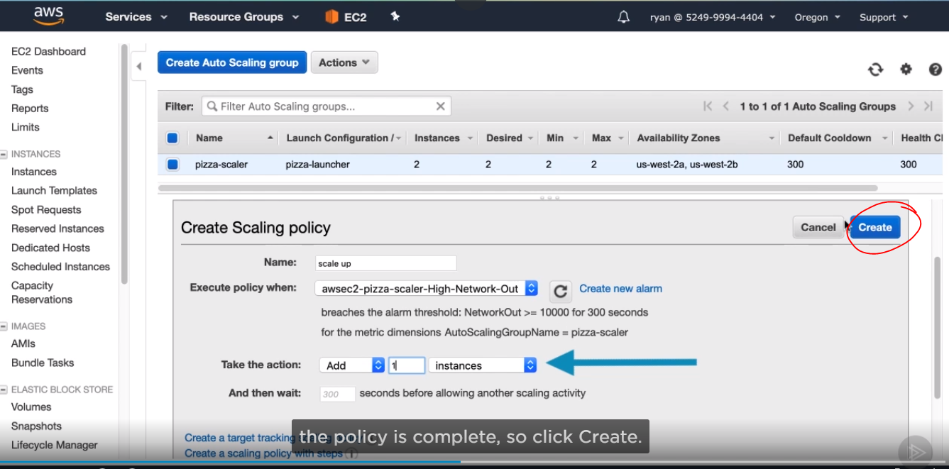

* Add more scaling back down. Click add policy. And create a simple scaling policy.

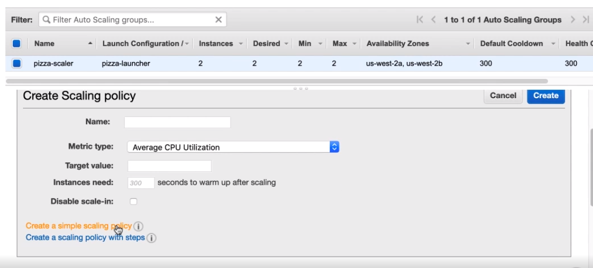

* We need another new name, then create a new alarm, Uncheck notifications. Change CPU Utilization to network out, Use the same 10, 000 bytes. But reverse the comparison from greater than to less than. We are setting this alarm to trigger when traffic has died down and we don’t need as many instances. Change the rule name from High-network-Out to Low-network-out, Then click create Alarm.

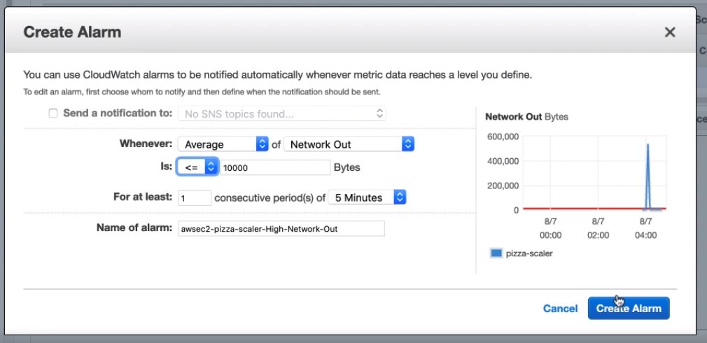

* Then we are going to terminate an instance instead of creating one. So change the Add drop-down to remove, and change 0 to 1, then create.

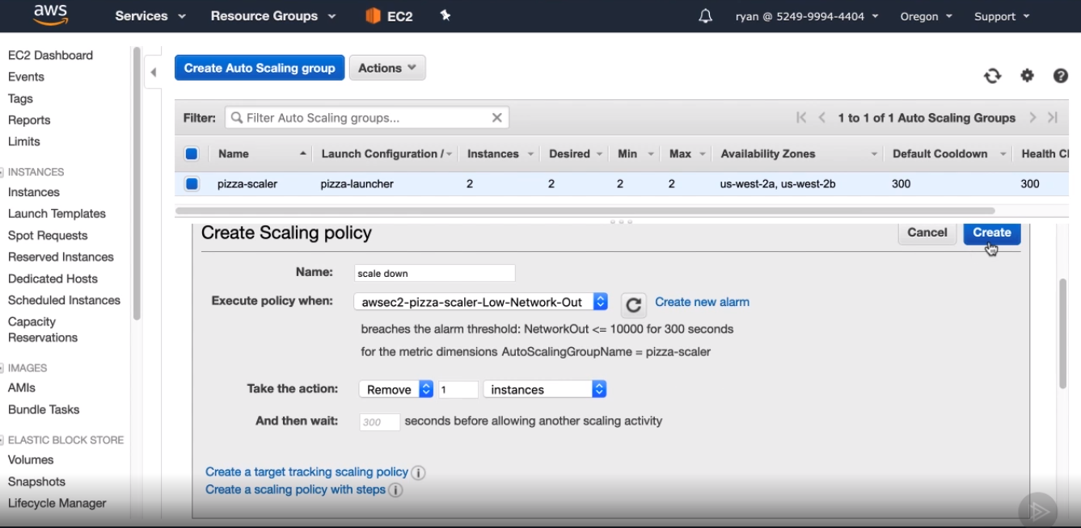

* Then, select details tab and hit edit. We can leave Desired and minimum at 2 but for a Maximum, let’s change that to 4 instances. Hit save an now our scaling policies will be able to add instances until the total reaches four and then remove them until the total reaches two.

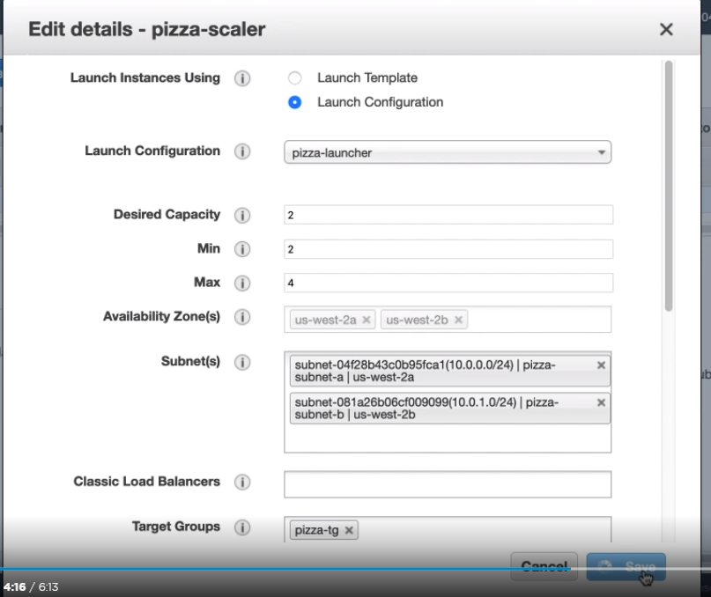

* We can put a little load on our application and watch the instances scale as needed. There are many ways you can simulate load. You could disable browser cache and refresh a bunch of times. A simpler and more automated way is to use a tool like JMeter or Apache Benchmark. We simulate a load on the load balancer and trigger scaling.

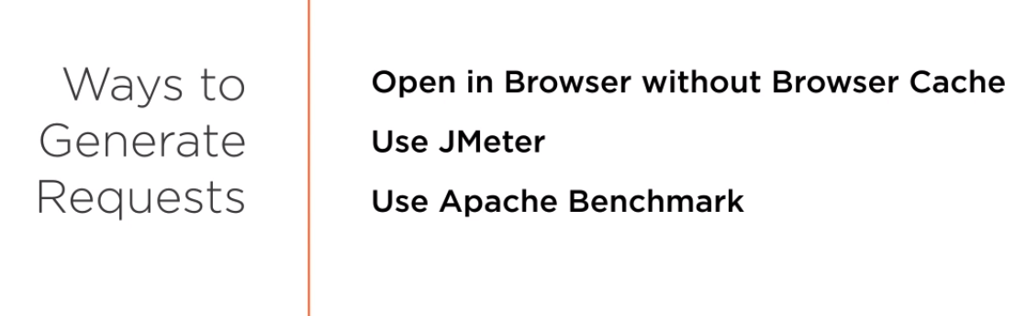

* We need to install Apache Benchmark, then go to command line, you’ll enter the command ab -n 100 -c 5 and then the URL for the load balancer with a trailing slash and the HTTP protocol. Then enter.

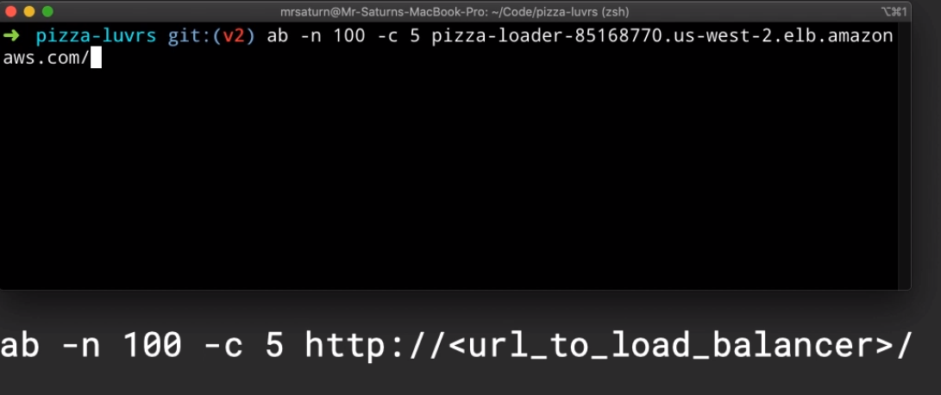

* This will send a total of 100 requests to my load balancer at a maximum of 5 concurrent requests at a time. This will easily trip the network out alarm and scale my instances.

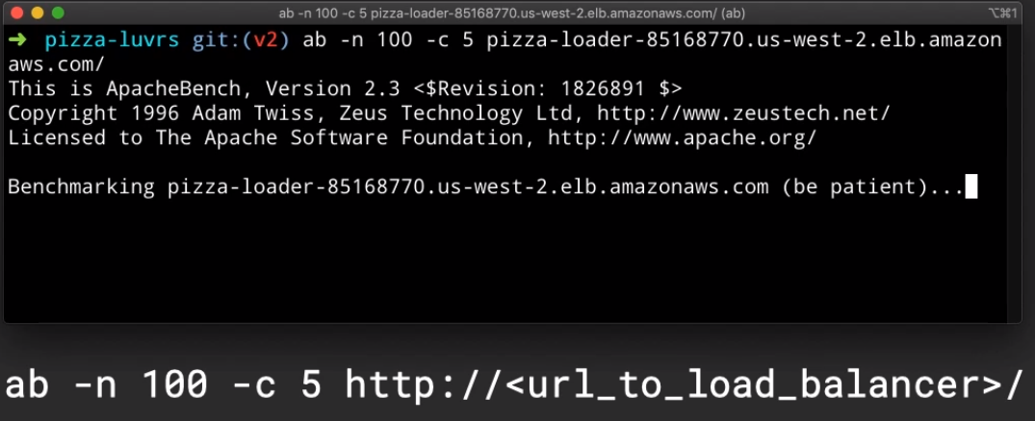

After kicking this off, I am going to time warp the video again as the cloudwatch alarm needs about 5 minutes do aggregating before it triggers.

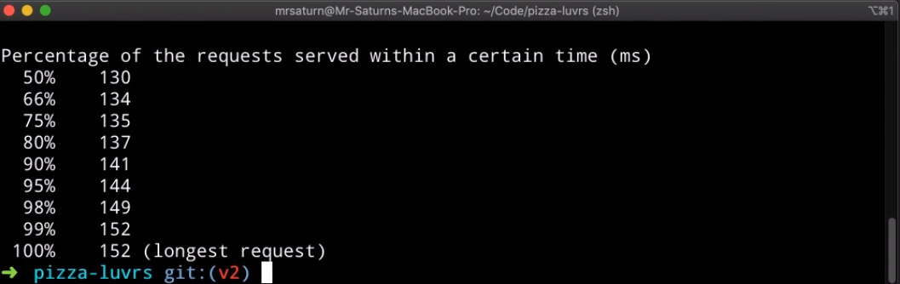

* Now if I update the activity history in my Auto scaling group, you can see that it is

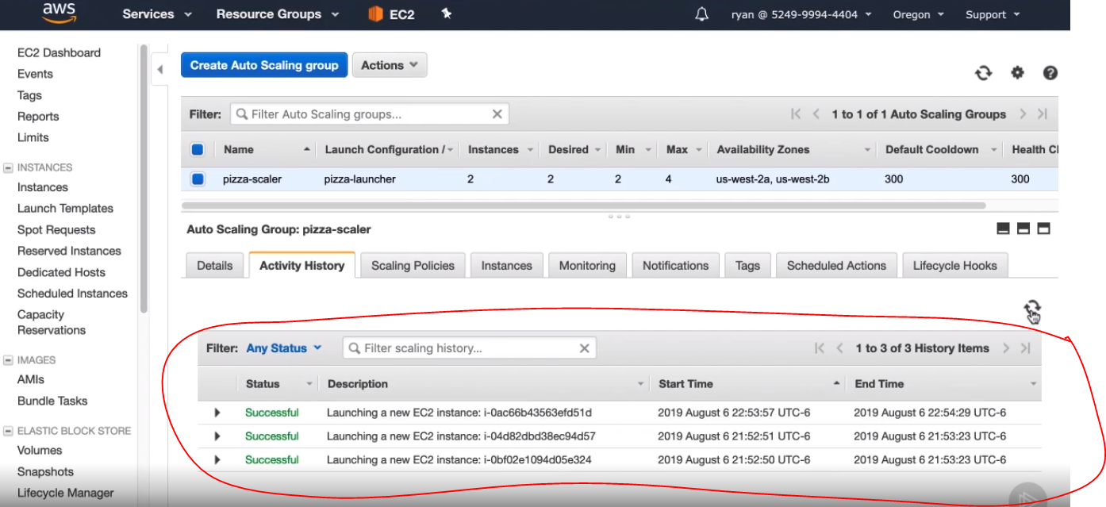

SIMPLE STORAGE SERVICE (S3)

It is one of the oldest services in AWS, alongside (next to) EC2. The longevity and appeal of this service is in its simple utility. S3 stores objects, whatever they may be, and allows you to easily configure who can see them. S3 stores your objects in whichever (no matter which) region you select, which can be important for legal or regulatory reasons. With the amount of regions available, this type of specificity in storage location should satisfy any concern.

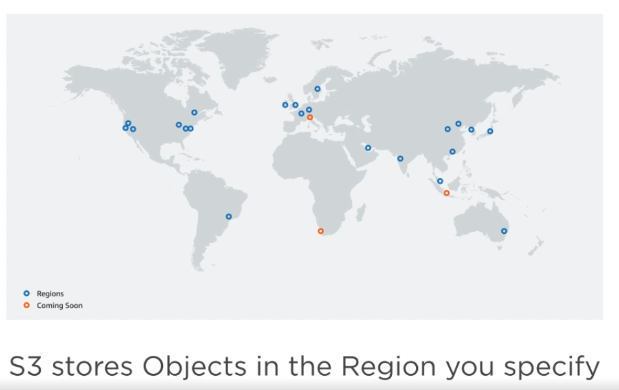

In S3, objects are the fundamental storage structure. An object is basically a file and metadata. (Metadata is "data that provides information about other data". In other words, it is "data about data." Many distinct types of metadata exist, including descriptive metadata, structural metadata, administrative metadata, reference metadata and statistical metadata.)

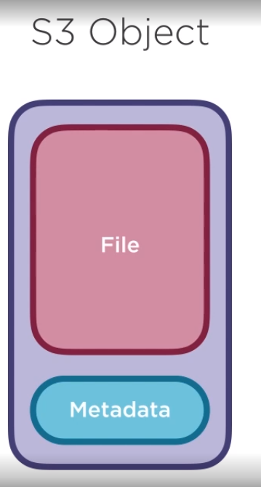

The metadata is used by S3 and includes things like file type and modified date as well as any custom metadata added. S3 doesn’t care what type of object it is, and the maximum file size limit is essentially a joke except in the most extraordinary circumstances.

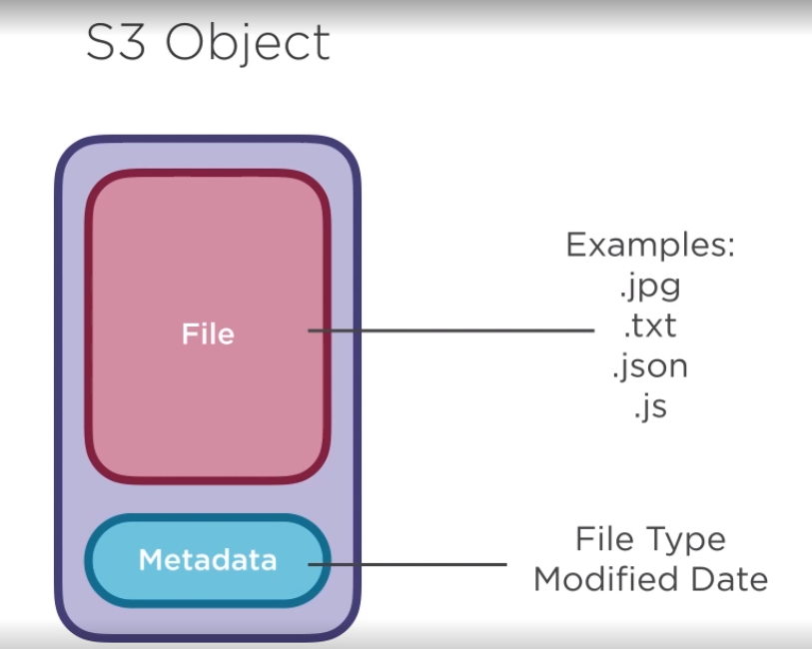

In case you ever need it, the maximum object size that can be stored currently in S3 is 5 TB. There is an upload limit as well for a single put operation at 5 GB, so to get to the 5 TB limit, you would need to use the s3 multipart Upload tool. I have personally never come close to approaching that type of storage in S3.



Objects in S3 are stored in another fundamental structure called buckets. A bucket serves a few purposes in S3, the first is to store your objects; simple as that.

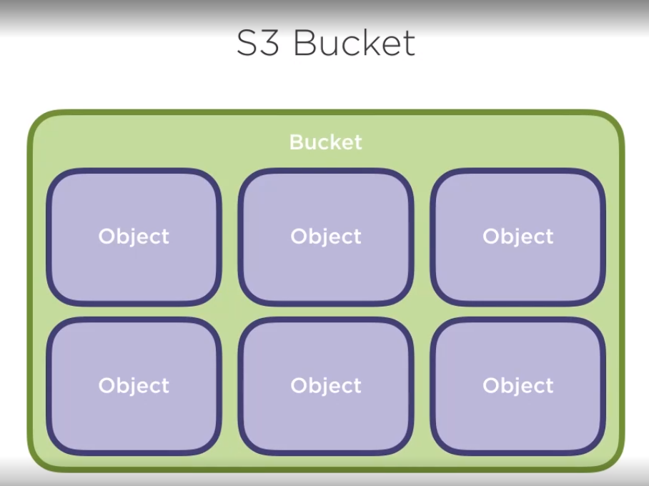

The second is to create a URL namespace for those objects. For instance, if we create a bucket in the Oregon region and named it pizza-lovers would assign this URL as the route for any objects. Because of this, the bucket name needs to be unique throughout all of S3, not just in your account. Objects are uniquely identified in S3 via their key, which is the path and file name, excluding the bucket name. For instance, an object with the file name image.png, in the folder images would have a key of images/image.png. when interacting with S3 via the CLI or SDKs, the term key is used often, so just keep in mind that it includes the path, as well as the file name.

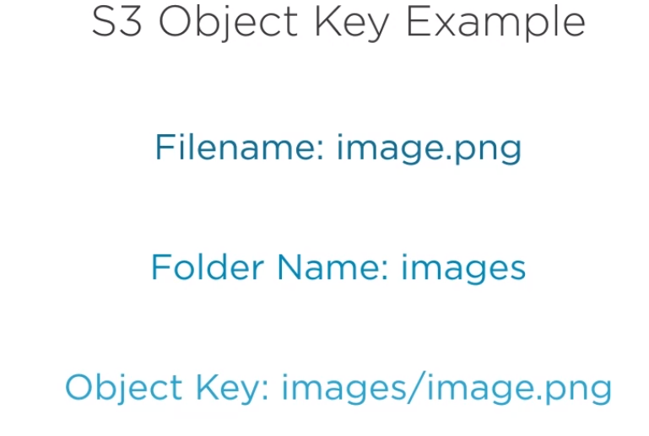

There are a few different ways that you can configure who can access your buckets and objects and how they can access them, but I want to focus on just two in this course, the first permissions for the bucket or object. By default, S3 buckets and objects are only viewable by AWS account which created them. Permissions enable you to grant access to another AWS account or anyone. Usually for web resources, you would want them to be viewable by everyone, but not modifiable.

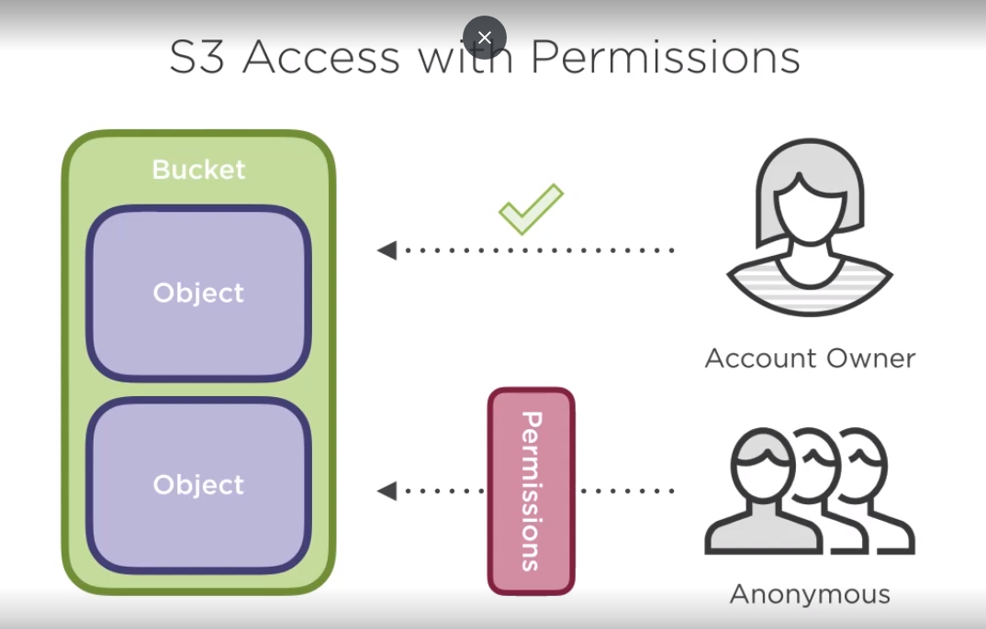

The other access mechanism is using S3 or IAM policies. We discussed policies in the clip on IAM, and by using those policies, you can enable a user on your account to interact with S3. The policies in S3 or IAM are modeled the same with some slight differences, and we will try out both in this module.

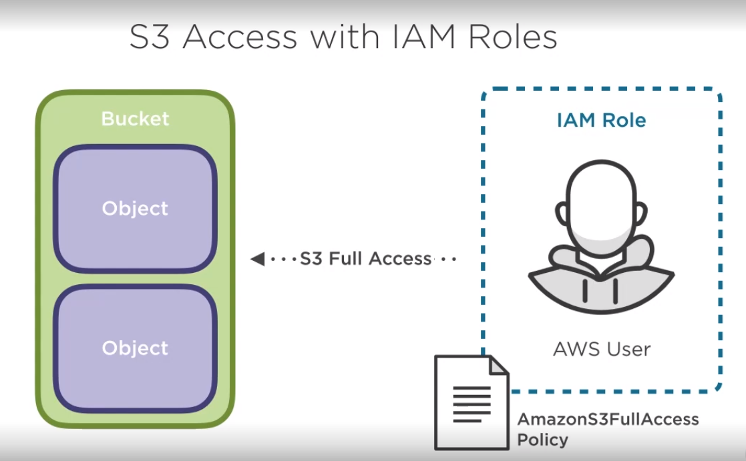

One thing you may be thinking is that storing all your objects in a single region may increase latency for users making web requests from other locations in the world and that is correct. Users from Australia, for instance, requesting and object from a bucket in say Oregon will experience more latency than if they were requesting the same object from a bucket in the Sydney

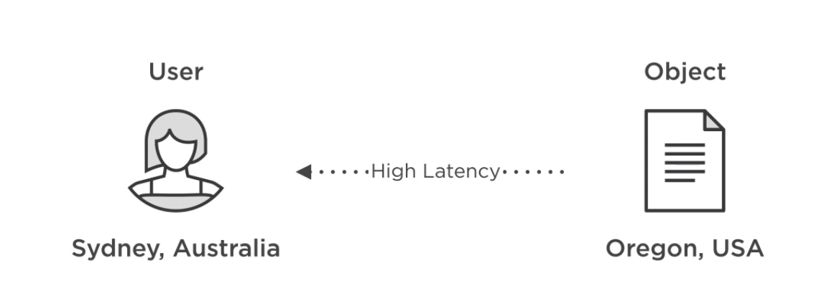

One solution for this issue is cross-region replication. This is a configured feature of S3 that will automatically copy any files added or modified in an S3 bucket to a different region. This feature can be used to reduce latency or to increase redundancy of the data. One consideration though is that cross-region replication will copy to only one other region.

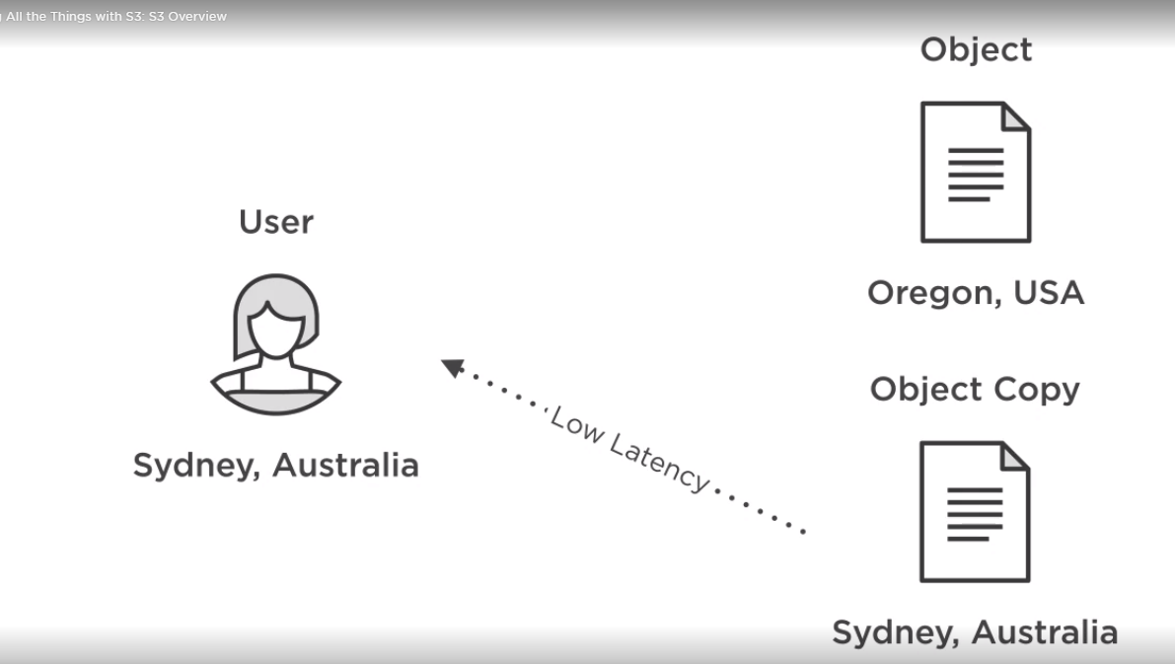

If you want to have a worldwide reduction of latency, your best option is CloudFront

Creating an S3 Bucket

* We can upload objects and store the pizza images. Just like EC2, we are probably going to be accessing S3 a lot, so click on the blue Create bucket button.

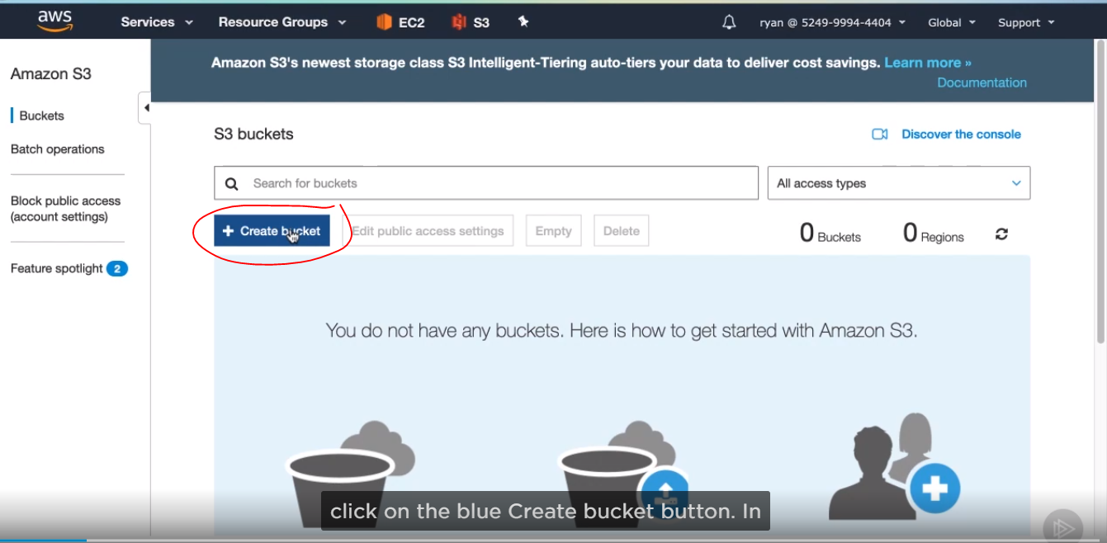

* In the bucket name field, we’ll need to enter a unique name for our bucket. I’ll name mine pizza-lovers-juan. Next is the region where the bucket will be located. You’ll notice that the region menu option at the top of the screen is now listing Global. In S3, you will be able to view all buckets from any region simultaneously, which is a little different than most other services. That’s why you see this region drop-down instead of it just automatically being launched in the region you are currently in. Now click next.

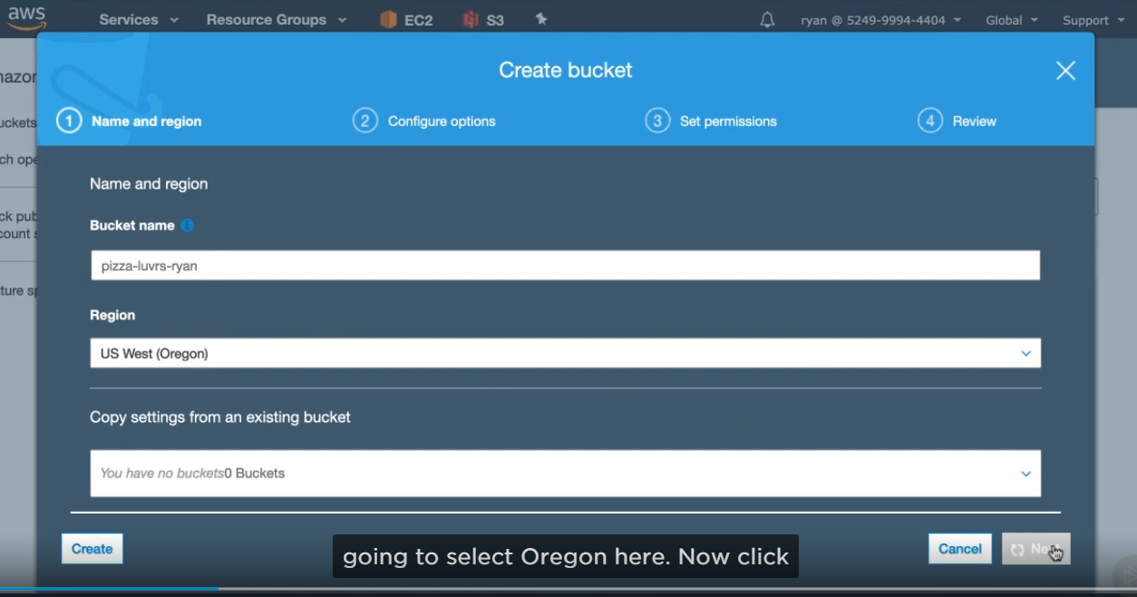

* Here we’ve got settings for versioning, logging and encryption. We don’t need to set any of these, so click next.

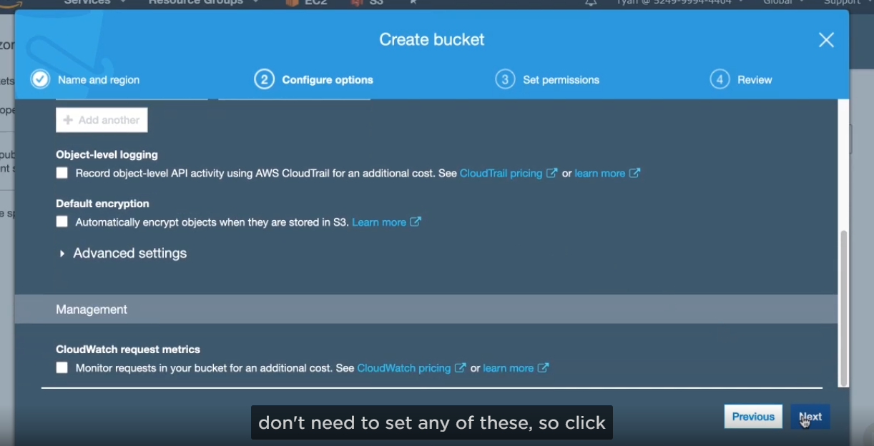

* Now we have settings for the privacy of your bucket. AWS is setting this bucket to be private by default but for our purpose, this bucket will be serving up assets to users through our web app, so we need to be public. Uncheck this box next to block all public access so that we can add public access to the bucket later, now click Next and then create bucket.

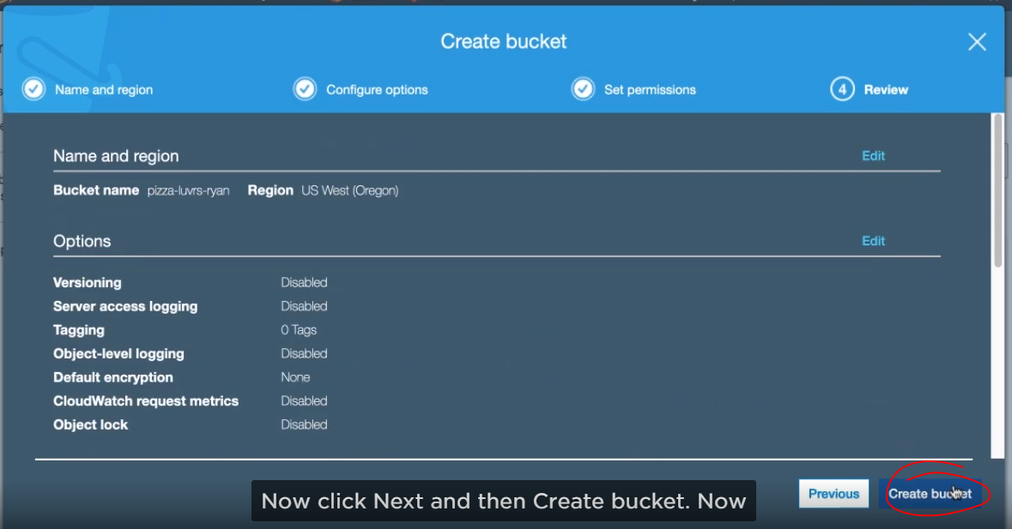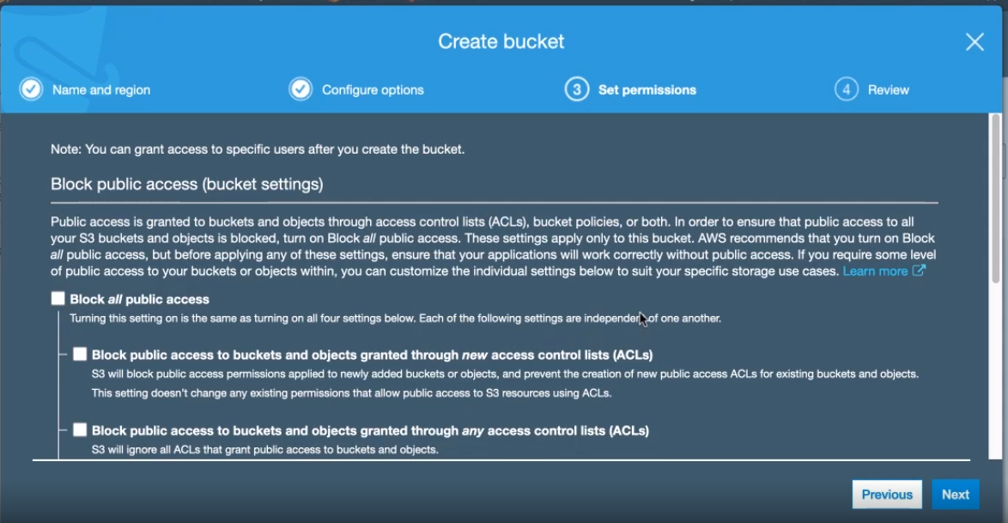

* Now you can start uploading objects to it immediately, but before we do that, I want us to configure permissions for the bucket.

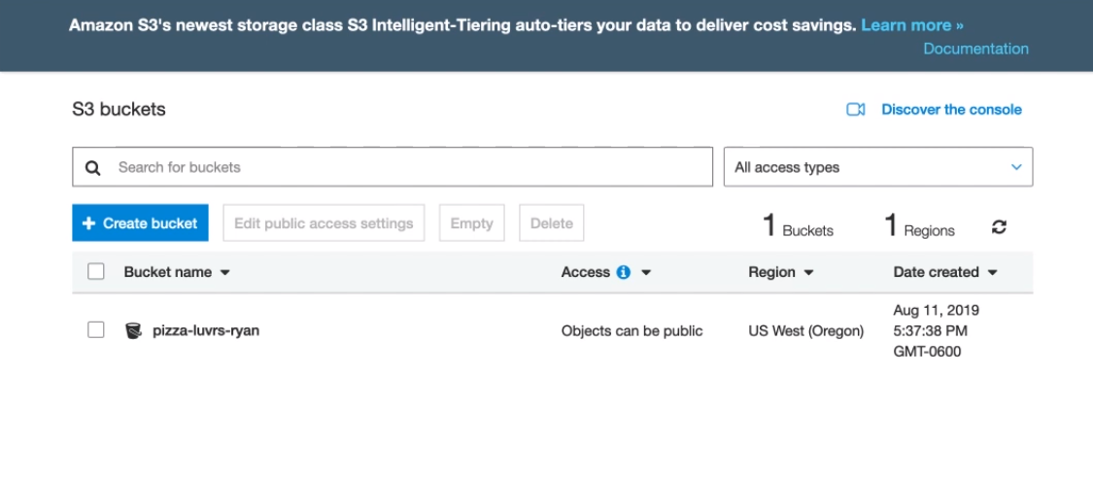

* Now, we need to click into the bucket, and then click on permission tab.

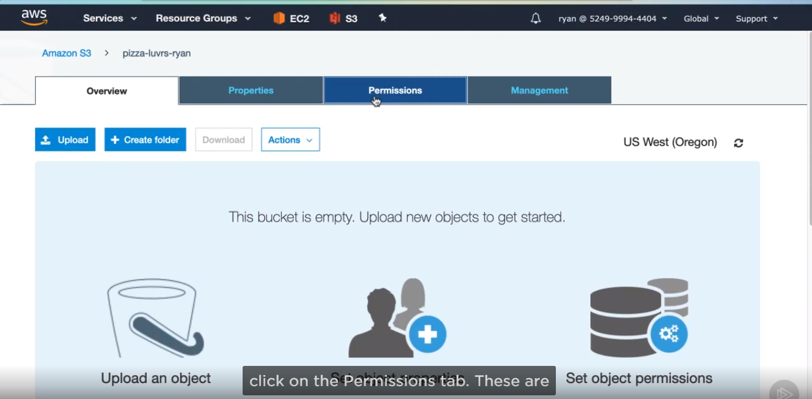

* These are bucket permissions, which give access to view the bucket’s contents and make changes. Each object also has its own permissions, which give you more fine-grain control. However, we will be allowing this bucket to be completely public, so we want to apply a single permissions policy to give anyone access to view every object in this S3 bucket. By doing this, we won’t have to give individual object permissions to every object we upload.

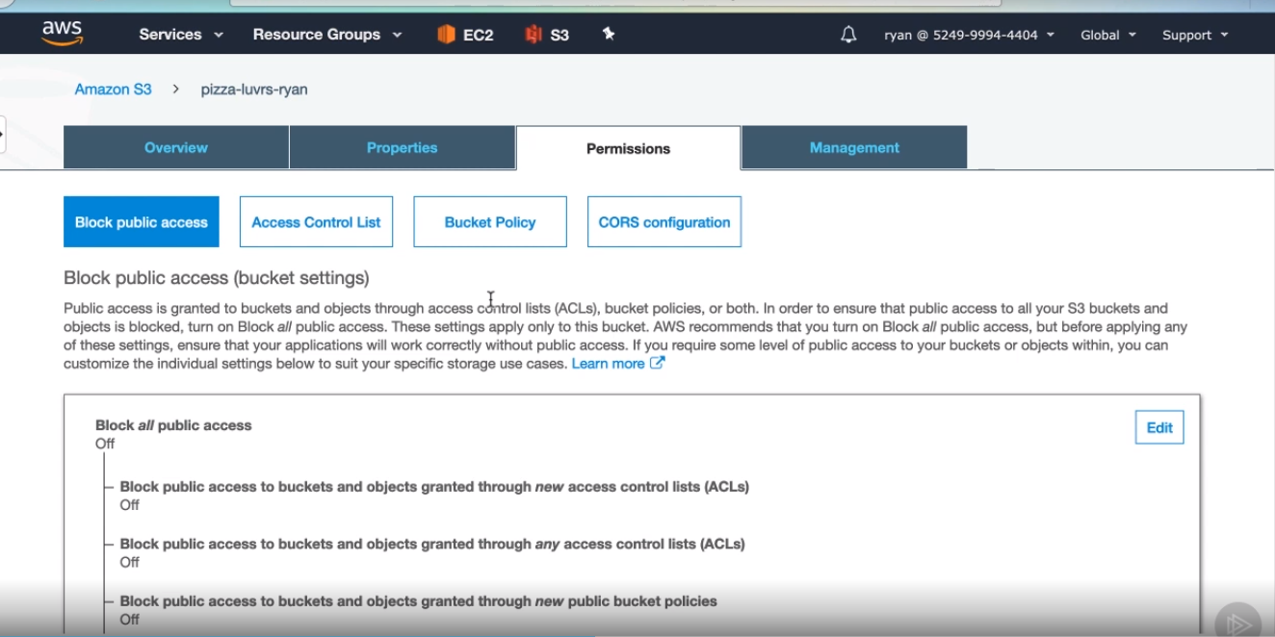

AWS already provides a really good tool to build policies. Policies, as you saw in the IAM module, are just JSON and they can be a little tedious to create by hand that’s why the AWS Policy Generator is so great. Let’s use Policy Generator tool to give anyone permissions to view objects in the bucket we just created. Go to the link

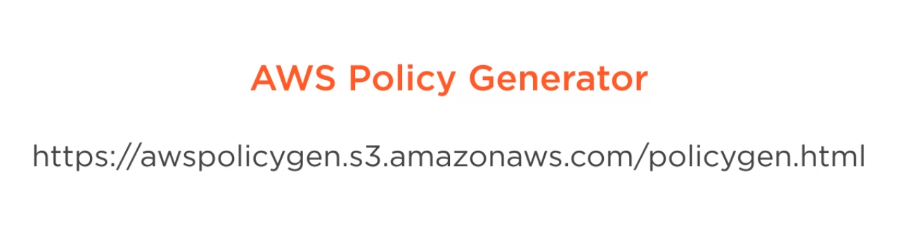

There are many different types of policies that this tool can generate, so you may want to use it anytime you need to generate a policy.

First, select S3 Bucket Policy.

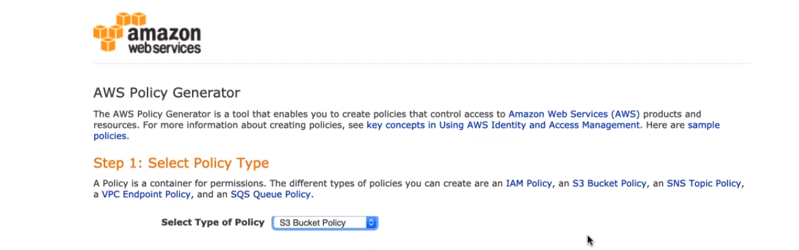

* Now we can add one or more statements to this policy, but we’ll only need to make one for our purpose here. The Principal field is who should be able to access it. If you wanted to give access to another AWS account, you would enter the Amazon resource name for that account. We want to give access to everyone, so enter an asterisk * here. The next drop-down, which is for services, is preselected due to the first drop-down, next we need to pick the action, which is what the principal can do in S3. Select GetOject from the drop-down. Since we want them to be able to download and view images and assets in their browser. For ARN, we will have to build this ourselves. The ending /* is important because this should apply to any object in my bucket. The ARN that you should enter and have your bucket that you created. Then click Add Statement.

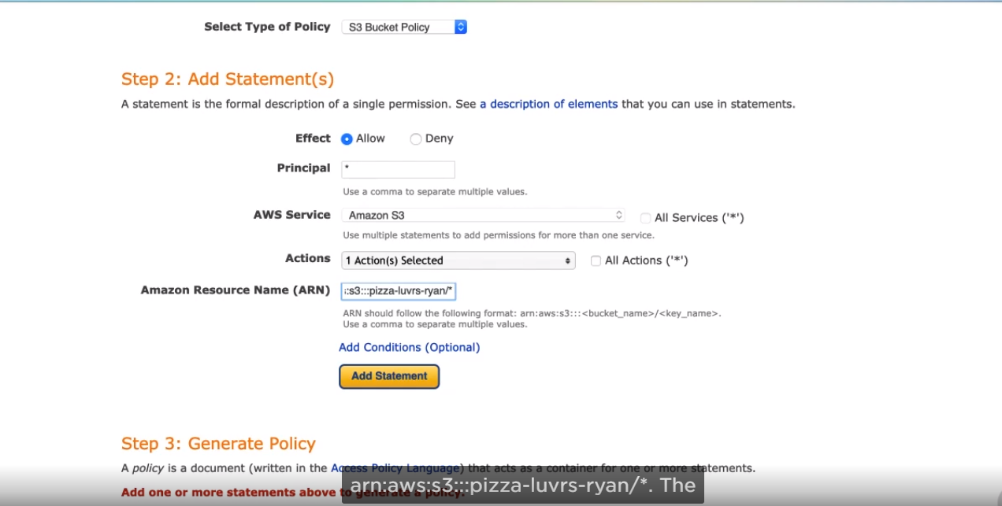

* You can add more statements, then click Generate Policy.

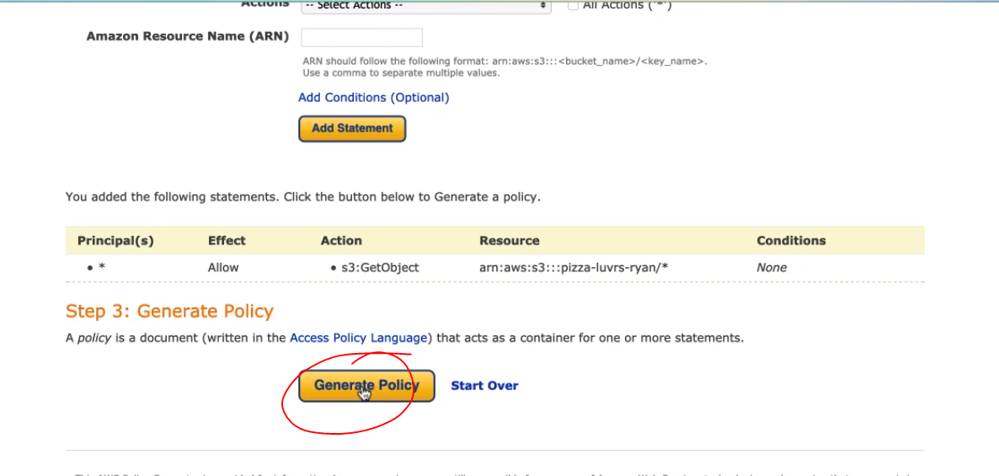

* Then copy the JSON in the window that pops up. We are going to use this with our bucket,

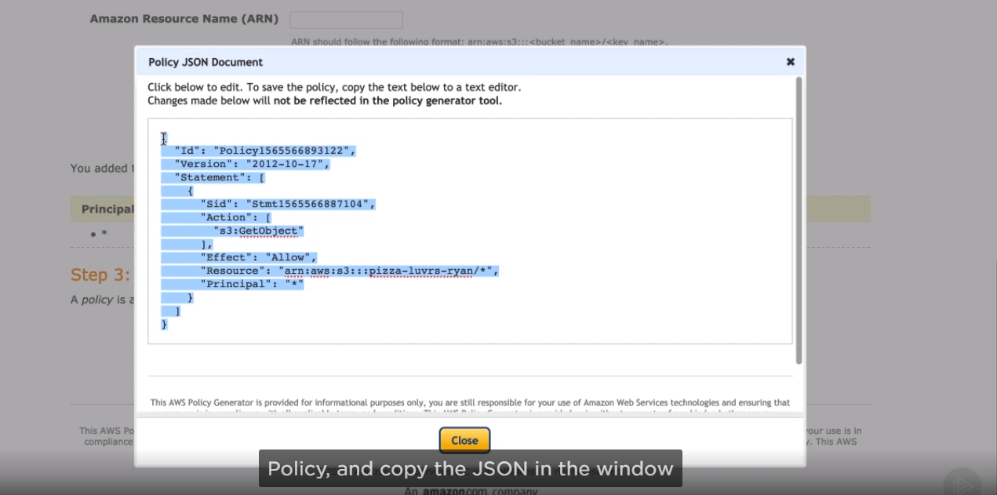

* so go back to the s3
* In the permission tab, click on the bucket Policy button. Copy the policy json. Then hit save.

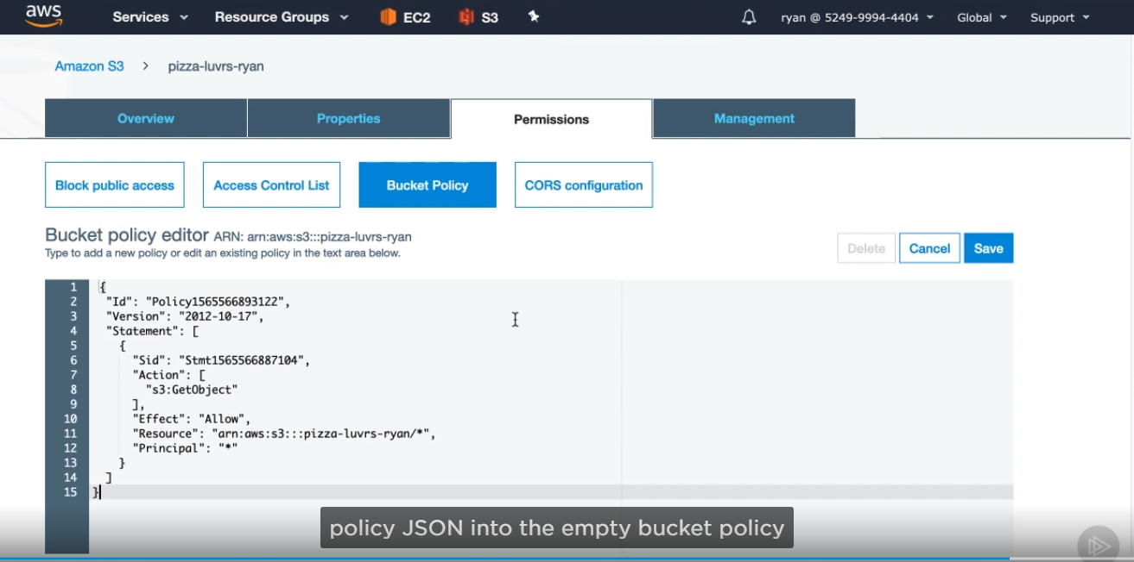

* You’ll notice a few things change, like this public notification and a warning from AWS.

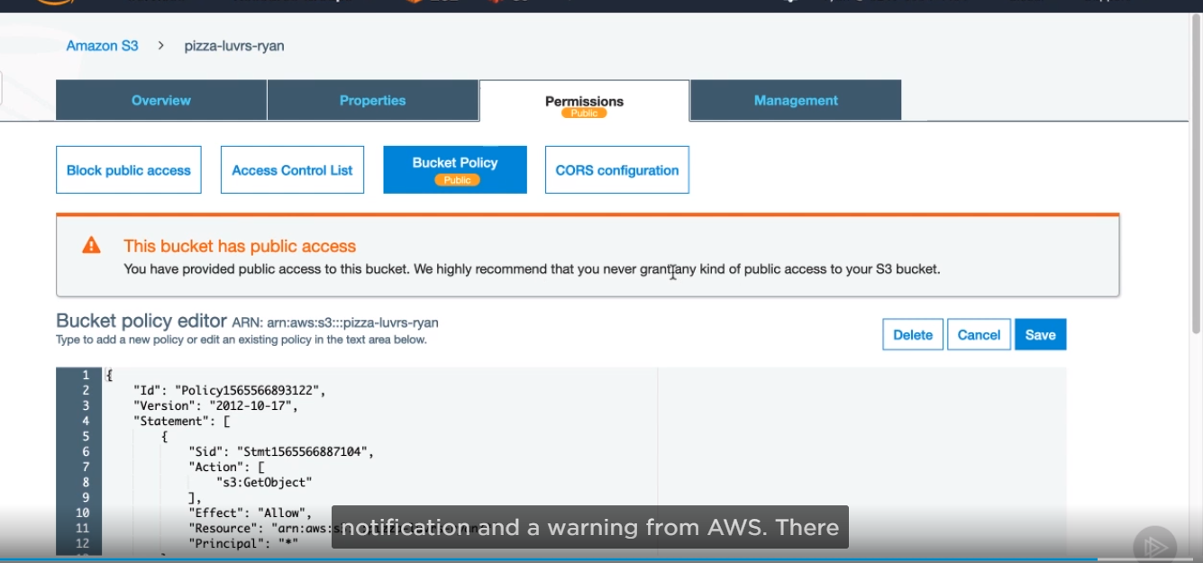

There have been some recent high-profile stories of data being leaked form customers accounts because they mistakenly had an S3 bucket configured to be public. AWS made these changes to make it brutally obvious whenever a bucket is public. Now with this policy in place, every object in this bucket will be publicly accessible, which is exactly what we want.

Now, that we have a bucket to store our objects, we need to actually get them there. Here are some of the various resources that our web application uses. We will be moving all of these to S3, and then we’ll need to change any references to these files in our code to the URLs used in S3.

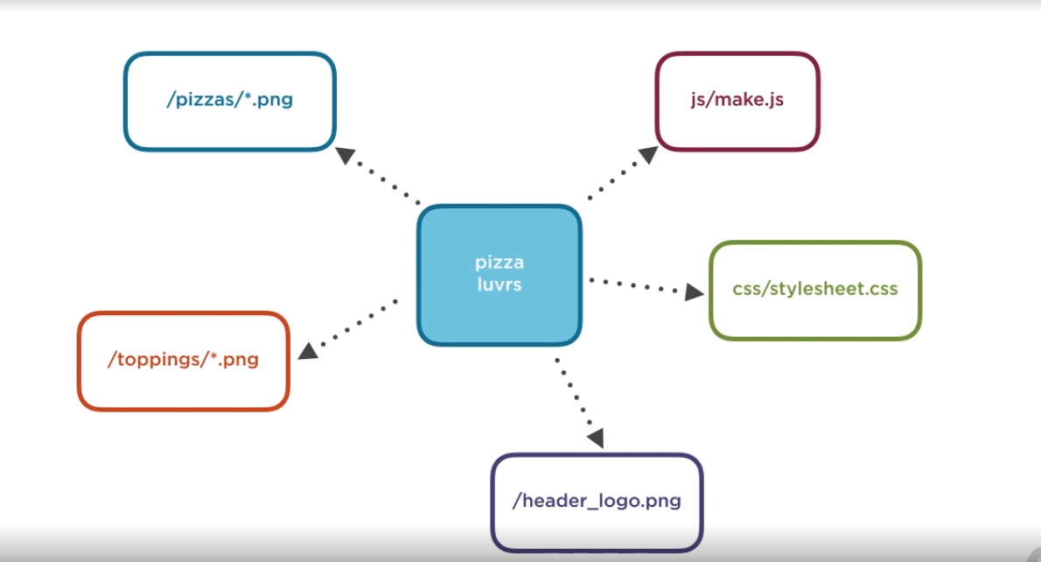

* You can upload objects to S3 using either the console, the AWS cli, or SDK, we will be doing all three in this module, in the next clip, we’ll dynamically do this for the new pizza images, but in this clip, I will demonstrate uploading with both the console and the cli. The console is an efficient way to upload a file quickly if you have small number of them. If you need to do bulk uploading, then the CLI is much better at that since there’s no GUI to have to click through. Let’s start by using CLI to upload some of our.

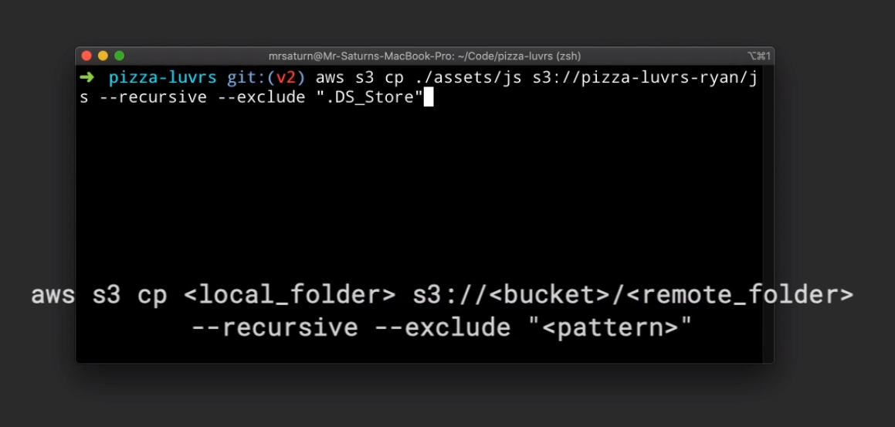

* Now let’s execute that command, and you should see the output that it copied a single make.js. now, recreate that same command but switch out js for css in both the source and the destination. This will copy another file, stylesheet.css Now, swap out css for pizzas, and execute command one last time.

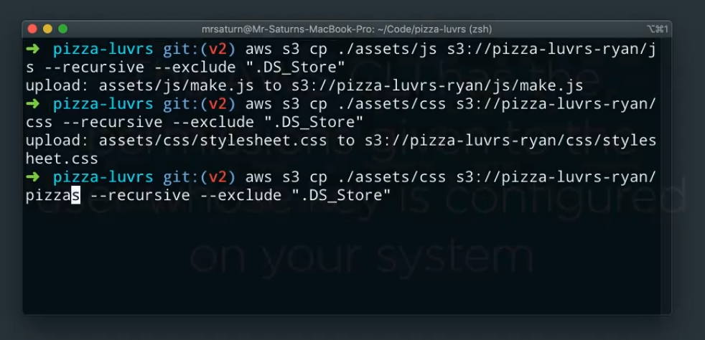

One thing to note We are executing this operation with the credentials from the user you created.

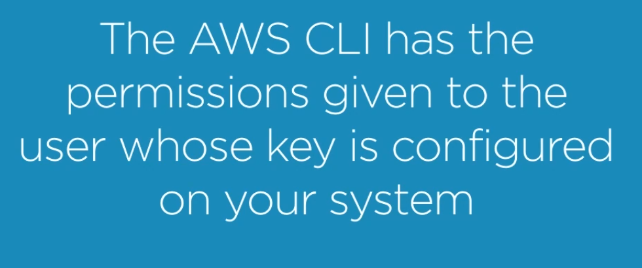

* Open up the S3 console, and click on your bucket.

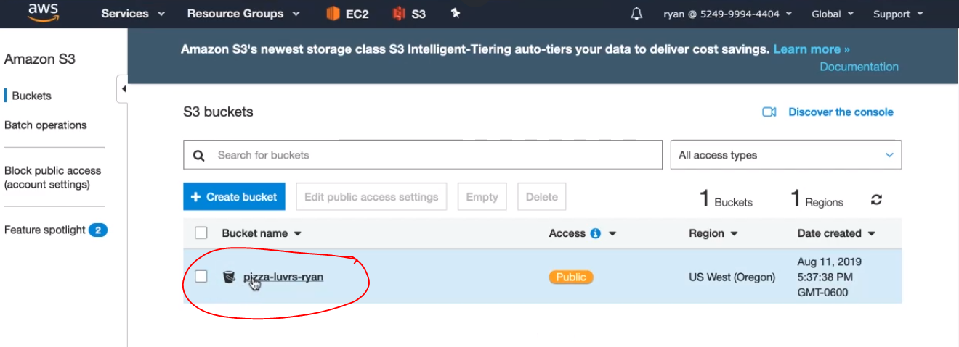

* It should load:

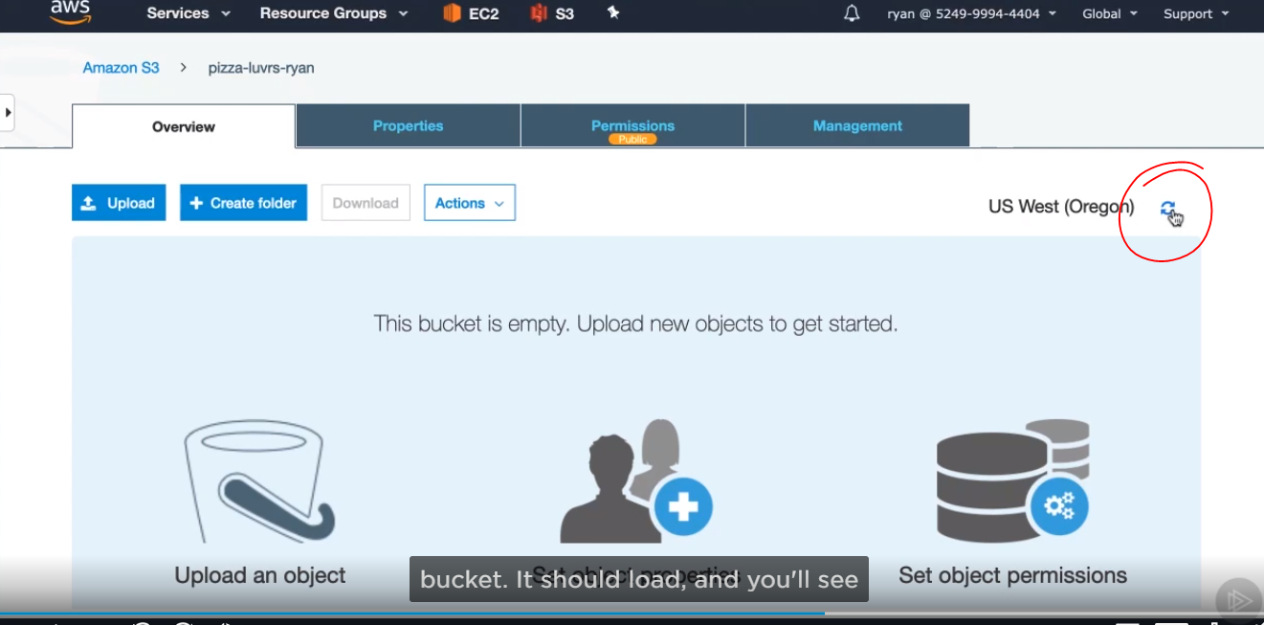

* You’ll see three folders here, css, js and pizzas.

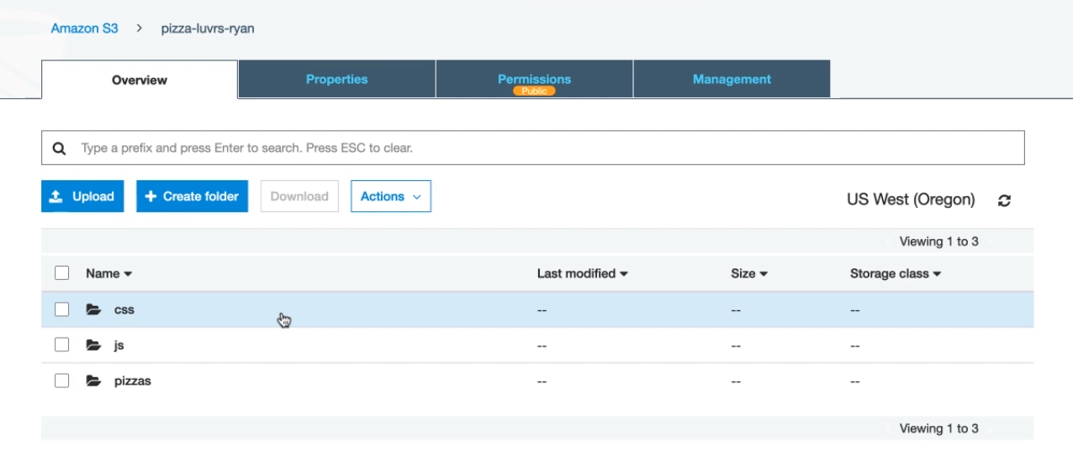

* If we click on pizzas, you should then see the pizza’s PNGs.

Let’s test out and see if our policy to make all these files visible is being applied correctly. Click on one of the PNGs, then click on the Open

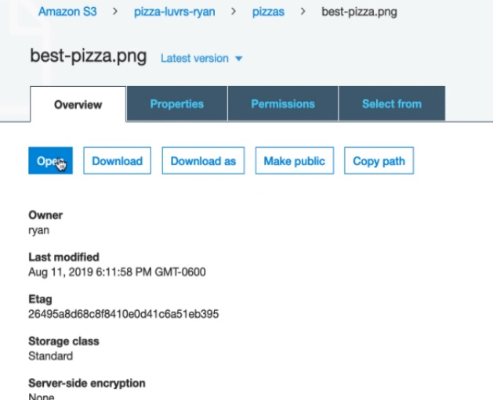

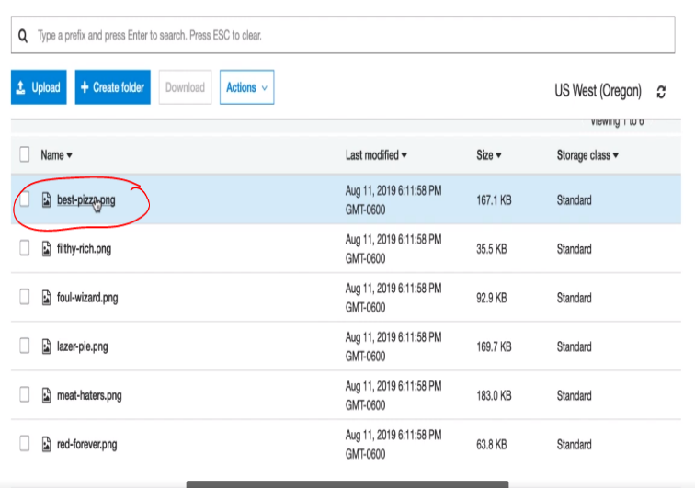

Then you can see the picture. When we make this web request to view the S3 object, it is doing so completely anonymously without the credentials you have in the web console, so successfully viewing the pizza is confirmation that our policy is working correctly.



* 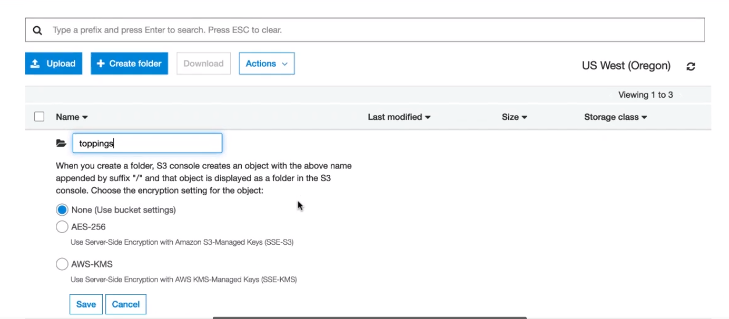We still need to transfer over the toppings and a few other files, Go back to the main bucket page via the breadcrumbs link towards the top of the page. Click the create folder button, and type toppings in the input that opens up. Now, click this toppings folder. And save.

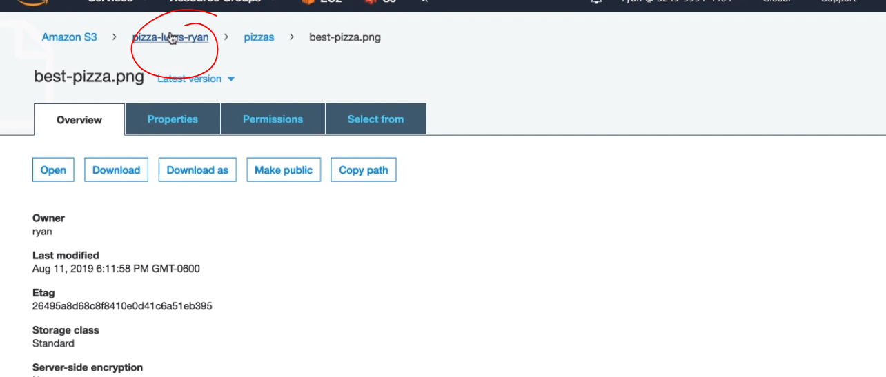

* We want to upload the toppings images here:

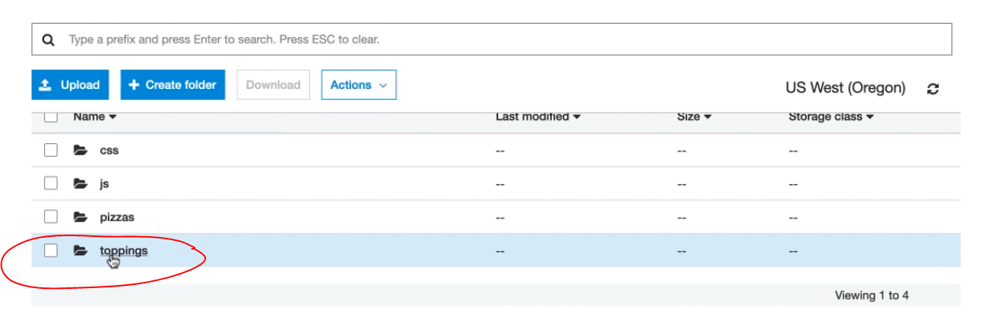

* Click the blue Upload button in the top left.

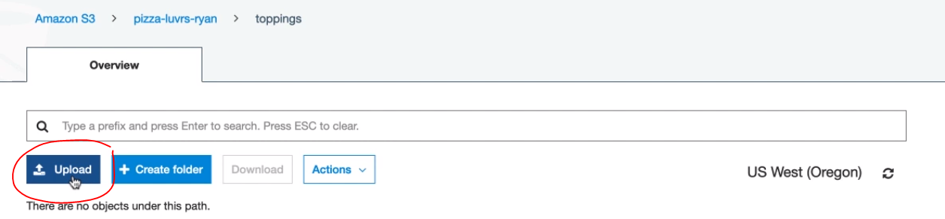

* Click on the Add files:

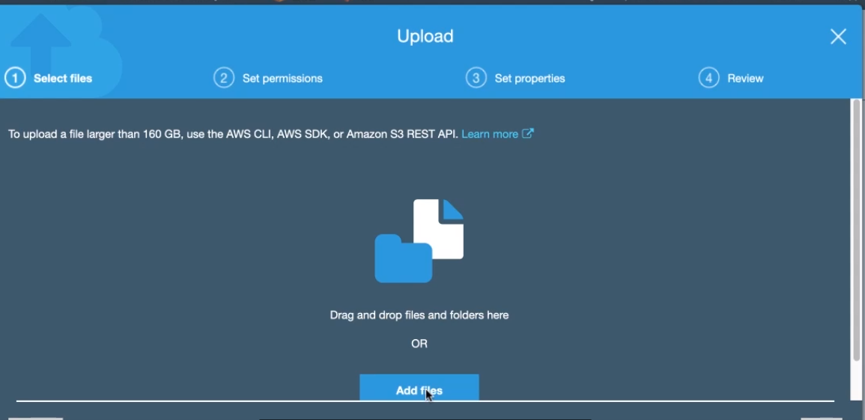

* And navigate to and select all the toppings PNG files.

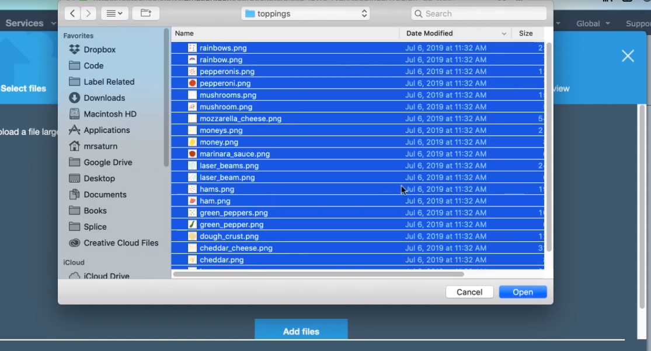

* So click upload.

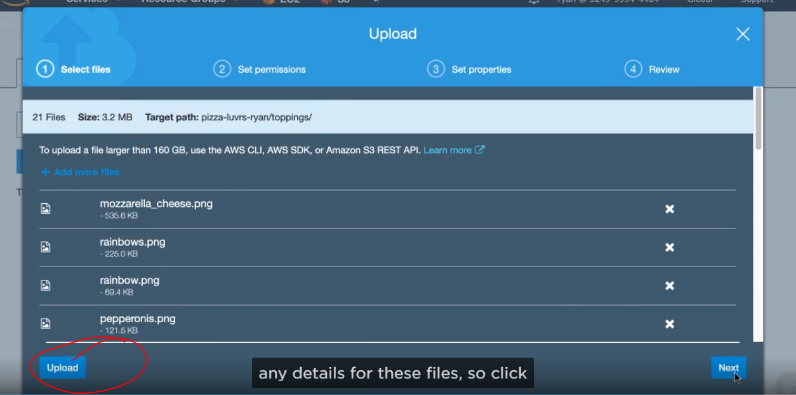

* We just have two more files to upload. Go back to the main bucket. Click the upload button

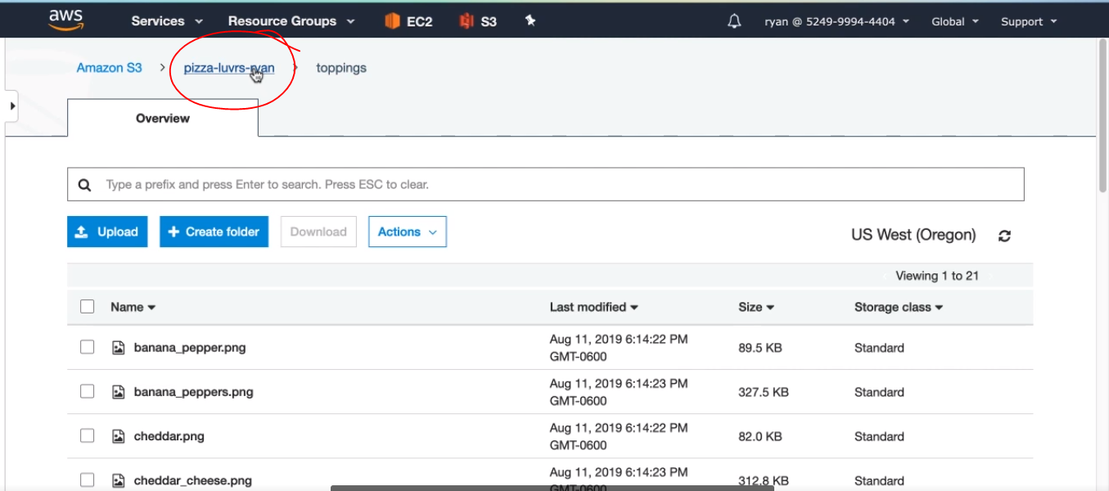

* Click upload, add files and select all PNGs at root assets. This should be a quick upload. And then we have got everything moved into s3 then upload.

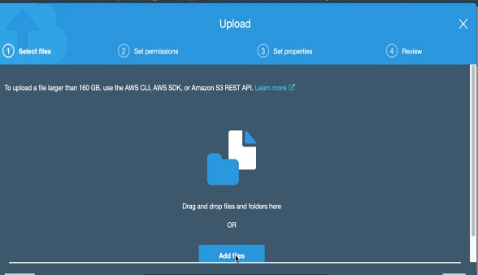



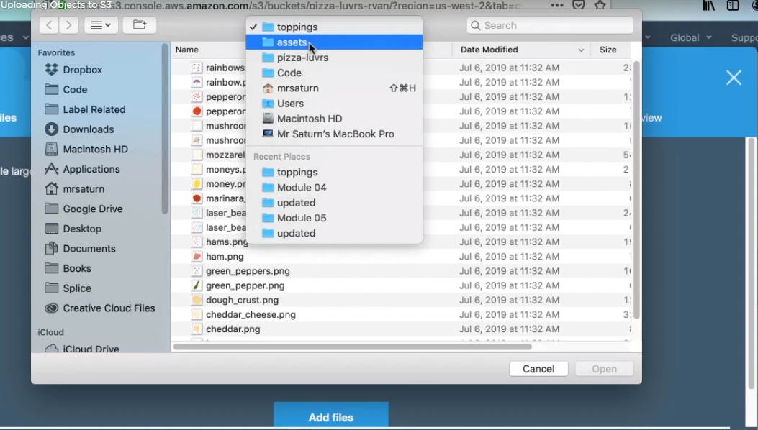

* In the next clip, we’ll modify our code to use S3 to retrieve these files and also use the AWS SDK to upload files to S3.
* Let’s modify our code to use this files, instead of those served locally. The first step is to get the route path that these files should share. Since path and filenames won’t change in S3, we really just care about the route that the new assets will have. Open the S3 console and navigate to your pizza bucket.

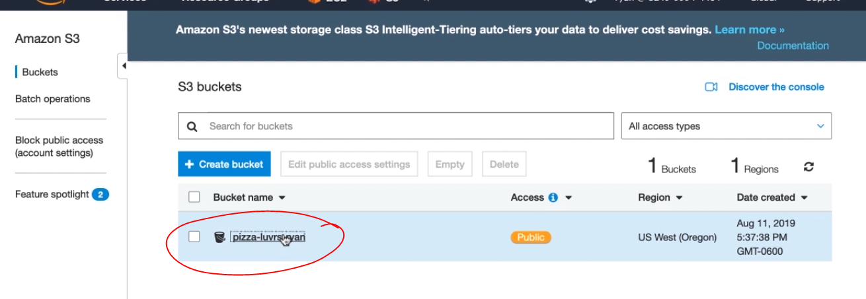

* Select one of the PNG files, and then scroll down until you see the object URL. Copy everything until the file name this is our new route path for assets.

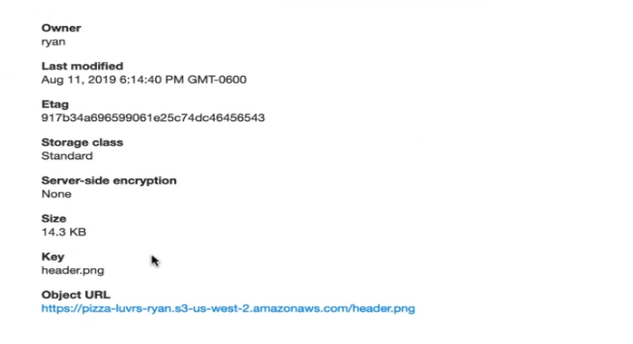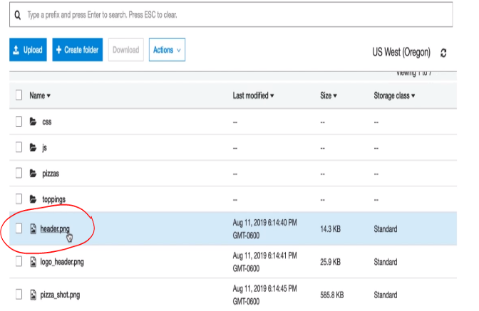

* Open the pizza-lovers code in a text editor of your choice. We’ll first change where the static assets like javascript files and css are coming from. Expand the templates folder, and open the layout.hbs. this is a handlebars.

On line 5 is a reference to our CSS.

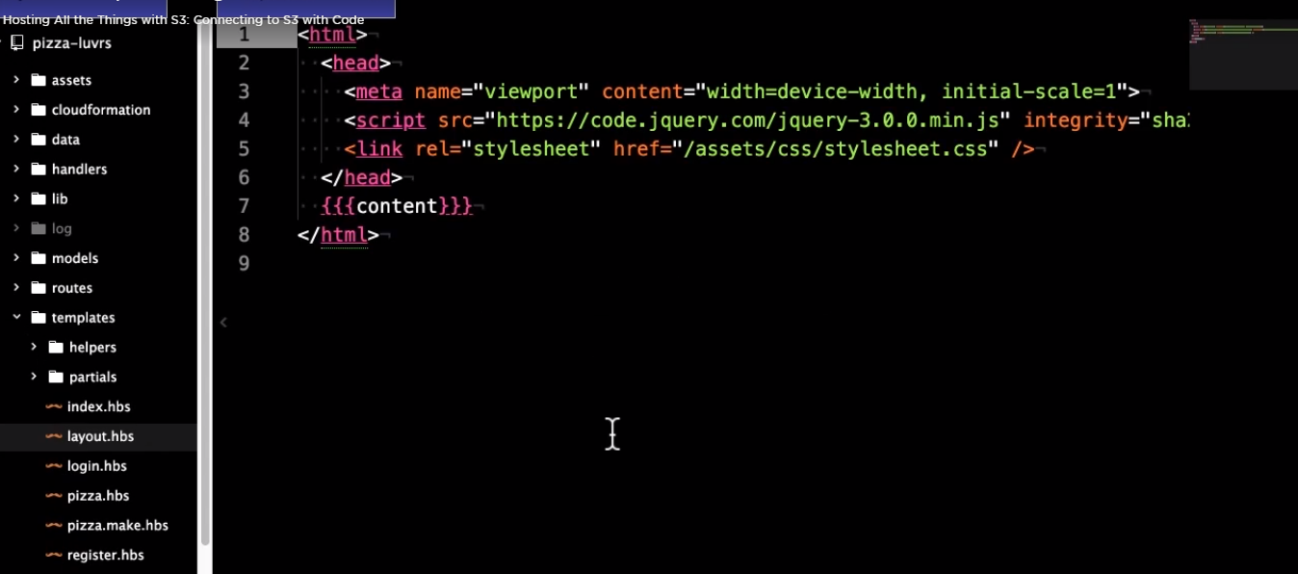

* Remove the /assets part of the and copy over it with the route URL. That you copie from S3. One important part of this is you do need to remove the protocole from the link so it is only starting with a double slash. This will avoid us running into conflicting security protocol requests in the future. You can copy that new route path without the protocol if it is easer for you. Now save that and open pizza.make .hbs.

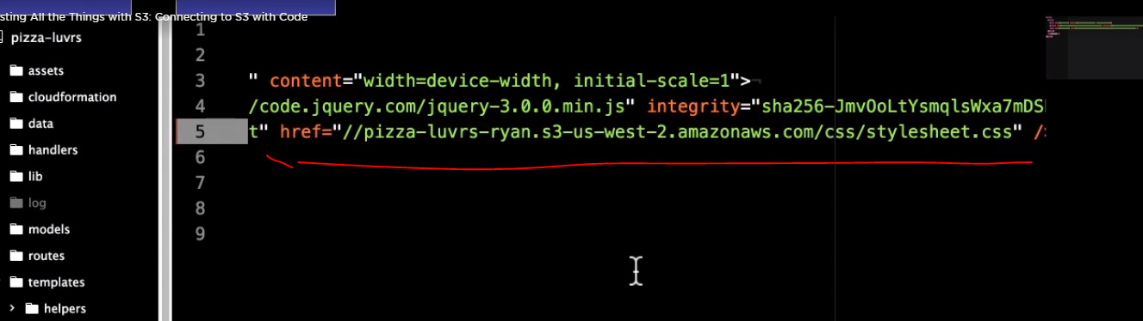

* On line 17, we preview the toppings images replace /assets with the S3 URL, and ensure the protocol is removed.

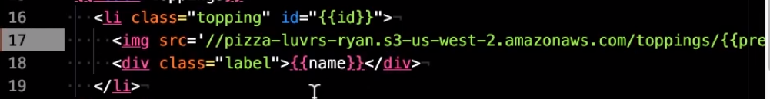

* On line 26, we are including a javascript file. Again, replace assets with the s3 URL, and make sure to remove the protocol. Tehn save it.



* And in index.hbs at line 5, fix the URL for the logol.



* Next file, in the partials directory, open the header.hbs, there are two images on lines 2 and 3



* The last change will be in our client-side javascript. Navigate to assets/js/make.js. On line 17, we are loading in the toppings images into memory. Replace /assets so it will pull from our S3 bucket. Save the file.



* Since we just modified the javascript, which is now being hosted in S3. We do need to reupload it to S3. Feel free to do this whichever way you want.

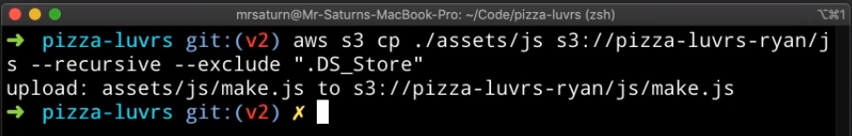

* And the last optional step is to change the location of pizza images for the mocks that hydrate the app when it starts. You can find them in the data/mock_pizzas folder, ad just want URLs as you did before, but you don’t need to do this. Now, with all those files update, we can move on to the saving of pizzas images. In the lib folder there are two files that start with imageStore. Both of these files are used to save a pizza image that was created in the browser. The imageStore provides an API for our code to use and ImageStoreFile.js is basically the local implementation. We’ll create S3 implementation. So, in this folder, go ahead and create a file imageStoreS3.js now let’s look at imageStore.js this file will expect a save function on our S3 implementation that takes a name for the image

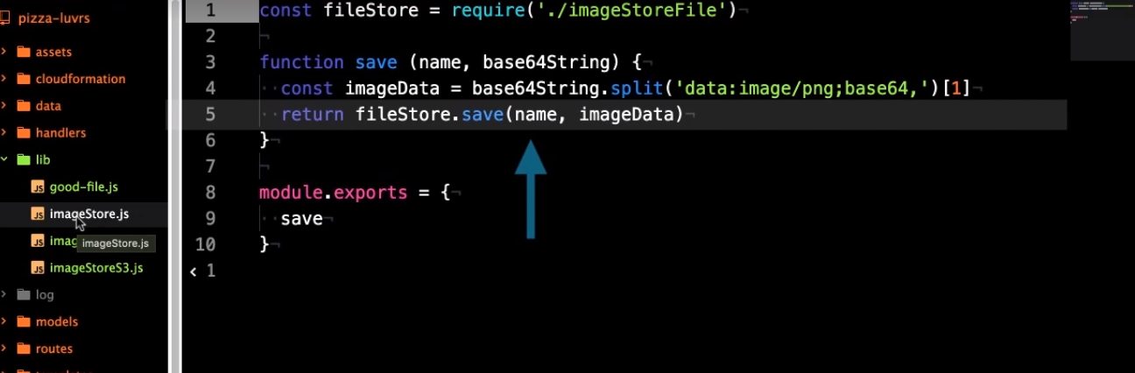

* and the based 64 encoded image data,
* Open imageStore.js, and type this a function new written and ES6, so you can read up on that if you want to. Let’s go ahead and complete this file we are here. I’ll walk you through it.

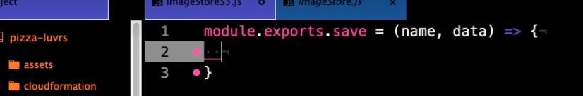

* We’ll start by importing the AWS SDK. At the top of the file, declare a const variable called AWS, all upppercase and assign to it a require function call string aws-sdk passed into it, Now, all the sdk code will be stored in our AWS variable. In the next line, we’ll instantiate an S3 client. Declare another const named S3, this time in lowercase and assign to it a new AWS.S3 function call. Because we previously configured the CLI with our credentials, the sdk will also read them and use them to create this S3 client. Now, inside our save function we have one main task. Call the put object function our S3 client. We do however, need to pass in a parameters object with information where the file should go and how it should be stored. But because we are using the async await pattern we need to wrap all this in a promise. So on the first line of the function, retunr a new Promise. The constructor takes a function with resolve and reject arguments. Now inside that function declare a variable called params, which will be an object literal. We will create some keys that all start with uppercase letters. The first Bucket, which will be given the name of the s3 bucket we created. Next is key which is the path and file name we want the object to be given. Since this is a pizza image, we want to put it in the pizzas folde, and we need to add the PNG file extension. Use the new string interpolation syntax here with backticks, and we’ll insert the name variable here with the dollar curly brace syntax. Next we’ll pass the actual file data as a body property. This property wants a buffer, so call the buffer. From method. The first argument will be our data, and the second is the enconding, which is base64. Next we will set the contentEnconding property to base64 so S3 knows how to decode the body and then the contentType property will be set to image/png. Now our params object is complete. Next we’ll call the s3.putObject function. The first argument is our params object, so enter that the second is a callback function with the first argument is err and the second as data, first check if there is an err, then in the else we’ll calll resolve and pass in the URL for the image. If you still have it copied, paste S3 URL route here, and use string interpolation to append the params.key value at the end.

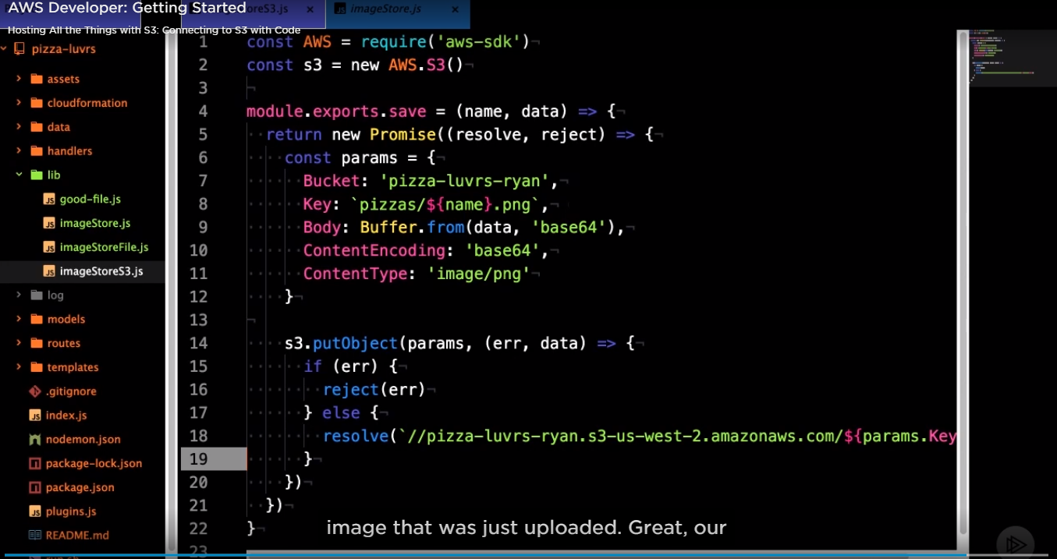

* Open imageStore.js. On line 1 you can see we are importin our file store Implementation. You can either replace this or add a new line for the S3 either way create a variable called s3store, and import the imageStoreS3 file. Then on line 6 replace, fileStore with s3Store, now we are saving

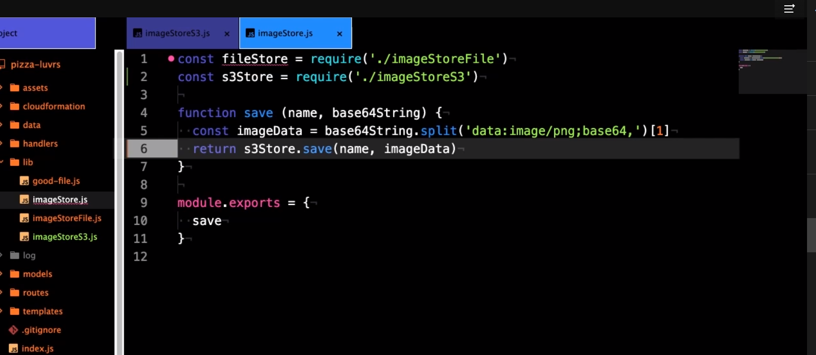

Working with CORS in s3.

* When requesting a resource via javascript in the browser from a different domain than the page was loaded from, your browser ensures that CORS is accepted on the target resource site.

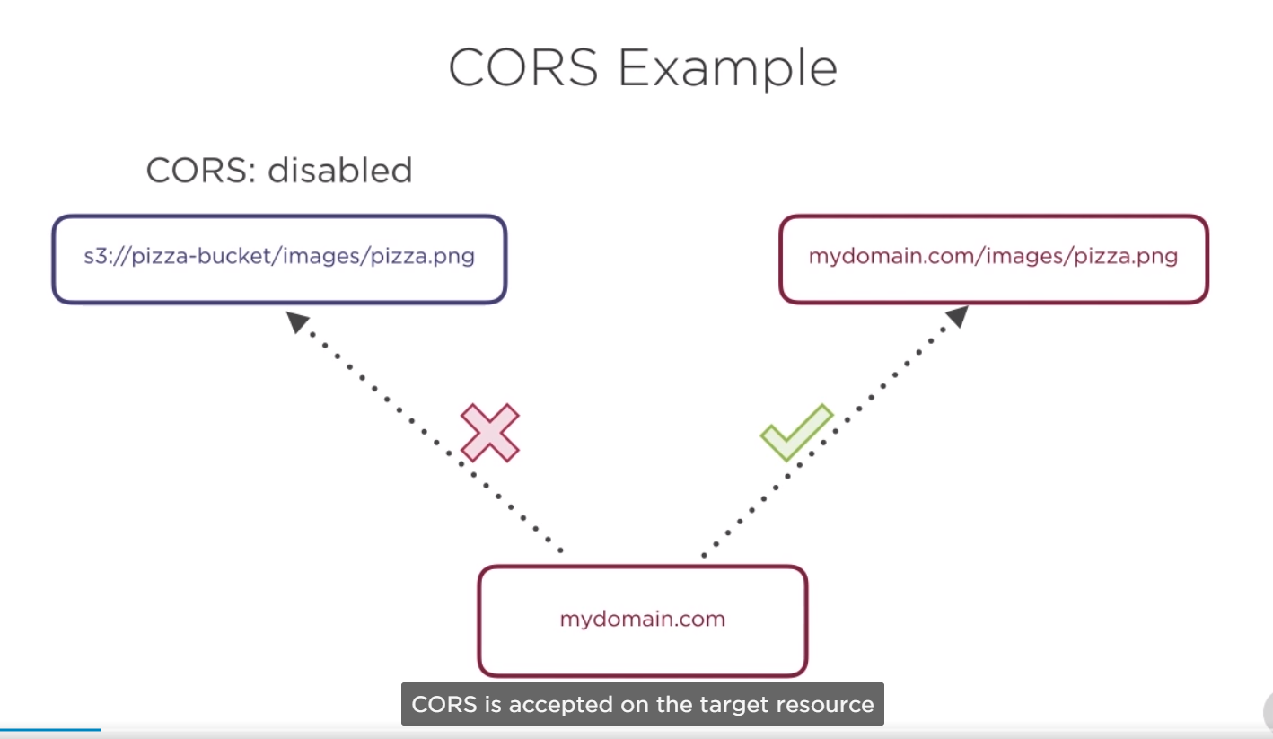

* If CORS is not enabled, it will place restrictions on the resource or sometimes not load it completely. Since S3 is not in the same domain when we are running our app, we need to enable CORS

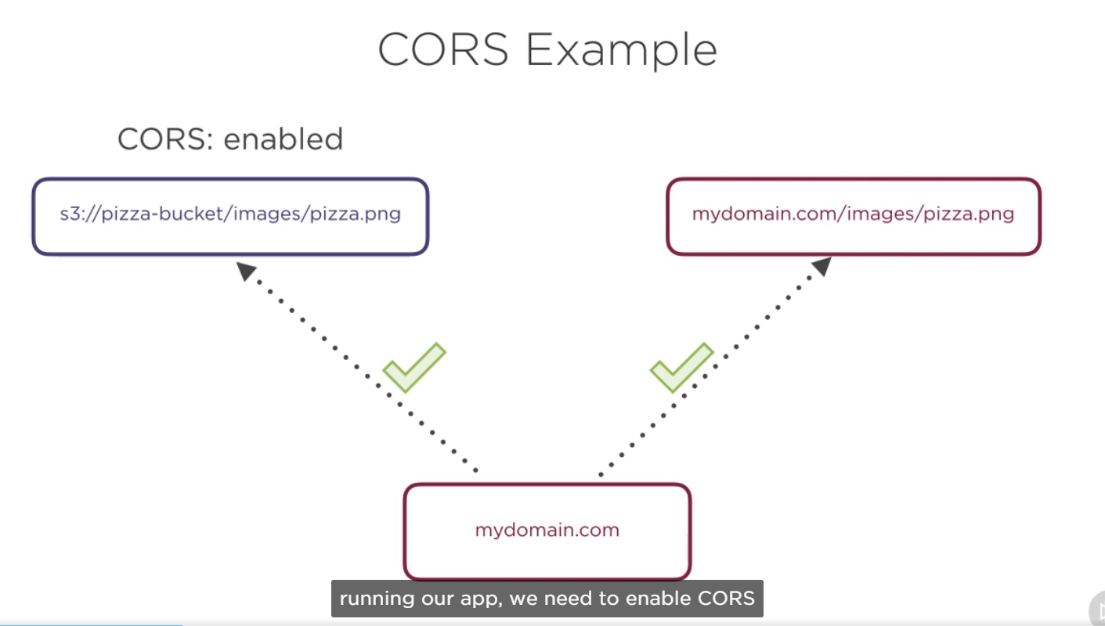

1. Enabling CORS is similar to how we added the policy for our bucket, click on the bucket you created. Then click on the permissions, then click on the CORS configuration. In cors configuration there is a placeholder example configuration document. This is the exact configuration we want to have, but unfortunately, since it’s a placeholder, we can’t just copy and paste it.

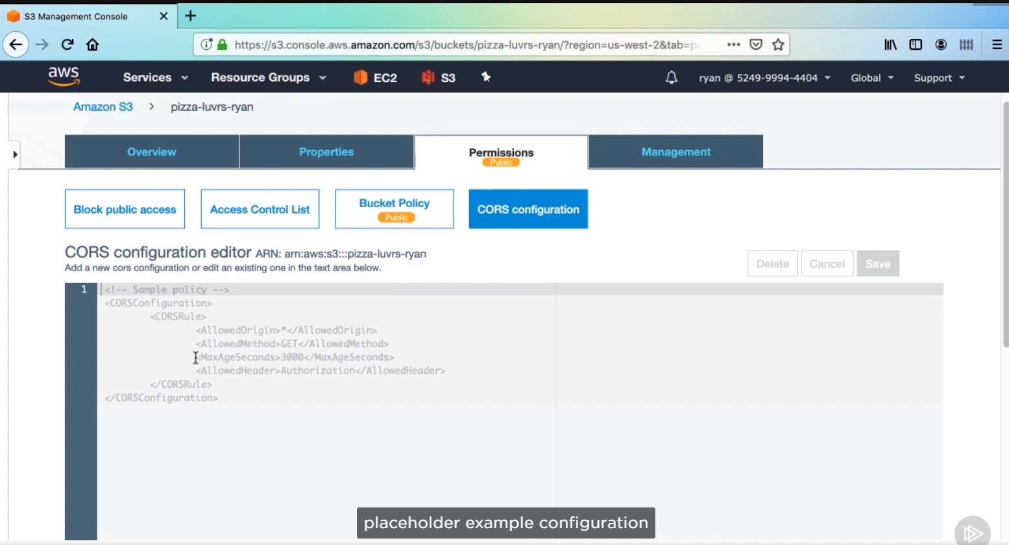

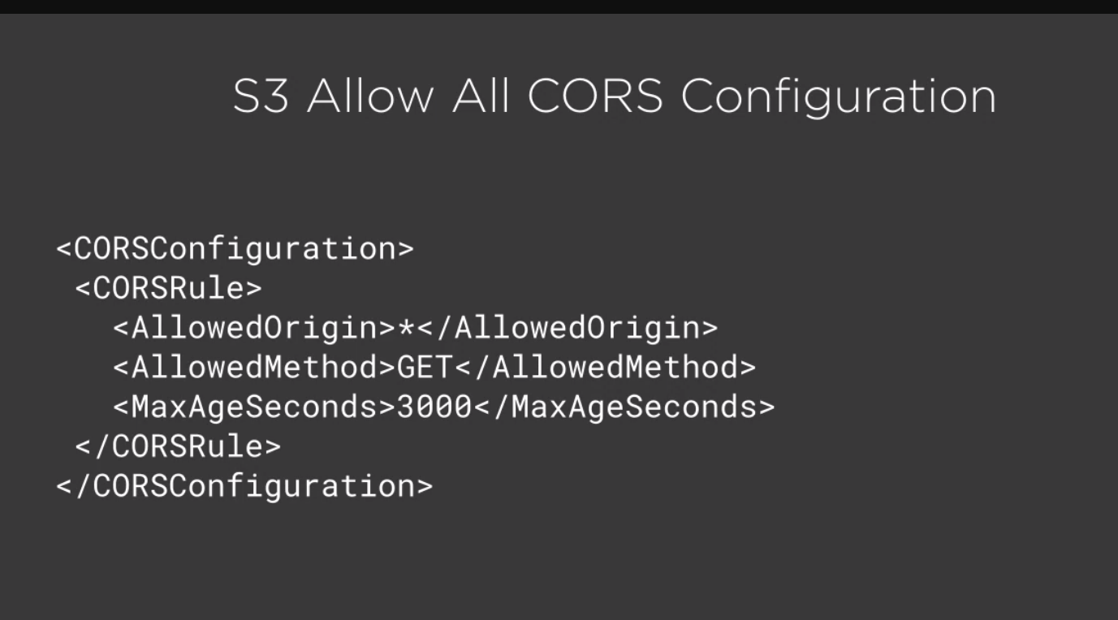

Click save, now we’ve made all modifications to the code and enable CORS. Let’s try out changes.

Then you have to run the app and create a new pizza and save it,

Go to the bucket, then you can see the pizza image.png created.

ASSIGN IAM ROLE TO NEWLY LAUNCHED INSTANCES.

First to update the pizza – og.ec2 instance with our new code, then create a new AMI, with that updated instance, and finally create a new launch configuration that. Will attach to our pizza Auto Scalling.

1. We’ll start by coping pizza-lovers code to the EC2 instance using SCP. Make sure to delete the node_modules, then execute this scp, there is one modification you’ll want to make to scp command, and that is to remove the destination folder name from the command.

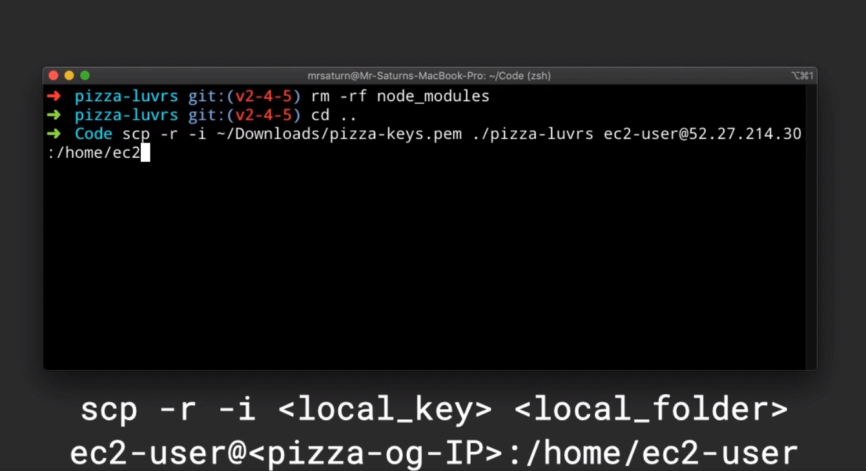

The scp command won’t overwrite our node_modules folder on the instance, so we shouldn’t need to run npm install again. Now our code has been copied, and everything is updated and ready to go.

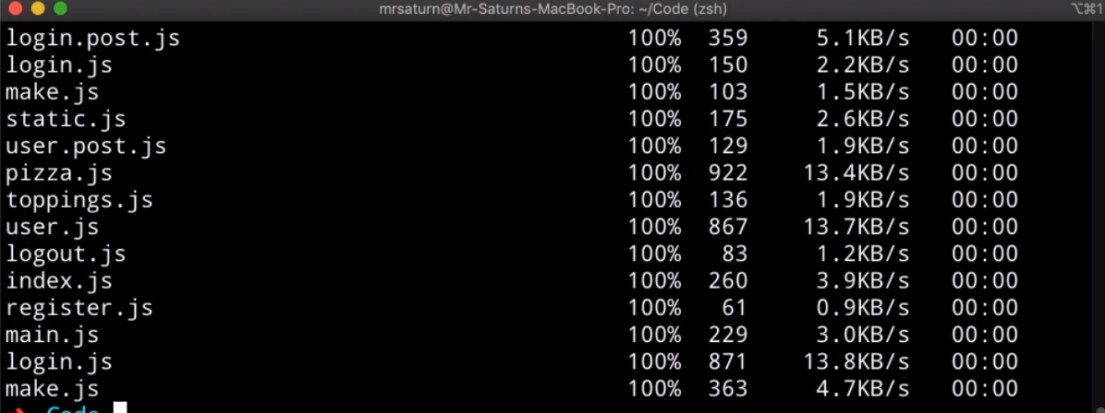

1. In the Ec2 console, click on the instances menu option on the aleft. Select your instances.

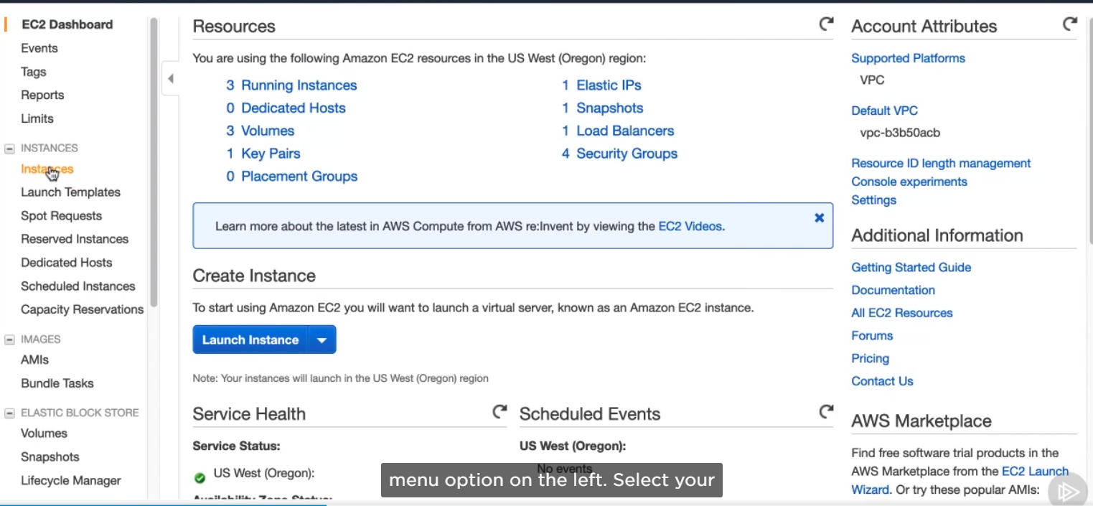

1. Select pizza-og:

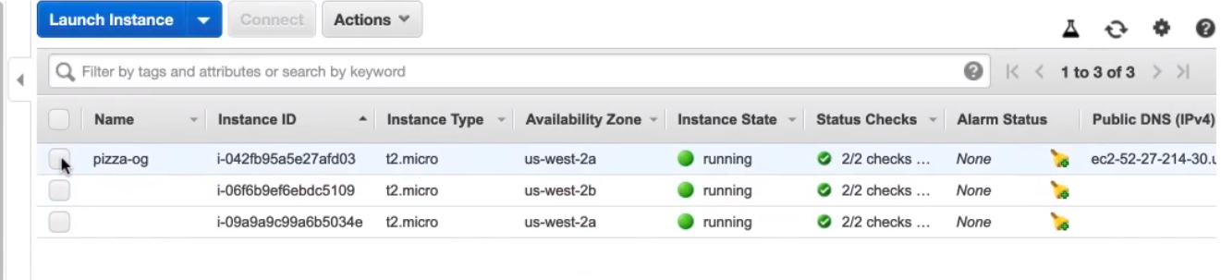

1. You have to go to create image :

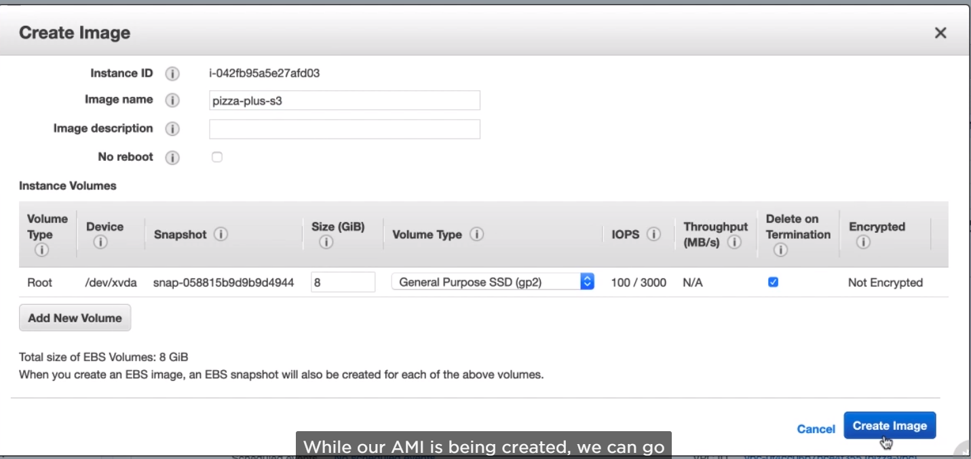

1. Create a role that we’ll use with our menu above, type Iam, and hit enter.

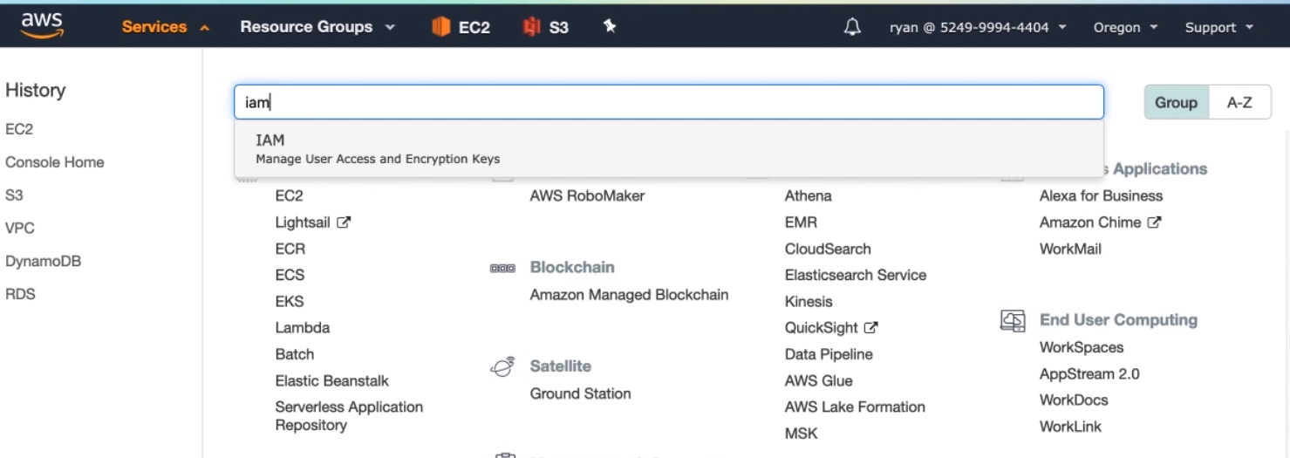

1. Then click on Roles.

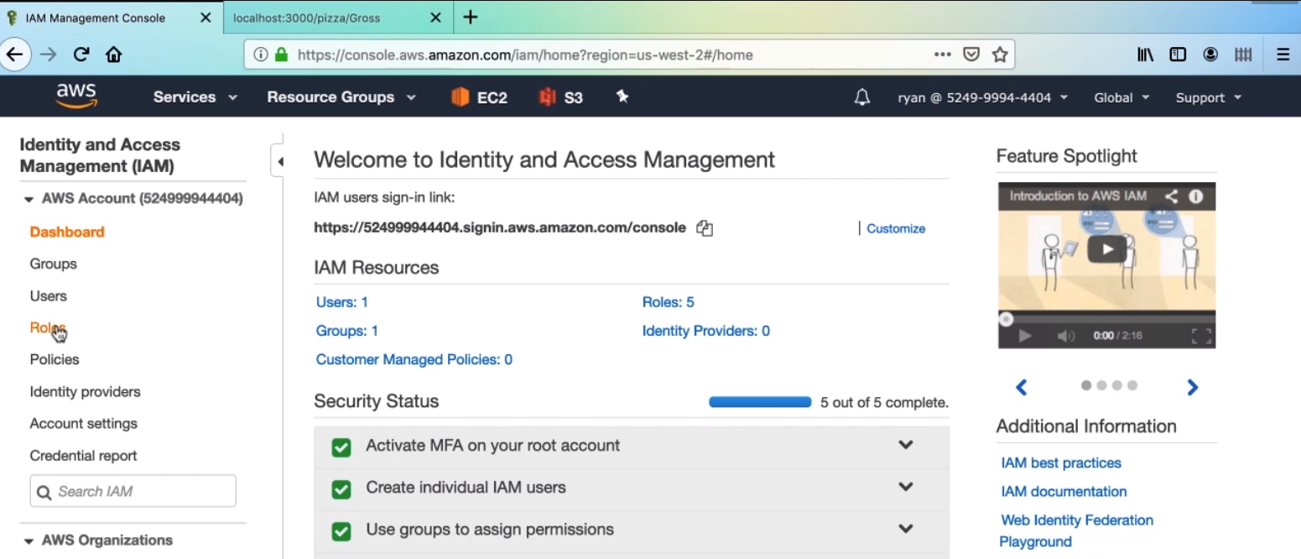

1. It is just something to attach policies to, we are going to create a role for our pizza. Click create role.

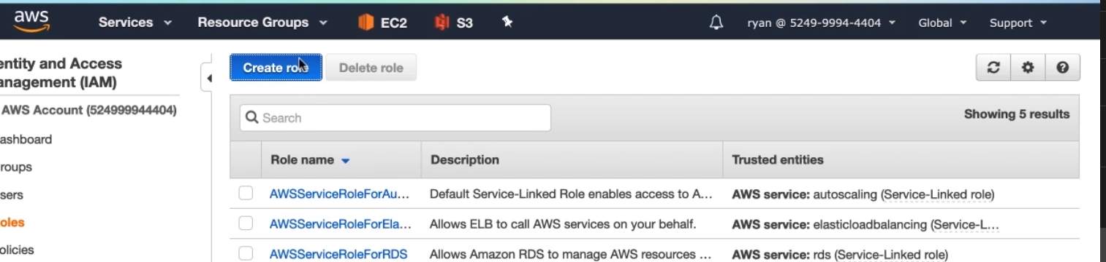

1. Then we’ll choose the service that will be using the Ec2, Now click Next.

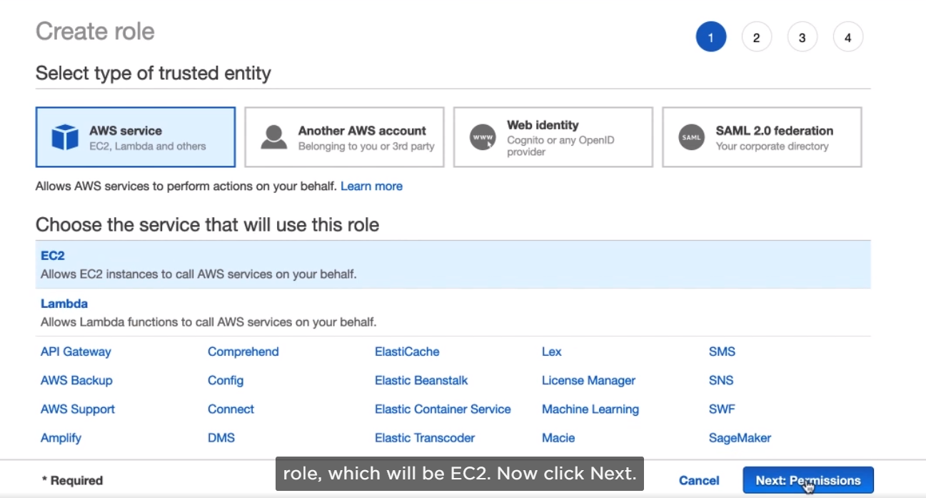

1. We only need to give the role access to S3, right now, so search for S3 in the input, then select AmazonS3FullAccess. Then click Next Twice.

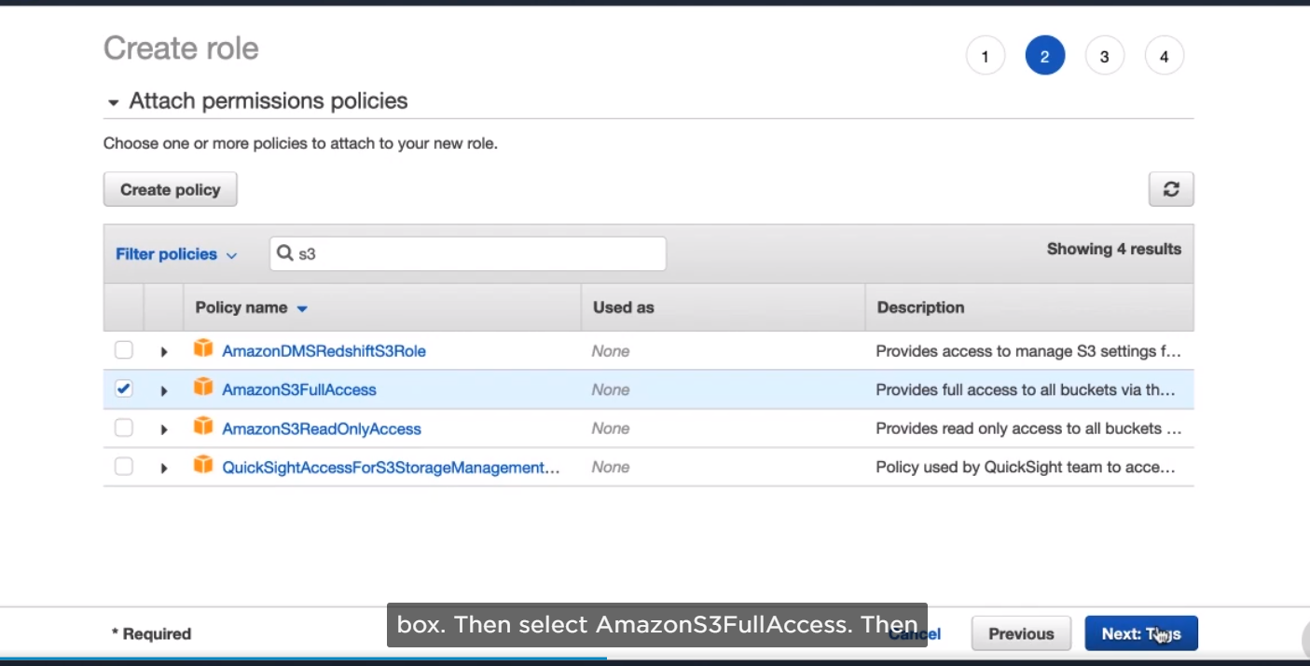

1. Name the pizza-ec2-role, and then click create.

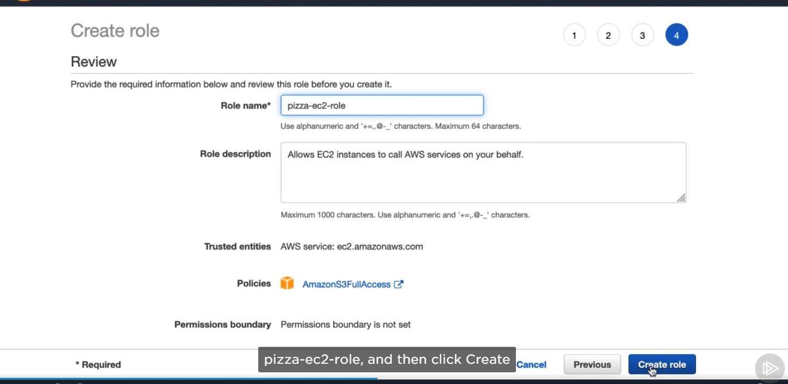

1. We can attach policies to the role, but don’t have to change which applications have the role.

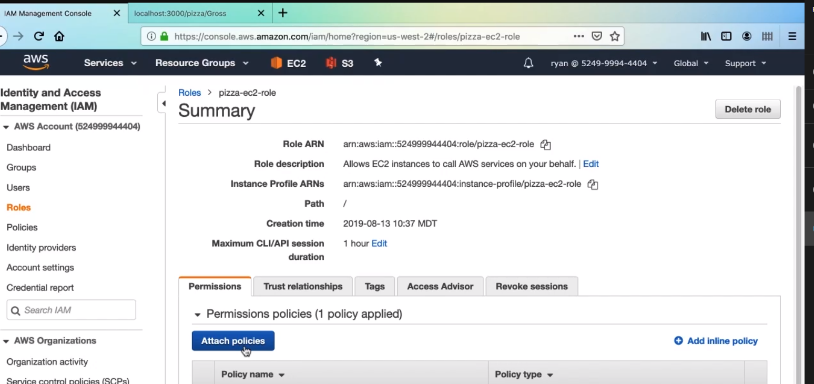

1. Go to launch configurations.

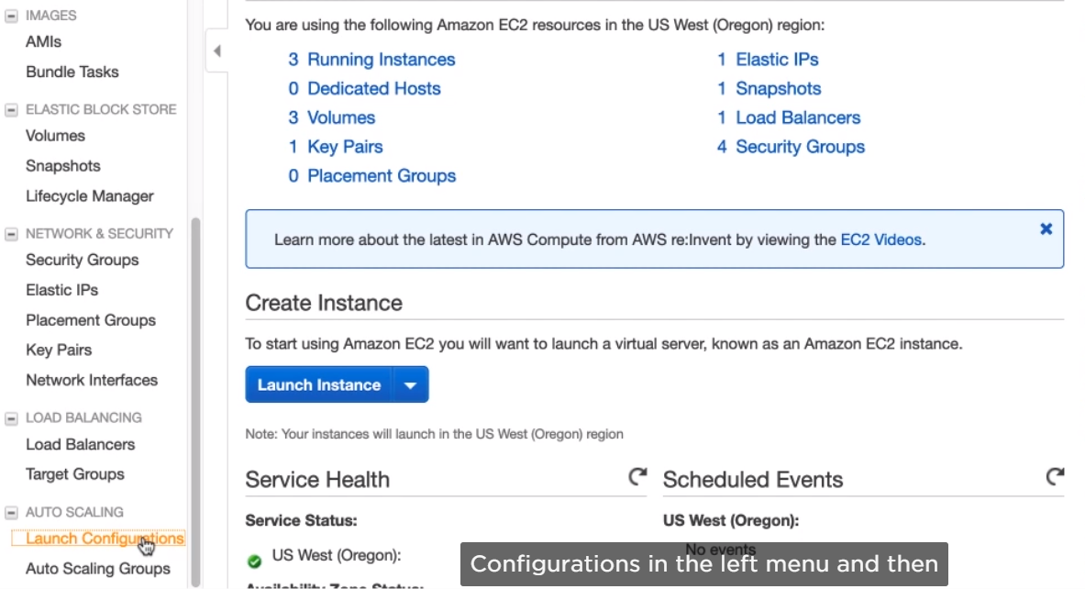

1. And then create launch configuration.

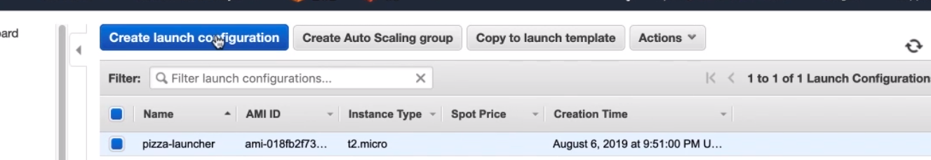

1. Select My AMIs and then pizza-plus-s3. Then next

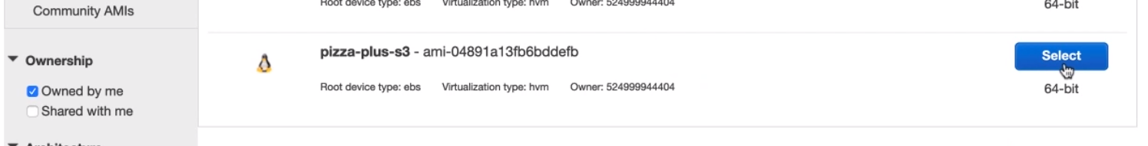

1. Name this pizza-launcher-2. In the IAM role drop-down, select the pizza-ec2-role. And advance settings, enter the same startup script before, so here it is again.

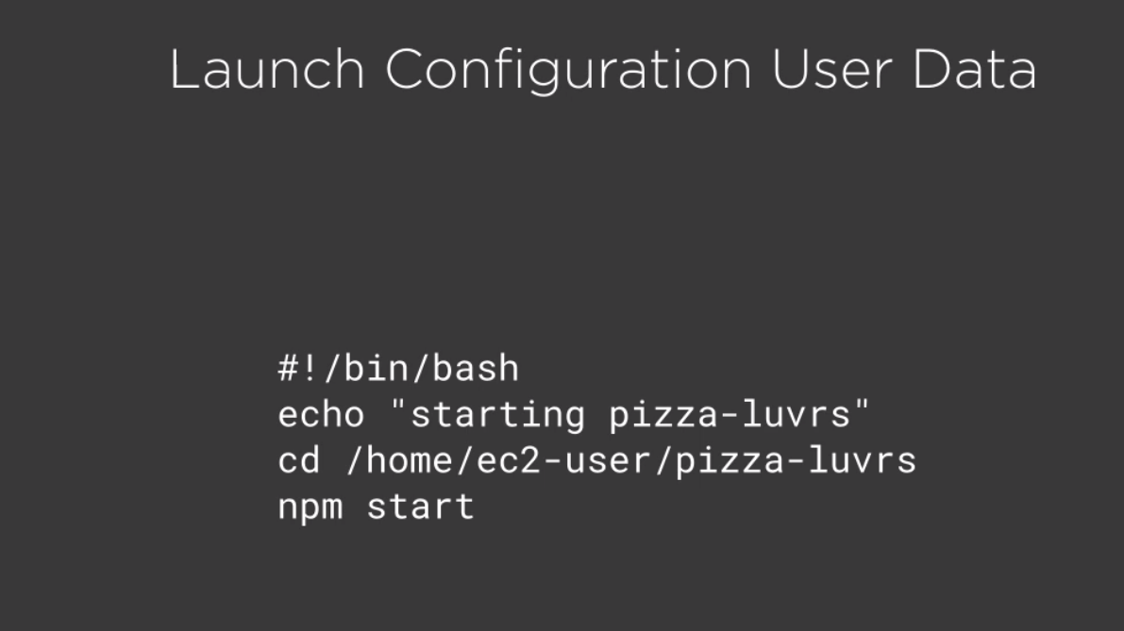

1. Select radion button, then next: Add Storage, then next again.

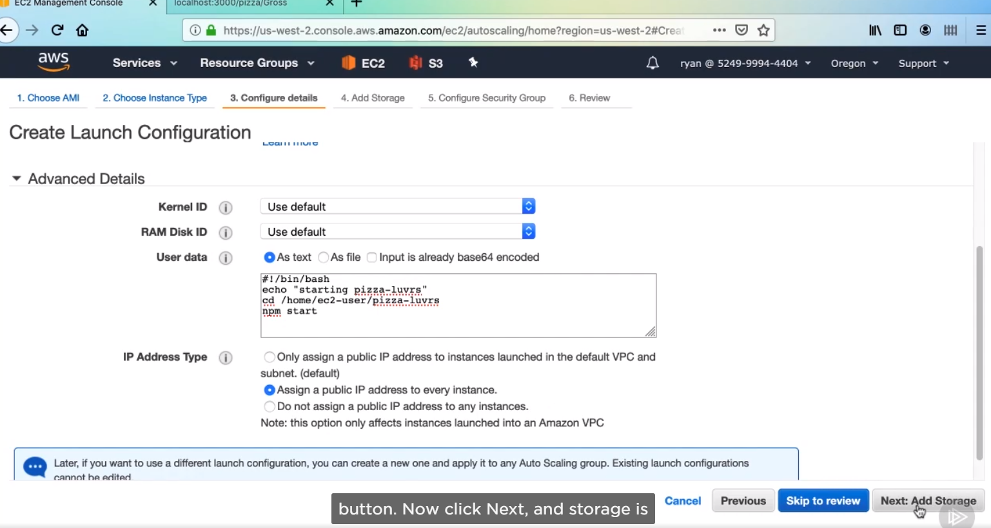

1. Then click Select an existing security group, and pizza-ec2-sg security group and review

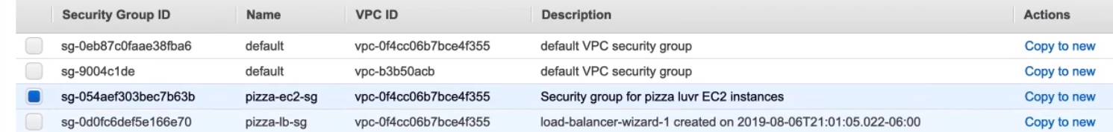

1. Finally create launch configuration.

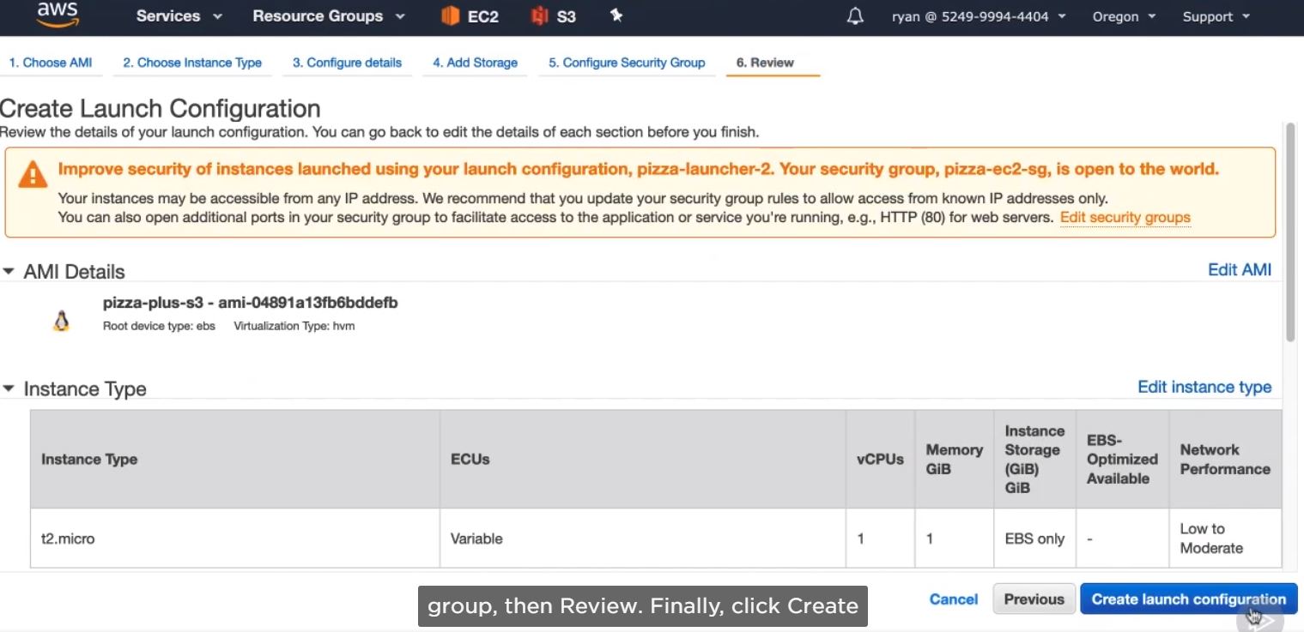

1. Then select the same pizza-keys as before for our key pair. Then create launch.

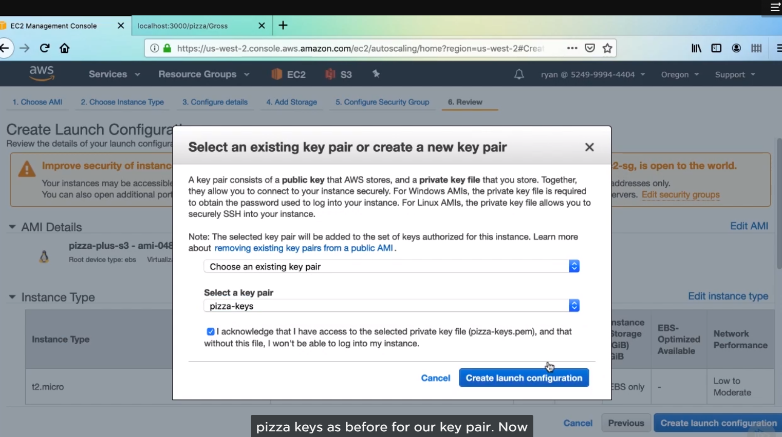

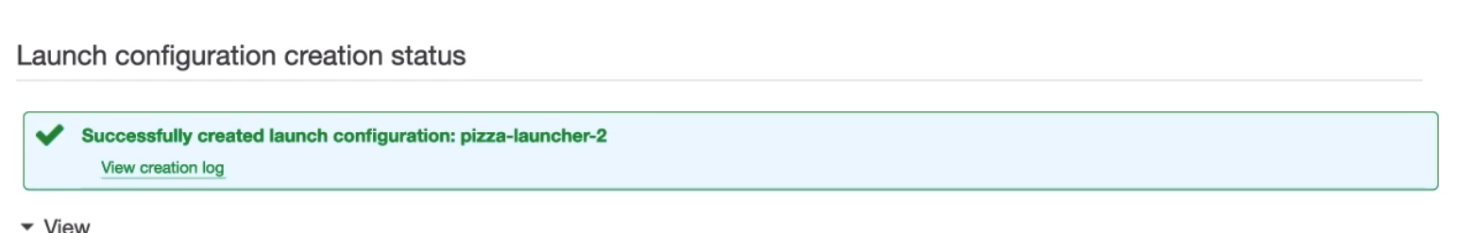

1. Now we just need to replace our configuration in our Auto Scaling Group with this new one, and this new one, and then refresh our instances.

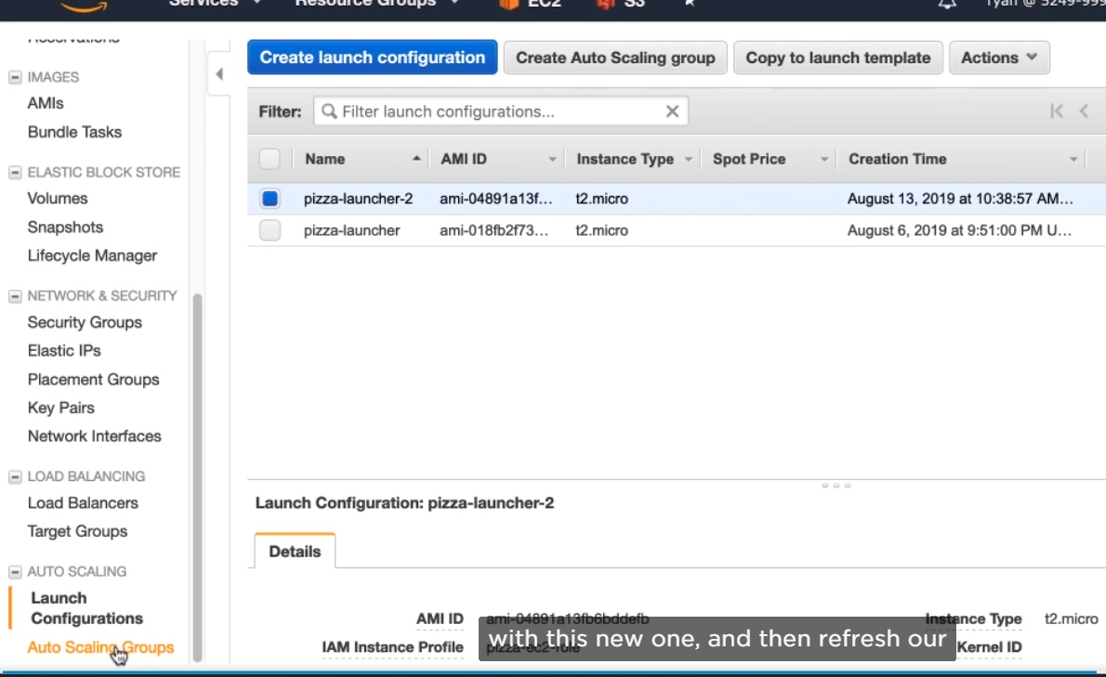

1. Then select pizza-scaler then select edit.

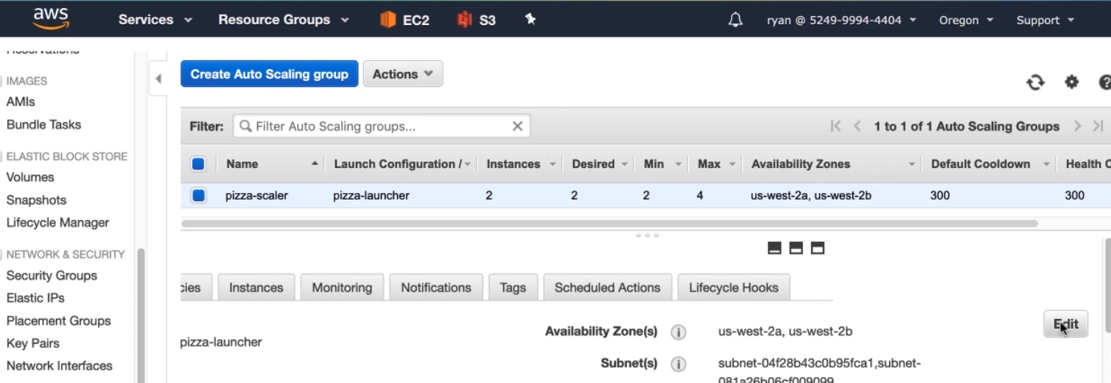

1. Change the configuration drop-down to use our new launch configuration. Then click save.

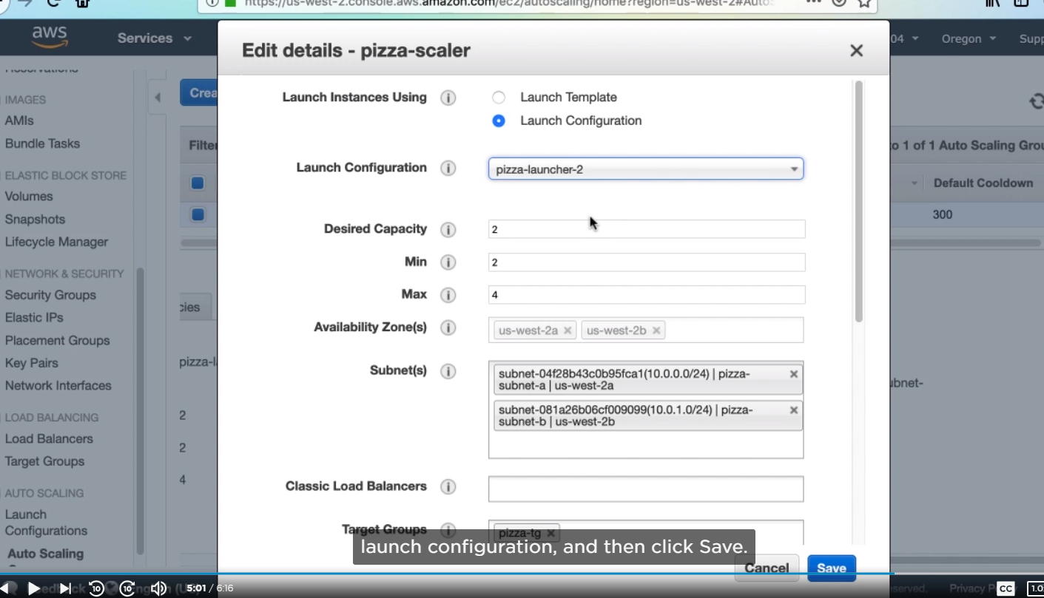

1. Then terminate any instances which are not releated.

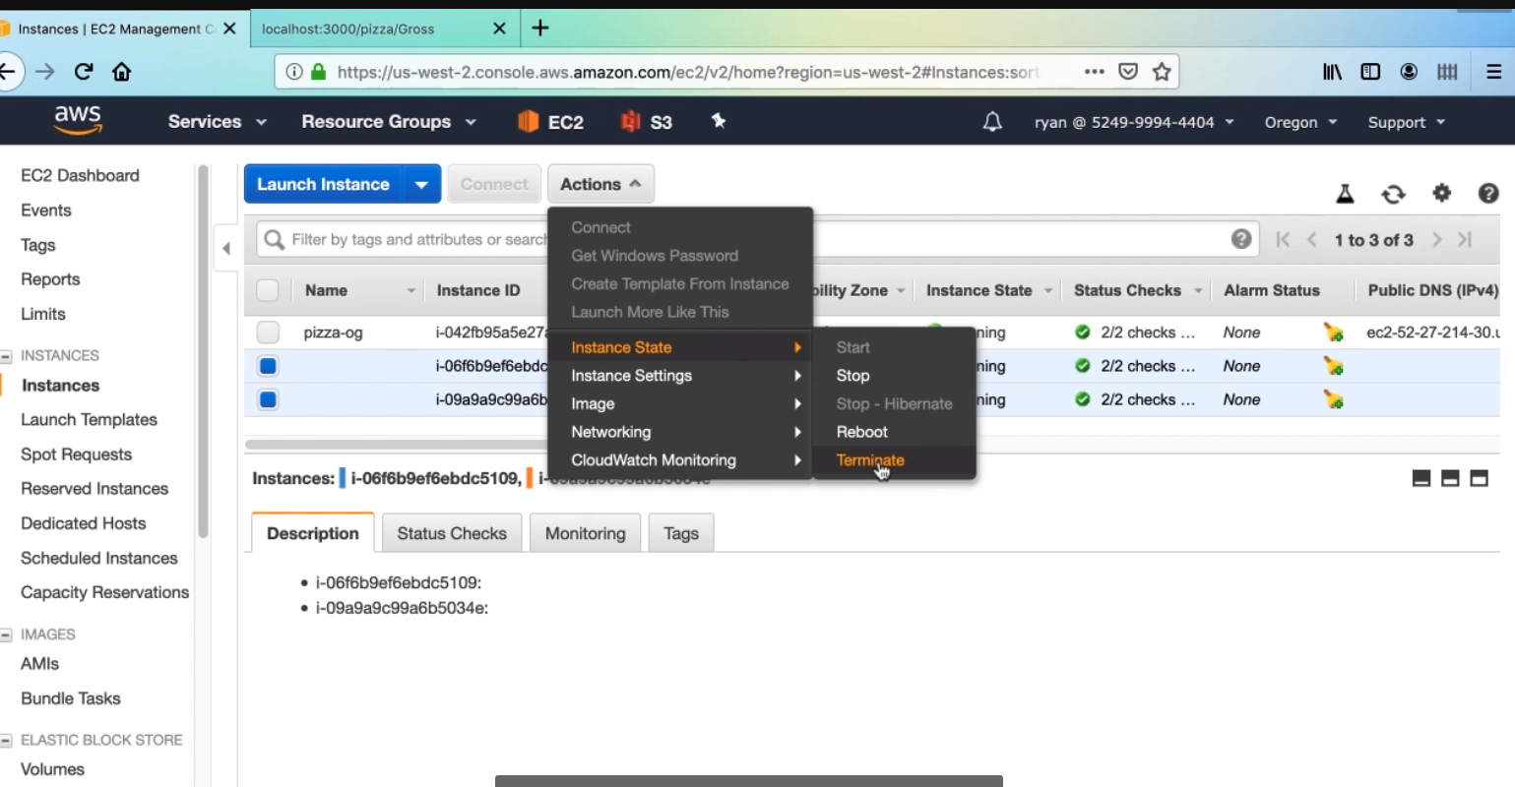

Conclusion:

* About different futures and structures in S3. Then we created our first bucket and began uploading objects, next, we went deep into the code and wired our Node application to S3. And finally we configured CORS in our bukect and created an IAM role for our application.



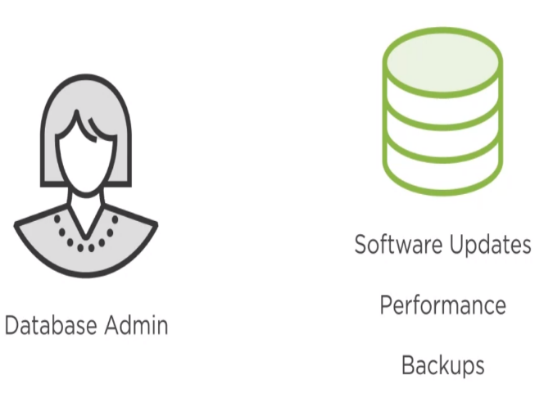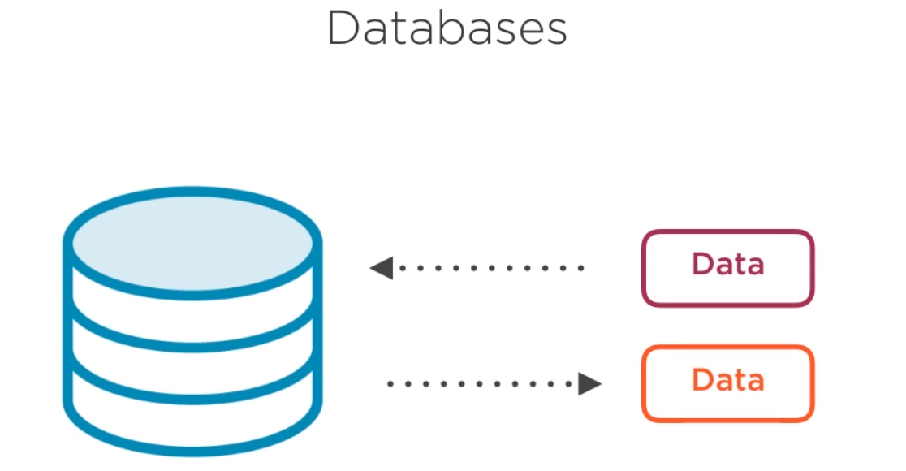



RDS allows you to easily create and configure relational databases running on EC2. These database instances are managed by AWS in which they handle many maintenance activities that you can configure. Some of the tasks they perform are operating system and minor version database upgrades, periodic backups, and system health monitoring. Combined with quick creation and easy configurations.

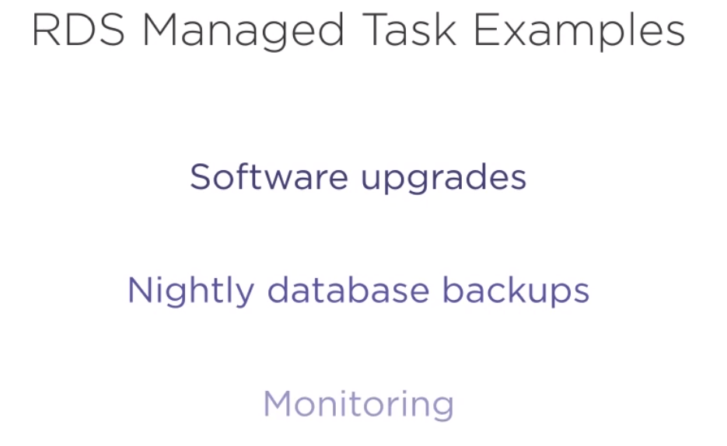

When you create a database instance on RDS, it creates a EC2 instance under the covers, installing an appropriate operating system and database engine. Because of this, you choose the size of the EC2 instance that is powering your database. This turns out to be very important since an underpowered, EC2 instance won’t be able to process queries very well and will impact your upstream application. Therefore, think carefully when choosing the instance type that will power your database. You do have the option to change the instance type once the database has been created in response to increased load, but from my experience, that change can be time-intensive activity. The data inside a database is sometimes the real value of any company, so it is incredibly important to keep it safe, secure, and available. There are a few features that RDS provides that enable this.

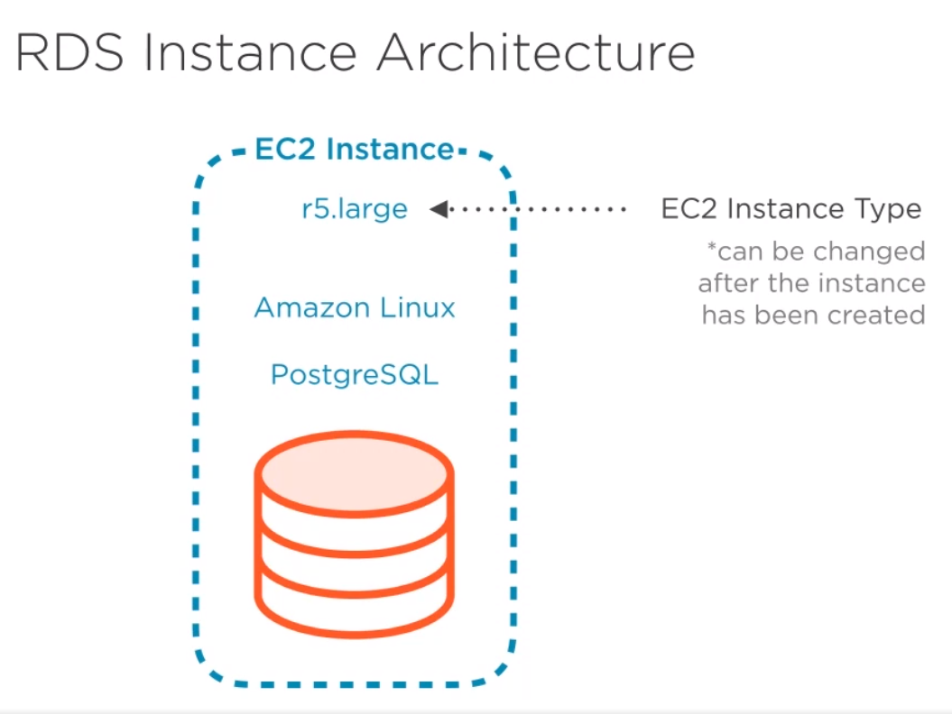

The first feature is periodic backups of your database. Configured by default, RDS will take a backup of your database daily during a backup window that you can choose. The backup can be stored from 1 day up to 35. And using this feature, you can restore your database back to a certain snapshot in case your data gets corrupted.

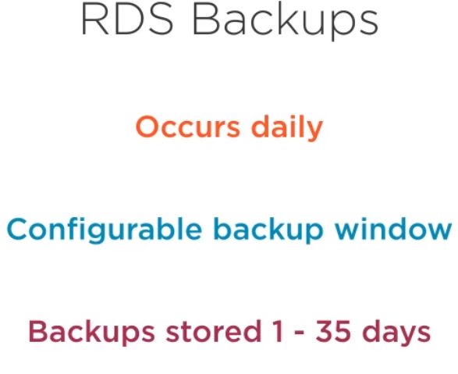

The second feature is Multi-AZ deployment, AZ standing for availability zone. If you turn Multi-AZ deployment on for a given database, AWS will create a replica of your database in another availability zone in the same region. If for some reason one availavility zone goes down or your specific database goes down. RDS will automatically failover (sistema de recuperacion ante fallos) to the instance in the other availability zone, ensuring your database experiences no downtime.

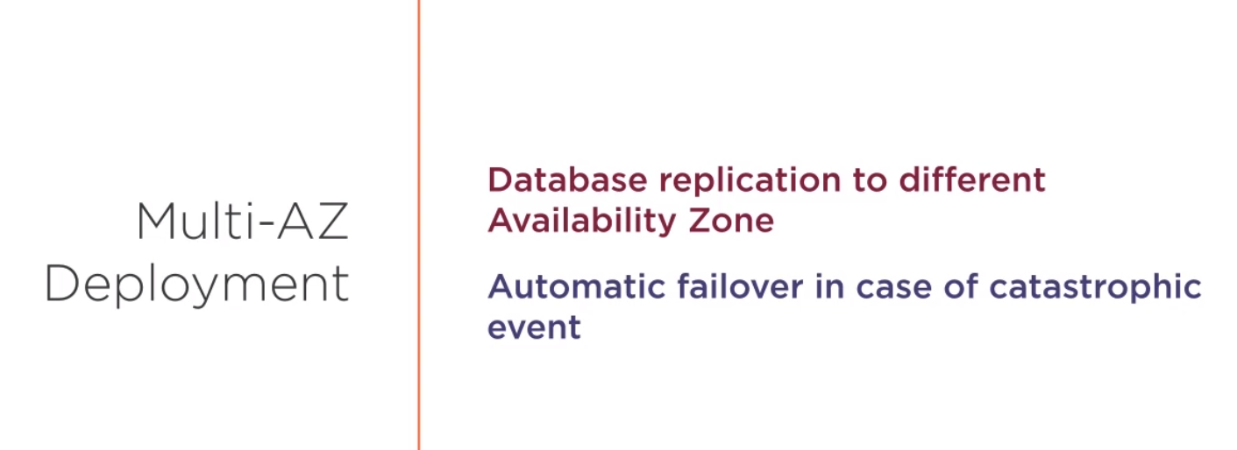

The last feature is the avilibility to create a read replica of your database, this is essentially a copy of your database that is not being used in production. The copying of data to this replica is done with eventual consistency so it won’t impact the production. Read replicas are perfect to let analysts and developers query data without impacting the customer experience. Read replicas are different from Multi-Az deployment in that the read replica will never be failed over to. It is only for non-production used.

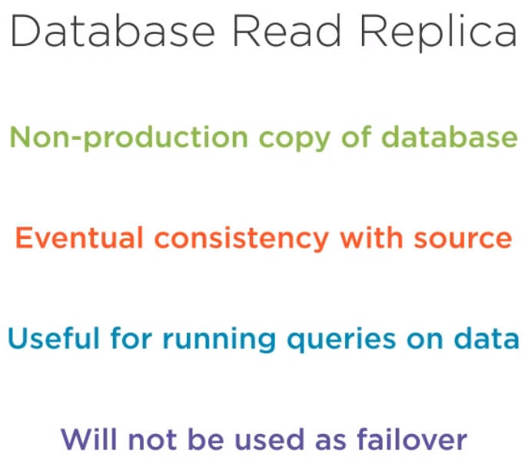



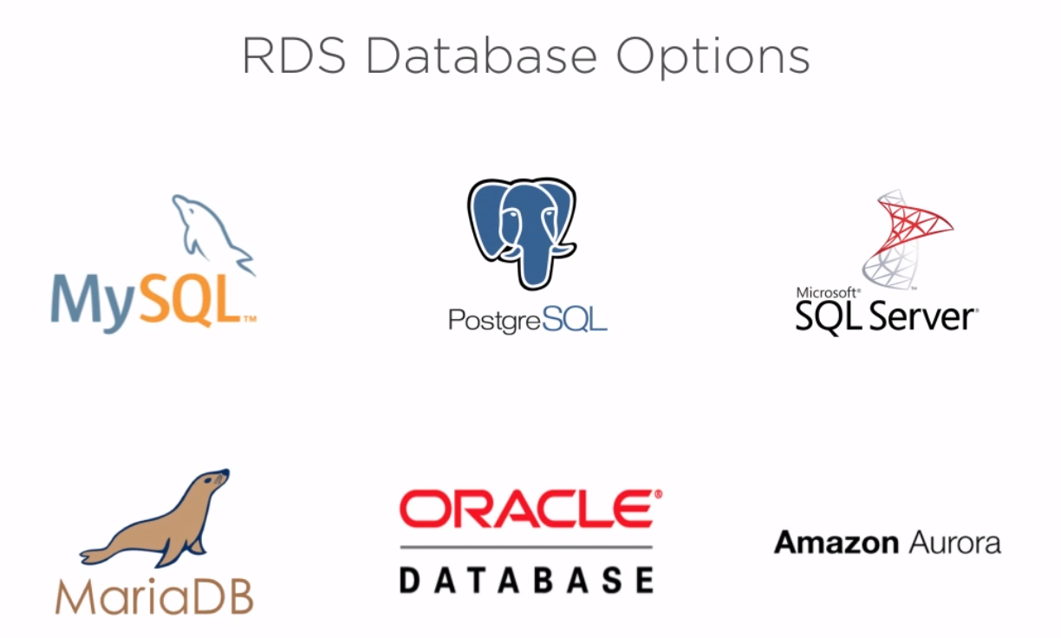



This works for existing projects that you are migrating to the cloud, but it may not matter if you are starting a neew project.



Since each type has a different cost this is an important factor.



If you have worked with a particular engine in the past, choosing that same one will save you a lot of ramp-up time, especially considering that working in the cloud presents its own learning opportunities.



A lot of your time interacting with the database engine will be done in some sort of GUI client, and the queality of those clients vary wildly, but they have a real impact on your usage.



1. Console, type rds into the services search, then press enter.

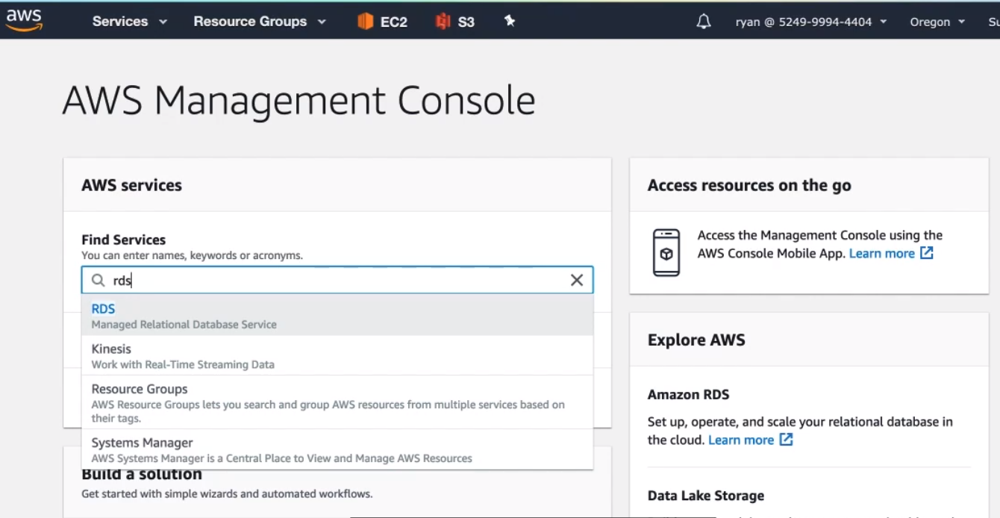

1. This is the RDS Dashboard. Over to the left is the dashboard menu. You can see options for databases, Snapshots, and subnet groups. Let’s make our Postgres database now.

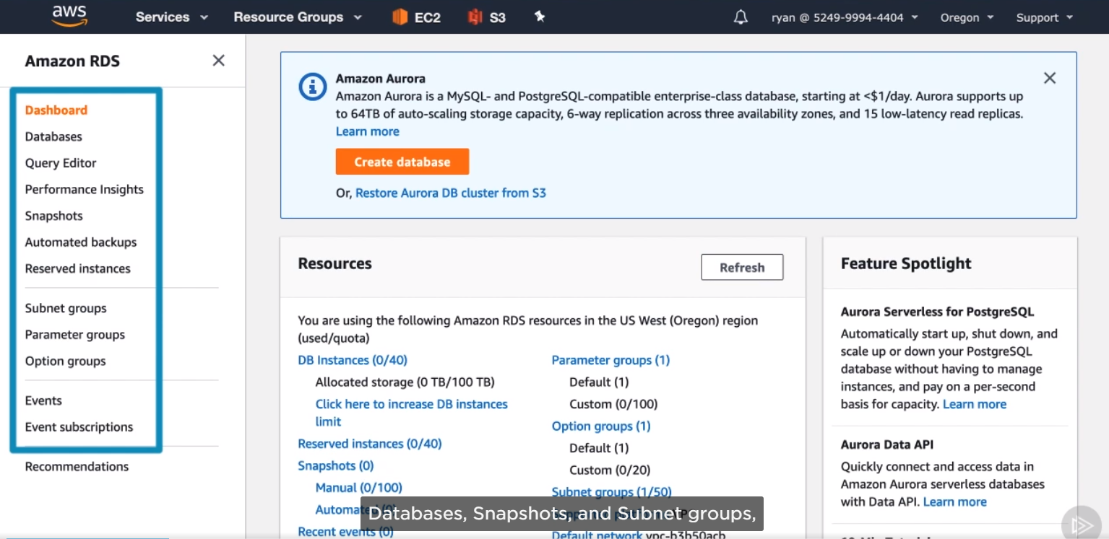

1. So click create database:

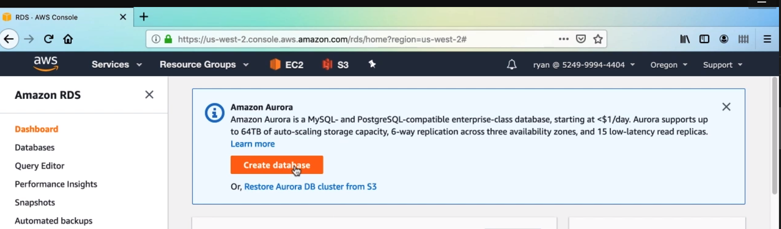

1. First, we’ll choose our database engine. For this course the PostgresSQL

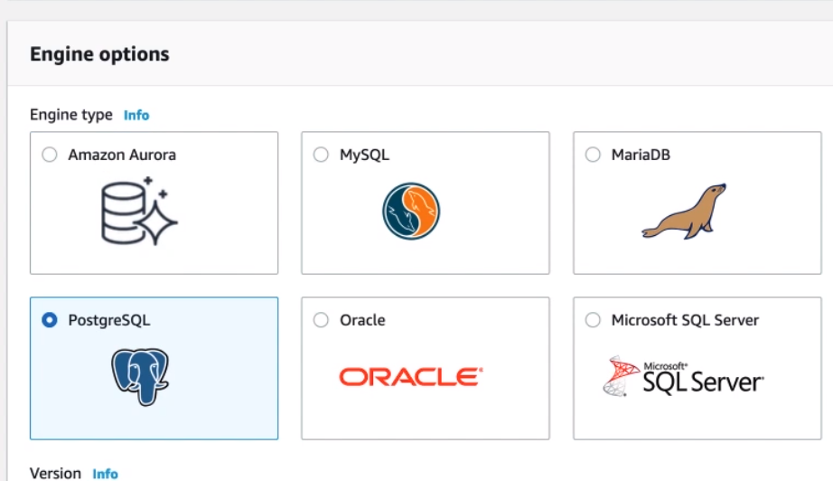

1. You can change the version of data base. For this demo, choose PostgreSQL 10.6-R1

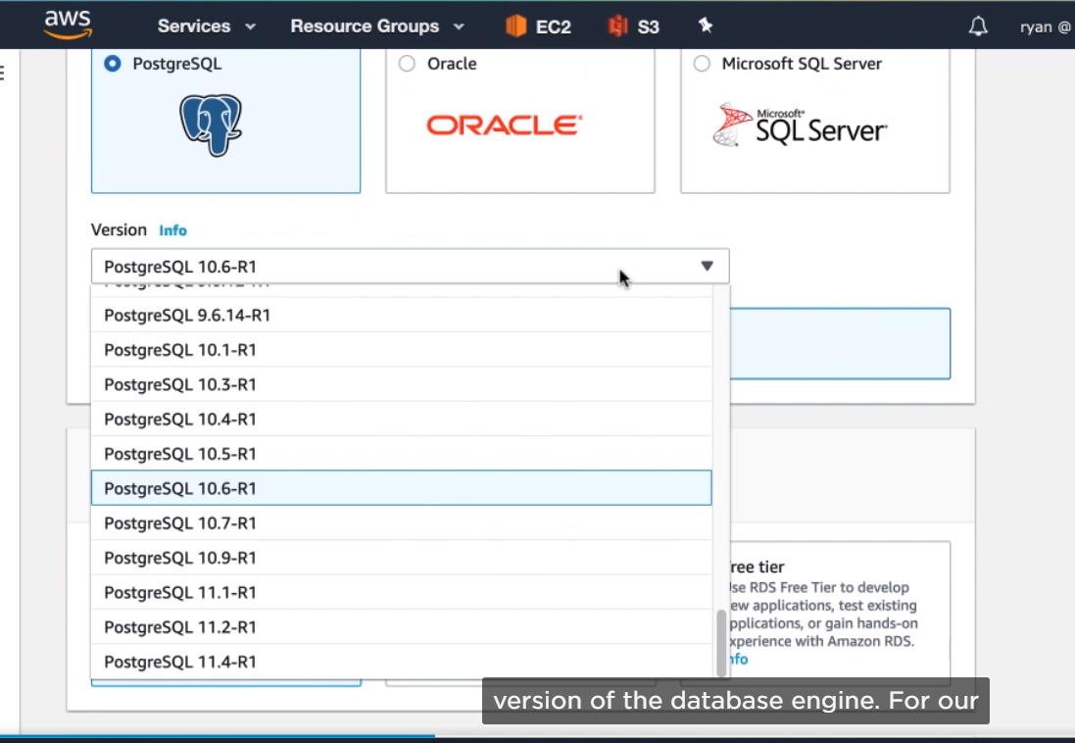

1. The templates section automatically sets some recommended configuration options, for you. Since we are trying to stay in the free tier for this demo, select the free tier option.

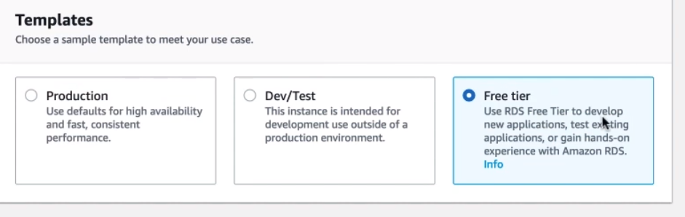

1. Next, we’ll name the DB instance. Enter pizza-db here.

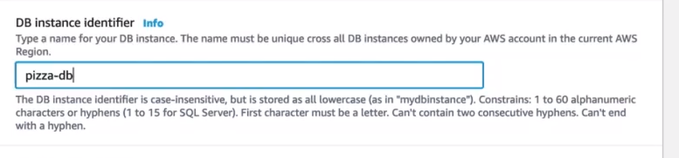

1. Then create a master username and password that you’ll use to log in to the database instance. 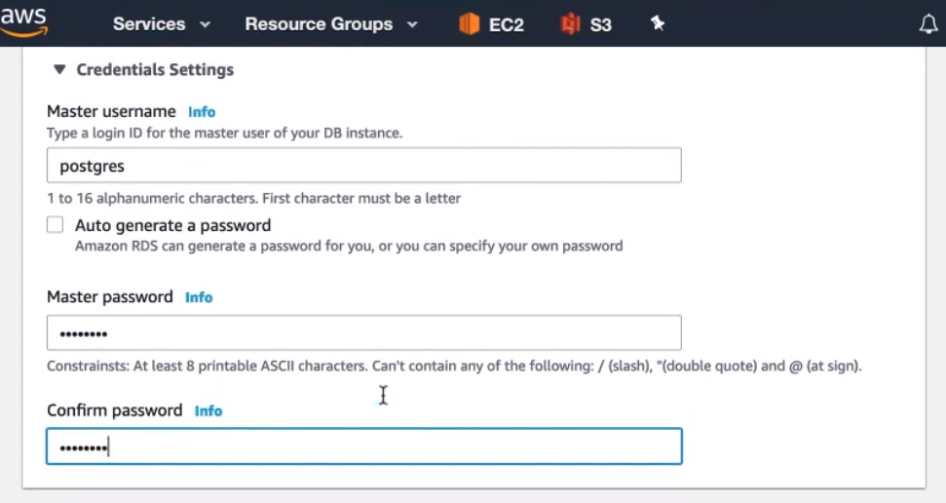
2. Now, for the instance type, it should already be configured for something like t2.micro which will fit in the free tier, so you can leave it as it’s set.

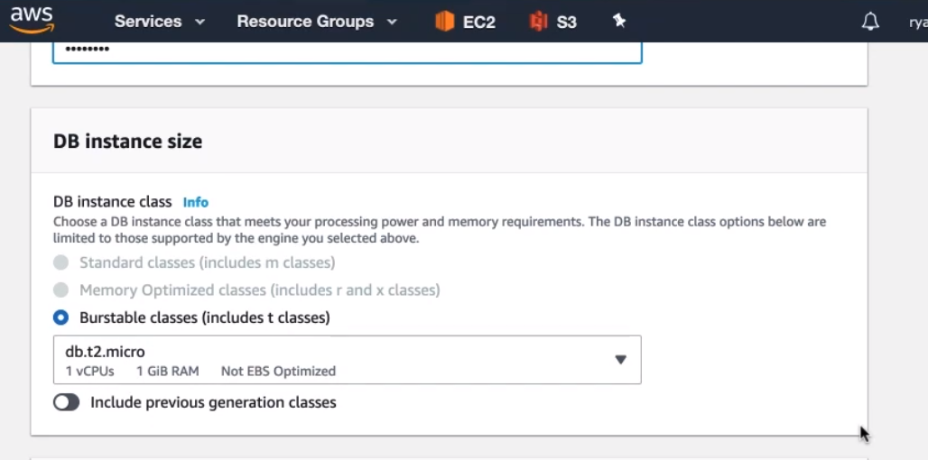

1. Storage won’t matter for our demo, so just leave it as it is. Skip down until connectivity.

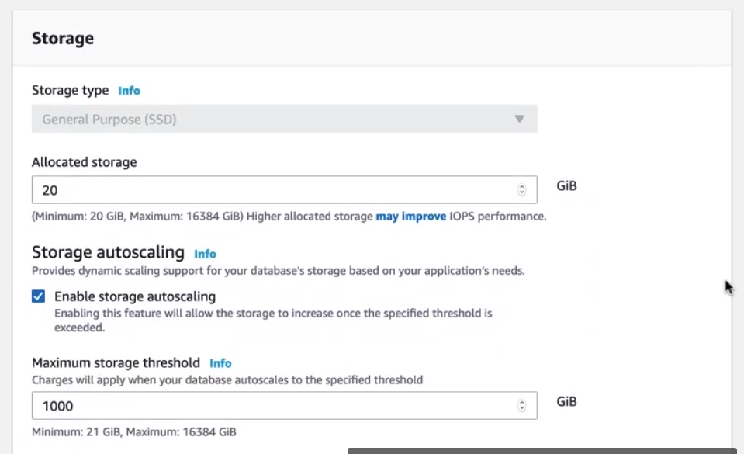

1. We do need the DB instance to be in our pizza-vpc, so select it from drop-down

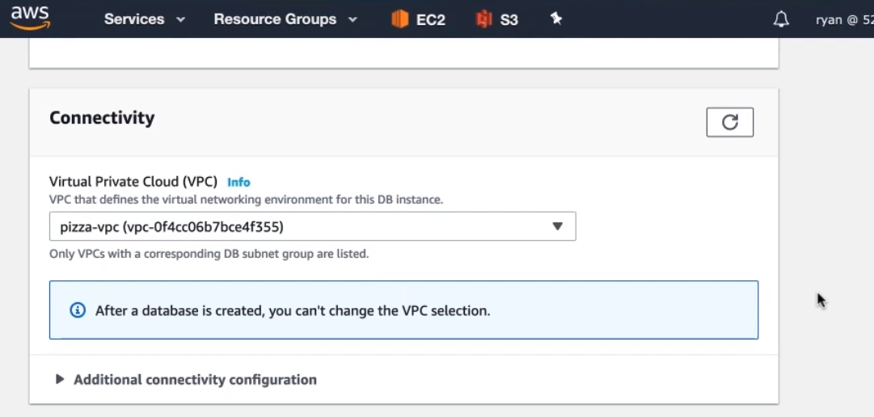

1. Next expand the additional connectivity configuration, and scroll-down to the publicly accessible section. Change this to yes.

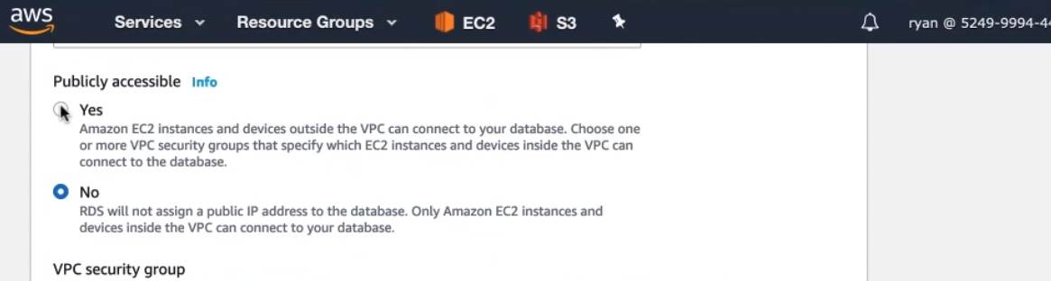

1. In a production setting, you’d want this to be No, but for the purpose of this demo porject, We want to get access from our local development environment. Once you’ve got everything running in aws, you should probably change this to a NO.

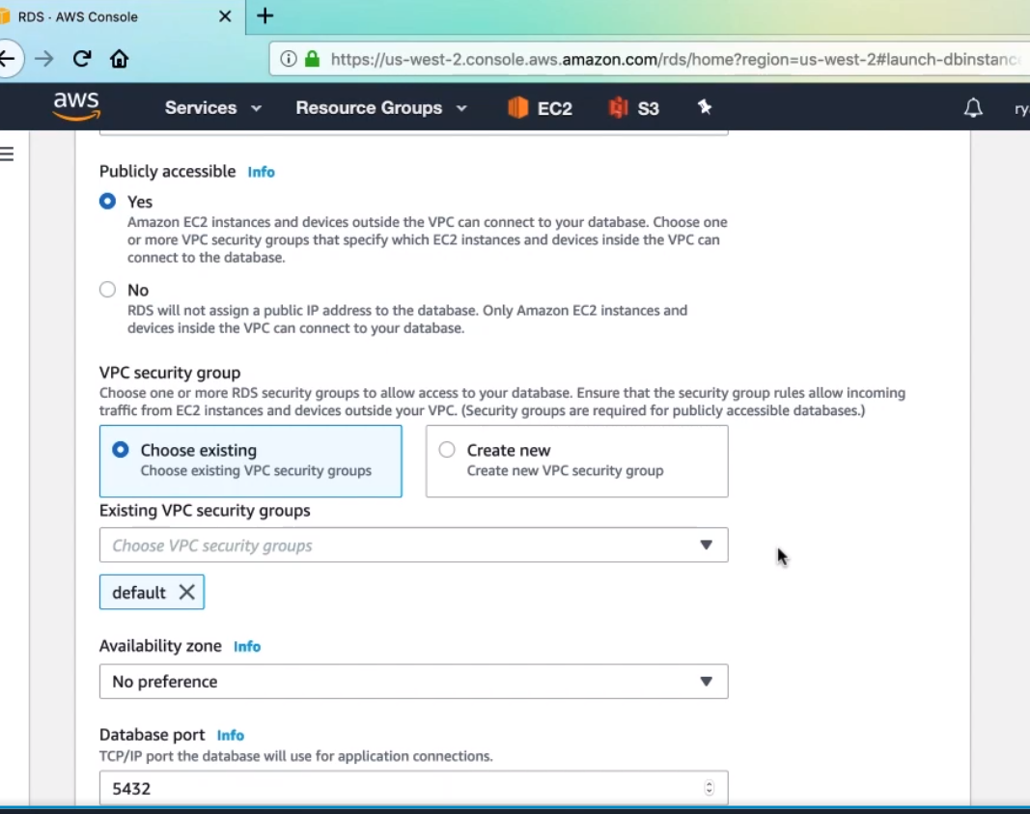

1. Then expand to additional configuration, We will want to have an initial database set up for us by AWS, so enter pizza_luvrs into this field. And that is

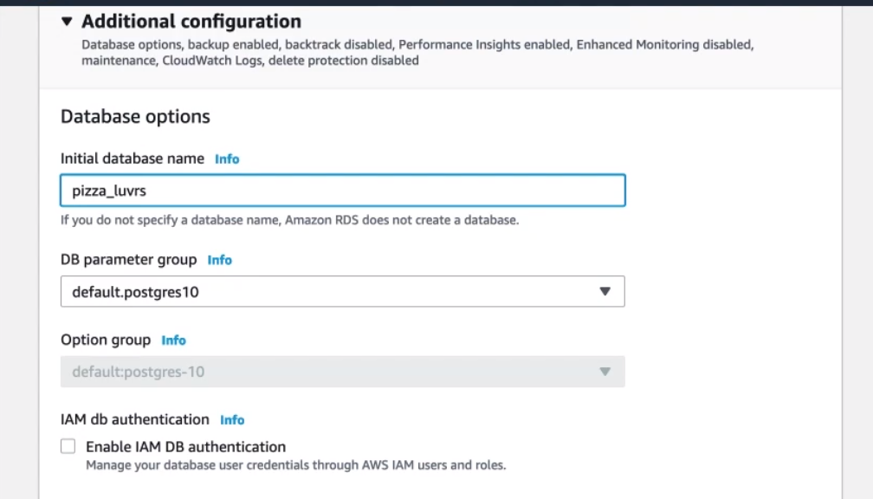

1. So scroll down an click create database.

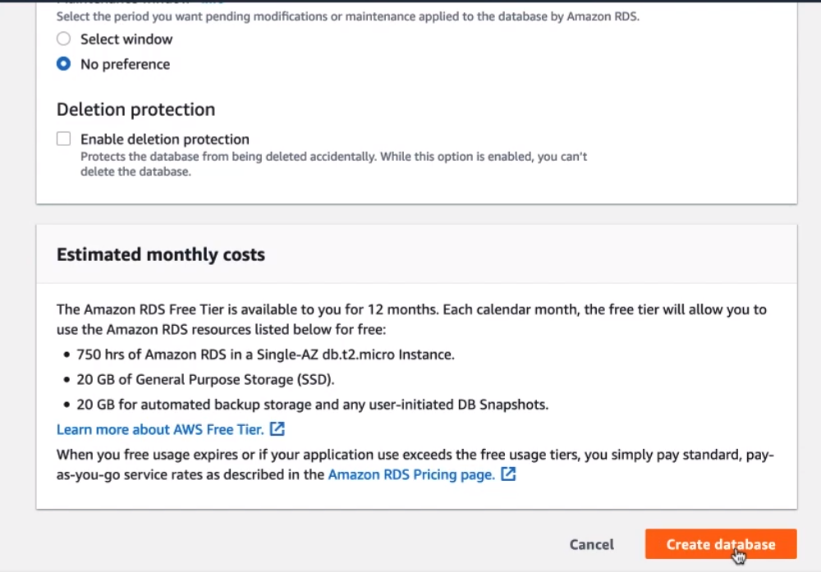

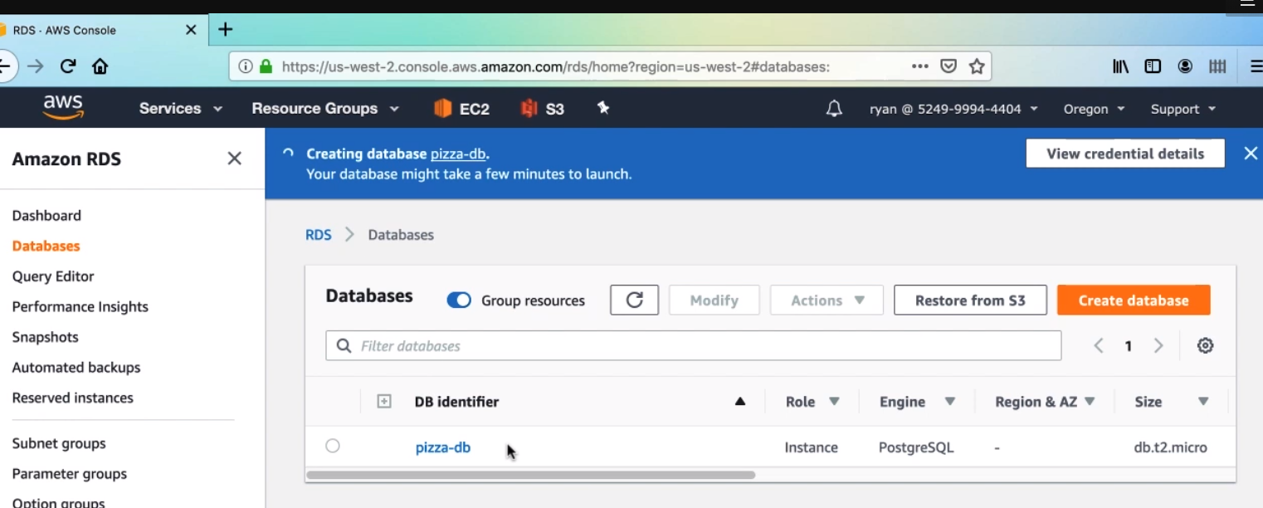

1. In the next clip, we’ll connect to this database instance.



* First, let’s take a look at the security group created for database. Click on pizza-db in the database list.

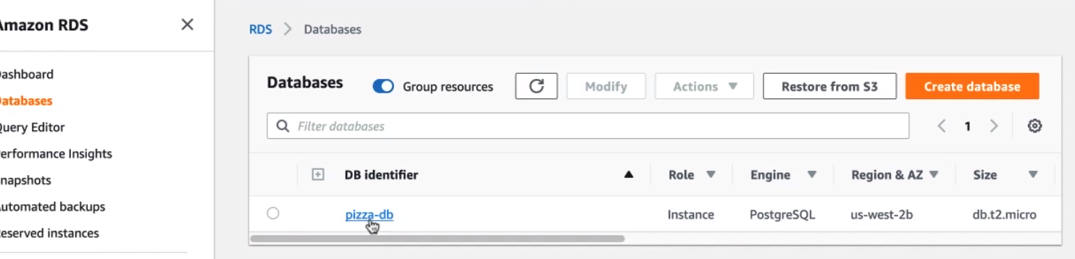

* Click on the security group,

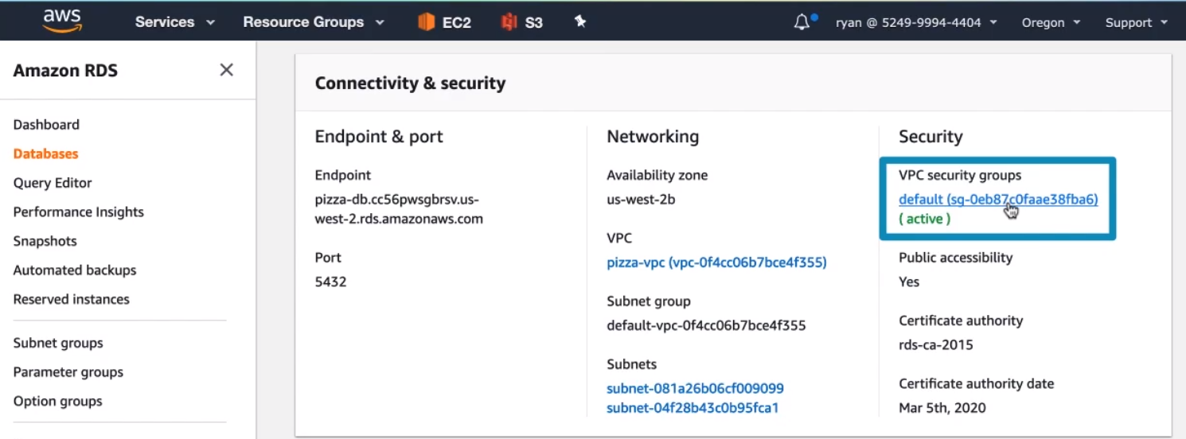

* Clicking on the inbound tab, the only rule shound see here is one that gives inbound access to anything with the same security group attached. We want to add a rule that gives our local IP address access into the database, so click Edit

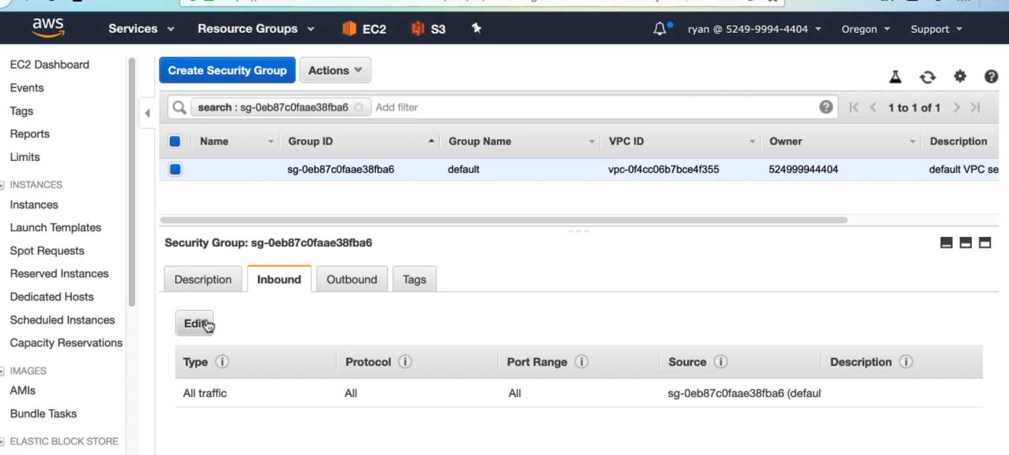

* Then Add rule, the type drop-down has a selection for PostgreSQl, so go ahead and select that option.

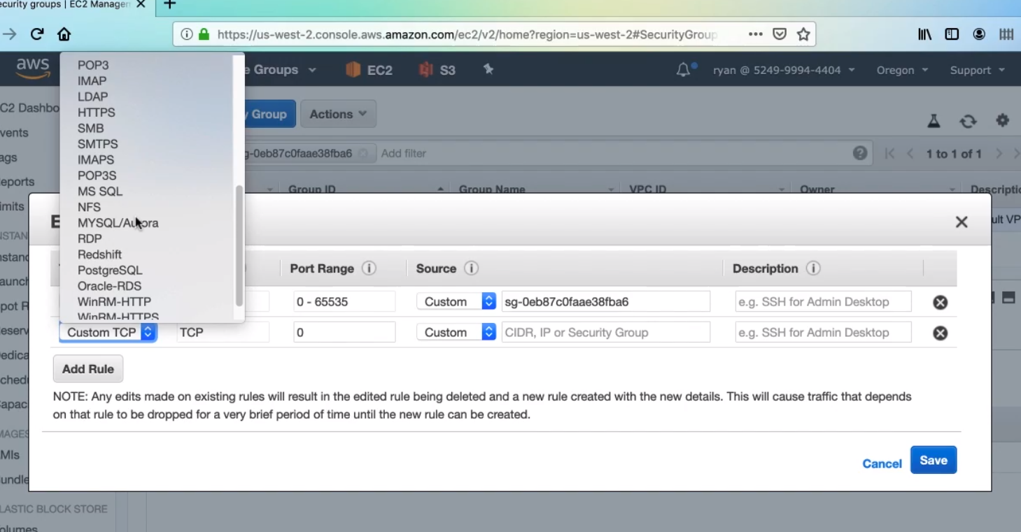

* And then in the source drop-down, select My IP, and then click save

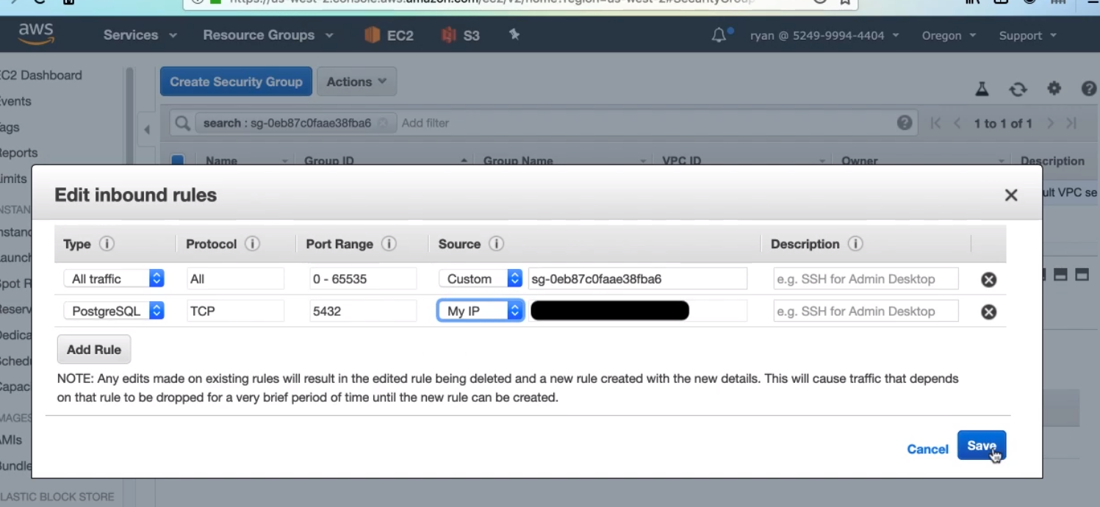

* Now, with our Postgres instance configured to let us in, we need to use some type of Postgres-specific admin tool to connect. I will use Postico, which is a paid app for mac, but it has a generous free trial. Another option is pgAdmin. Here are URLs to find either program.

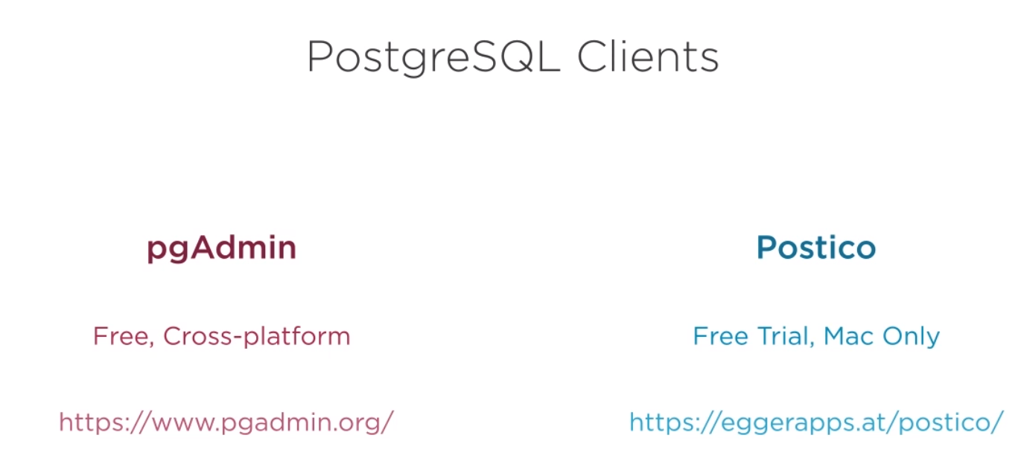

How to connect to postico,

* You can click New facvorite to create a new connection

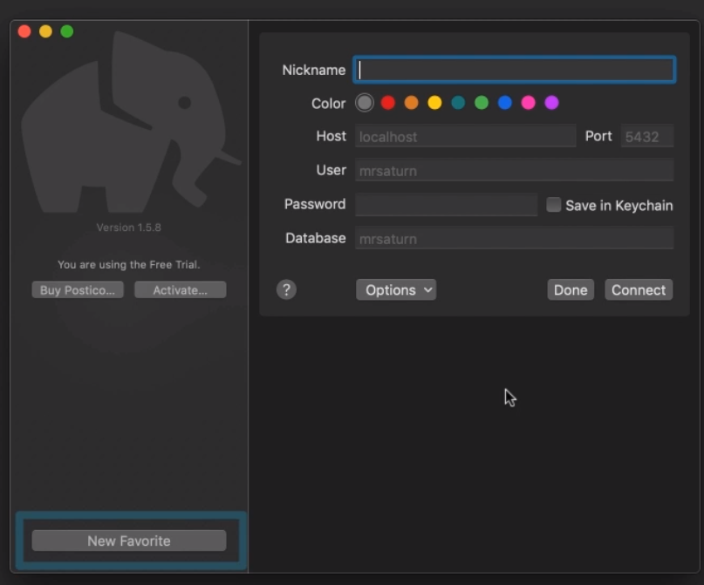

* 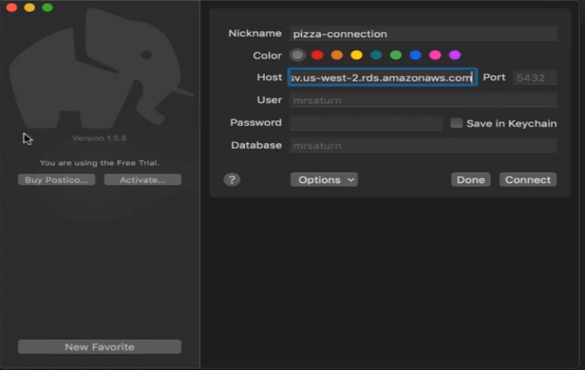 The first field is to enter a local nickname for our database connection. You probably guessed it. We’ll call it pizza-connection. Next we need to get the hostname for our database. We can get this from the database configuration panel in the web console. Copy that and paste it into the host field. You notice the port has a light gray value in. this is the default value that will be used, and it matches the default port our Postgres instance is listening on, so just leave it.

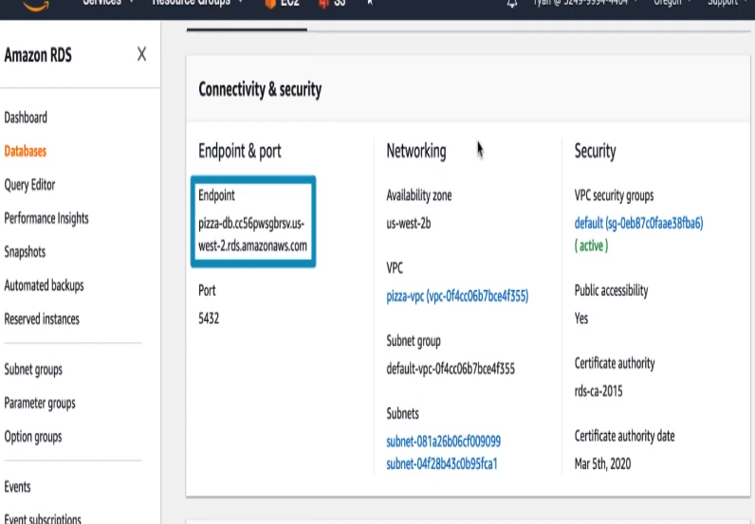

* Next, enter the username and password that you created for the databse. And lastly, Postico wants an initial database to open, so enter one that AWS created for us, pizza_luvrs. Now click connect. Then connection warning says something about certificate, this is totally fine for our dev envioronmnet. So go ahead and click Connect.

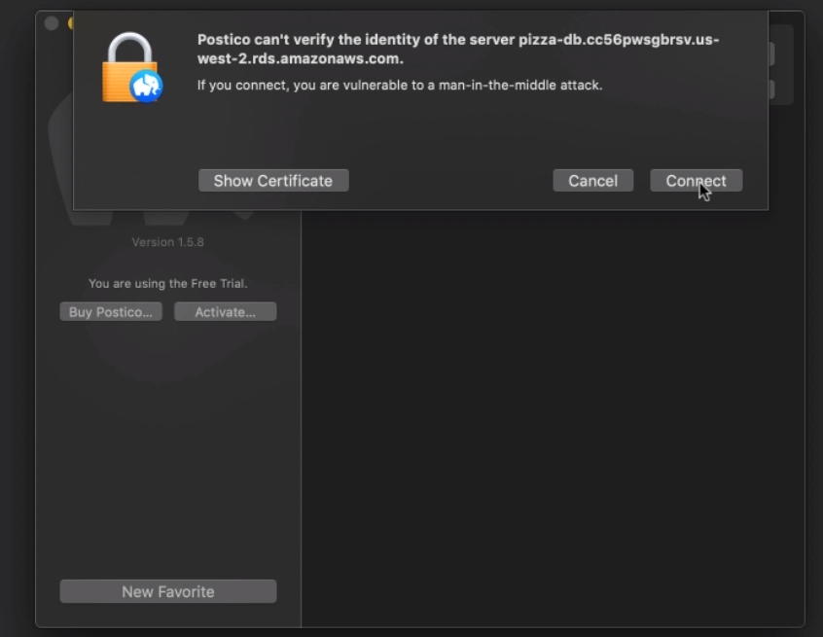

* We are connected directly into the pizza_luvrs database, and you’ll see some default folders in the database. We’ll be storing pizza data in here, so we need to create a new table with a schema that matches the pizza values we’are storing. Click the add Table button.

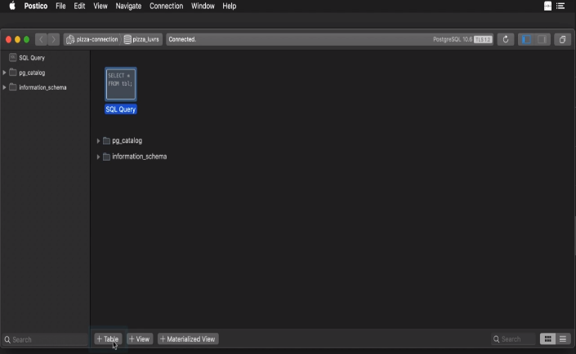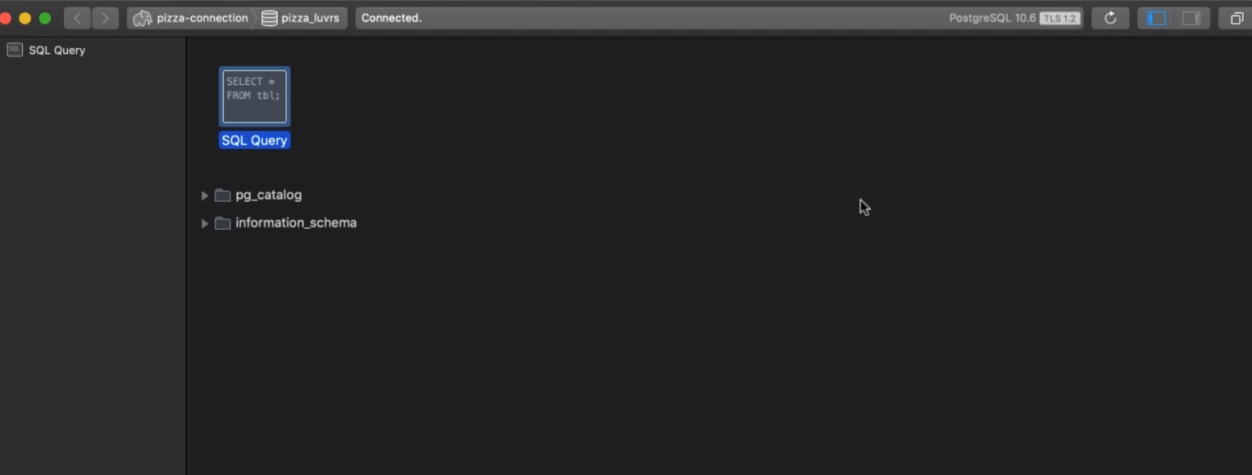

* This is where we will create the schema via a GUI. First, name the table pizza. Now we need to add the columns for data that we need to store. When creating a new table, Postico will create an identity id column. We can use this column, but we do need to change the datatype since por pizza ID is a string and not a number. Change the TYPE serial to text. The column already has a PRIMARY KEY constraint, which is exactly what we want. Now click the add column seven times since there will be several columns we need to create. Change the column names for the next columns to be name, toppings, img, username, created, createdAt and updatedAt. Then change the datatype

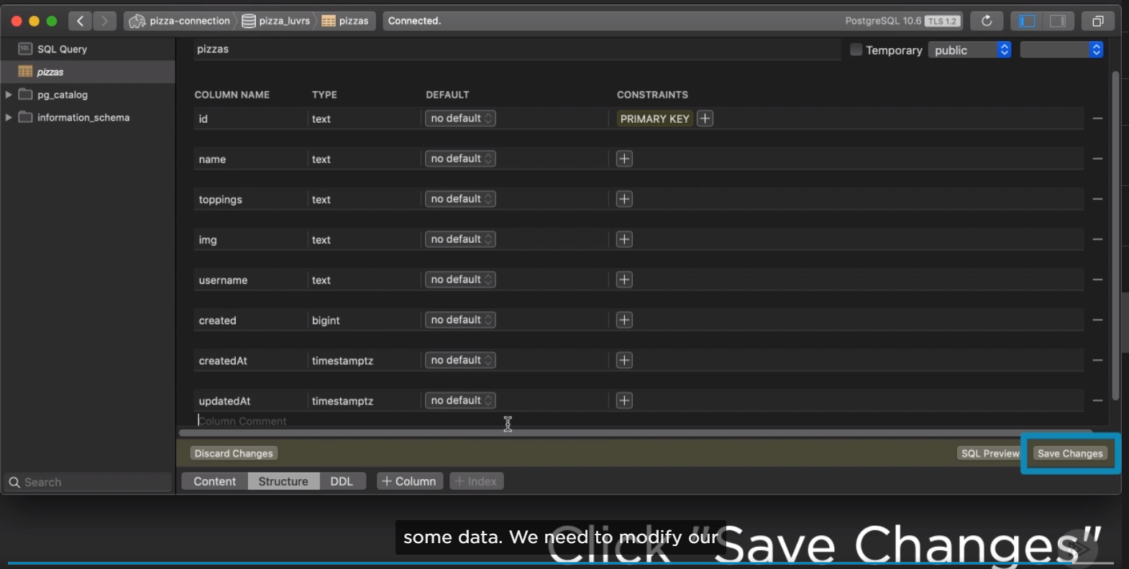



We want to connect to our database to create and to query pizza. Connecting to an RDS database instance doesn’t actually require the use of the AWS SDK. Since you choose the flavor of database installed, you’ll actually use a normal method of connecting to that database instance.

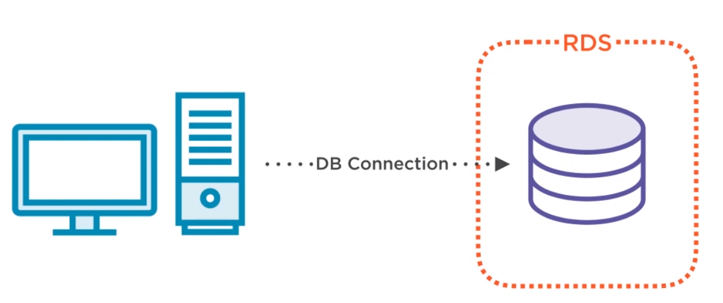

One of the solution is the object-relational mapping library, also called ORM. This transforms SQL queries and responses into basic function calls and objects that makes database much easier to work with. An added bonus is security since you won’t be writing SQL queries and worrying about injection vulnerabilities.

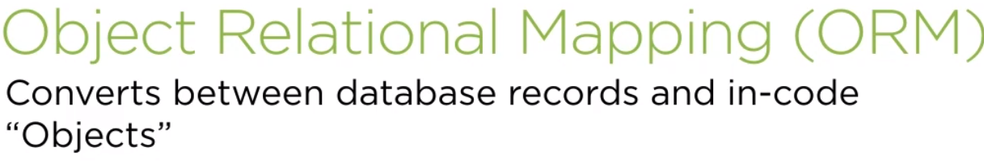

For our application, we will use a popular Node ORM library called Sequelize, which supports Postgres, but also MySQL and others. Ive already added

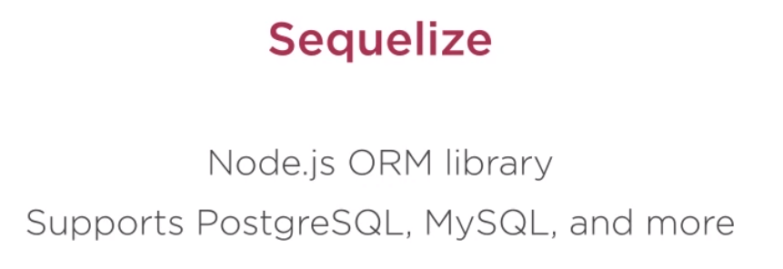

There are a couple issues with this approach though that our database implementation will solve. First is persistence. Because this pizzas variable is just in memory, once our app restarts, all the data will be lost, Second is scalability. As pizzas are added, memory usage will increase with no constraint. I the app any rise in registered pizzas. The memory would balloon out of control. So, for these reasons, we want to store our pizzas in a database.

1. First create a file pizzaStore.js then write paramaters for connection.

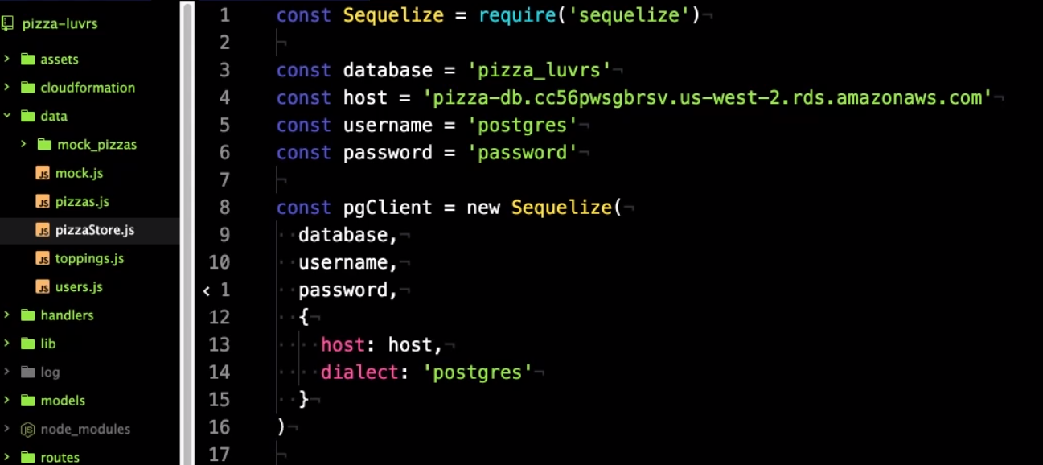

1. Then, next we need to sync up with our pizzas table and define the shape our pizza objects will take.

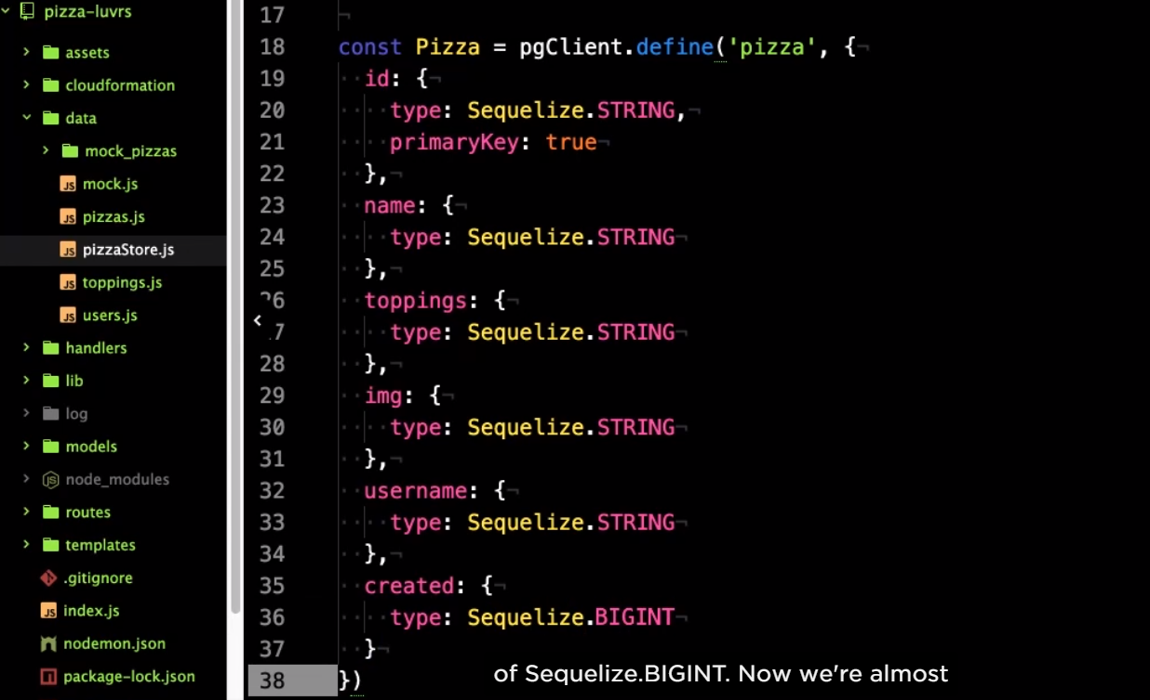

1. Create a connection with postgres, and a module.exports property.

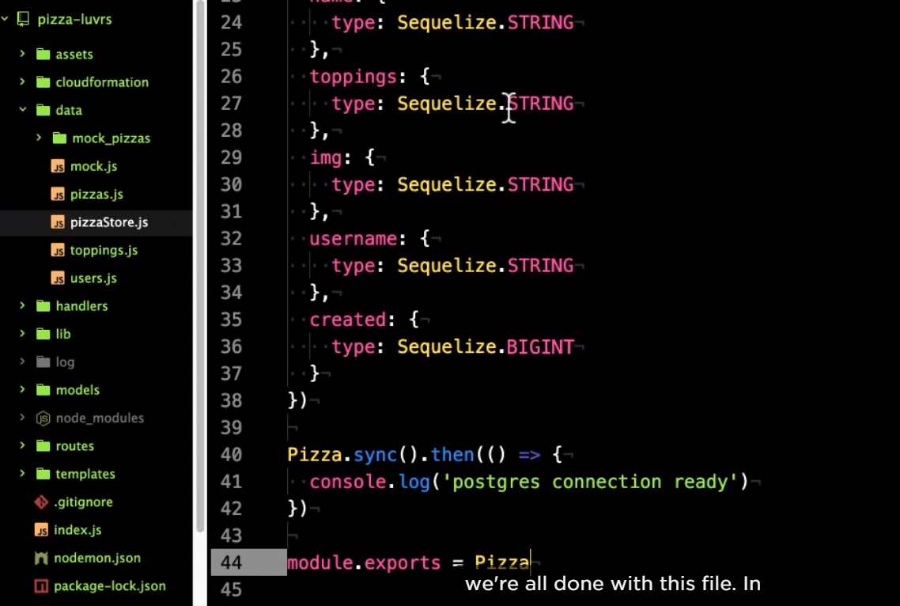

1. Then and pizza.js, use PizzaStore to store into database.

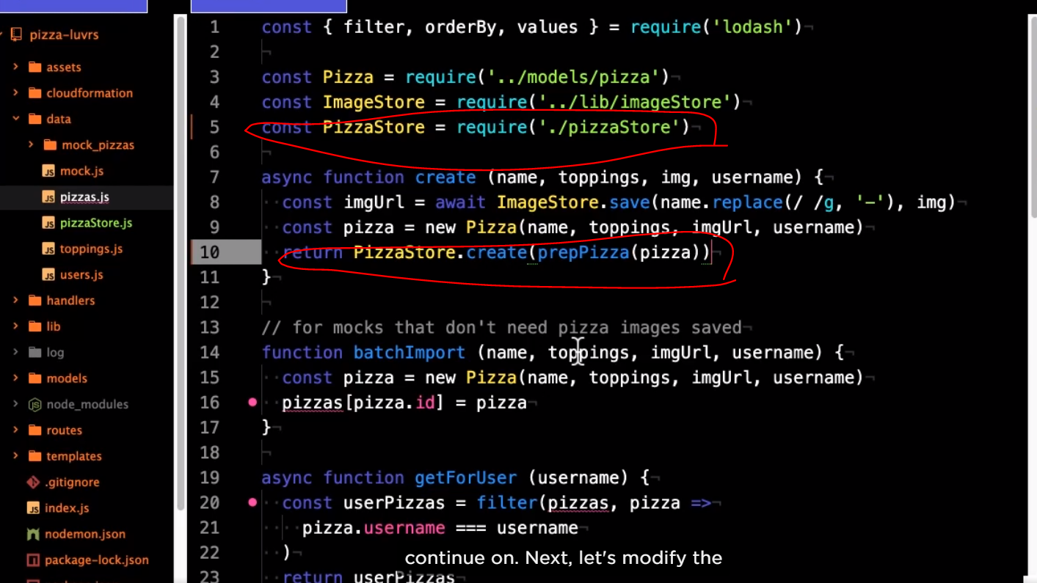

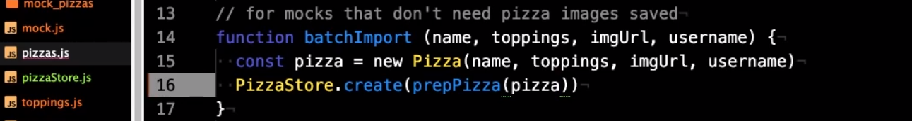

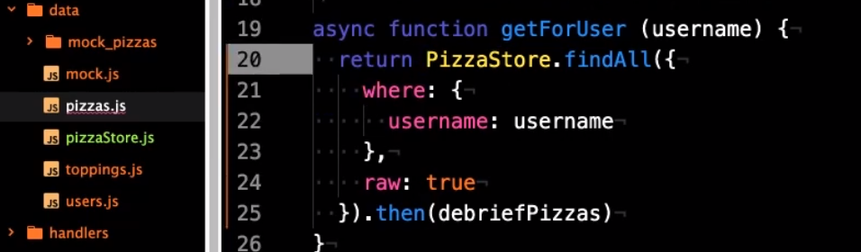

* This will sort all the pizzas from newest to oldest. Add another value limit with the property 4, this will only return the top four.

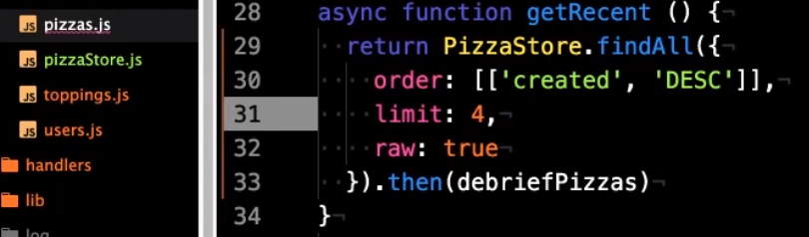

* We’ll use the find one function on PizzaStore to get a pizza. So call that. And pass in an object literal. This argument provides the criteria for what record to find.

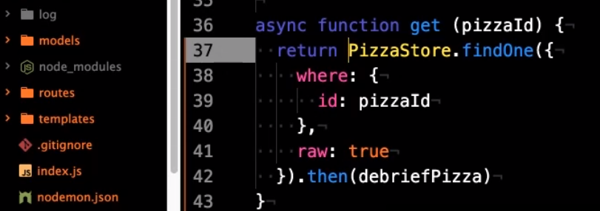



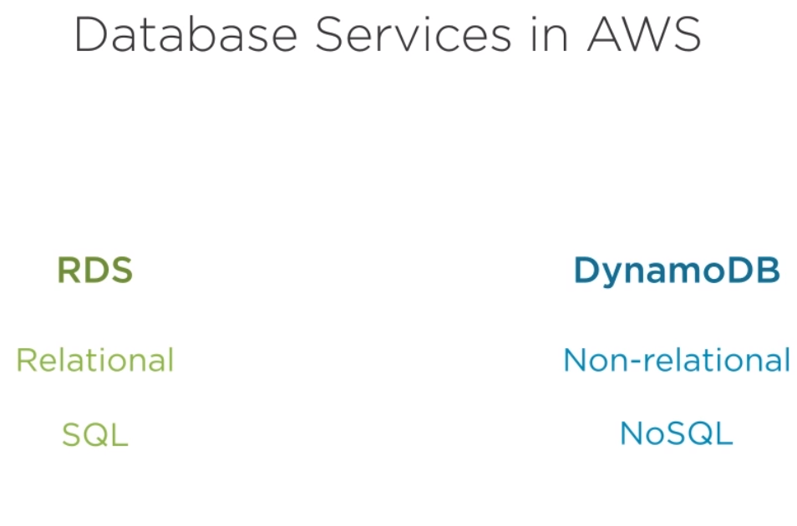

What do I mean by not realtional?

Well, in relational database, there are built in ways to relate different tables in database usually by using keys this makes querying and storing data very structured and in some ways modular. In addition, each table has a strict shecma that must be followed for each row of data.

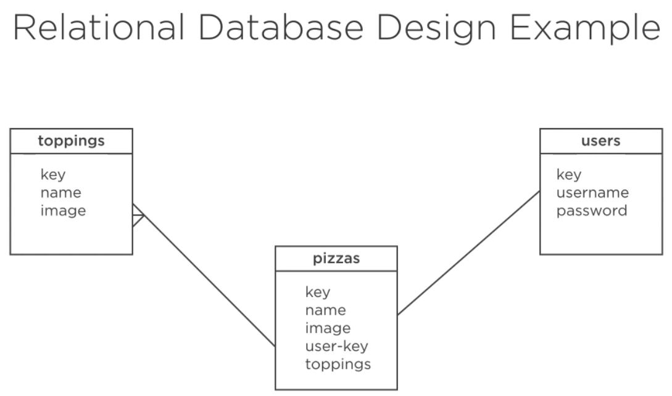

NoSQL, or non-realtional databases throw all that out the window and just store data in tables without much configuration. There’s not set schema so you can change what data you are storing at any time.

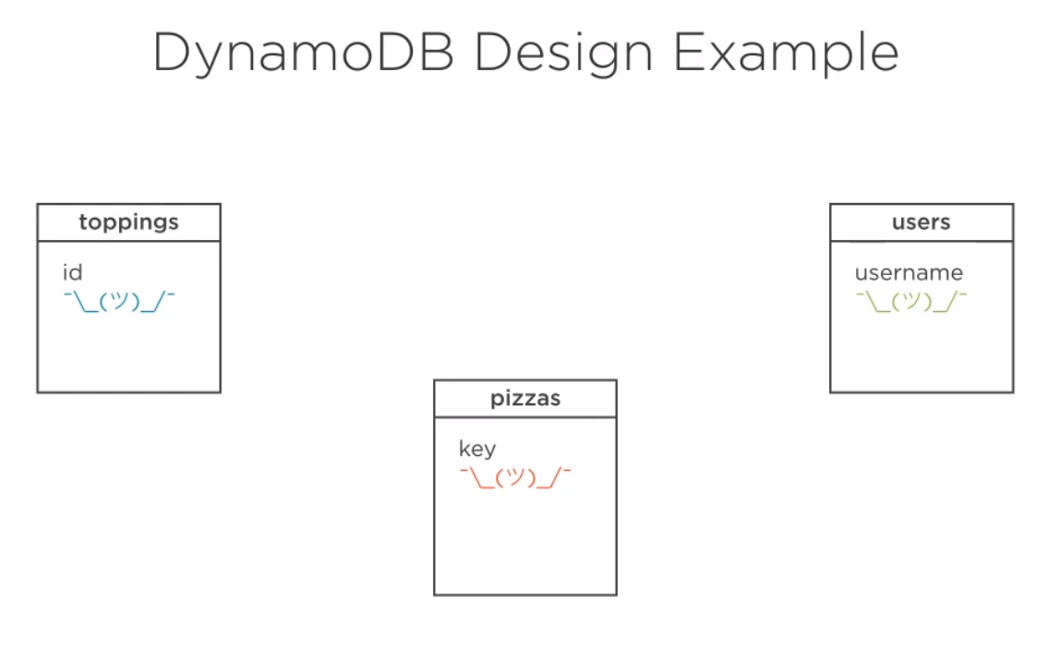

The main structure in DynamoDB is a table. A table contains many rows of data called items that have whatever schema you give them at the time of putting them in the table. The one set aspect of your items is that they do need to include the same primary key. This is used to index the data and make it efficient to query items based on that key. You have only got a few different types to choose from for this primary key: string, number, or binary.

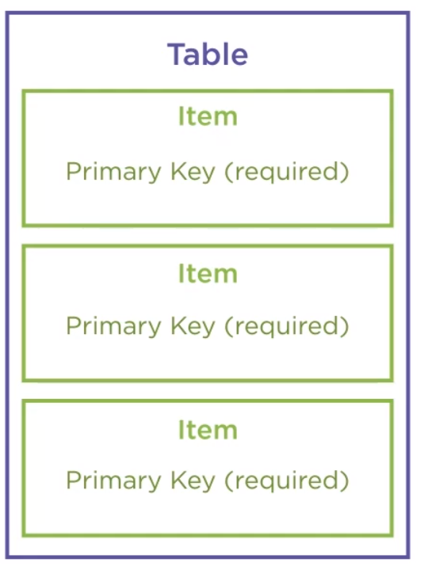

. Besides the key options, the only other really configurable property of a table is the provisioned throughout capacity. This defines how many read or write operations can happen in a given second and tells AWS how much hardware to provision for your table. Since there is not instance option for DynamoDB table. Provisioned throughout is how you prepare your table to take load.



The number represented on the read-write throughout capacity is based on a read or write unit, which is 4 kb in size.

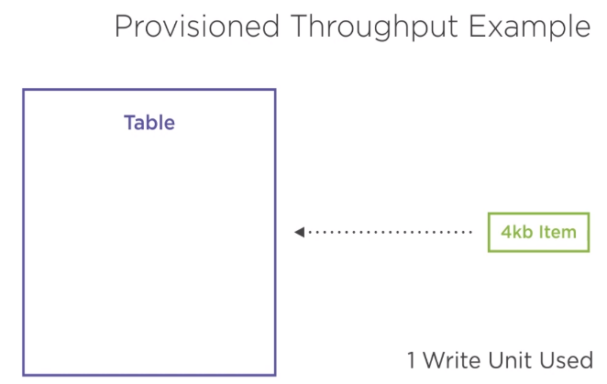

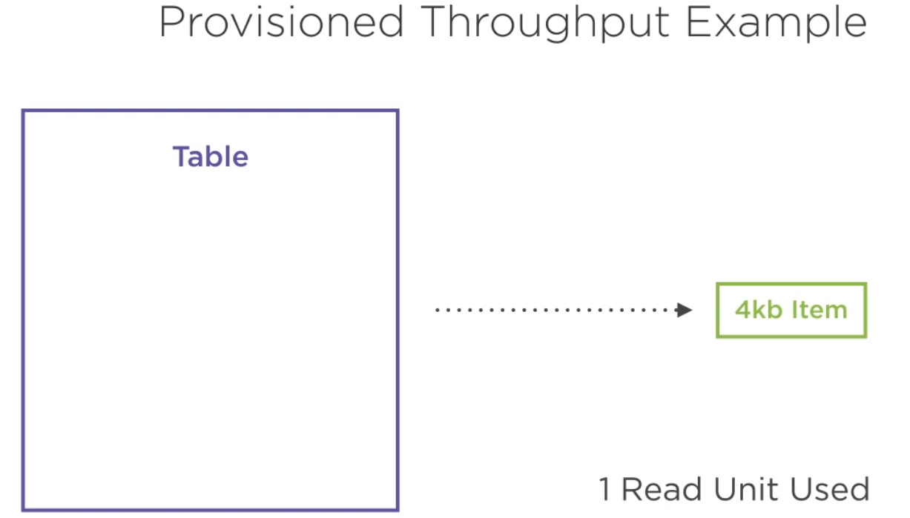

If the item you are reading or writing is larger than that, it will consume more units. If your read-write throughout exceeds the provisioned amount AWS may throttle the request to read-write or even deny them. It‘s important to right-size the provisioned throughtout capacity for your table, and since it’s a configuration factor that you can modify on your table as needed.

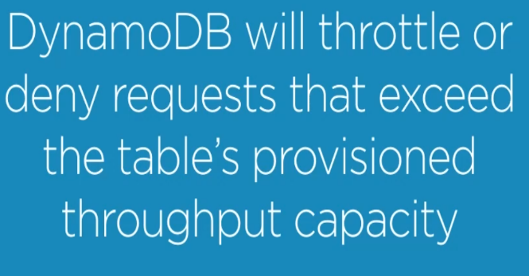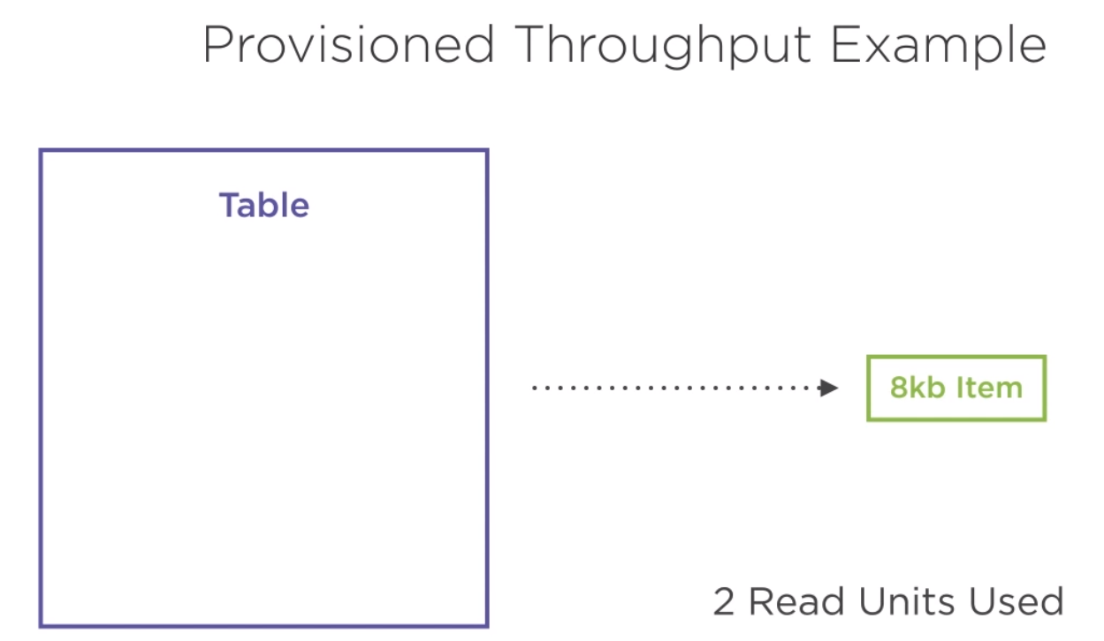





That RDS and DynamonDB are opposites on, which should help you decide which to choose. RDS, like a typical database, it can be used for many different purposes. Putting data in and getting it out is very efficient. One aspect of relational databases is the strict schema of the data being stored. When you are developing and adding properties to your data, this schema constraint can become frustrating as I’ve experienced.

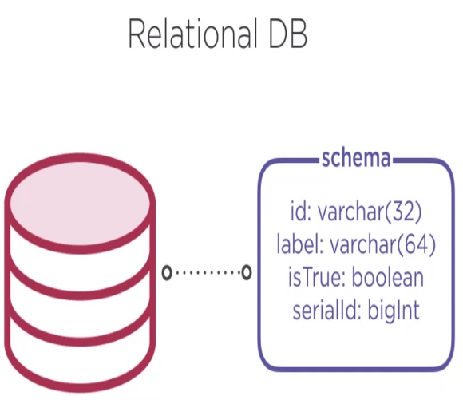

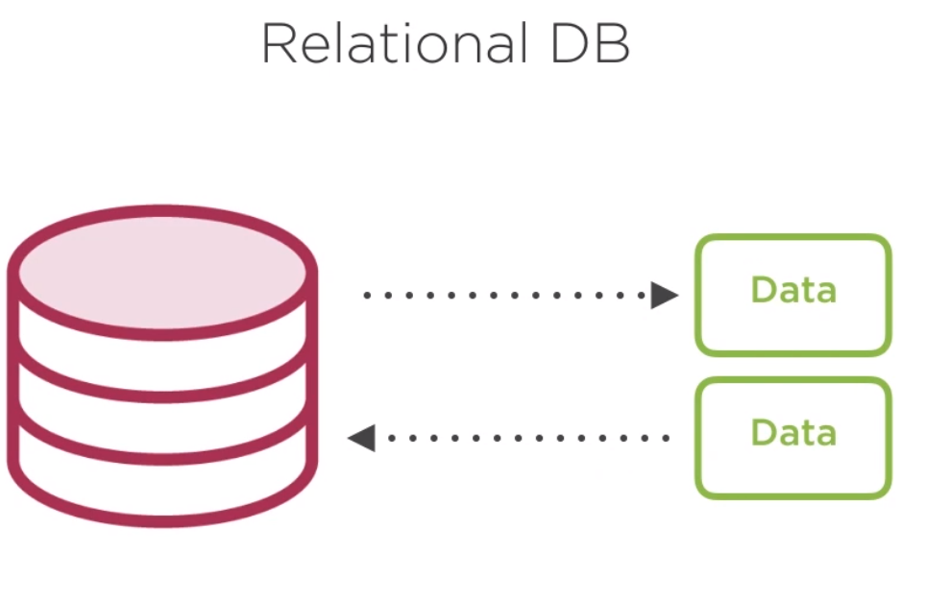

DynamoDB, on the other hand, is extremely flexible with how your data looks. You can add a new field at any time and put it in a table with data that have different schema. As long as your primary key is there. Dynamo won’t complain. This flexibility obviously speeds up development time and makes it easier to iterate. Because of this, I like to say the Dynamo DB has strong storage flexibility. On the other hand side of this however, it is querying the data. To get data out of a database,

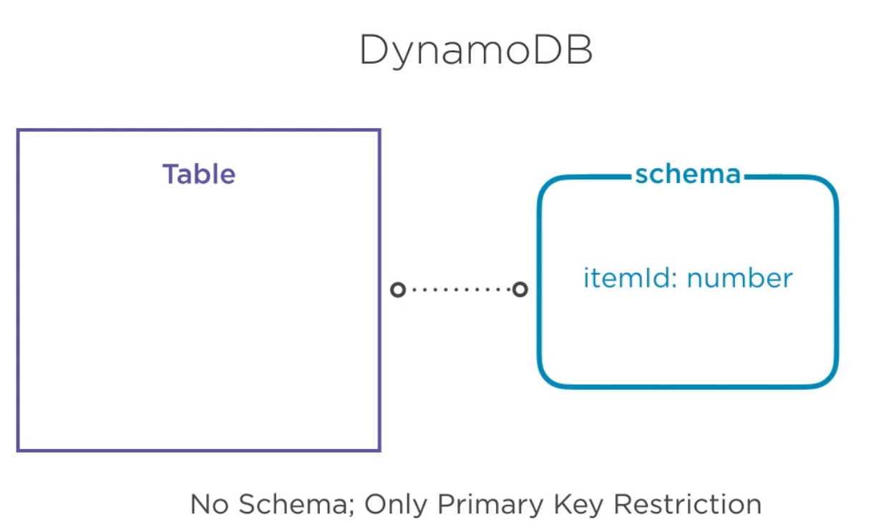

you typically need to give it some factors to look for. In querying relational database, Excel and Structured Query Language, or SQL, is perfecting for getting data out however you need it. The strict schema of relational databases actually make it easier to query data.

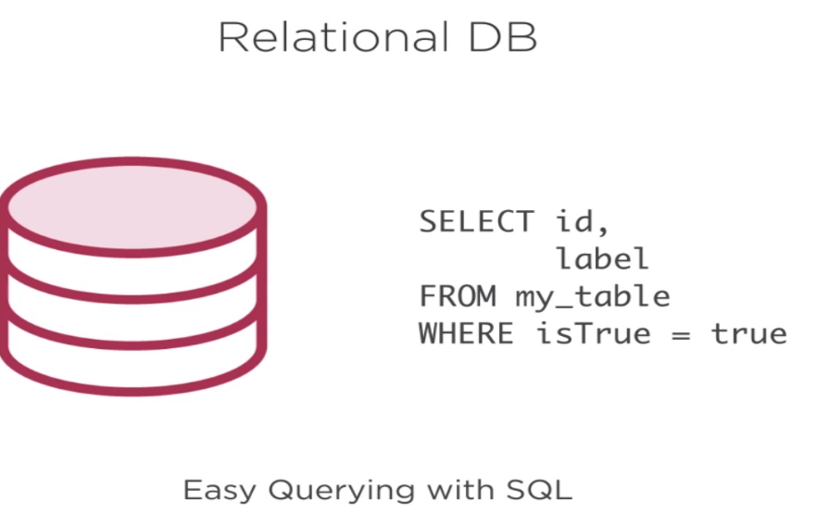

DynamoDB, however is not very flexible with querying data. Getting out items by primary key is fast and easy, but trying to query based on other properties becomes very difficult. You can create secondary indexes on other properties of your data, but again, it’s just matching an id.

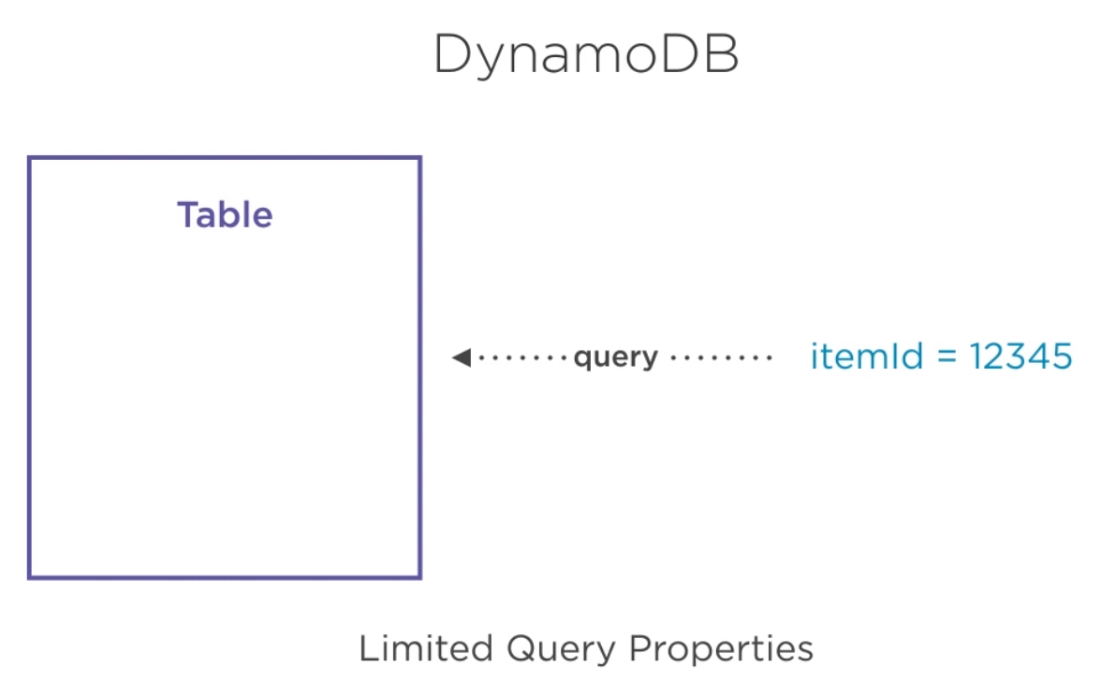

You’ll quickly find that RDS has the strongest query flexibility. So, to me, this is a deciding factor between these types. For a given data set, do I need storage flexibility or do I need query flexibility?

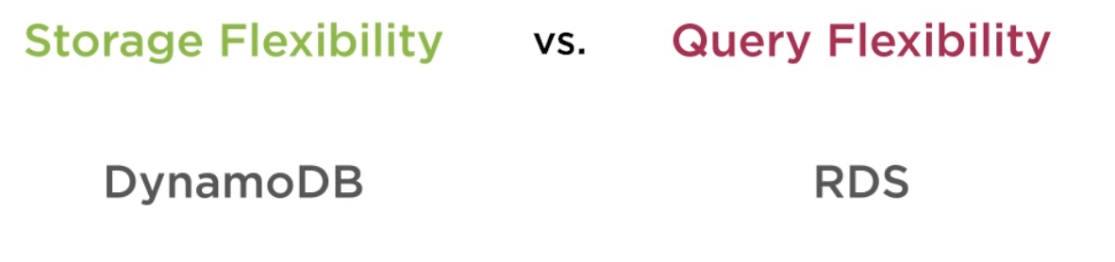

For storage flexibility, I would choose DynamoDB. If I am only ever pulling data out by ID, then I don’t need query flexibility and can opt for DynamoDB, but for query flexibility I’d go with RDS. Strict schemas can make it more tedious to work with, but if I need to do range queries or query on multiple properties.

Creating a table in Dynamo DB:

1. From your AWS Console, type DynamoDB into the services and search.

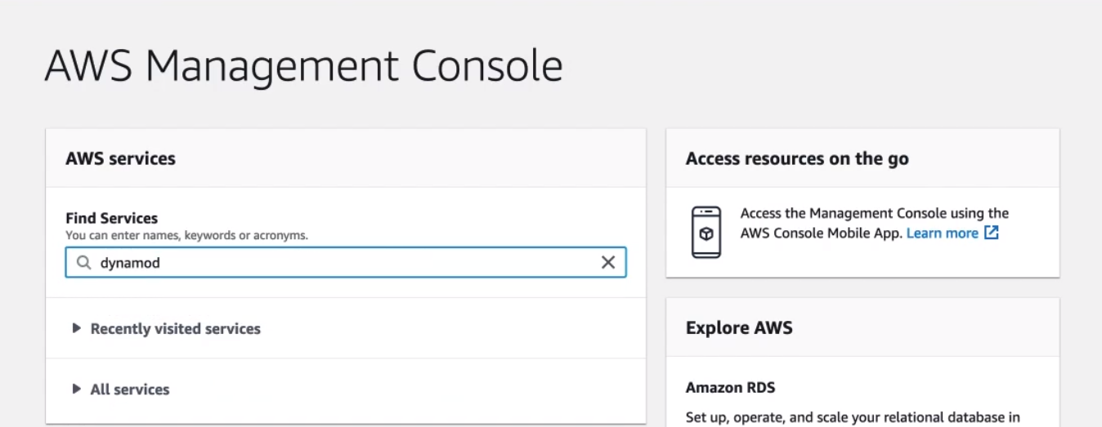

1. Then create table,

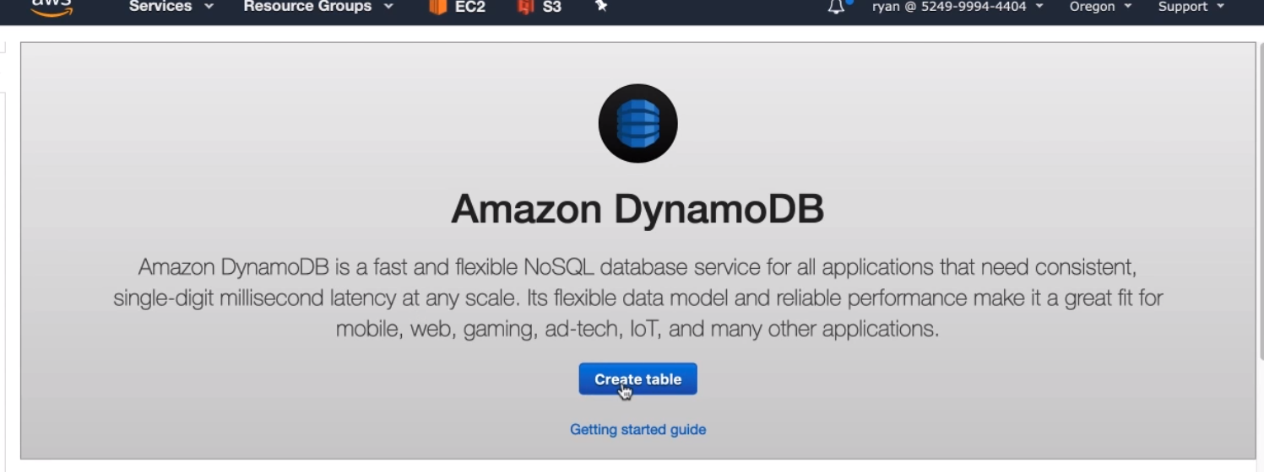

1. For the first table, we want to store the toppings that are used to make pizza. Let’s just call the table name toppings. Now we need to define the primary key for each item. We’ll call it id, and in the drop-down for the datatype leave String selected.

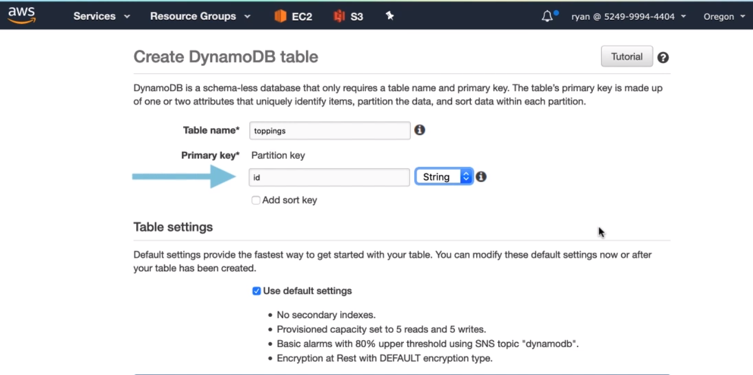

1. In the table settings option, you’ll notice it lets you use defaults to create your table. These defaults are just fine for our table. Since we can change all of these later. Just leave the box checked.

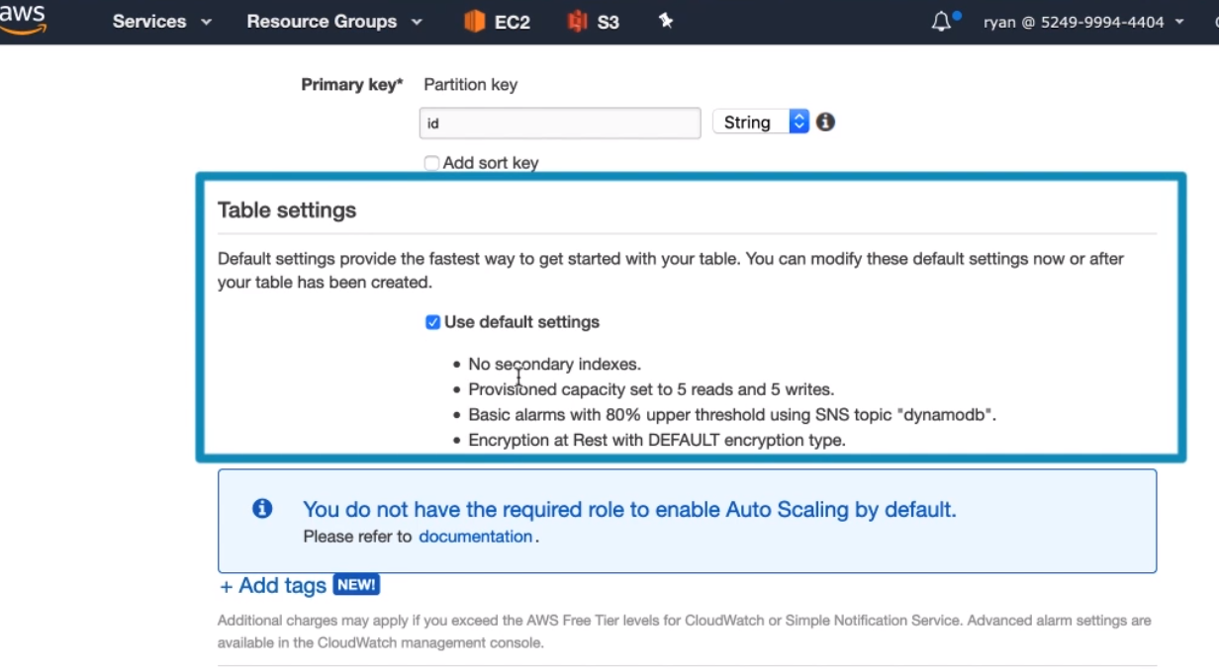

1. Then select create button.

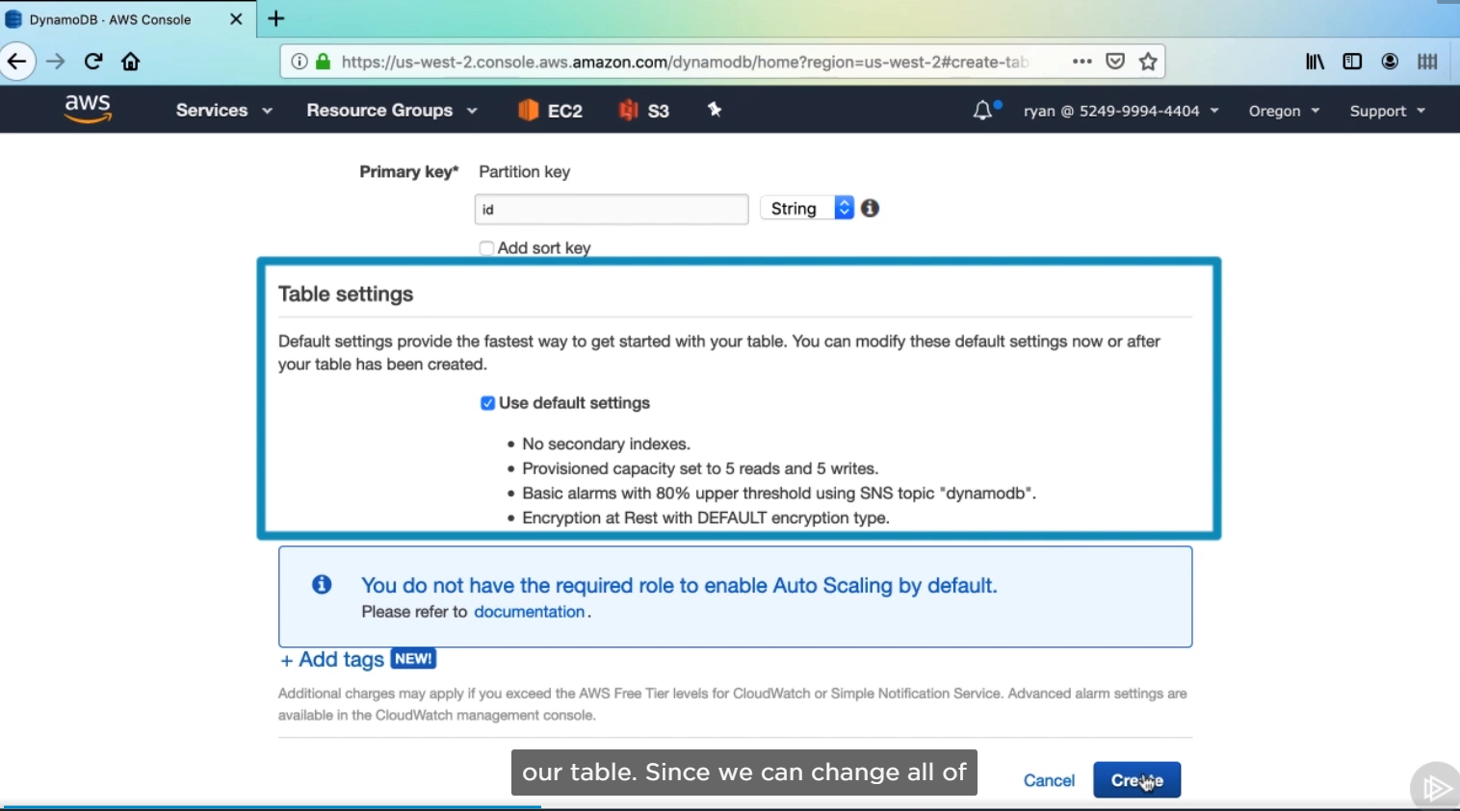

1. Let’s create another table.

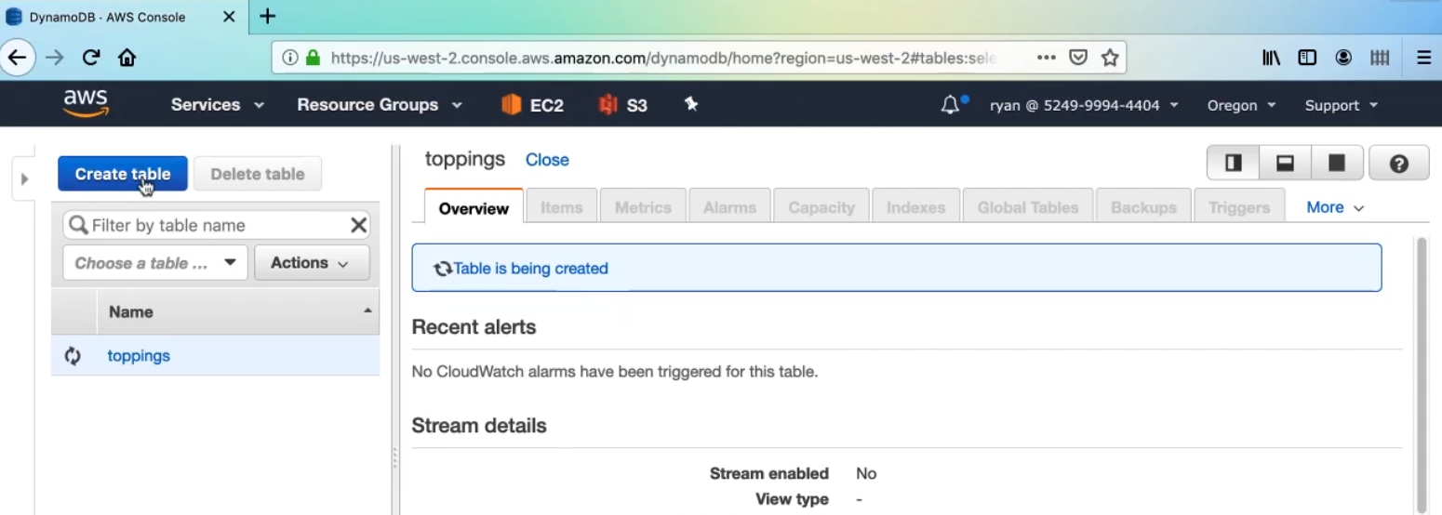

1. Name the table and the primary key, then select create button.

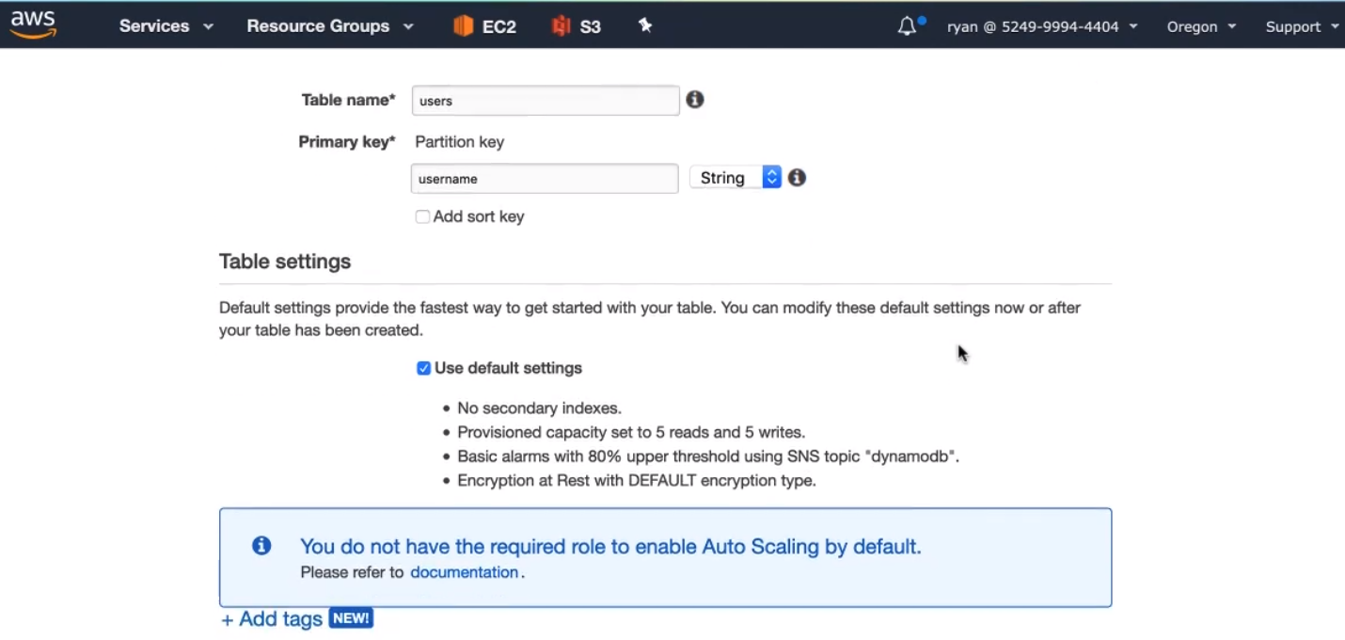

1. Click on toppings and it gives you some brief details. DynamoDB does use Cloud Watch alarms to let you know if it throughout exceeds the provisioned capacity , and this section will show you if there were any recent alerts.

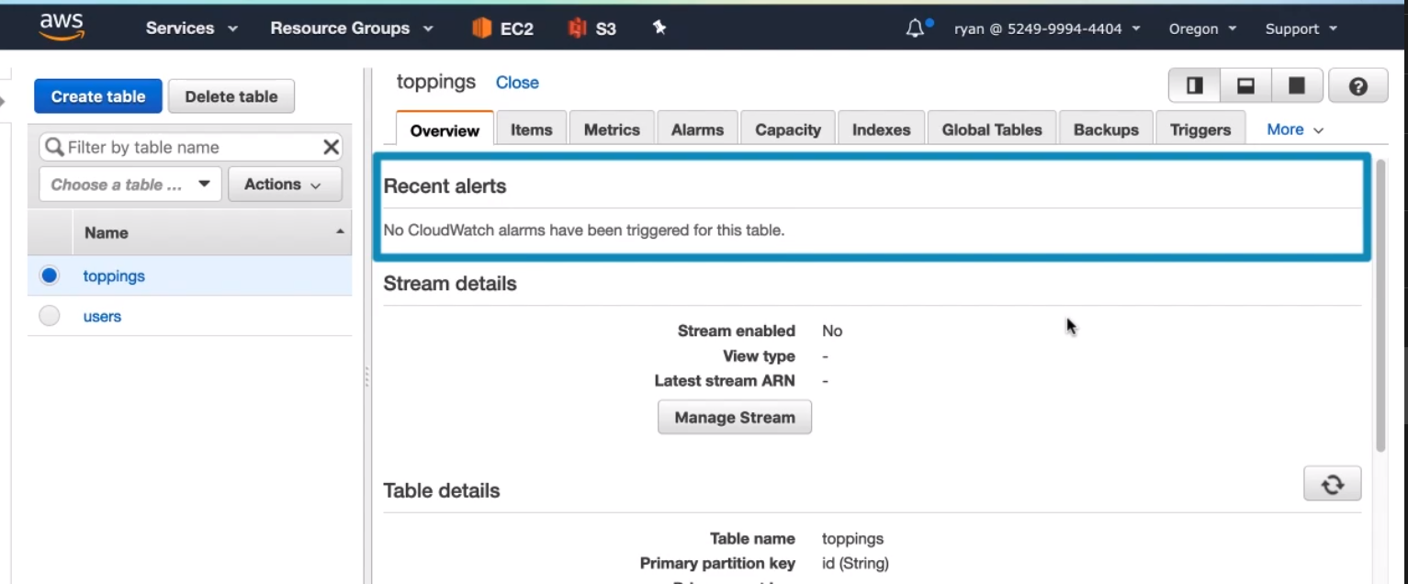

1. The Items tab shows you what’s in your database. this is basically a GUI representation of the data you can use to manage the items. There’s obviously nothing here yet, but once we connect, this should be filled with toppings.

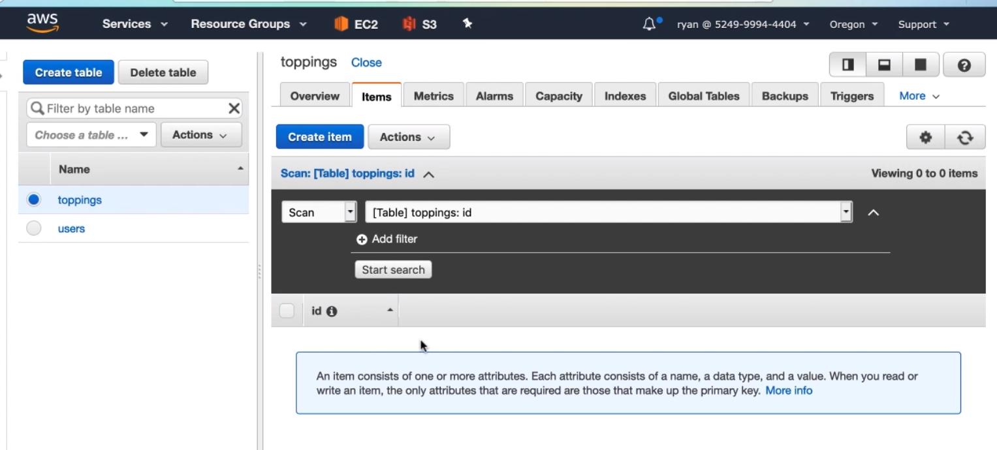

1. The capacity tab shows your current provisioned throughout capacity and lets you modify it as needed. It also handily shows you how much the estimated cost for this table is monthly.

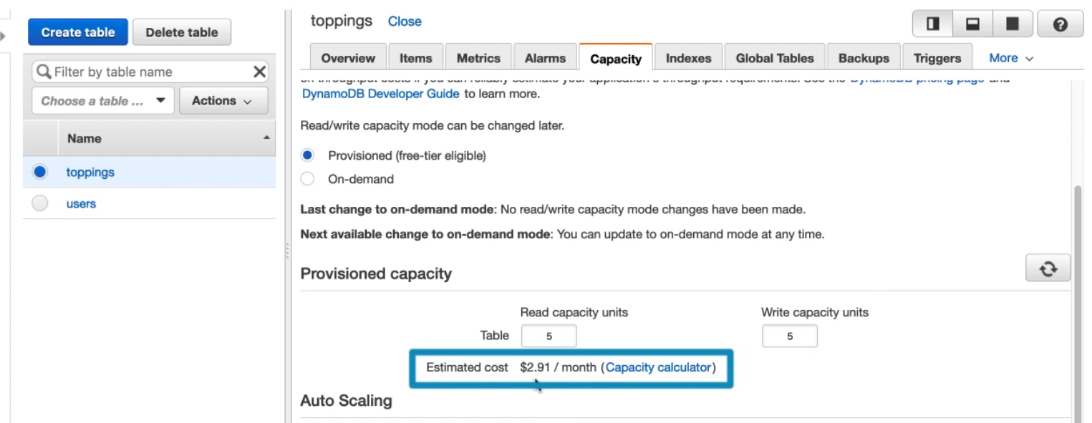

In the next clip we are going to connect to these tables with our application.



1. Create a file dynamoStore.js and on line 5 we’ll assign to it a new AWS.DynamoDB.DocumentClient constructor call. This DocumentClient class makes it a little easier to interact with Dynamo DB documents. This dynamoStore module will have three exposed functions, putItem, getItem and getAllItems. This will cover all the needs of both our toppings and users modules.

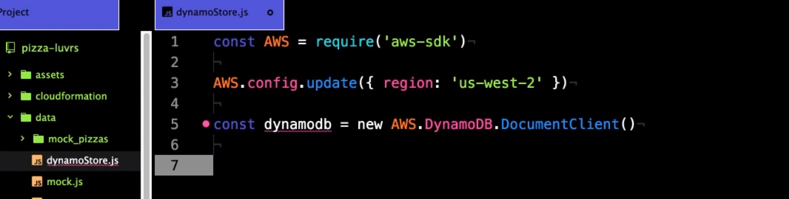

1. First let’s create the putItem function

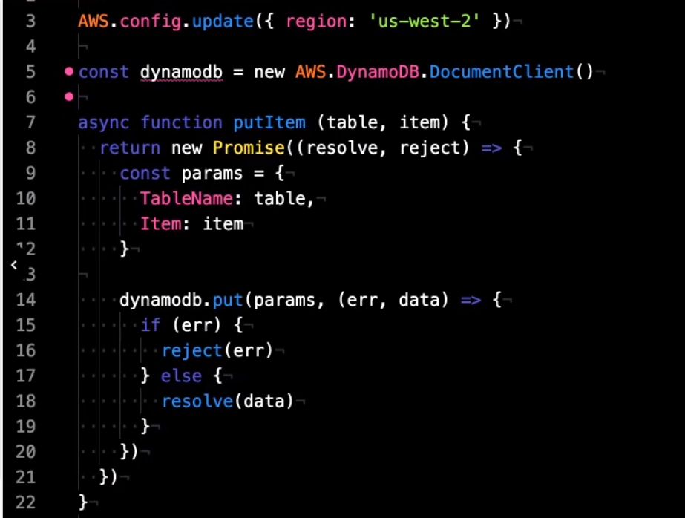

1. Create getAllItems function:

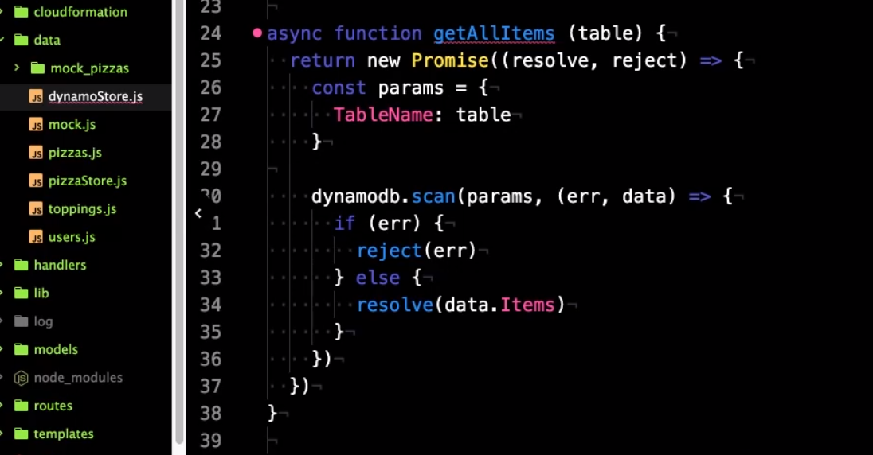

1. Create function getItem:

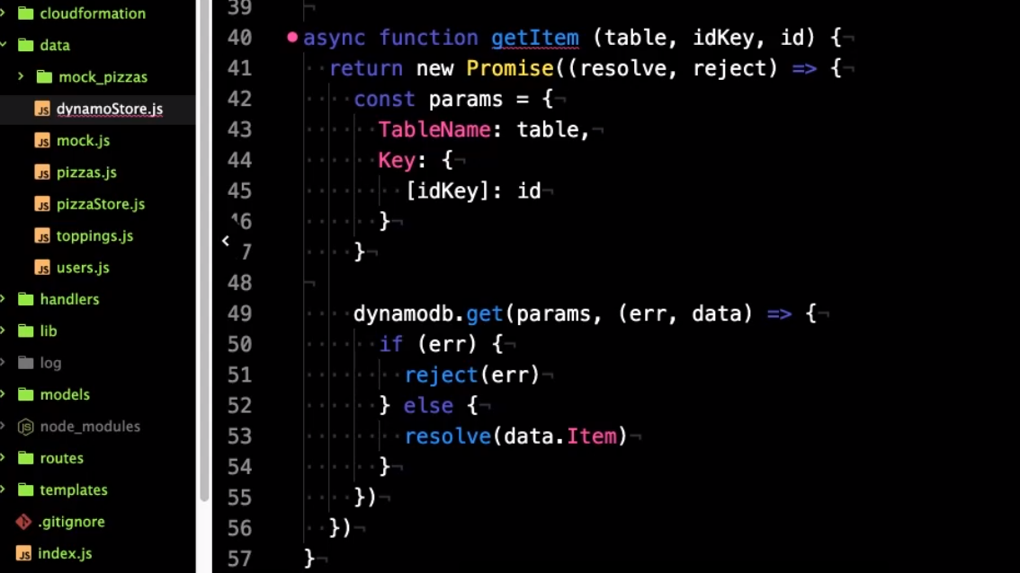

1. Finally we need to export these functions, so set an object literal to module.exports, and add all the function identifiers from above.

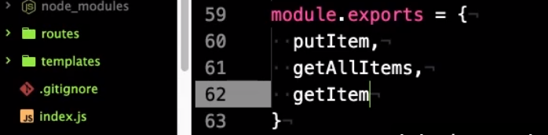



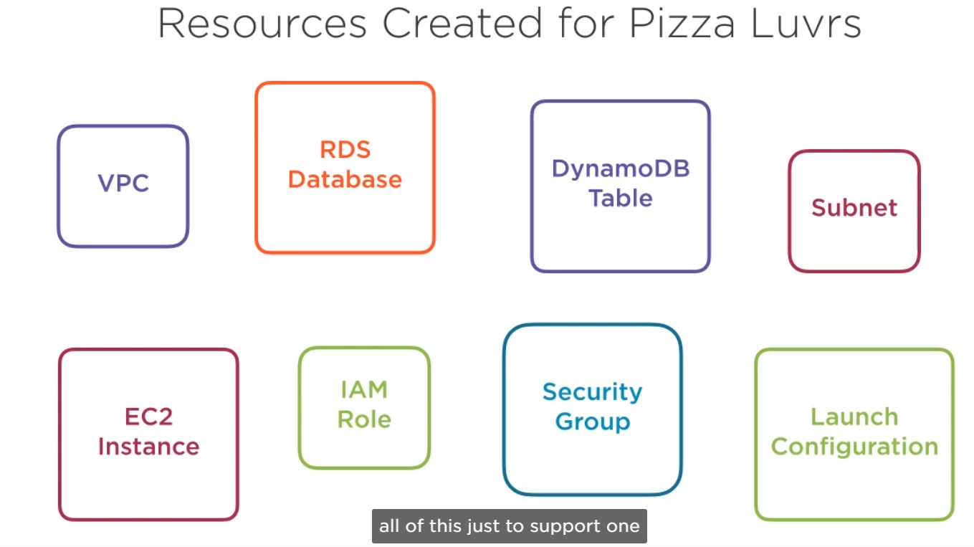

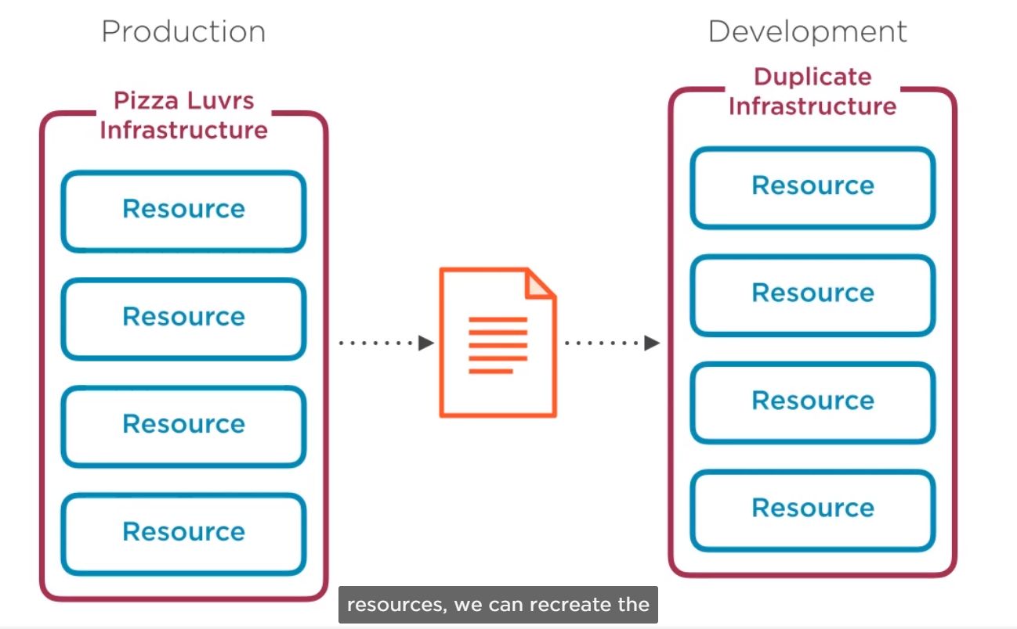

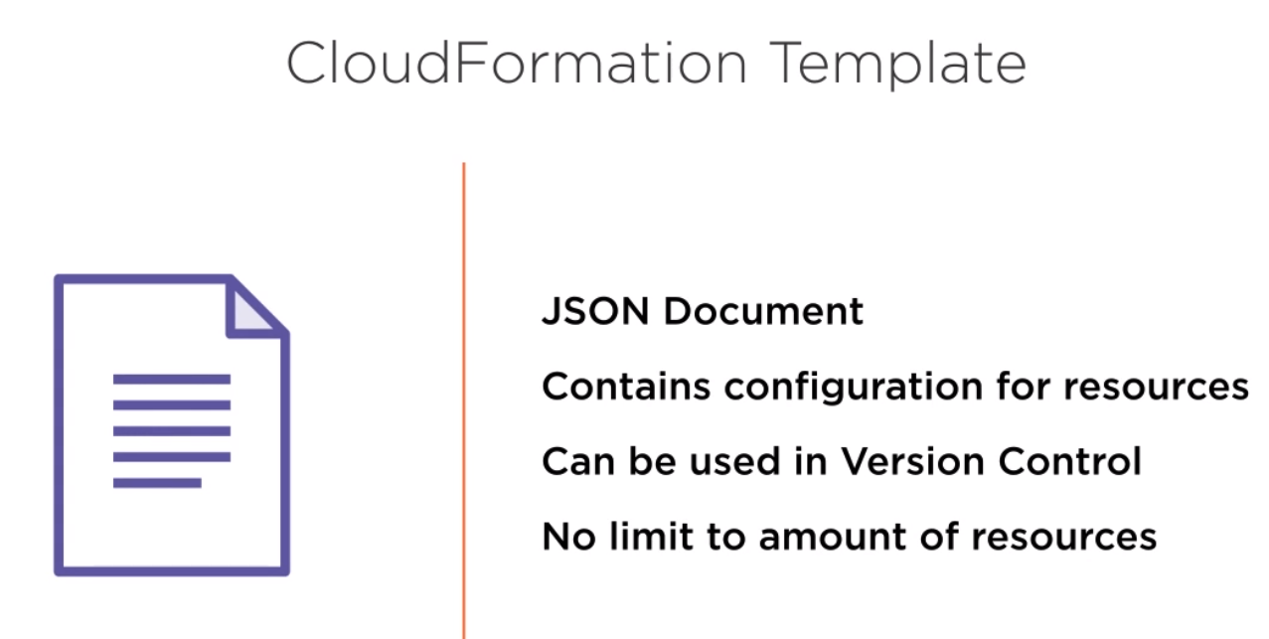

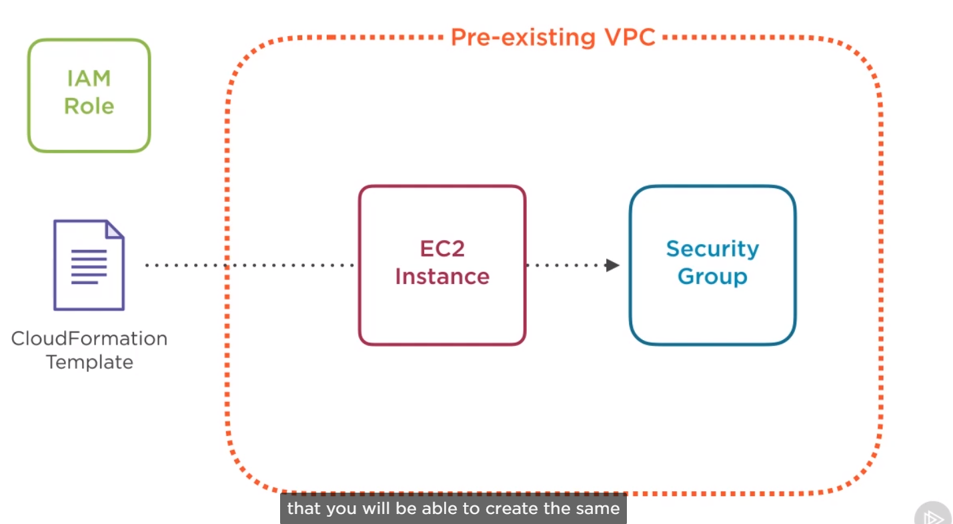

The other cloudFormation concept is the idea of a stack. A stack is essentially a group of AWS resources created by a single cloudFormation template. A template can be used to create more than one stack, but each stack needs to be named uniquely.

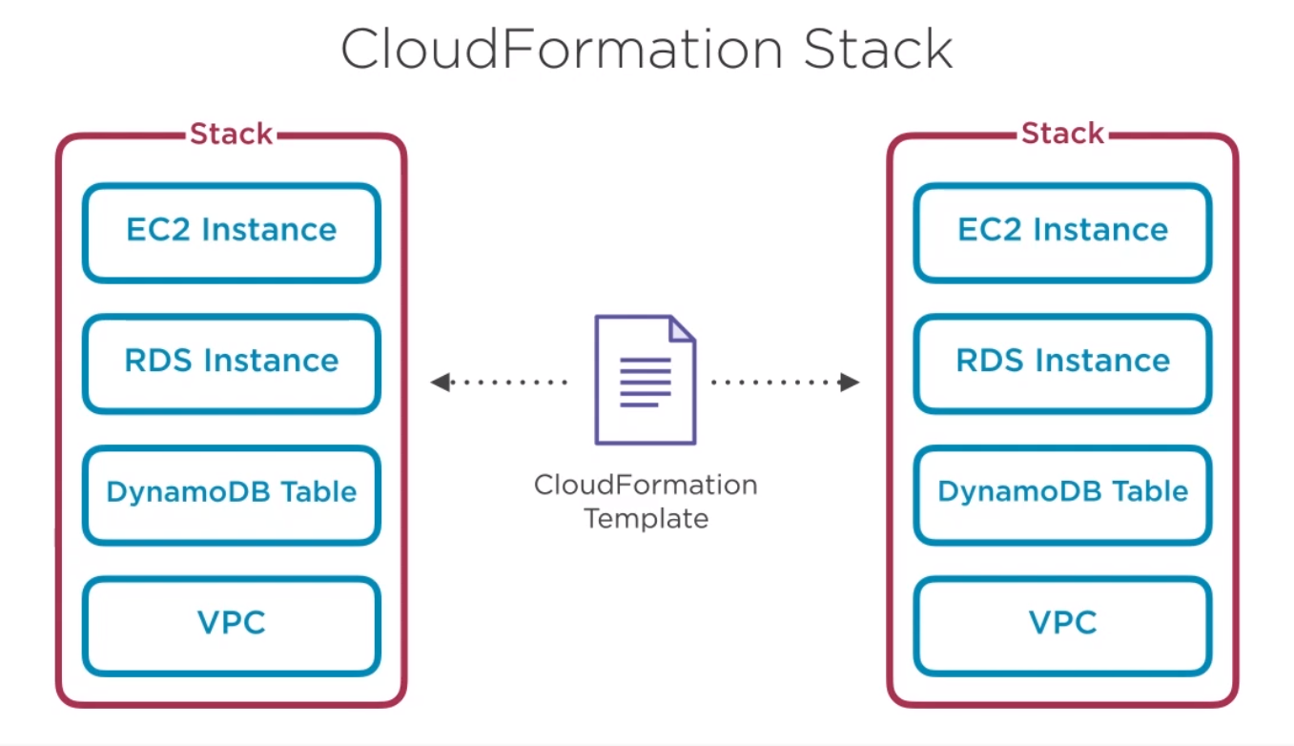

It can also update and delete.

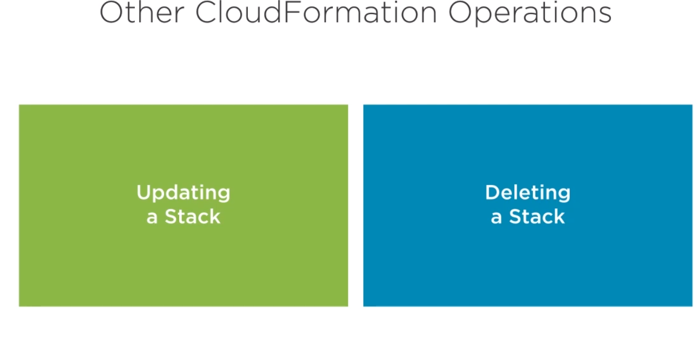

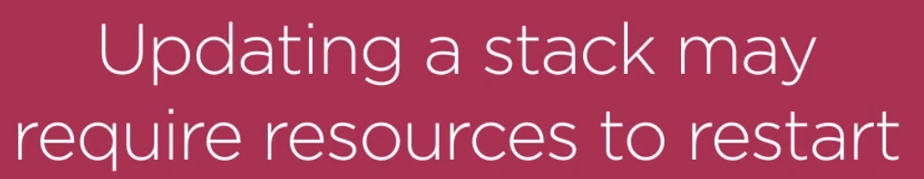



One important thing to know is:

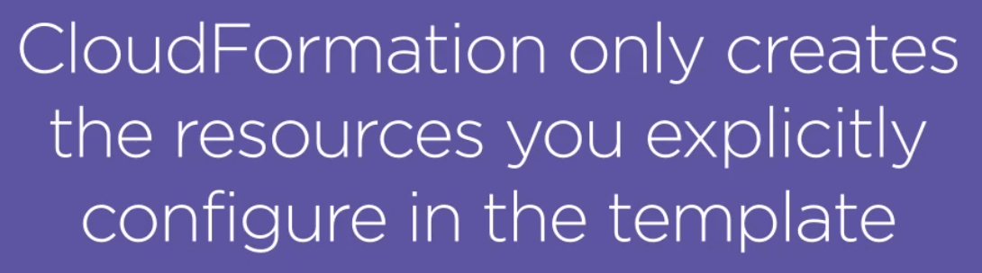

The first tool is the CloudFormation Designer. This is a drag-and-drop tool to create cloudFromation templates. You can create one from scratch or import an existing CloudFormation template to modify it. The Designer allows you to visualize the resources that your CloudFormation template will create and modify the details of each.

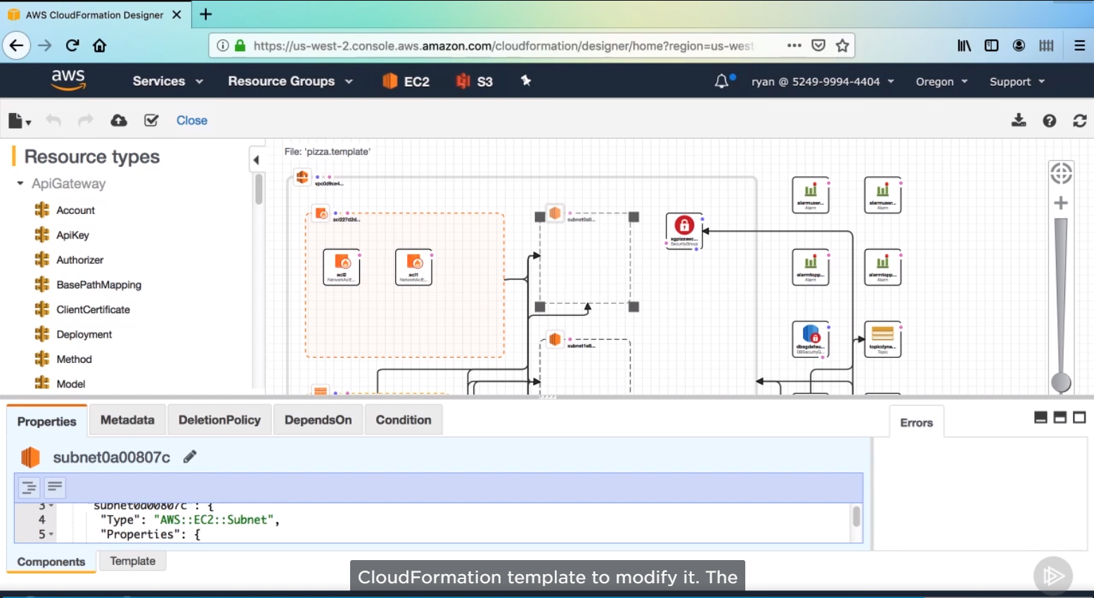

Even more powerful, in my opinion is the cloudFormer tool, this tool will look at your existing resources and create a CloudFormation template for you to recreate them. Using a wizard, you select which existing resources to include in the template, and then it finally creates it for you.

